Tour of Potters Field in Florence, KS and Council Grove, KS
May 1, 2010
Notes and photos by Melvin D. Epp, President

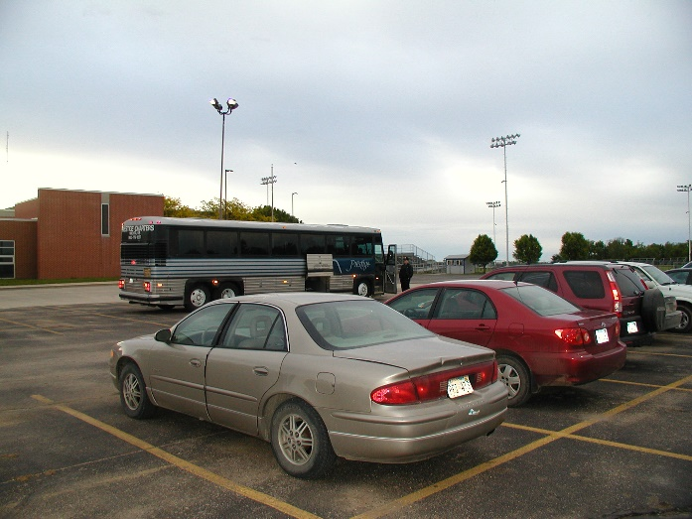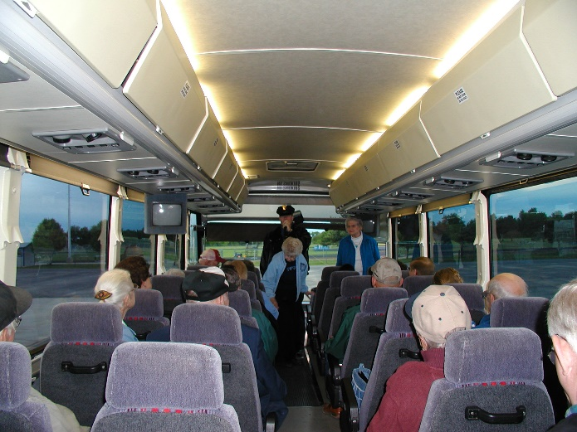

The tour was initiated on a cloudy morning in the Remington High School parking lot. Our tour guide, Sharon Regier, and tour facilitator, Agnes Harder, warmly welcomed the group aboard the Prestige Tour bus. The first stop was at the Hillcrest Cemetery north of Florence, KS to view Potters Field.

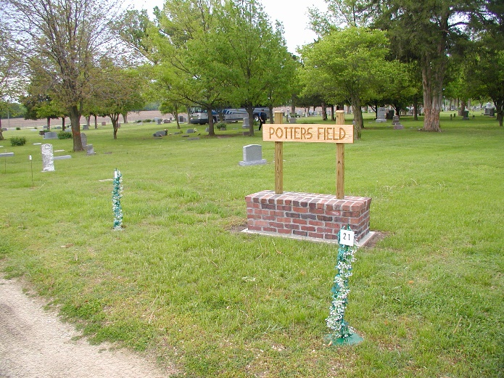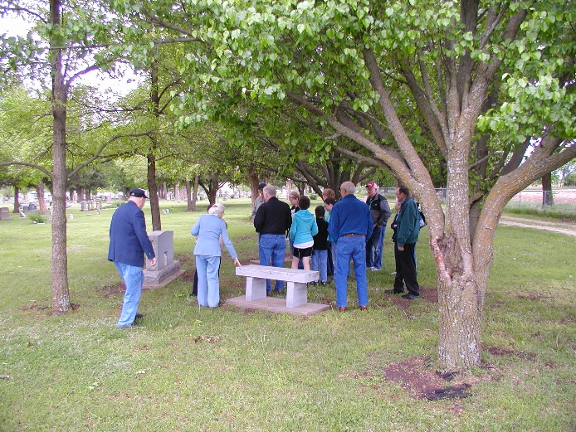

Hillcrest Cemetery was established in 1871. The monuments that were erected are the only available record of burials for the early years. The winter of 1874-75 brought with it a smallpox epidemic, which took the lives of many Russian Mennonites housed in Florence for the winter. They are buried in a mass grave—Potters Field.

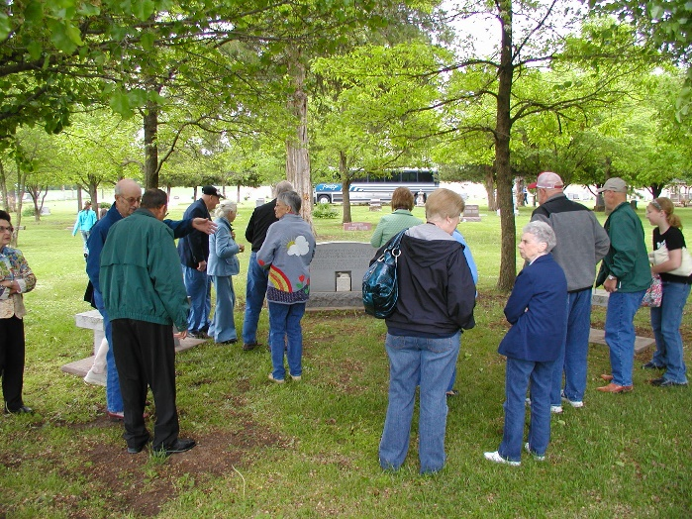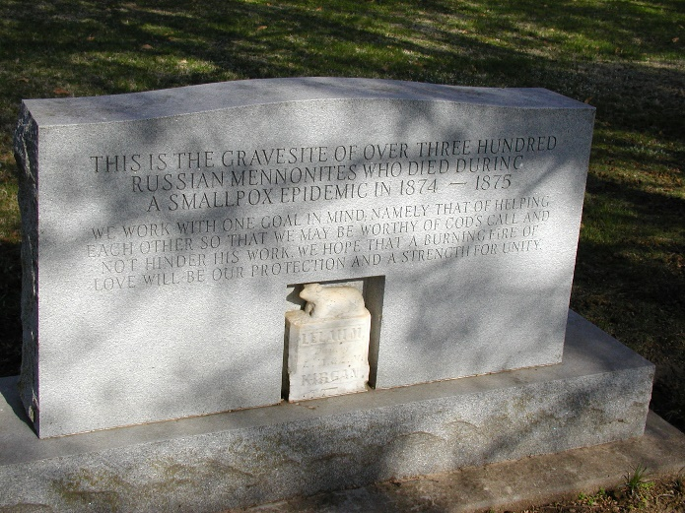

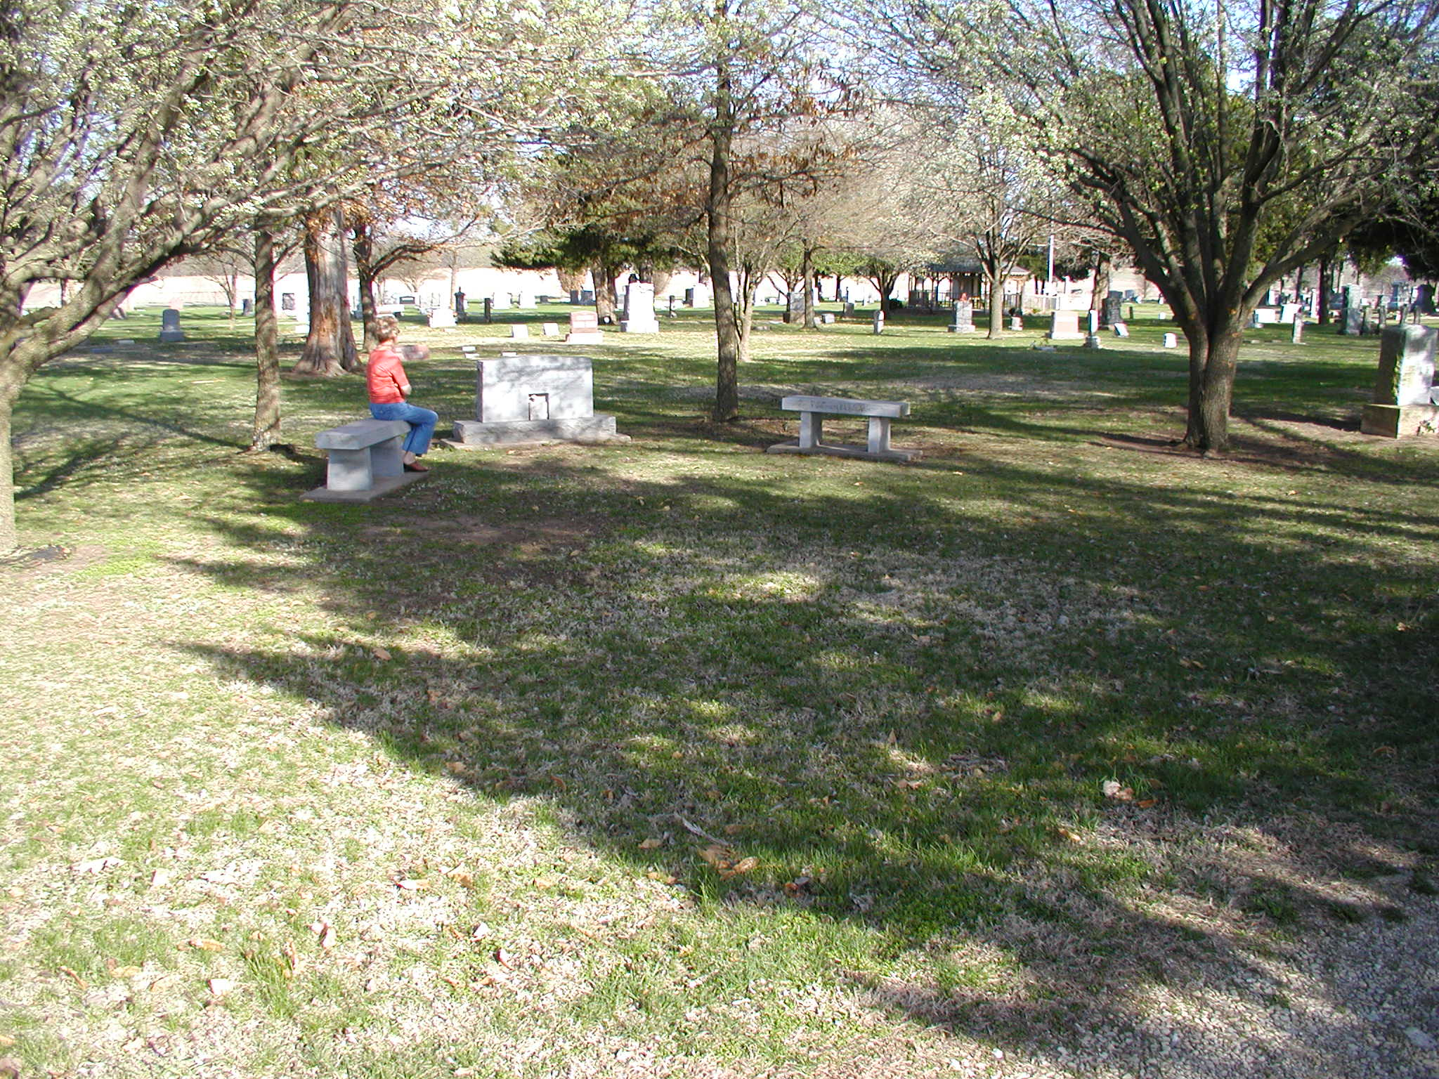

The monument with a small white carved Russian bear displayed at the bottom reads, “This is the gravesite of over three hundred Russian Mennonites who died during a smallpox epidemic in 1874-1875. We work with one goal in mind, namely that of helping each other so that we may be worthy of God’s call and not hinder his work. We hope that a burning fire of love will be our protection and a strength for unity.”

The survivors of the large group of Russian Mennonites, who the Santa Fe Railroad allowed to overwinter in a vacant warehouse in Florence, were moved in spring of 1875 to Lone Tree Township, McPherson County, Kansas where they established their community around The Lone Tree Church of God in Christ Mennonite Church. Ted Regier shared their story as we drove through the Flint Hills from Florence to Council Grove.
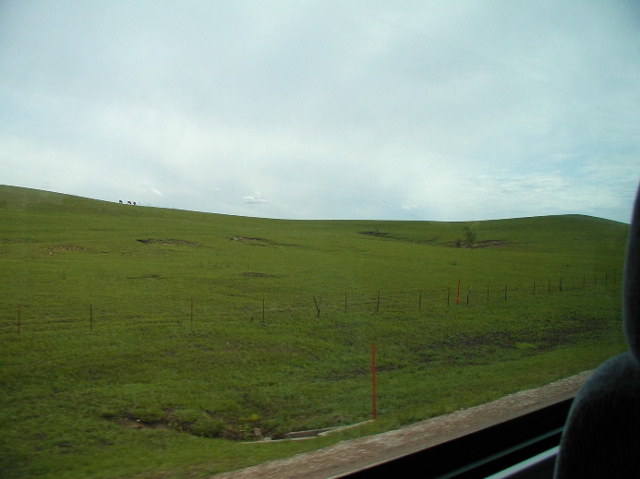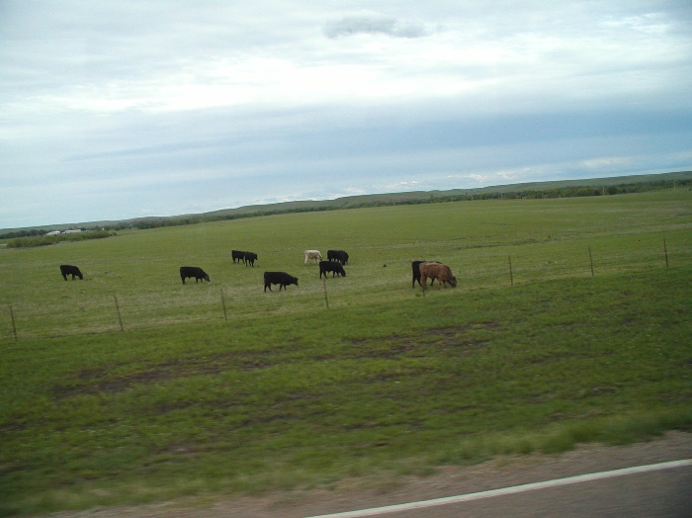

The balance of the day was spent sightseeing in Council Grove, Kansas, which was pivotal as a major supply stop along the Santa Fe Trail. Council Grove, fifty-five miles southwest of Topeka, is the county seat in Morris County. It was named after an agreement between European Americans and the Osage Nation about allowing settlers' wagon trains to pass through the area and proceed to the West. Pioneers gathered at a grove of trees so that wagons could band together for their trip west.

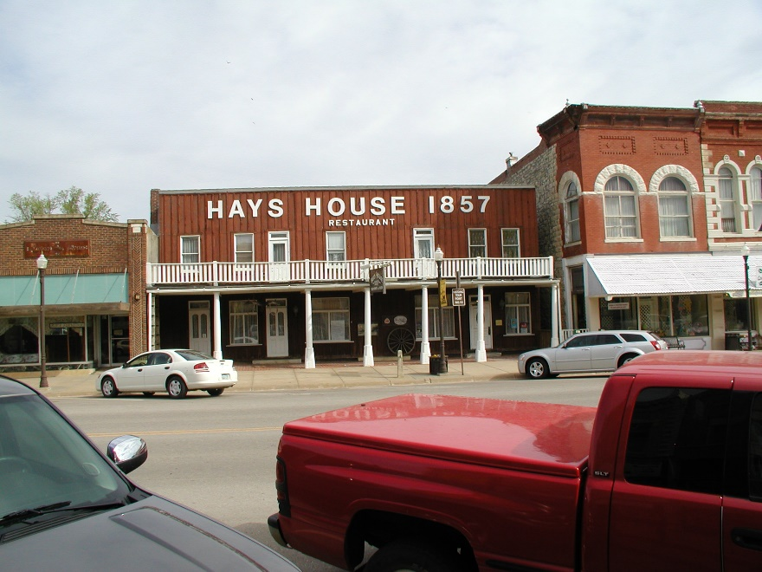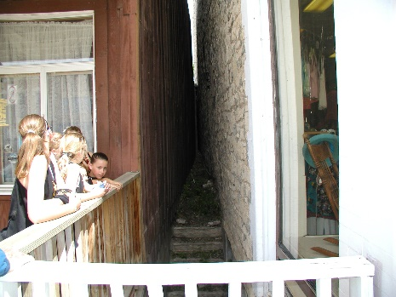

Council Grove was one of the last stops on the Santa Fe Trail heading southwest. The first European-American settler was Seth Millington Hays, who came to the area in 1847 to trade with the Kaw tribe, which had a reservation established in the area in 1846. Hays was a great grandson of Daniel Boone.
A post office was established in Council Grove on February 26, 1855. In 1858, the town was officially incorporated by the legislature. Hays also opened a restaurant in 1857, the Hays House, which is said to be the oldest continuously operating restaurant west of the Mississippi River. The Hays House restaurant building was originally built in the 1850s and is off-set from the newer adjacent buildings along the street. Our tour group initiated our visit to Council Grove with lunch at the Hays House.
The town has 13 sites listed on the National Register of Historic Places, including the Kaw Mission.
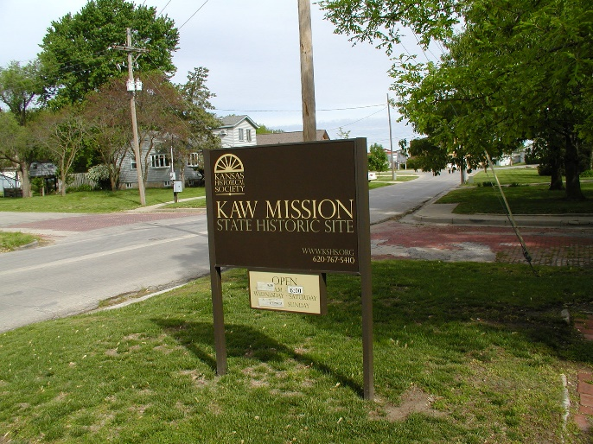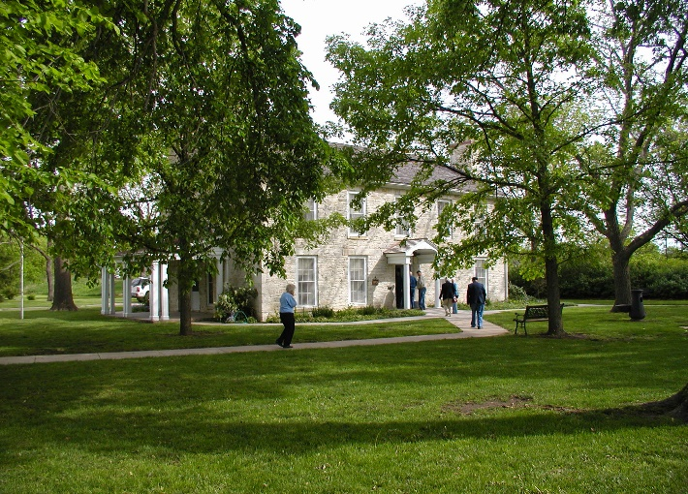
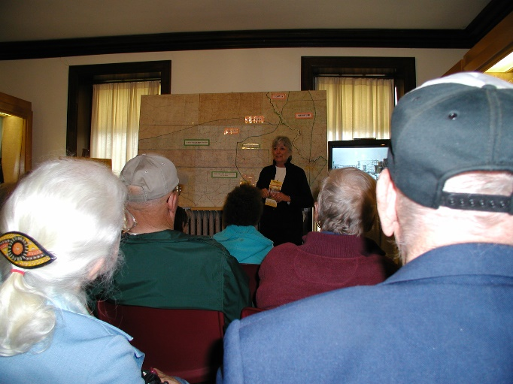
The story of the meeting of these two cultures in Council Grove is told in a graphic and three-dimensional form at the Kaw Mission State Historic Site. Here in the early 1850s, Methodists attempted to educate Kaw boys as a means of folding the Indians into the Euro-American culture.
The Kaw Mission story reflects the universal themes of two cultures in historical collision, the lethal impact of this collision on the native peoples, and the modern re-integration of the
Kaws and their stories into the tribe's ancestral home near Council Grove.
The interior of the Kaw Mission contains exhibits telling the story of the Kaw Indians, the Santa Fe Trail, and early Council Grove. An eight-minute introductory video, The Original Kansans, provides an overview of the history of the Kaw Mission and the Kanza Indians. Written by Kaw Mission curator Ron Parks, the video was produced in October 2000 by KTWU-TV in Topeka.
Following the video, visitors are free to explore the two rooms downstairs and three rooms and large hallway upstairs. Exhibits include Kaw leather craft, beadwork, textiles, and a Kaw photo gallery. Additional artifacts include Santa Fe Trail-related items and early day furniture, weapons, tools, and domestic paraphernalia.
In addition to the Kaw Mission, a reconstructed small stone "Indian Hut" is situated on the historic site. This is one of 138 of these structures the federal government built on the diminished Kaw Reservation in 1861 as intended residences for the Kaws. The Indians, who had for generations been living comfortably in skin tepees and bark-and-mat lodges, wanted nothing to do with their new homes, choosing instead to stable their horses and dogs in them.

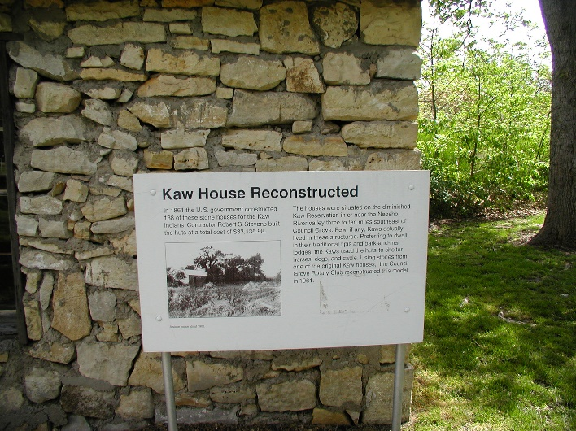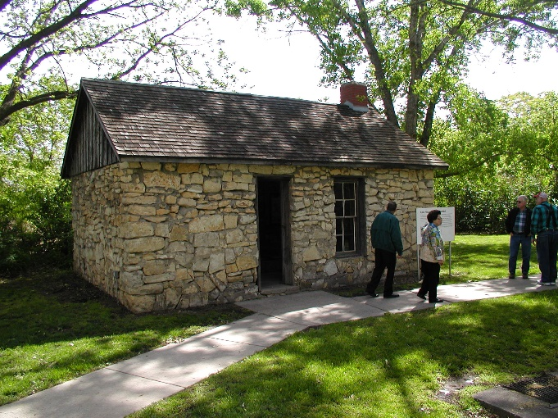

The Kaw Mission State Historic Site is also Council Grove’s official visitor information center. The site is situated on the northern end of the new one-half-mile-long "Riverwalk," a beautiful, winding walkway hugging the banks of the Neosho River.
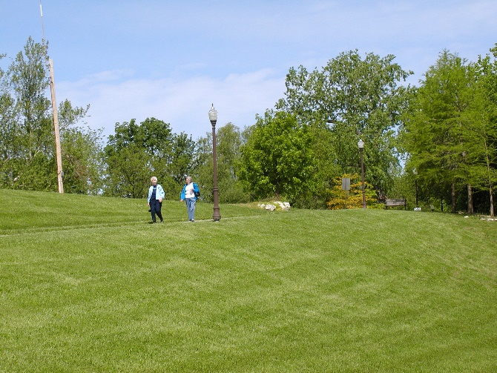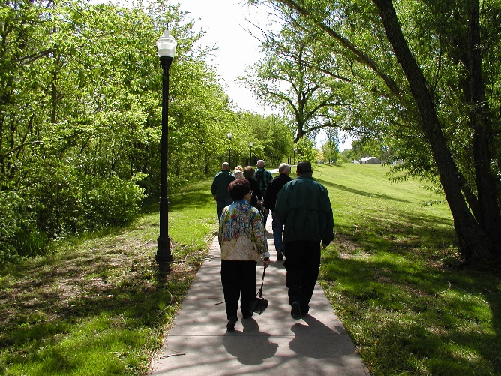

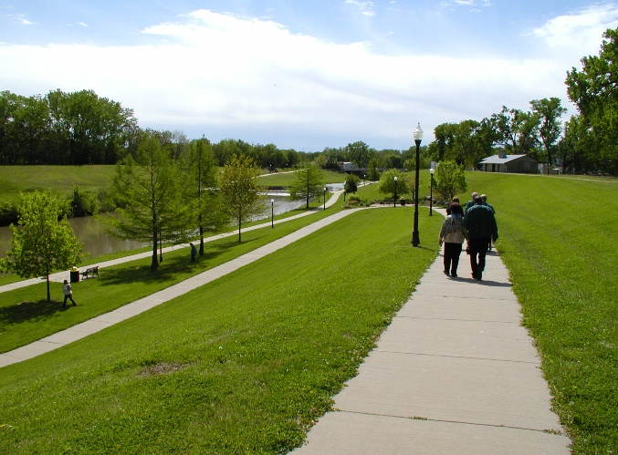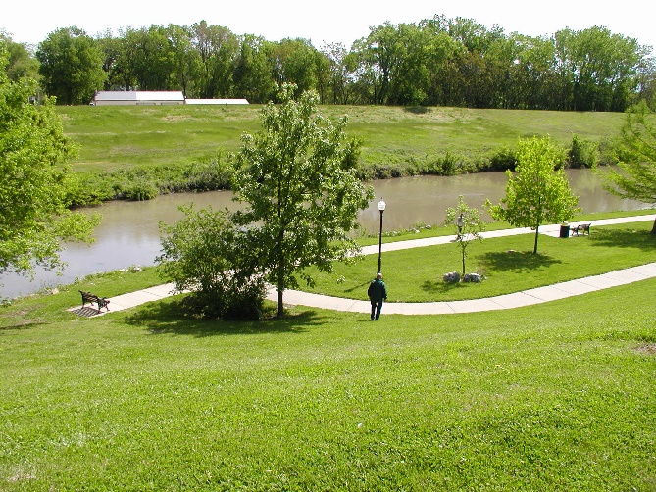
At the southern end of the "Riverwalk," located at the intersection of K-177 Highway and Main Street (Hwy 56 and the Santa Fe Trail), is the lovely bronze statue of a Kaw Warrior. Named "The Guardian of the Grove," this eight-foot sculpture provides a powerful visual statement about the historical presence of the native peoples for whom the state of Kansas is named.
“The Guardian of the Grove” now stands as a reminder of our not so distant past. It is a tribute to a Native American people who have refused to fade away into extinction; it stands as a challenge to future generations to preserve our history. Standing now on the Santa Fe Trail overlooking the Neosho River the past meets the present by means of a bronze statue that is filled with symbolism. This statue is meant to guide understanding of the significance of the Kansa people.
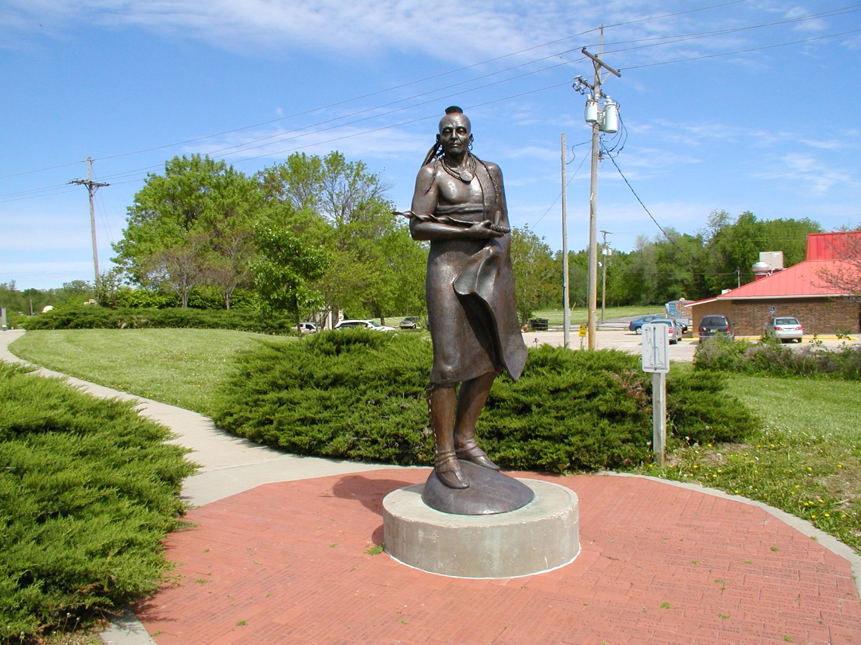
To the east across the street on Main Street is a pink Algonite stone statue “Madonna of the Trail.” Erected in Council Grove in 1928 by the Daughters of the American Revolution, the “Madonna of the Trail” depicts a pioneer mother with her two children. It is a memorial to the pioneer mothers of the covered wagon days.
It is here at this intersection where “East met West” when the old Santa Fe Trail was established on August 10, 1825 at the council between the United States Commissioners and the Osage Indians.
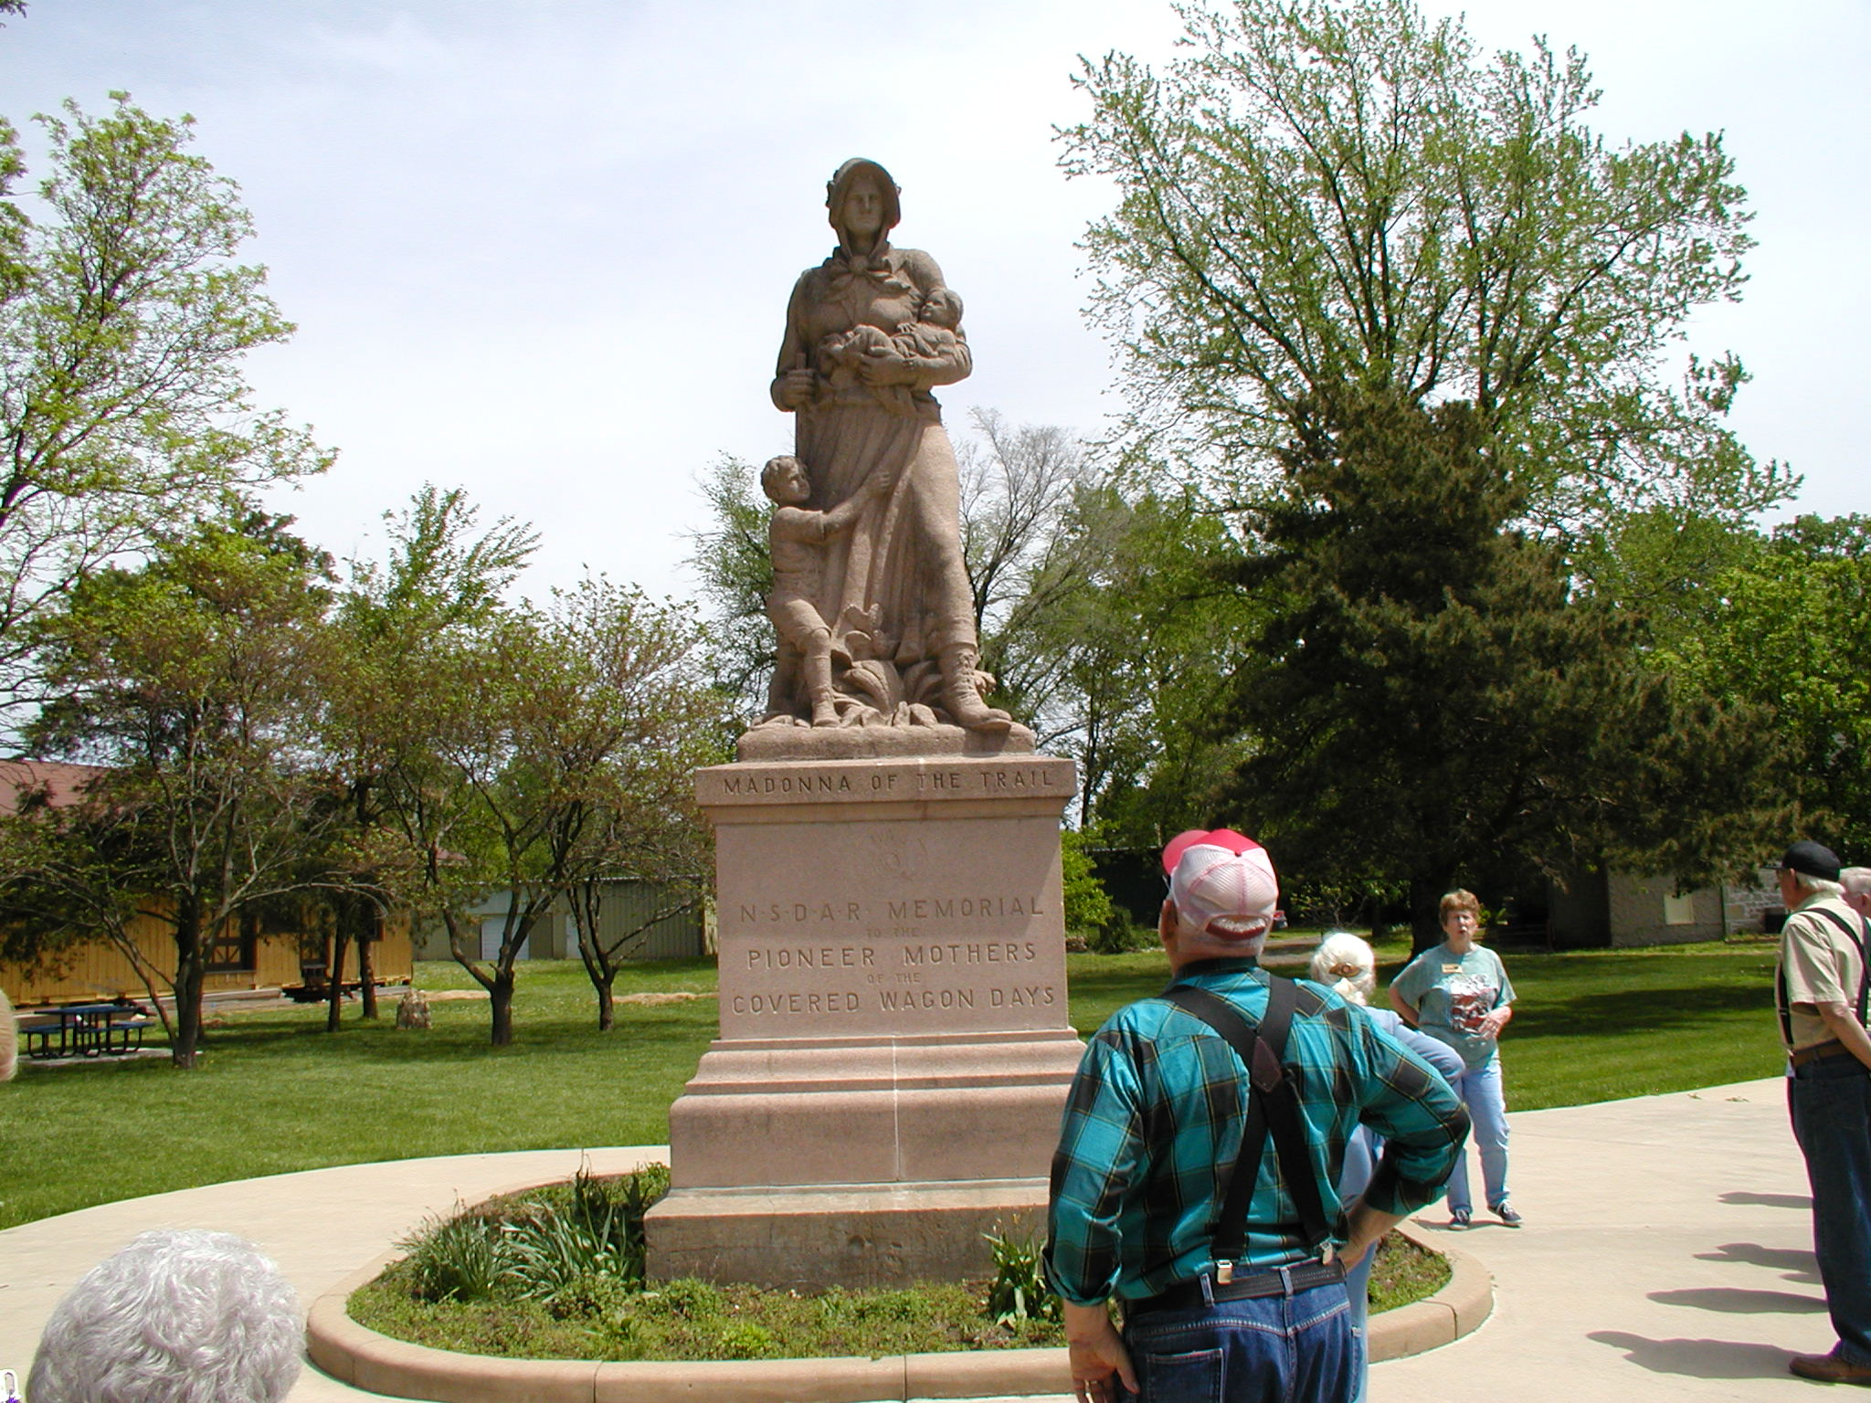
Further east is the Post Office Oak. Believed to have been 270 years old when it died in 1990, this bur oak is said to have served as an unofficial post office for travelers on the Santa Fe Trail from 1825-1847. Passing caravans could leave messages for future travelers in a cache in the base of the tree. The tree trunk stands next to a stone building erected in 1864 for use as a brewery.
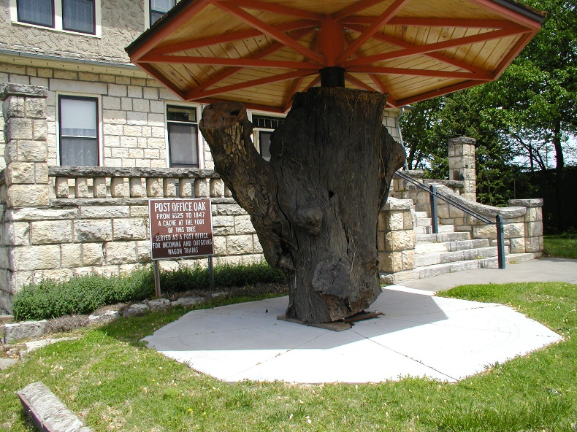

Travelers left their mail in this designated tree to be picked up by others going in the right direction.

East of the Post Office Oak stood the Council Oak. A council was held under this tree August 10, 1825, attended by three U.S. Commissioners and the Osage Indians. The resulting treaty gave Americans and Mexicans free passage along the Santa Fe Trail through Osage territory in return for $800. It was also at this time that Council Grove got its name. The Council Oak was part of a mile wide grove of trees that provided shelter and wood for wagon repairs on the Santa Fe Trail. Before it blew down during a windstorm in 1958, the oak was approximately 70 feet high, and measured 16 feet around.
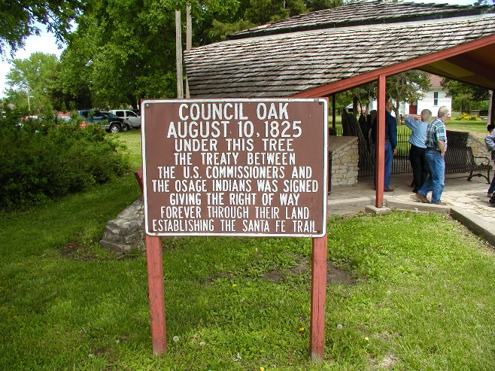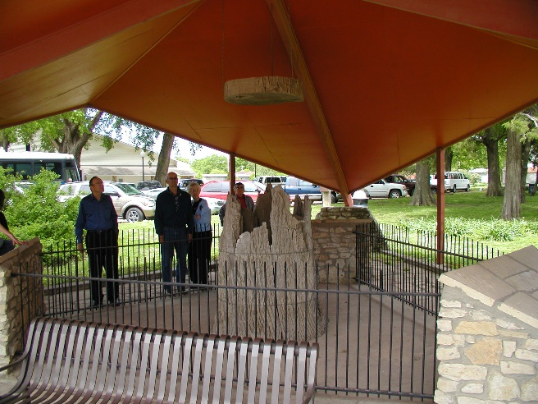
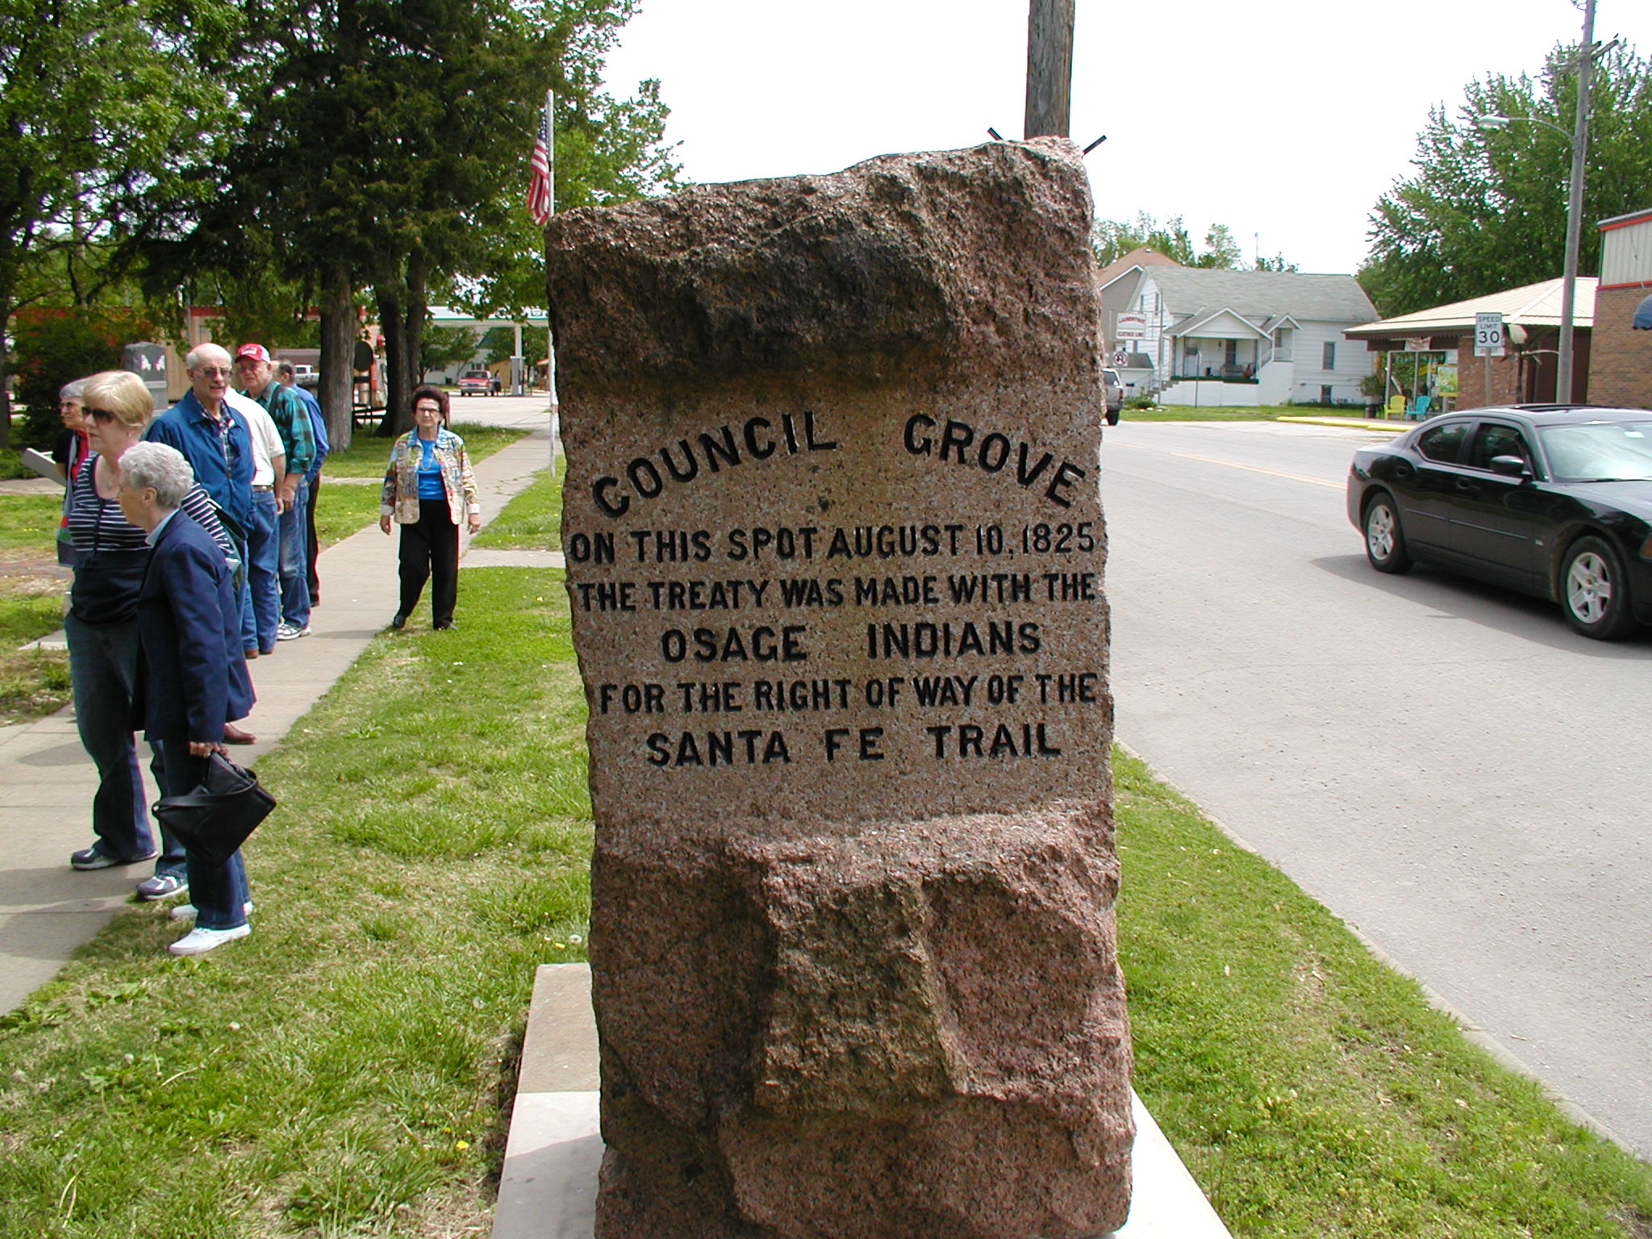
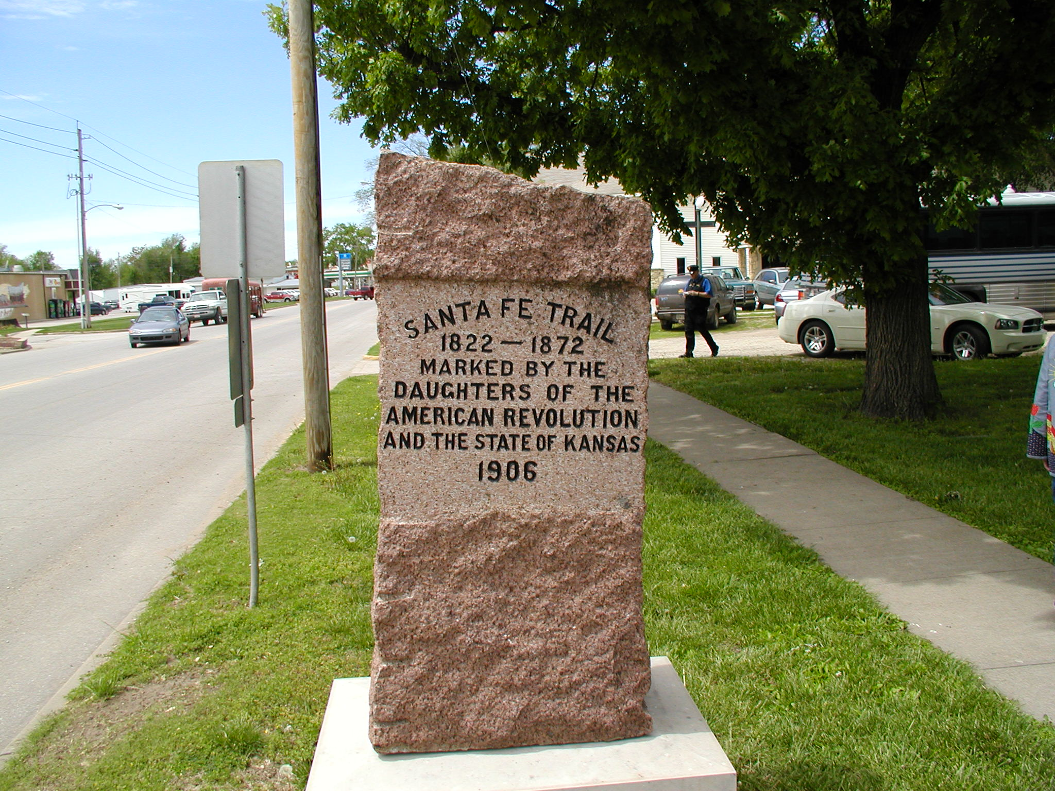
One of the most documented crossings on the Santa Fe Trail, this natural rock bed crossing at the Neosho River, can best be seen from the north side of the Neosho River Bridge on Main Street.
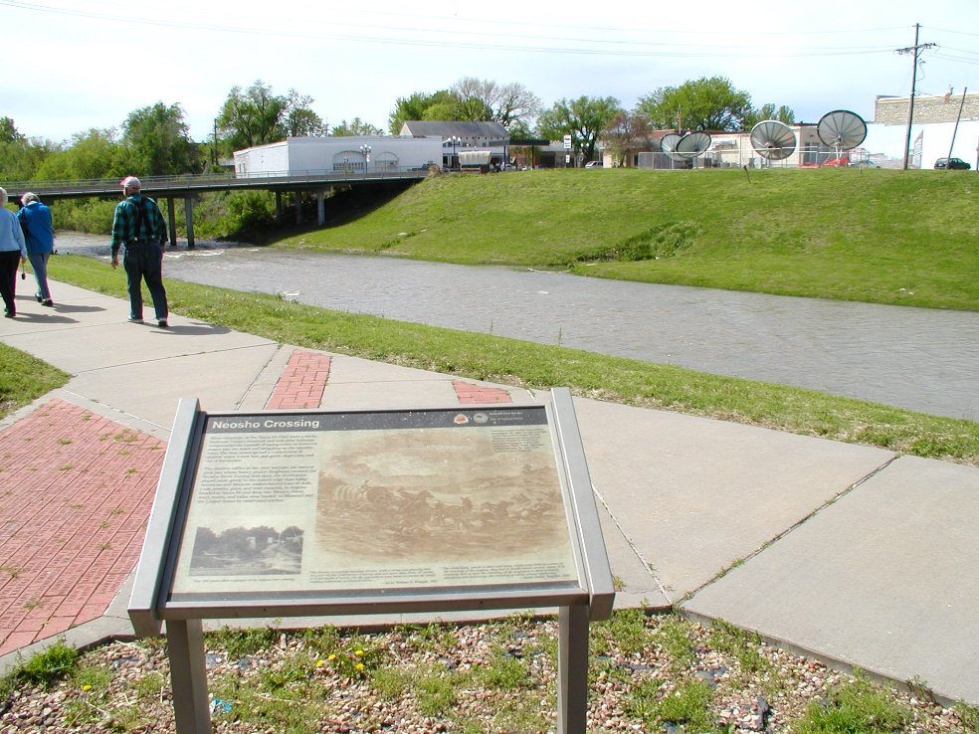
A National Park Service Wayside Exhibit is on the east side of the Neosho Riverwalk.
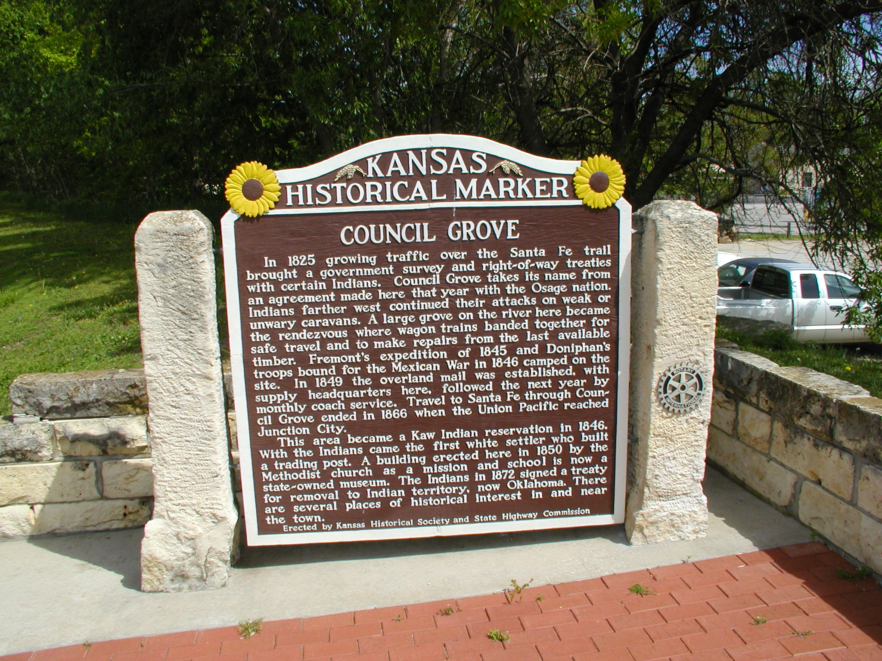
Crossing the Neosho River going west on Main Street, a covered wagon is a reminder of the extensive traffic on the Santa Fe Trail.
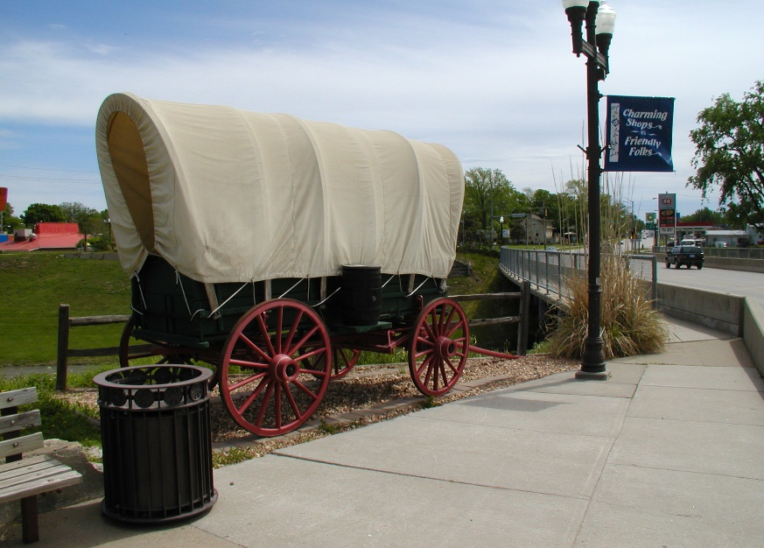
West of the wagon on Main is the Hays House built in 1857. The next pictures depict the interior of this establishment: plaque on outside door, basement ceiling structure, basement reception room, wall décor in an upstairs reception room, and the sculpture on a fireplace mantel “Conjuring Back the Buffalo” inspired by Frederic Remington.
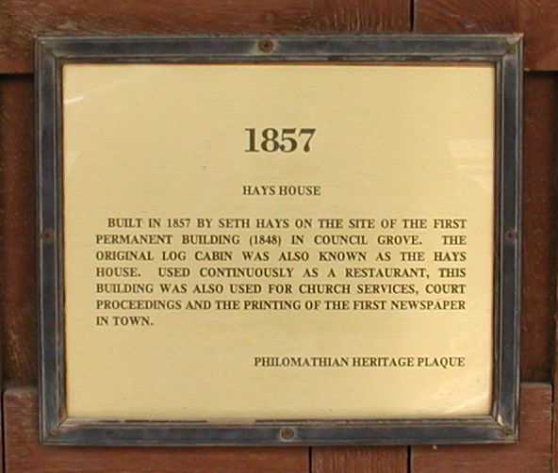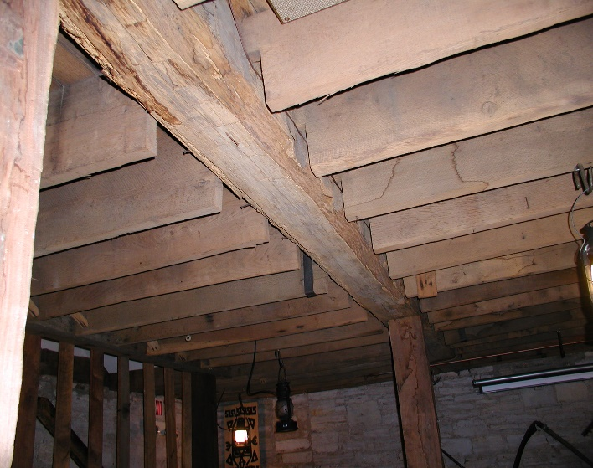
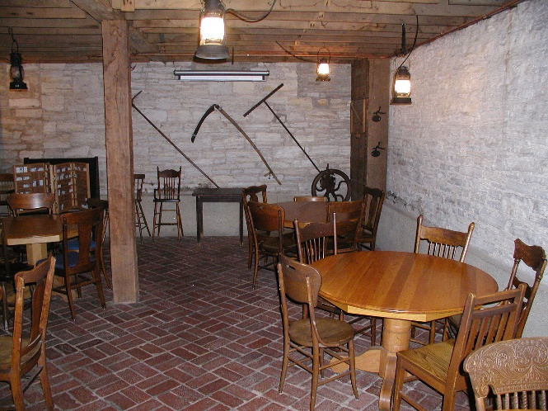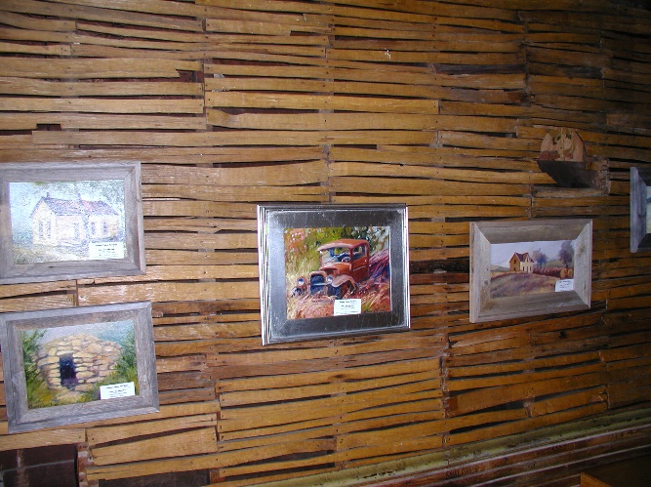
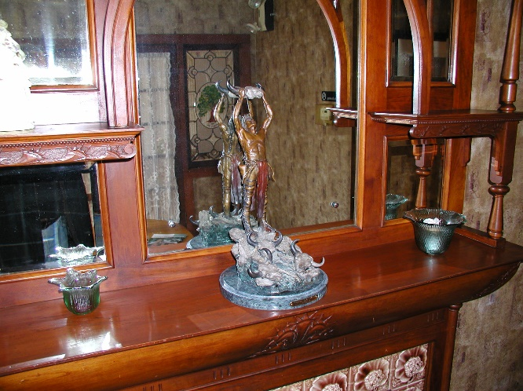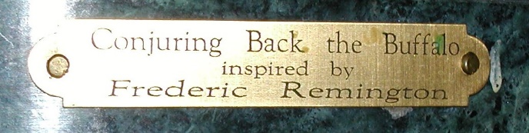
Concluding this historical trip were stops at the following sites shown below. The bus then turned homewards after an exceptionally informative afternoon in Council Grove, Kansas.
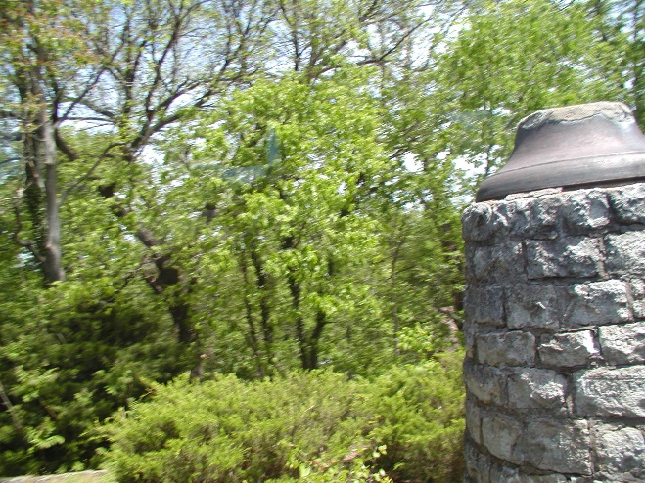
This Large Bell was brought to Council Grove in 1863 and put in use atop a tall tower in 1866. For 30 years it served as an alarm bell for those bent on misdeeds in Council Grove, as a school bell, and as a church bell. A stone monument, capped by the bell was erected in 1901 and stands today as a reminder of the services performed by this historic bell
Hermit Cave on Belfry Hill in Council Grove. Down the steps and under the rock in front of you is a small recess. For a few months in 1863, it was home to a religious mystic. Born in 1801 in Novara, Italy, he was known locally as Father Francesco. In his travels through Europe and the Americas, he used other names, including Matteo Boccalini, and his birthname, Giovanni Maria de Agostini.
Son of a nobleman, he received a fine education in preparation for the priesthood,
but reportedly was forced to leave Italy after falling in love with a young lady.
The Hermit left for southern New Mexico and the Organ Mountains in 1867. He was mysteriously murdered in 1869.

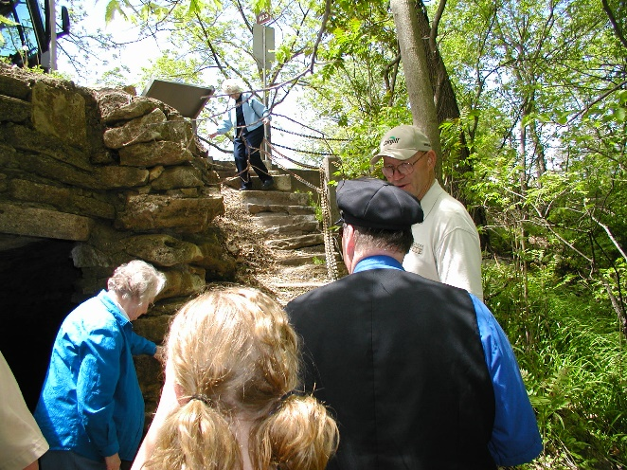
He left Council Grove with a wagon train owned by Don Eugenio Romero and captained by Dionicio Gonzalez, walking the entire 550 miles to Las Vegas, New Mexico. There, he is said to have performed miracle cures, which attracted crowds. He retreated to a nearby mountain. Initially called the Hermit of El Porvenir, he lived in a cave on what came to be known as Hermit's Peak. The citizens of Las Vegas soon built him a small cabin, where he carved religious emblems, which he traded in town for cornmeal.
The Hermit left for southern New Mexico and the Organ Mountains in 1867. He was mysteriously murdered in 1869.
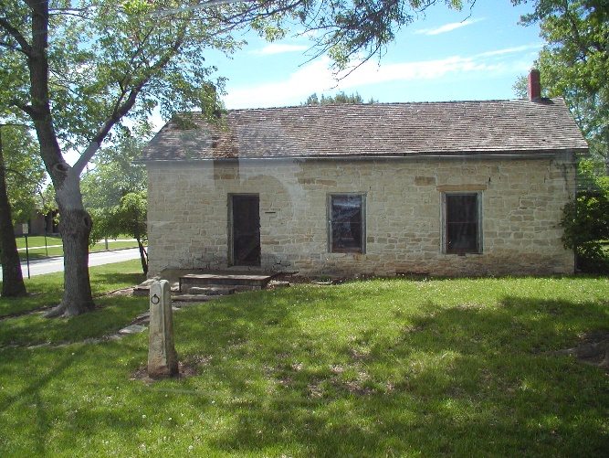
The Last Chance Store was built in 1857 along the Santa Fe Trail at Council Grove, Kansas. Located where the trail crossed the Neosho River, it was the last store in the settlement before the river. It was operated by Tom Hill as a trading post, as well as a post office and a polling place. The structure is constructed of local limestone, irregularly coarse, with a gable room and some quoining at the corners.

