Great Bend, Kansas Tour
Saturday, May 5, 2012; 7:00 AM
Present: 39 Members and Guests

Melvin Epp, President, and Agnes Harder, Treasurer, initiated the day’s activities with a warm welcome to members and friends. Sharon Regier introduced the Prestige Bus Company bus driver, Don, and proceeded to present a schedule with information about the tour activities for the day.

The bus left the Remington High parking lot at 7:00 AM with 39 members and guests on board anticipating a pleasant, fun-filled day. The weather was picture-perfect for the beginning of May. The bus stopped in North Newton to pick up three riders, and stopped again in McPherson for a refreshment break at McDonald’s. Don kept the riders well entertained with his repertoire of jokes and stories.

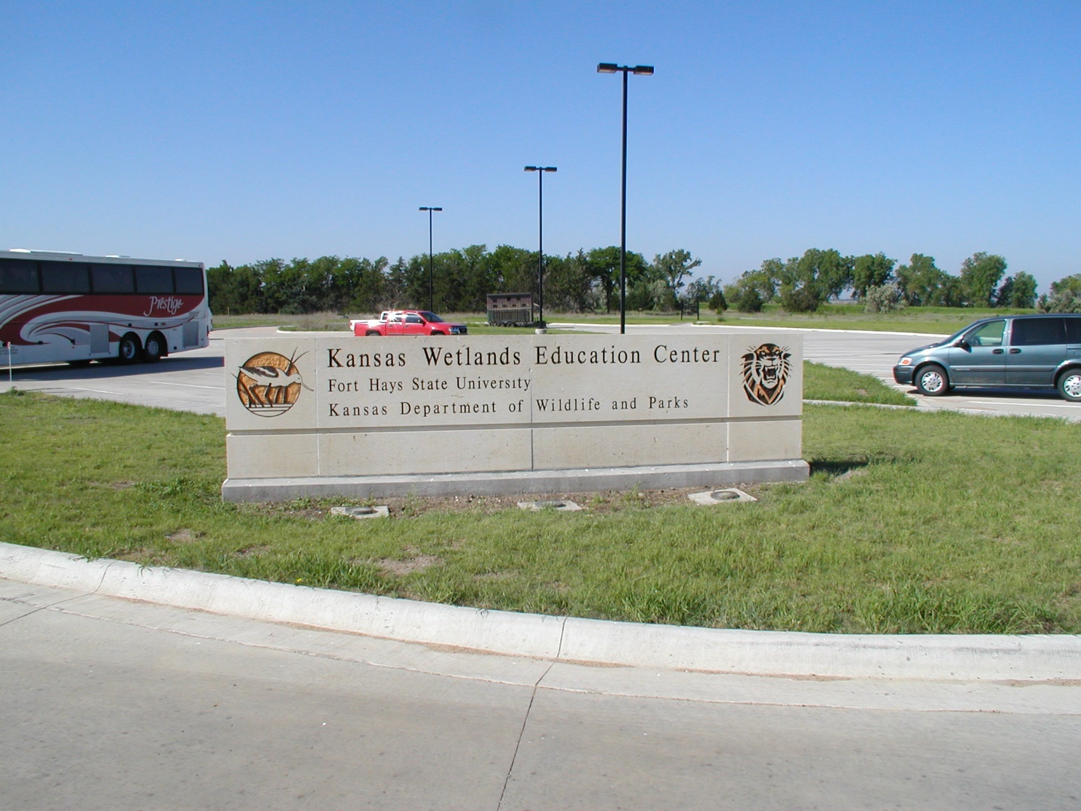

The tour group arrived at the Wetland Educational Center at Cheyenne Bottoms (CB) around 10:00 AM. Members climbed out and entered the building for a quick introduction to Scott, our CB guide for the morning. After a quick initiation of the building and CB site, members reboarded the bus for a tour of the CB wetlands. With 41,000 acres of wetlands, Cheyenne Bottoms is the largest inland marsh in the United States. The 20,000 acre center belongs to the Kansas Department of Wildlife and Parks and is administered as the Cheyenne Bottoms Wildlife Area. The Nature Conservancy owns an adjacent 7,300 acres which is administered as the Cheyenne Bottoms Preserve.
Members, armed with binoculars and bird identifying information sheets, saw many different types of waterfowl, such as herons, egrets, and many busy wading birds, and other wildlife such as a muskrat. After the wetlands tour, members returned to the Educational Center to view two informational films and browse the excellent museum. Some members toured the walkways outside the building to see the birds close-up since the weather was so very pleasant.

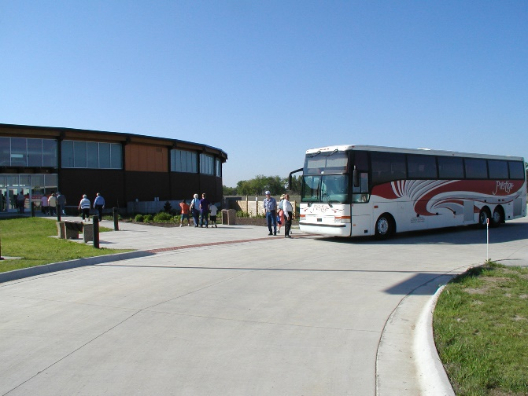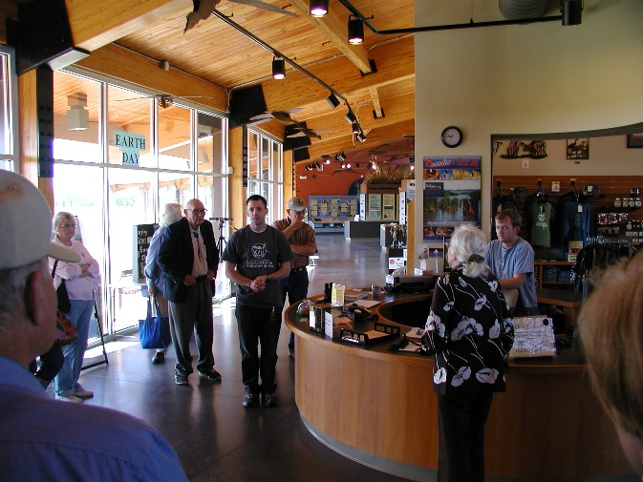

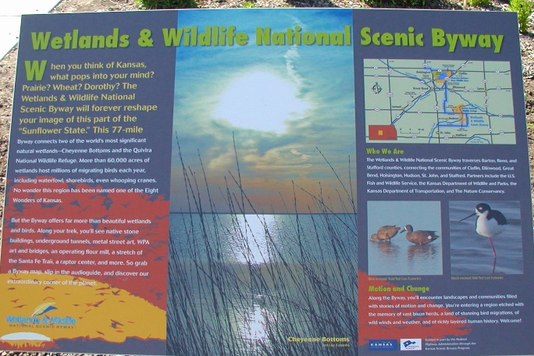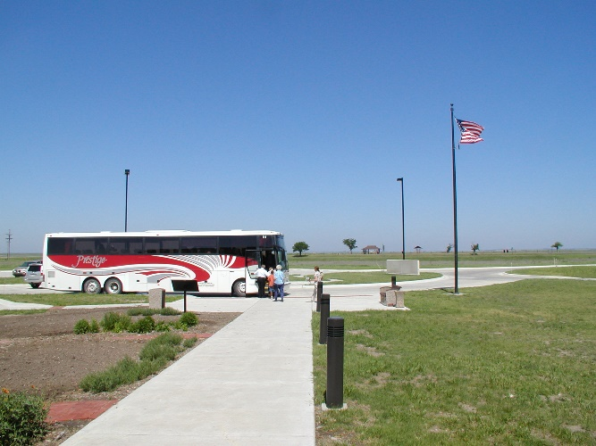

The members reboarded the bus at 12:15 PM for a short trip to the Barton County Historical Society Museum and Village, south of Great Bend on US Highway 281, arriving at the museum at approximately 12:30 for lunch.

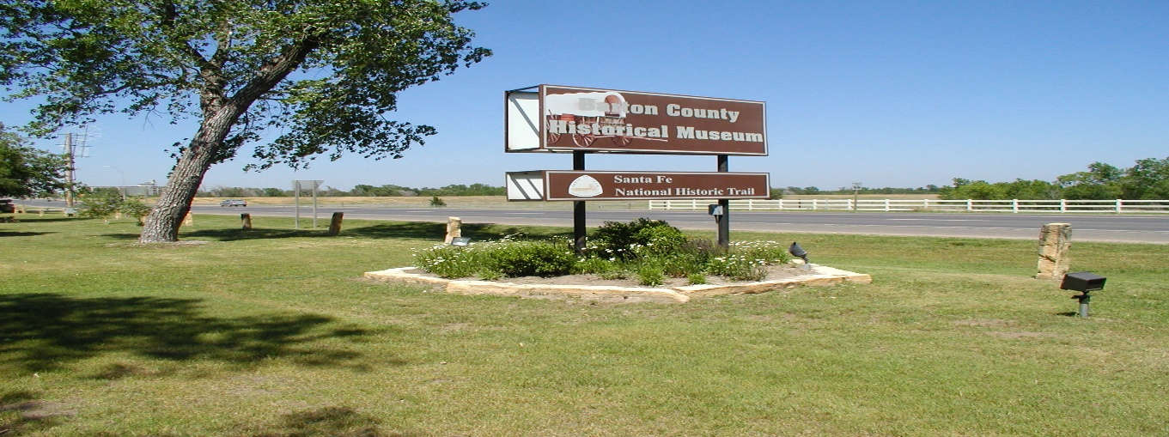
The meal of smothered steak, mashed potatoes, green beans, fresh salad, and bread, with dessert of chocolate cake, was served buffet style by the Hudson Caterers. Everyone agreed that the meal was most delicious!

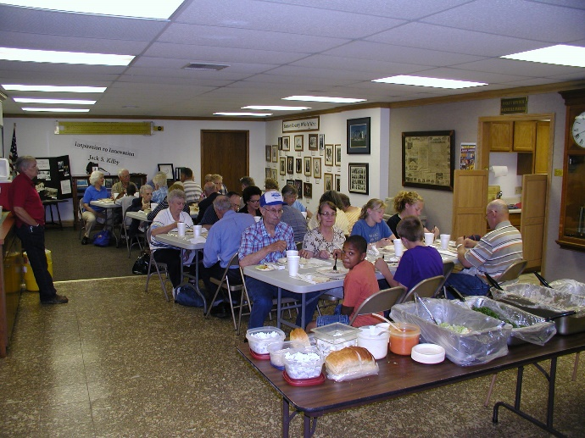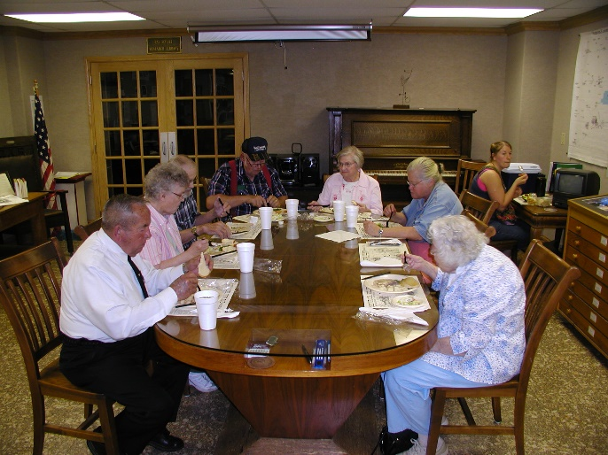

Following lunch and a brief welcome from the Barton County Museum staff, the group independently toured the museum, both inside and outside. Many items of historical interest were on display for members to observe and learn about. Some enjoyed the benches outside in the shade of the big trees while others spent their time browsing the many interesting historical buildings and displays.

The Barton County Museum

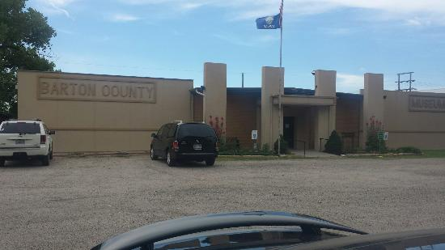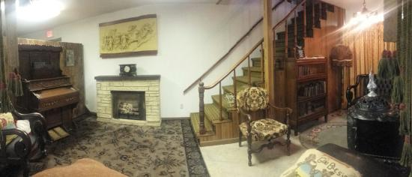

Beautiful flower beds The Barton County Village Old farming equipment
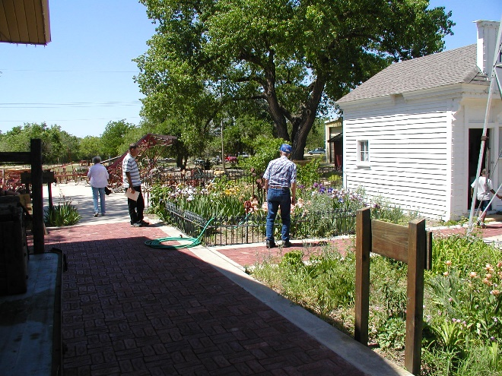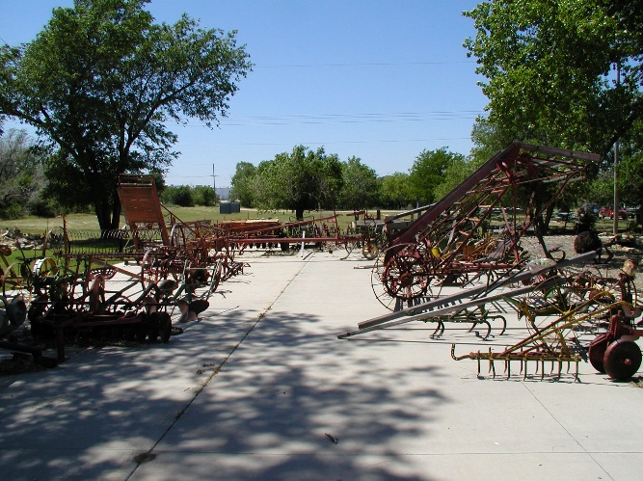
An 1873 native stone house With adjacent hand-dug water well

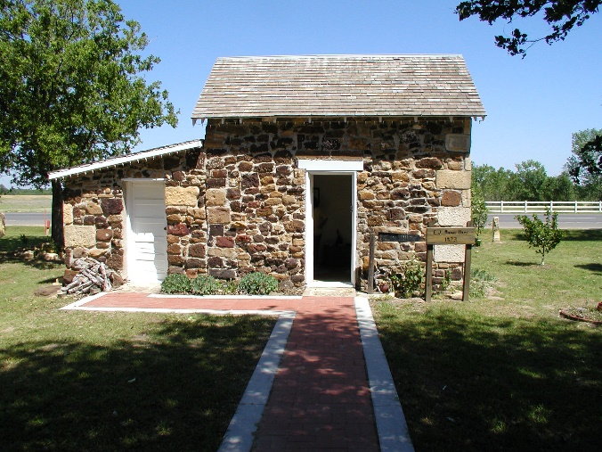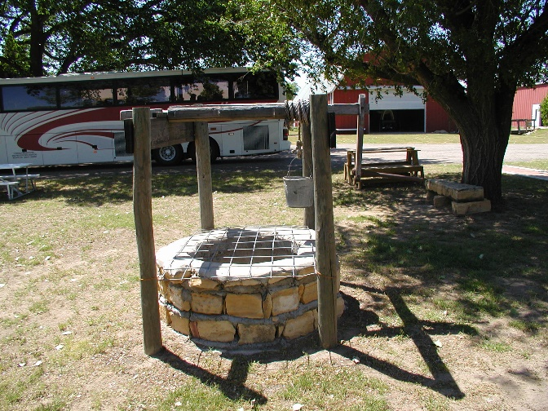

St. Paul’s Lutheran Church, Albert, KS 1871-1964 The 1898 church building

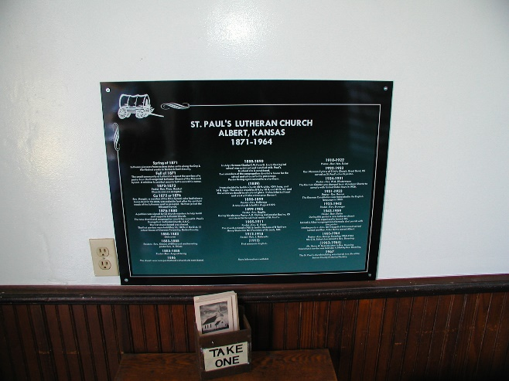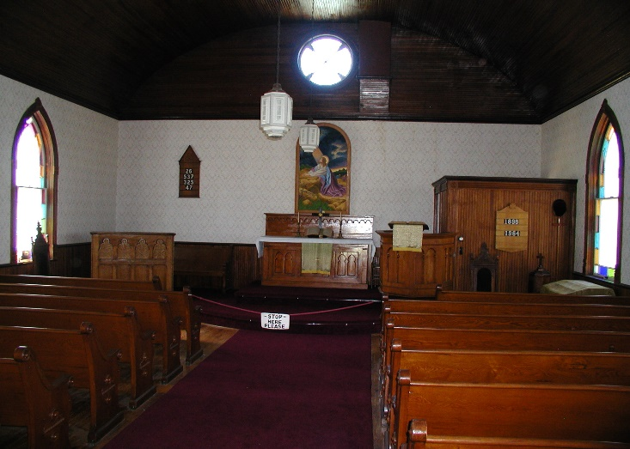

The 1910 railroad depot Post office on village street

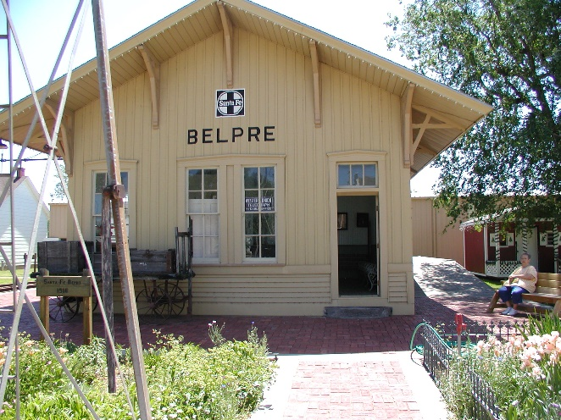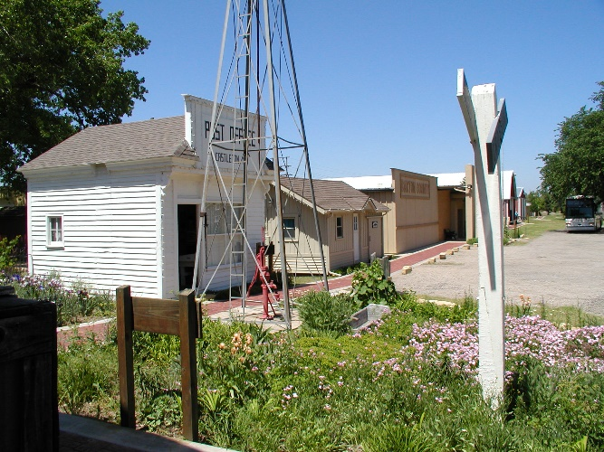

A 1915 school house

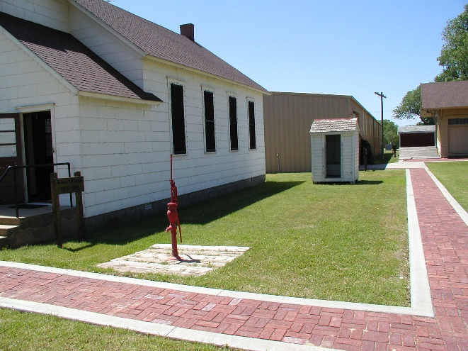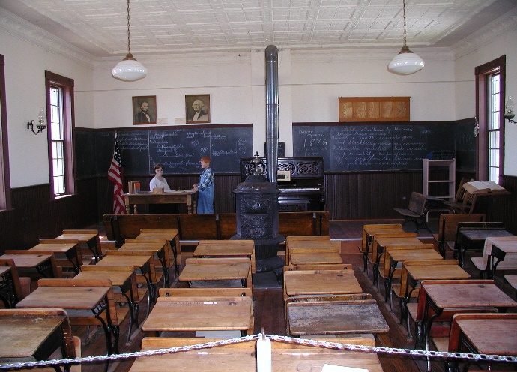

1950 Lustron Home
- Lustron houses are prefabricated enameled steel houses developed in the post-World War II era United States in response to the shortage of houses for returning GIs. The low-maintenance, extremely durable, baked-on porcelain enamel finish was expected to attract modern families who might not have the time or interest in repairing and painting conventional wood and plaster houses.

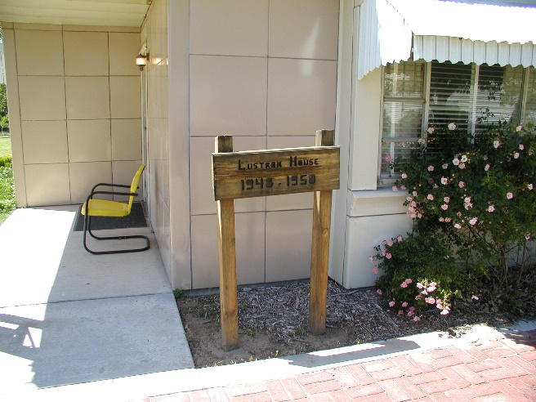

The Waupun wood-vane windmill with hand pump
for fresh water Antique tractors

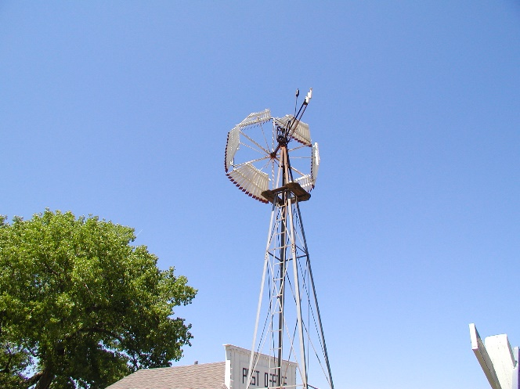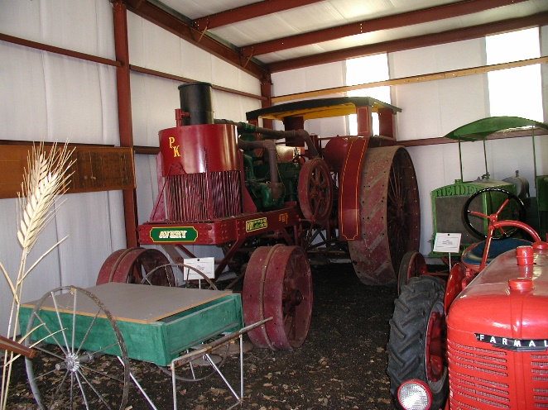

More antique tractors Antique modes of transportation

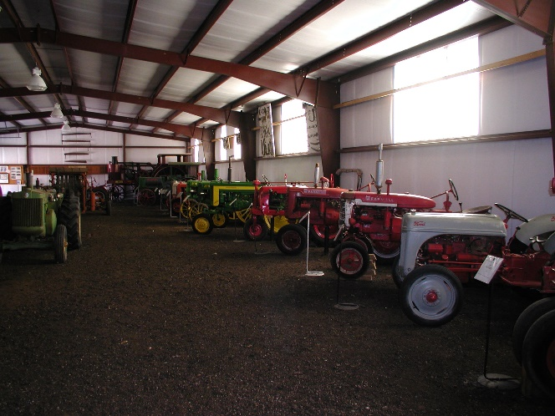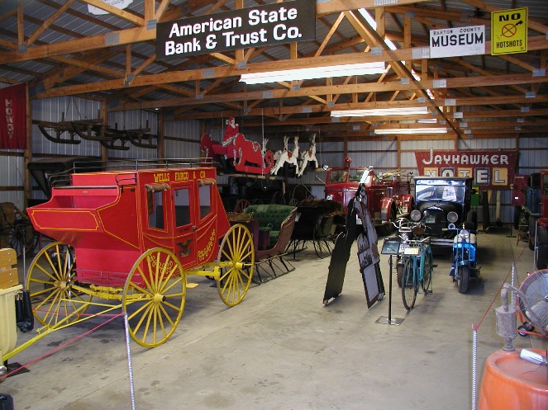

Museum of mechanics

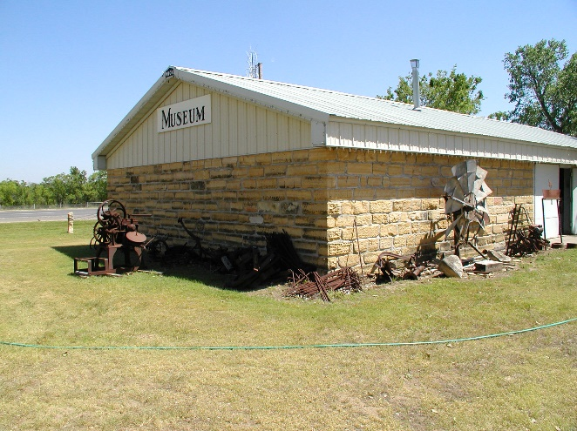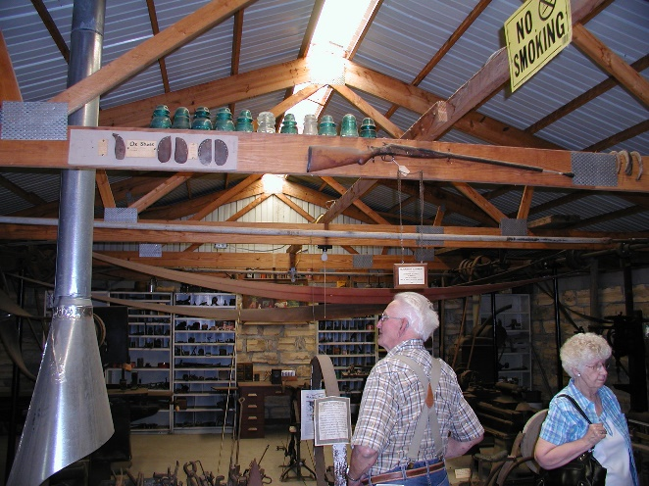

The group left the museum grounds at 4:00 PM and took a short drive through Great Bend and headed to the McPherson McDonald’s for a refreshment / supper stop. Another stop was made in North Newton, before the main group returned to the RHS parking lot at around 6:30 PM to return home.

All agreed that the day had been most interesting at both sites visited. We also enjoyed each others’ company and got to know each other a little better as we looked at the wildlife and historical items and shared our ideas and thoughts about what we saw.

Notes submitted by Cynthia Rhodes, Secretary
Photos by Melvin D. Epp, President

