Dinner and Tour
Historic Morgan House, Peabody, Kansas
Friday, May 6, 2011 and Saturday May 7, 2011
Present: 44 Members and Guests

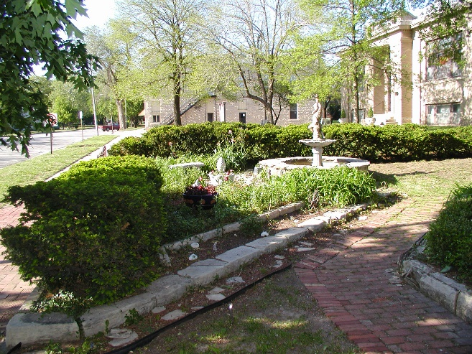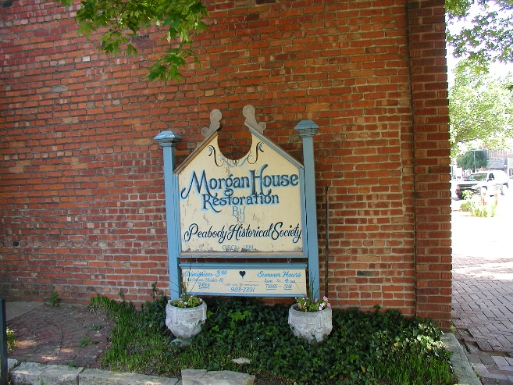

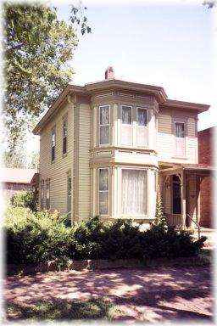
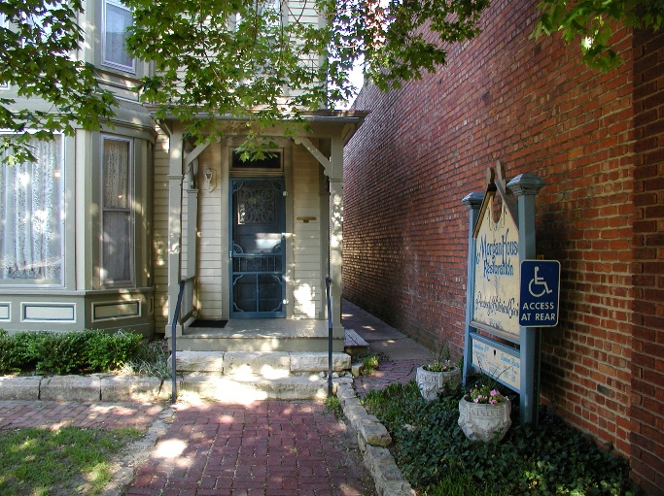

The W. H. Morgan House was built by W. H. Morgan for his family in 1881. He was the first editor of the Peabody Gazette. The W. H. Morgan House was listed on the National Register of Historical Places in January 22, 1996. It is located in the Peabody Downtown Historical District at 212 N. Walnut Street. Constructed by A. K. Stewart in the architectural style of Late Victorian: Italianate.

It was remodeled in 1992 and furnished as a home of the 1880s. Gourmet meals are served by reservation using fine china, silver and linens donated by the community. Authentic foods of the era and costumed servers made a memorable dining experience. Tours of the fully restored 1880s house follow the dinner.

The Powder Room is a fully modernized outhouse behind the building.

The evening was reminiscent of earlier times when people had time to visit and share a gourmet dinner. This was a contemplative historical tour of note.

THE MENU
May 6 & 7, 2011

Fruit & Cheese Tantalizers

Peter Rabbit’s Fantasy Soup

Doyle Valley Greens with Ross’s Dressing

Dr. Green’s Pork Medallions with Dressing
Vivian’s early Peas with New Potatoes
Schroeder Orchard Spiced Peach

Ruth Truax’s Butterhorn Rolls

“Red Wolf” Coffee or Iced Tea

Doyle Valley Schaum Torte

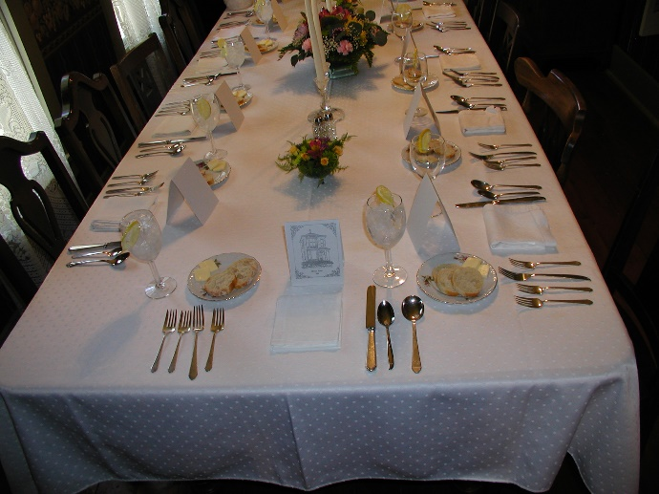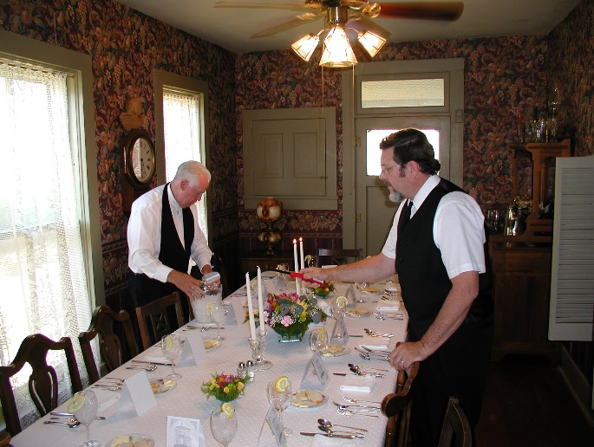

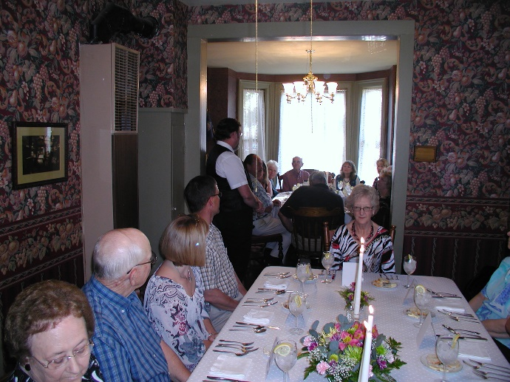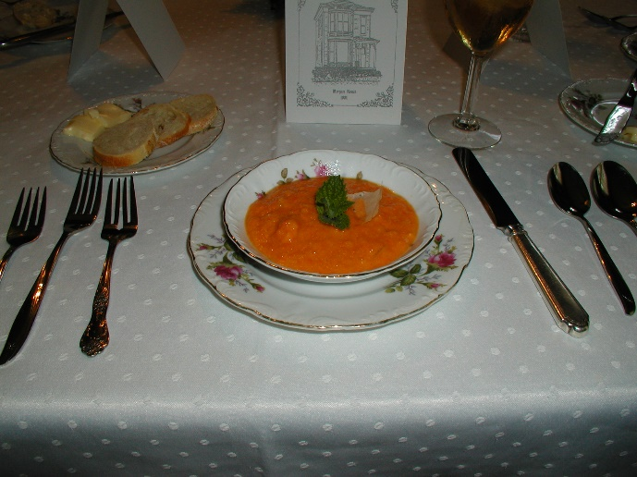
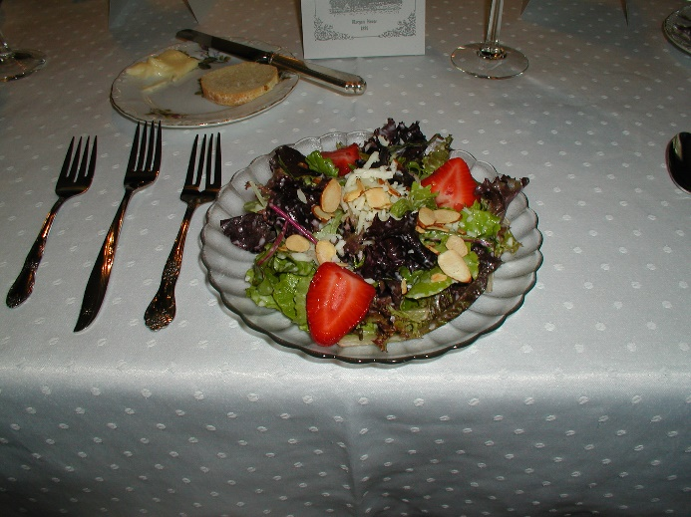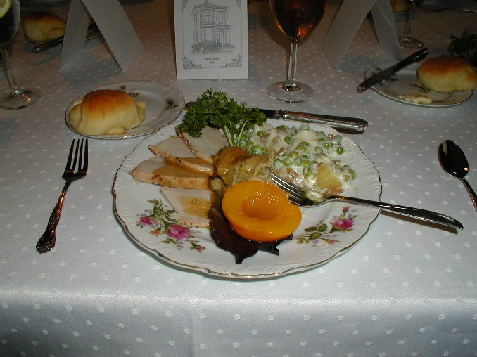

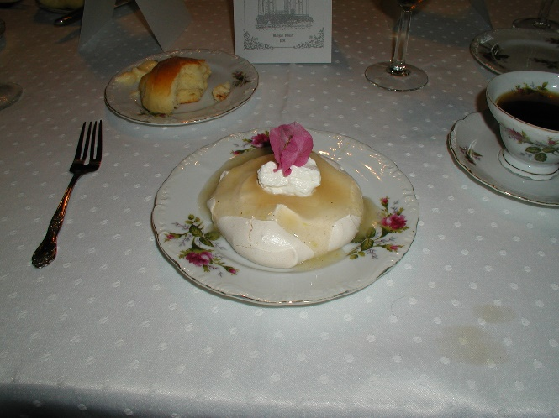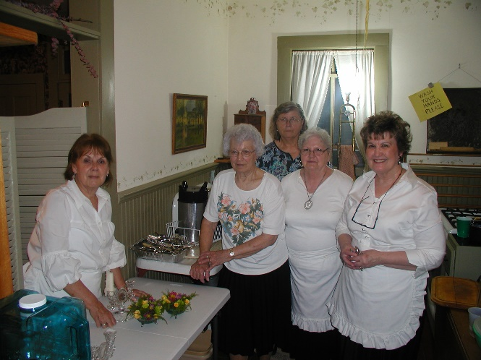

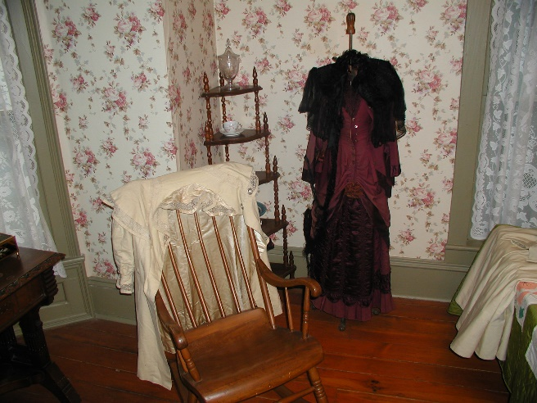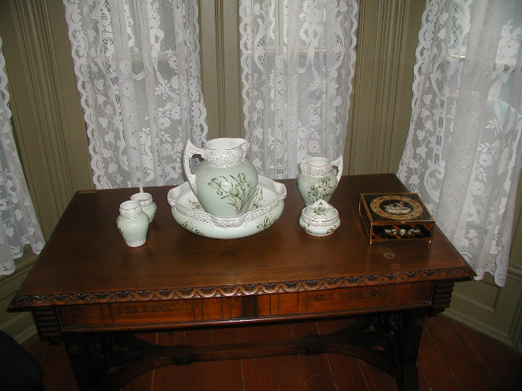

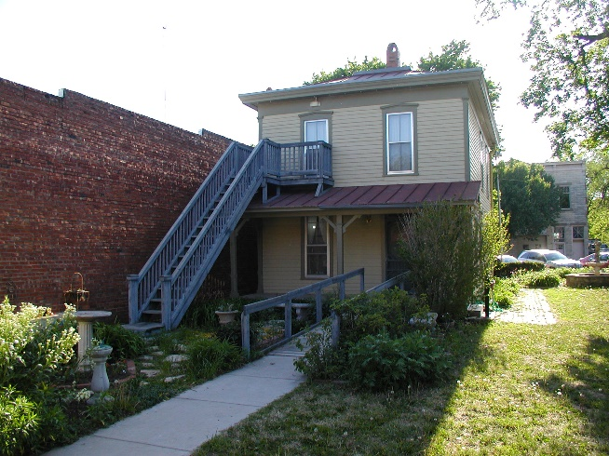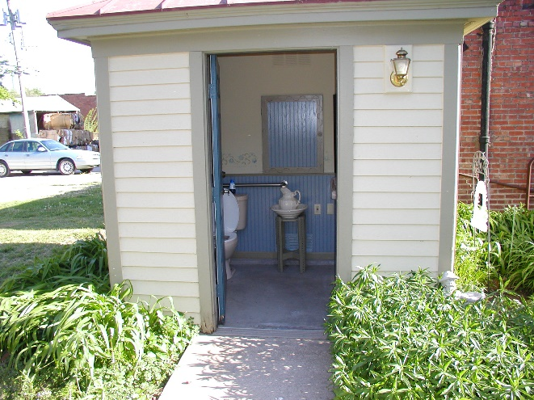

Photos and notes submitted by Melvin D. Epp, President

