Abilene, Kansas Tour
Saturday, May 4, 2013; 7:00AM to 8:30 PM
Present: 32 Members and Guests

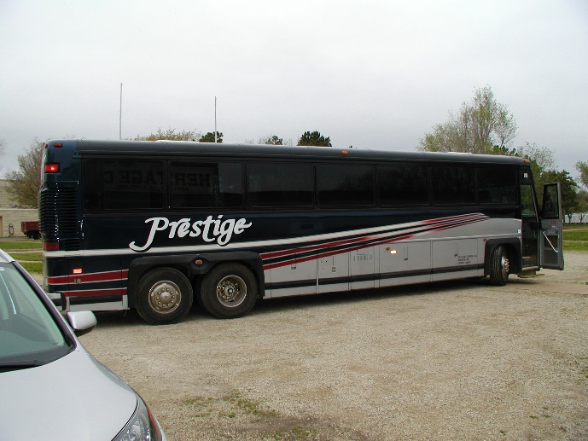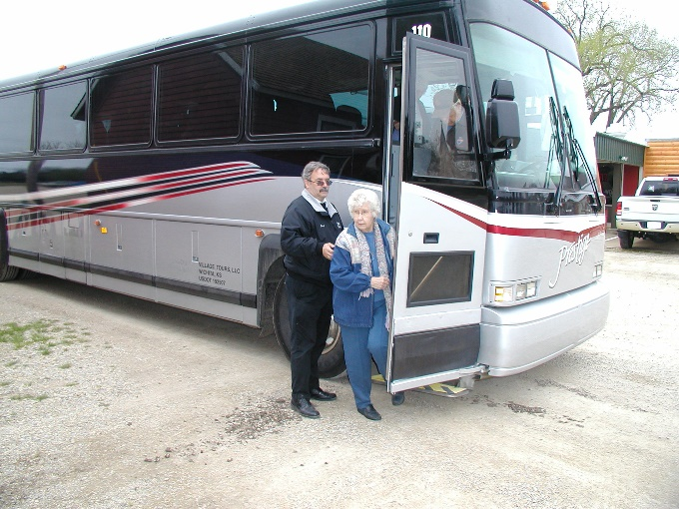

The Prestige Busline bus, driven by Derek Harrison, left the Remington High School parking lot with 25 riders at 6:55 AM and stopped at the Newton Outlet Mall parking lot to pick up 7 more tourists. The bus arrived in Abilene at 8:35 AM and drove through town to the west side to the Abilene Airport for pancakes and sausage at the Abilene Aviation Fly-In annual fundraiser in the old hanger. Members enjoyed mingling with the local Abilene aviation enthusiasts while eating breakfast. The bus became stuck while pulling around to pick up the riders for the town tour. After about an hour’s wait, a brand new John Deere 4 dual wheel tractor was brought from the CTI dealership a mile to the east of the airport and easily pulled the bus back onto the pavement. Riders boarded the bus at 10:20 for a tour of Abilene town.

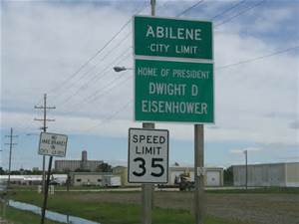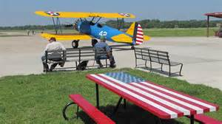

At the Convention and Visitor’s Bureau, tour guide Linda Duncan got on and spoke for an hour about the history of the town as the bus drove by the sights of interest. Included in the tour were old homes and mansions, Eisenhower Park and rodeo area, downtown buildings and businesses, Old Abilene restoration progress and Eisenhower Museum complex.

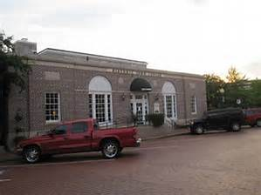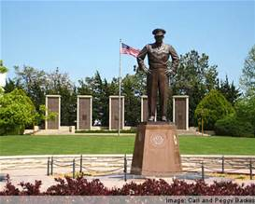

Convention and Visitor’s Bureau Eisenhower Library Grounds

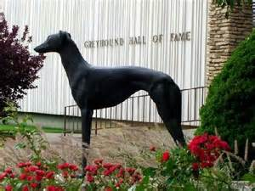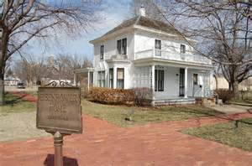

Abilene Greyhound Hall of Fame Eisenhower Home

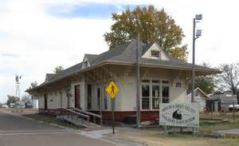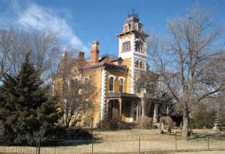

Abilene KS Tourism Lebold Mansion

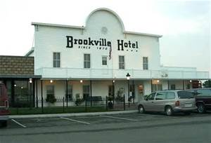

After dropping Linda off at the Convention and Visitor’s Bureau, the bus arrived at the Brookville Hotel for lunch at 11:55. Diners filled four large tables and enjoyed a sumptuous meal of fried chicken, mashed potatoes and gravy, creamed corn, sweet coleslaw, sweet pickles, biscuits, vanilla ice cream, coffee, tea, and water.

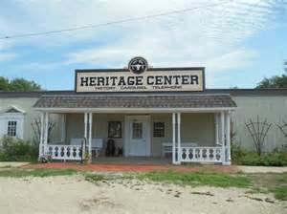

At 1:30, after a filling meal, riders boarded the bus again and were taken to the Heritage Center for a museum tour and carousel ride at 2:30.

The Carousel:

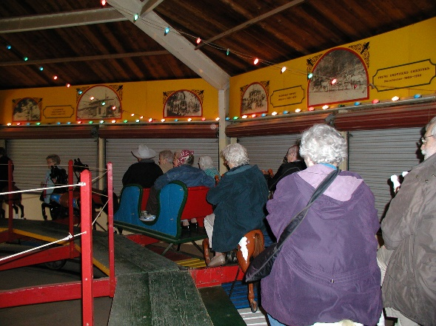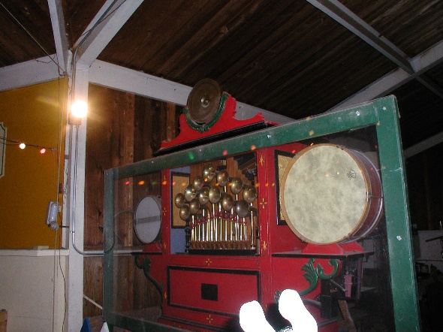
A log cabin:
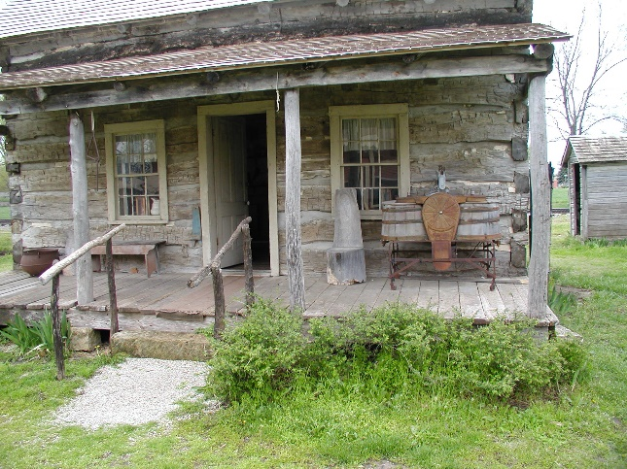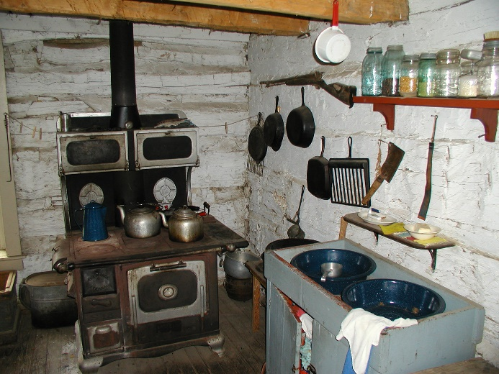

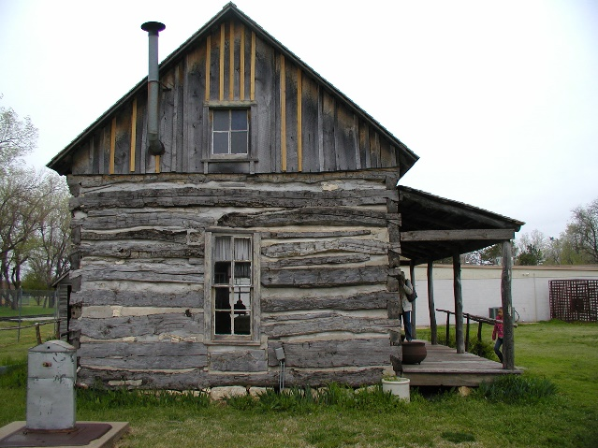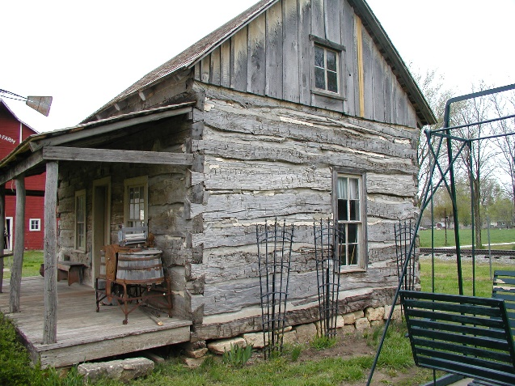

The ACME Telephone Assn. 1905-1969 The old saw mill
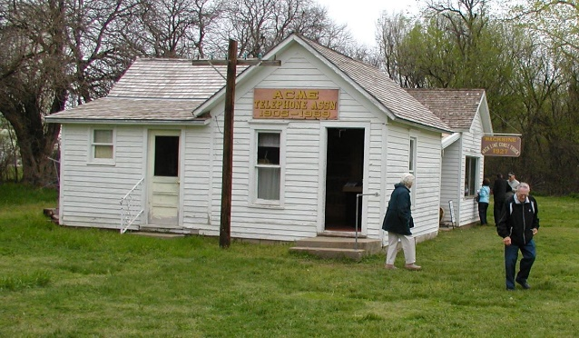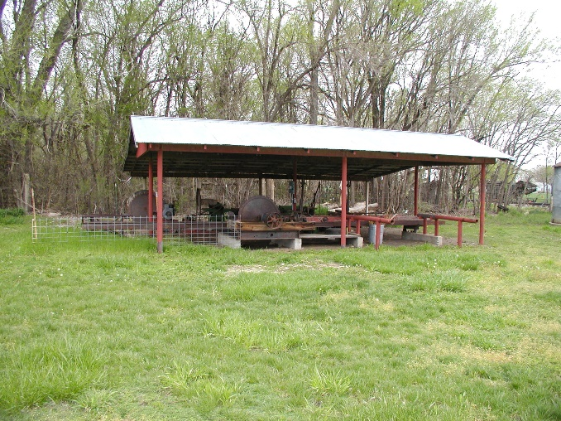

Antique Farm Machinery:

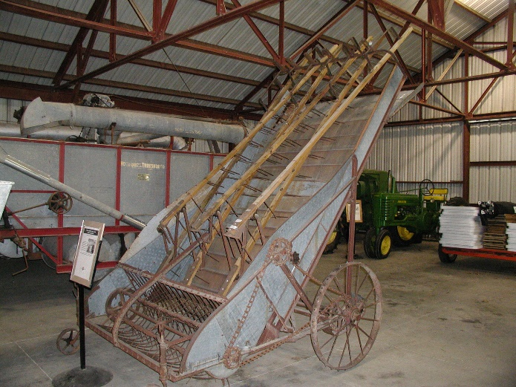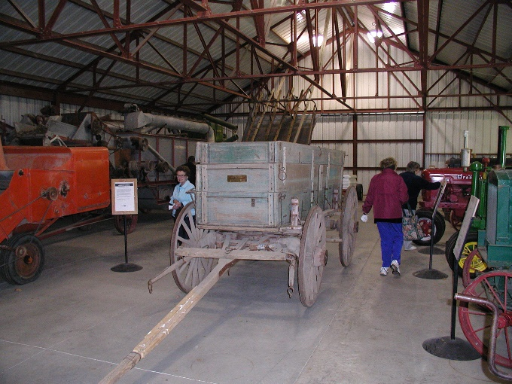

From 4 to 5:30, the FRAHS tourists were taken to Old Abilene for a gun fight and diesel train ride to Enterprise (east of Abilene).

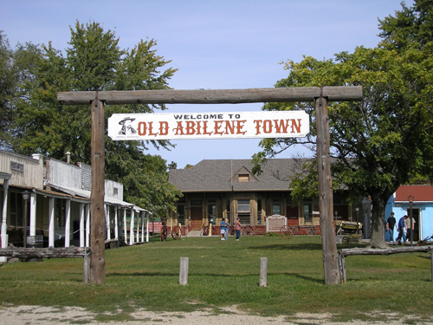

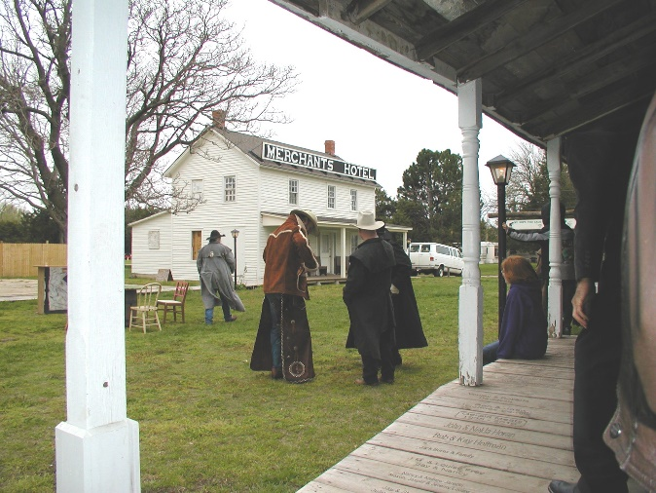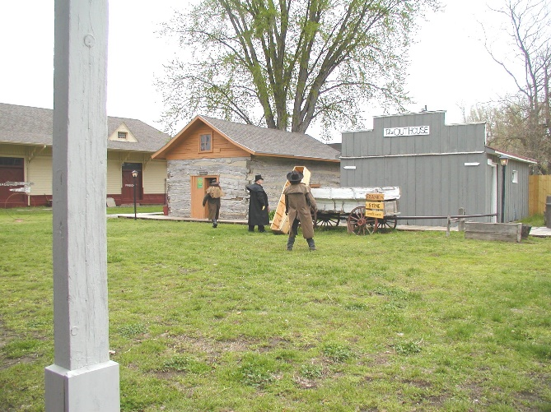

Ruby Moore on the diesel train ride to Enterprise Crossing a bridge

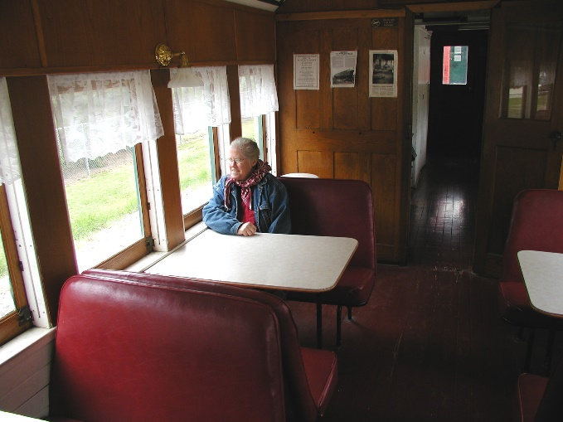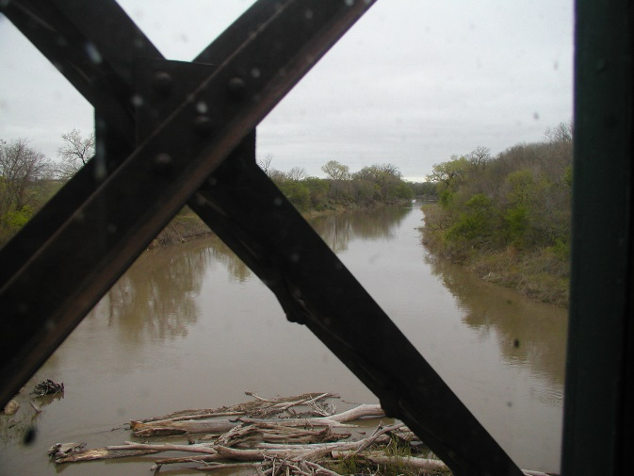

The last stop for the day for the bus before departing for home was the Russell Stover Candy Outlet Store. Shoppers sampled delicious chocolate samples and then bought what they thought would soothe their sweet tooth at home.

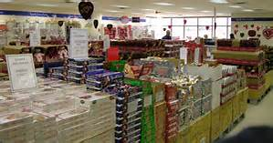

The bus departed for Whitewater at 6:30, and after stopping along I-70 north of Salina at a Wendy’s Restaurant for a quick bite for supper, the bus arrived at the Newton Outlet Mall at 8:00 PM and back to Remington High School at 8:30 where members were invited into the school to enjoy a high school dance that was in progress. The dance had been postponed to tonight from earlier in the winter due to bad weather at that time.

The day was cool (mostly in the upper 40’s), cloudy, damp, and slightly windy making for a chill that just wouldn’t go away, even with movement and activity. Members enjoyed their day’s activities very much and gave Sharon Regier, tour guide and organizer, many complements at the conclusion of the trip. But, members were glad to go home to warm up at the end of a long and eventfully fun day.

Notes submitted by Cynthia Rhodes, Secretary
Photos from Melvin D. Epp, President

