Frederic Remington Area Historical Society
30th Anniversary Dinner
In Cafeteria of Frederic Remington High School
May 5, 2008

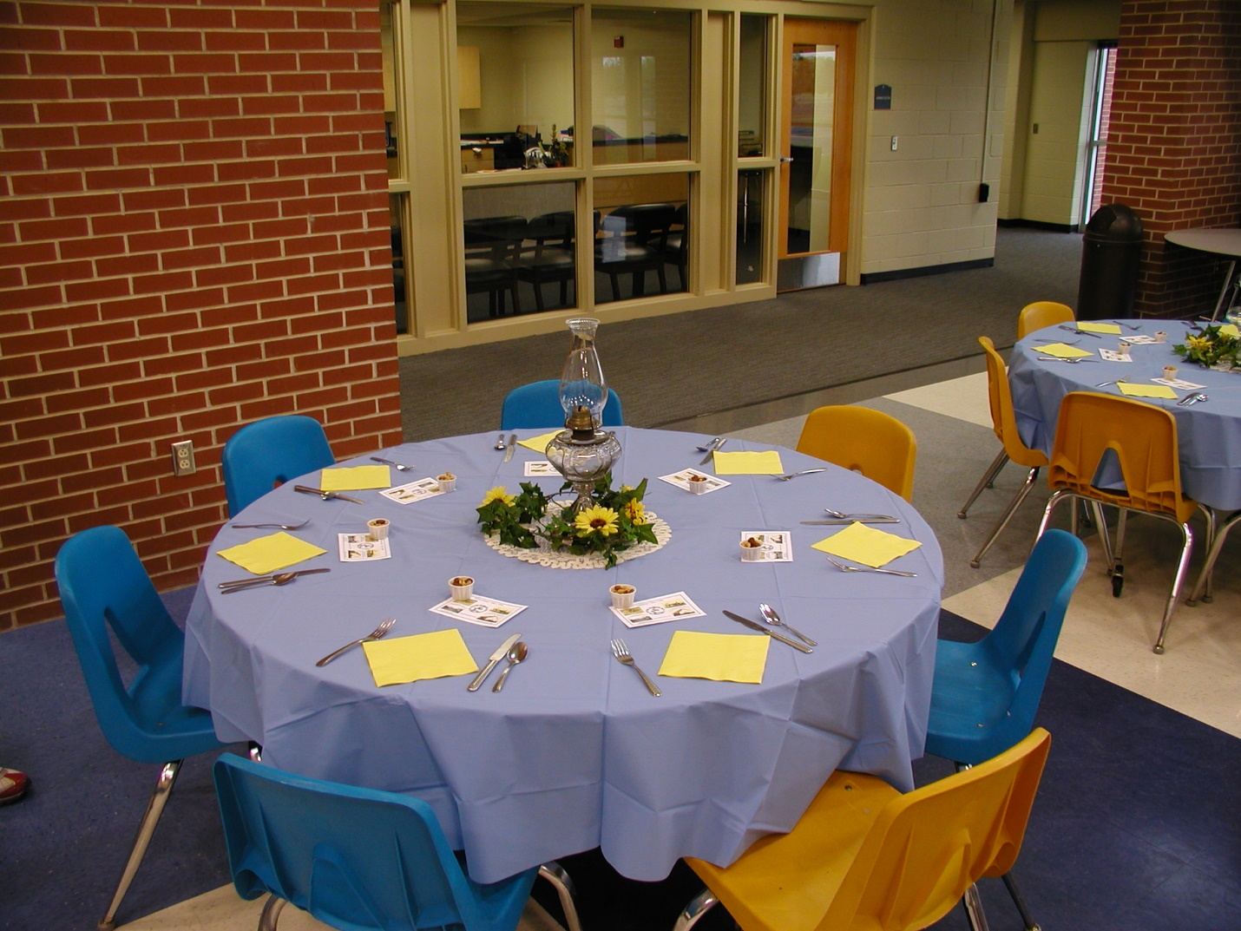

Decorated table prior to catered dinner on March 25, 2008.

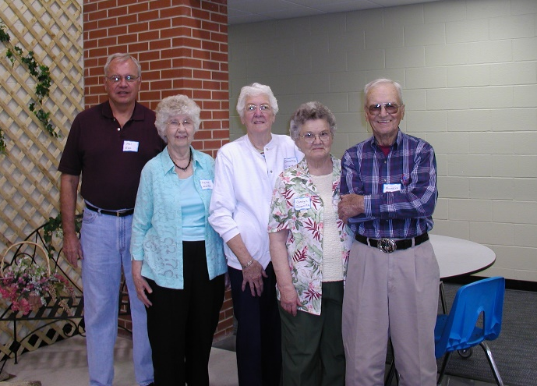
FRAHS Board 2007-2008 (l. to r.)
President: Melvin D. Epp
Treasurer: Agnes Harder
Member-at-Large: Dorothy Glass
Vice president: Carolyn Busenitz
Secretary: Novallis Toews
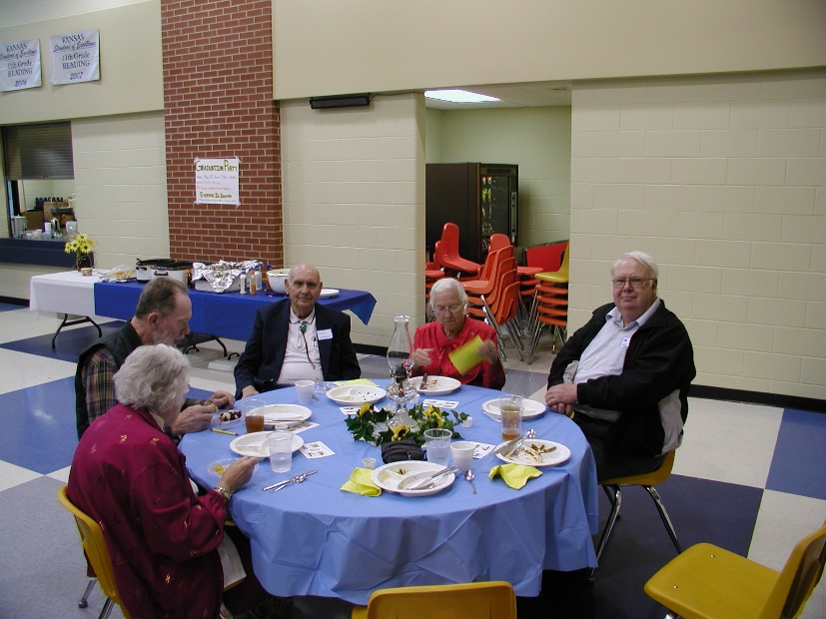
Dinner Guests
Left to Right

Zola & Elbert Esau

John & Marilyn Umbach

Donald J. Martin

Delbert & Hazel Wiebe

Lymen Spencer

Becky & Mike Dudte

Olin Claassen

Art Busenitz

Neysa Eberhard

Betty & Bob Baker

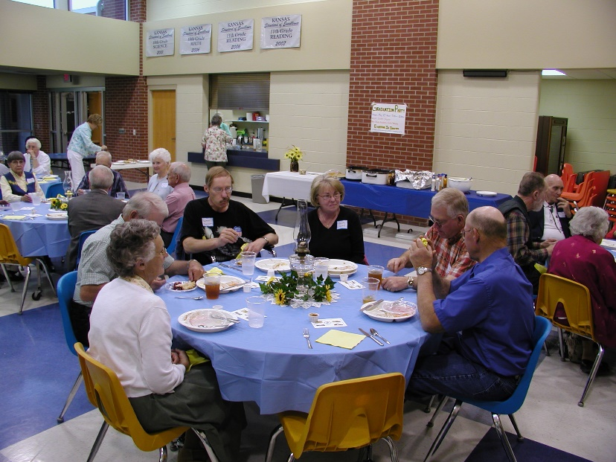

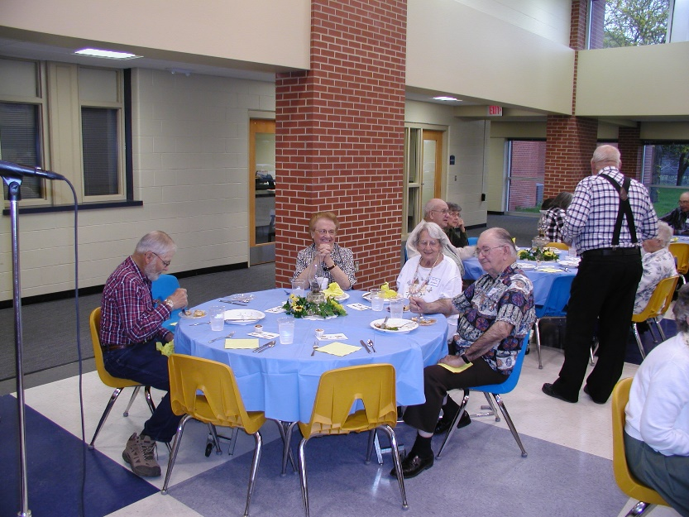
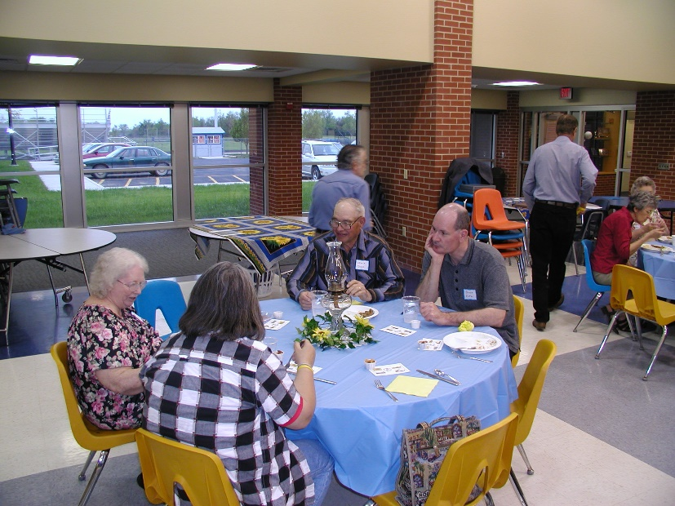

Carolyn Fisher

Vivian Smith

Lewis Glass

Bruce Entz

Pauline & Nick Toews

Cynthia Rhodes

Joyce M. Taylor

Bob Allen

Jerry Peterson

Shari Regier
Carolyn Busenitz
Dorothy Glass
Edgar Harder

Standing:
Daryl Regier
Agnes Harder
Sylvia Epp
Monte Fisher

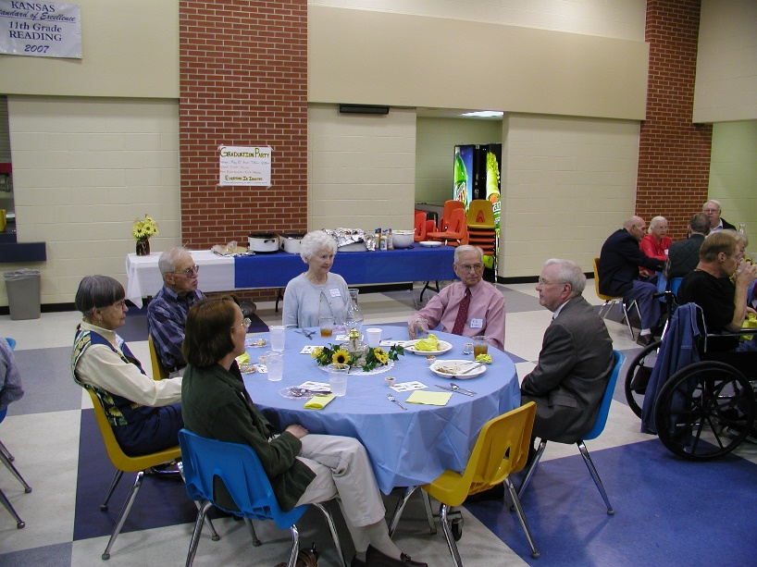

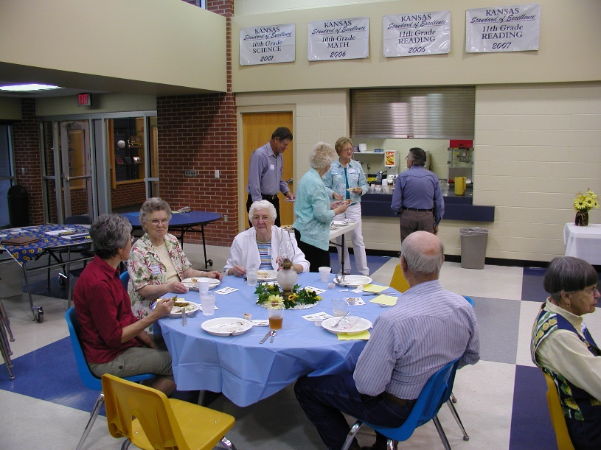

Bob & Betty Baker

Elvin Wiebe
Martha Epp
Miriam & John Claassen
Wilber & Dorothy Wiebe
Gladys Reimer
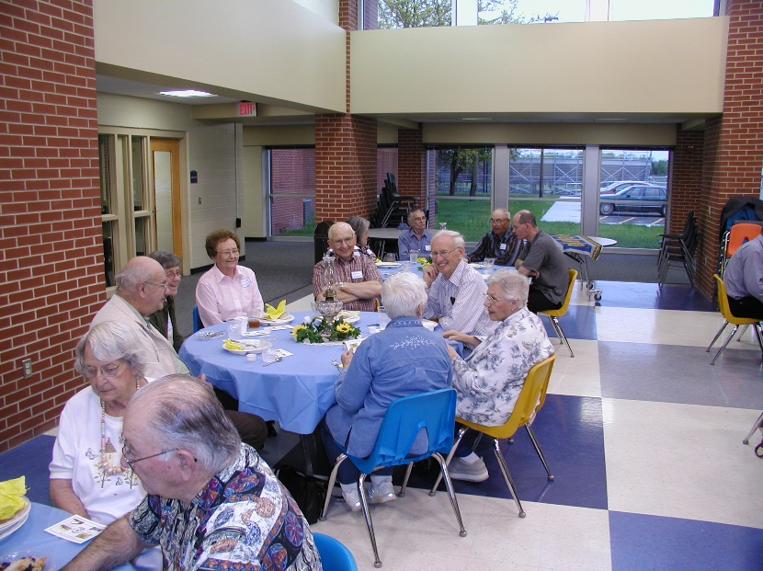

The Frederic Remington Area Historical Society (FRAHS) celebrated the 30th anniversary of its organization with a dinner and program beginning at 6:30 p.m. at the Remington High School commons area. The tables were decorated in a country theme of blue tablecloths and kerosene lamps surrounded with ivy and sunflowers. Napkins were bright yellow and at each setting was a memento card with early pictures of the area. FRAHS was incorporated by the State of Kansas on June 21, 1978.

The evening began with Melvin Epp, President, presiding. He gave a brief history of saying grace before meals. We all repeated in both German and English a favorite grace used by many families in the area.

The catered meal prepared by Arleta’s Catering, Burns, Kansas was served buffet style. The delicious meal consisted of shredded beef or pork, cubed potatoes, green beans, tossed salad, French bread and a choice of fruit pies for dessert.

After the meal, Agnes Harder gave a report on the early history of FRAHS and a tribute to William Regier, Elbing, for his interest in starting an historical society. In the early programs, Mr. Regier used slides for his presentations. Agnes mentioned that these slides have been scanned into the computer by the students at the high school and are now copied onto CD’s for sale.

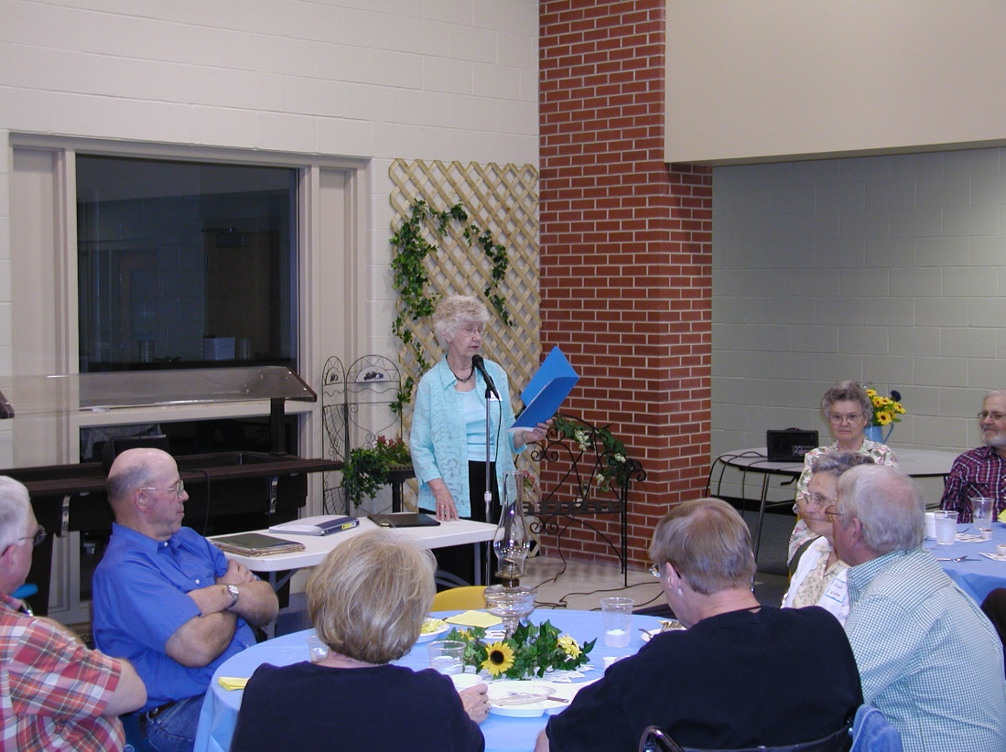
Guest Speaker
Agnes Harder:
“As you know we are celebrating the 30th anniversary of the Frederic Remington Area Historical Society. I would like to share a few thoughts of

the activities of the past 30 years.
“The late William Regier of Elbing perceived the need to preserve the history of the area and formed a non-profit membership organization in June 1978 giving the name Frederic Remington Area Historical Society. Records show that a Charter was granted in June 21, 1978.
“The first few years Mr. Regier planned and prepared the programs using slides that he prepared from pictures from the communities’ histories. These slides were arranges in 12 carousals, each a different story, totaling about 700 slides. After Mr. Regier’s death in 1984 the family donated the slides to the Frederic Remington Area Historical Society.

“In the mid 80’s Elma Esau and I documented the slides and they sat in the archives of the Remington High School. As technology became more advanced it was apparent that it was time to copy the slides into CD format. In the summer of 2005, I approached Simon Esau a student at the high school and asked him it was possible to scan the slides. He looked into the matter and with his help, as well as another student Justin Klaassen, they scanned all the slides into the computer during the winter. I then labeled each slide and made legal descriptions where necessary. This past winter with the help of a student Natasha we completed the project and have them available for today. One of the carousals Early Day Harvesting was copied and prepared to a separated CD with the original script and is available in several versions for viewing. On your table are souvenir cards with pictures taken from these slides.

“The first fourteen years 7 programs were planned a year. In 1991 it was changed to 5 programs with one or two tours taken each year. There have been 7 different presidents.

“We have had a total of about 170 programs some that stand out are the Family Histories and Larry Hatteberg, TV personality. There have been programs from the Kansas Humanities Council and from other historians from the greater area, but local people and their historical stories presented most of the programs. There are a large number of audio cassettes of the earliest programs and 63 videos of the past programs in the High School Historical Library.

“Each year since 1985 we have toured places we would have not seen by ourselves. There have been 27 tours. In the first years we traveled by the yellow school bus, then in 1995 a chartered a motor coach was used, which made traveling much more pleasant. A couple of tours that stand out were the trips to Kansas City to visit Arabic Steamboat Museum and to Topeka to the Treasures of the Czars. We visited many historical places in both Kansas and Oklahoma. They all were well attended and wonderful social events.

“In 1995 we began receiving funding from the Butler County Mill Levy distributions. Projects given to the community were the Reader Printer and 100 reels of microfilms of all the old newspaper from the area and are located in the Whitewater Memorial Library. Books were purchased for the our Historical Library, a Historical Sign placed on the rock at the Remington High School yard and in the near future a map of all the early towns, post offices, cemeteries, trails, school and churches will be made available.

“We are very grateful for the special Media Room set aside in the Remington High School Library for storing our historical material and to Pam Harber, the Librarian, who is so helpful in encouraging us to preserve the areas history and allowing her students to help with our projects.

“We will forever appreciate Mr. Regier’s interest in starting this historical society in our area to preserve a unique reginal history.”

The second speaker for the evening was Jerry Peterson of Wichita formerly of Potwin. He told that his great-grandfather immigrated to Brainerd in the 1870s and owned a livery stable. The family continued to live in the area and in 1949 Jerry moved with his family to a farm near Potwin. After his higher education he returned to Potwin and became manager of Circle E Feedlot. In reminiscing about the area he told about the organization and activities the Potwin Pride Program and the Potwin Community Building.
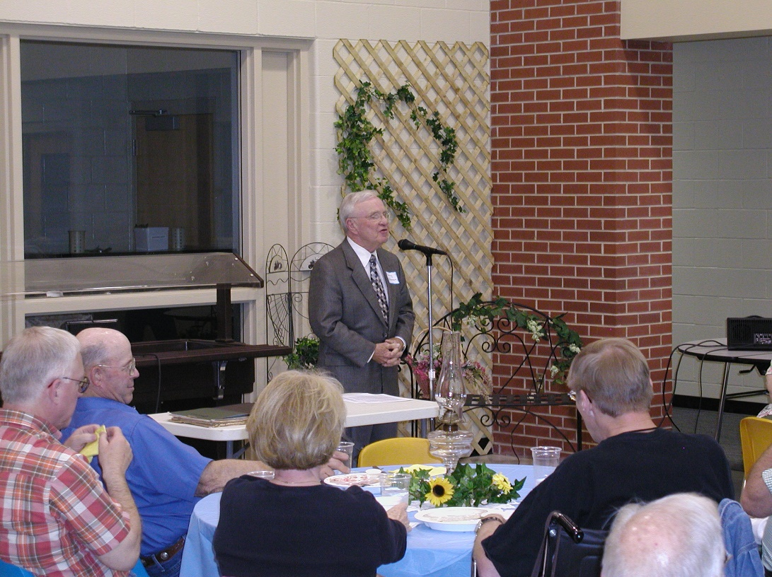
Founding member and guest speaker:

Jerry Peterson, Retired Manager, Circle E Feedlot

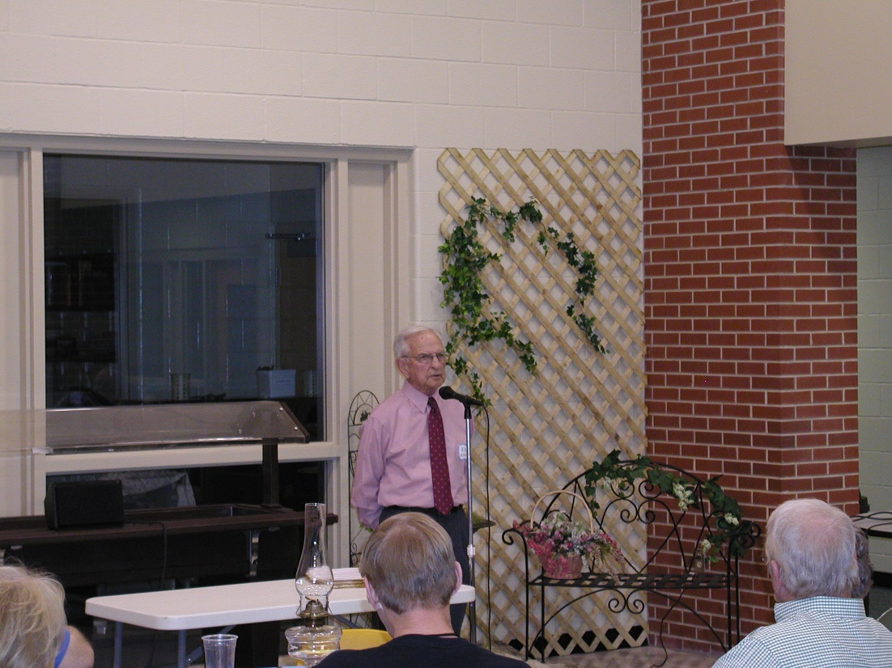
Founding member and guest speaker:

R. D. Allen (Bob),
Past Super-intendent, USD 206

The third speaker was R. D. Allen of Potwin, one of the first organizers of FRAHS. He with William Regier, Kaete Dyck, Francis Joseph, Charlotte Reed, and Elizabeth Regier were members of the first executive committee. Mr. Allen was superintendent when the school community was consolidated into the Frederic Remington District #206 in the early 1960s. He told of its struggles and early beginnings when the country grade schools and high schools were consolidated into one school district.

The evening was concluded with visiting. Forty-seven members and friends were present.

