Manhattan, Kansas Tour
Saturday, May 3, 2014; 7:00 AM to 7:00 PM
Present: 12 Members and Guests

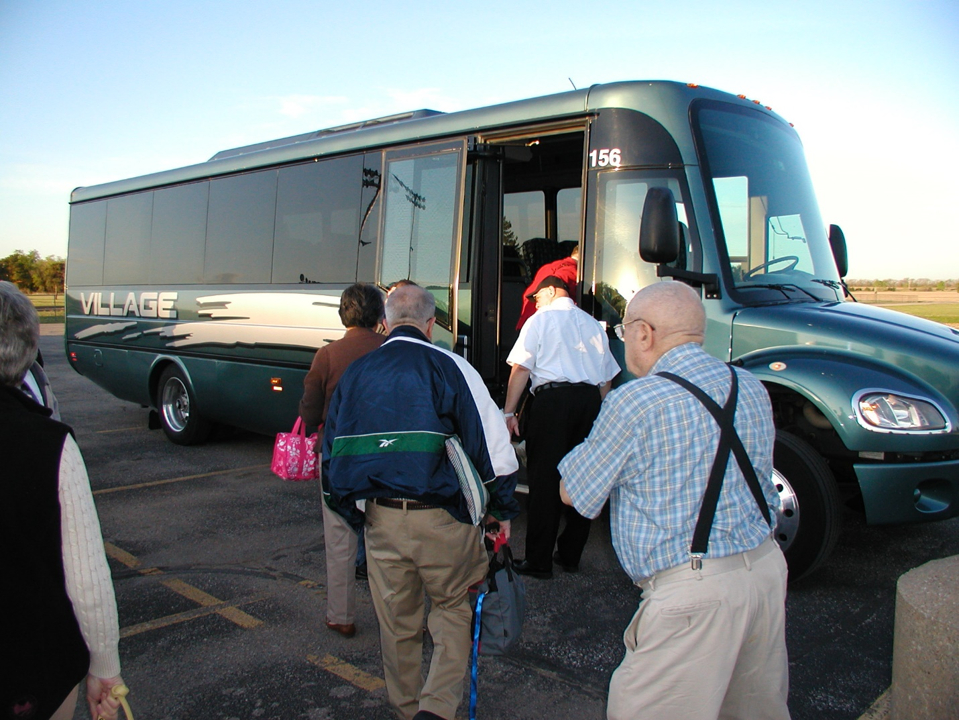

The Village Tours bus left the Remington High School parking lot at 7:00 AM on Saturday, May 3, 2014 for the tour destination of Manhattan, Kansas. Twelve members and guests were present for the day’s activities.

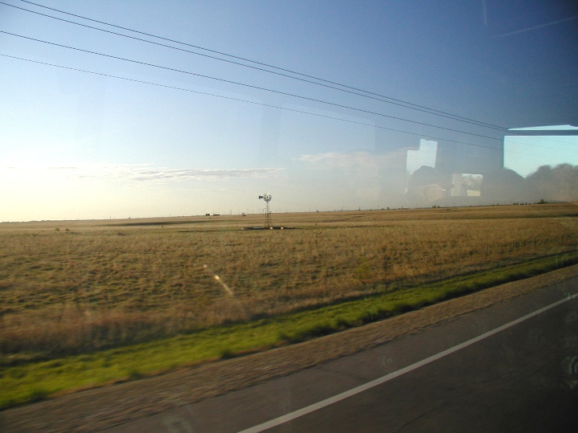
The bus drove from Brainerd to El Dorado along Highway K-196. Passed Potwin the Flint Hills topography already becomes evident. Turned north on Highway 177 east of El Dorado. The views from the bus windows were so pastoral. We passed the Tallgrass Prairie National Preserve Welcome Center as well as the School House at Tallgrass. And cattle grazing.

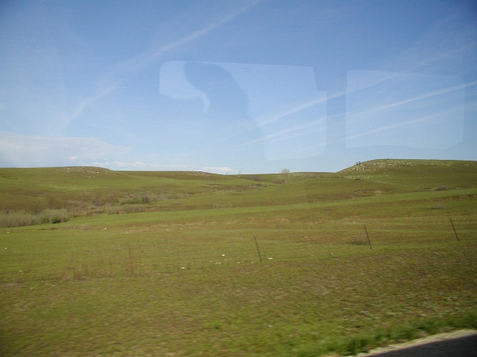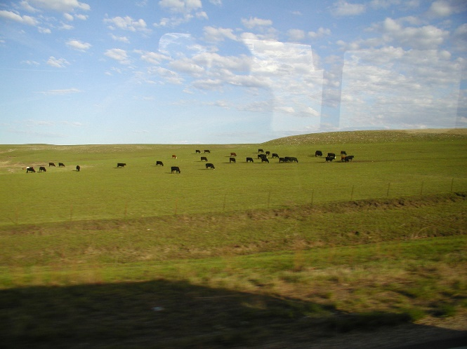

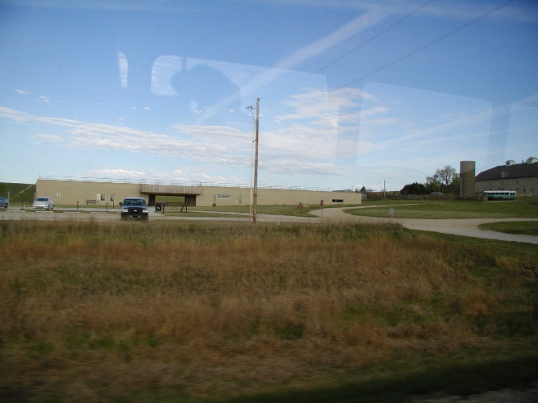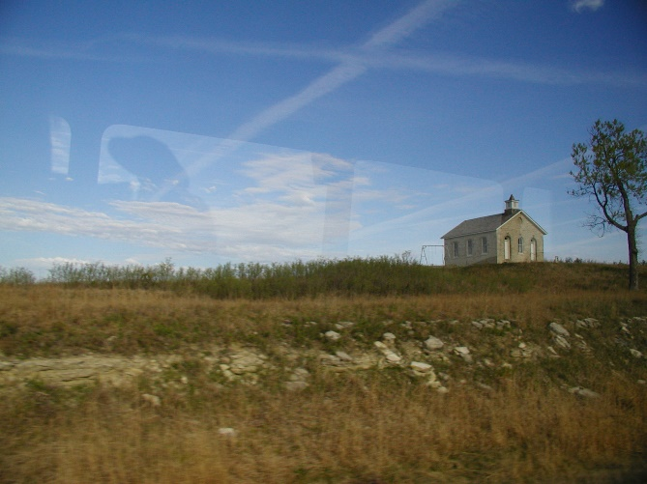

The tour bus arrived at the first destination, the Flint Hills Discovery Center, at approximately 10:00. The tour group explored the learning center which includes the science and history of the Flint Hills Kansas prairie region.

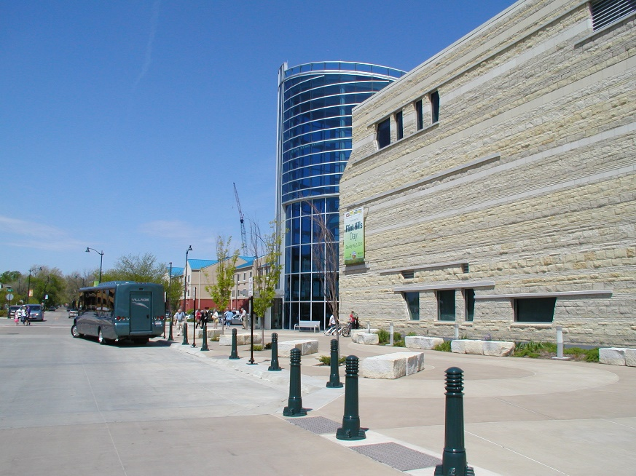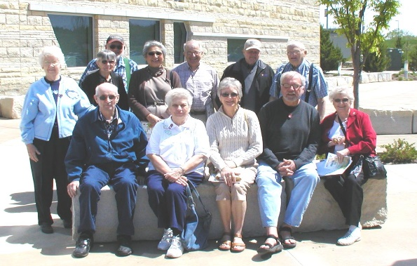
Of course, we had to have a group picture taken. Then there were many interesting things inside the Center as well as around the building outside.

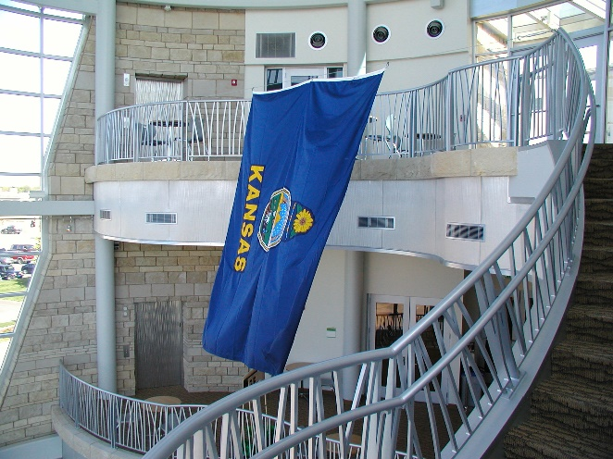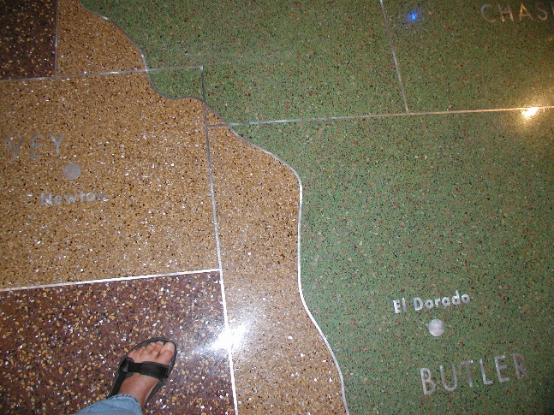

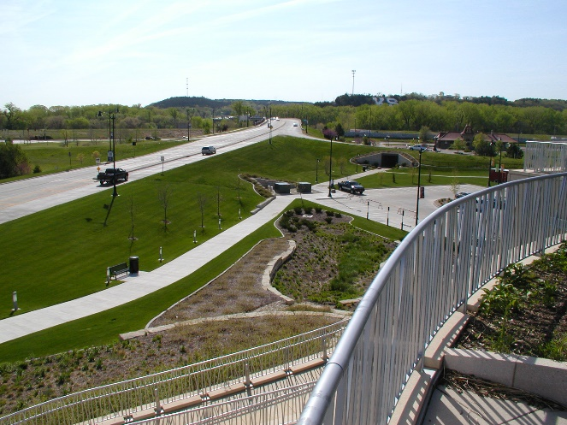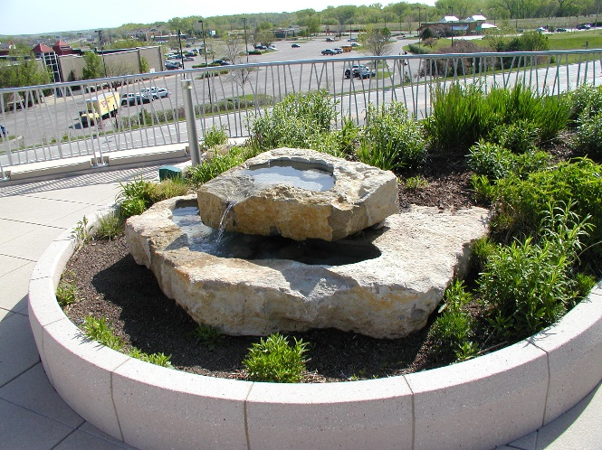

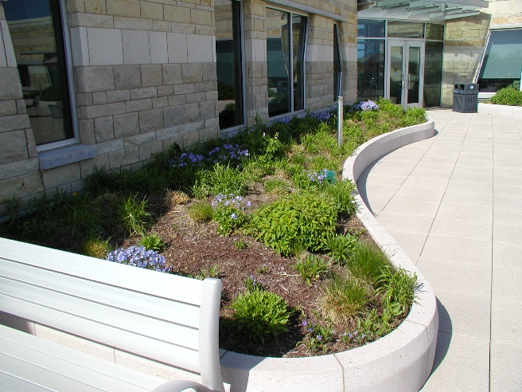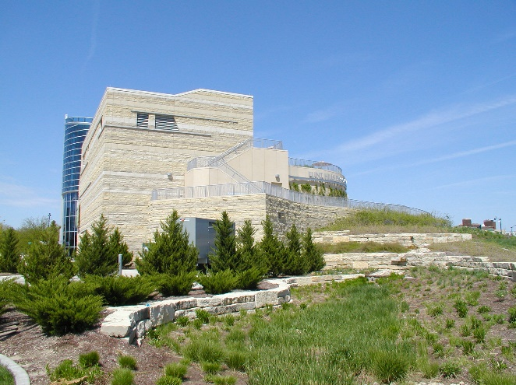

Following a morning at the Flint Hills Discovery Center, hungry members were treated to lunch by FRAHS at the Texas Roadhouse at the Manhattan Town Center. Members thoroughly enjoyed the fresh shelled peanuts and delicious chicken fried steak dinner.
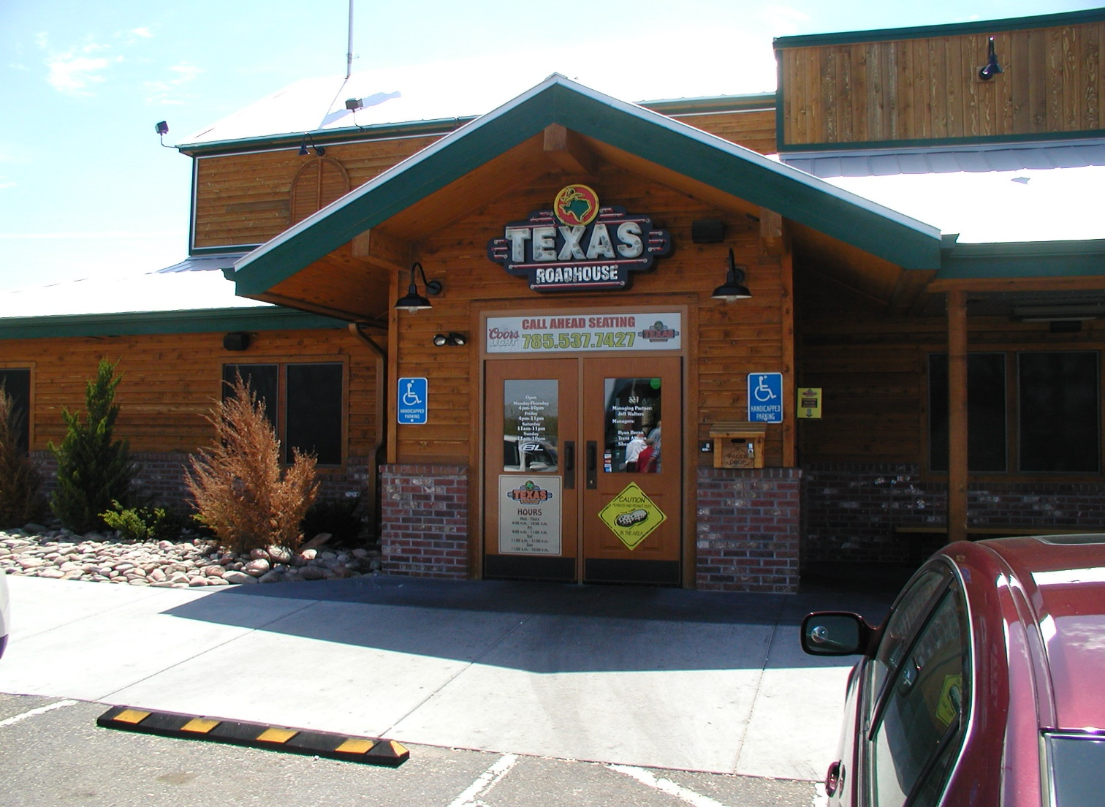

The afternoon’s activity included a trip to the Riley County Historical Museum to view the exhibits on Riley County history. Additionally there were three outdoor buildings for which the Museum arranged a tour guide.

This included the Randolph Jail:

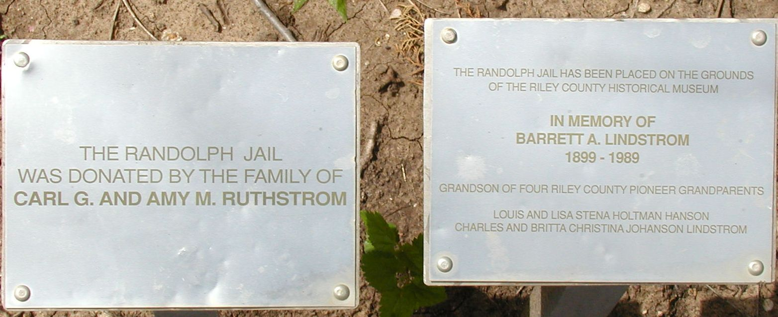

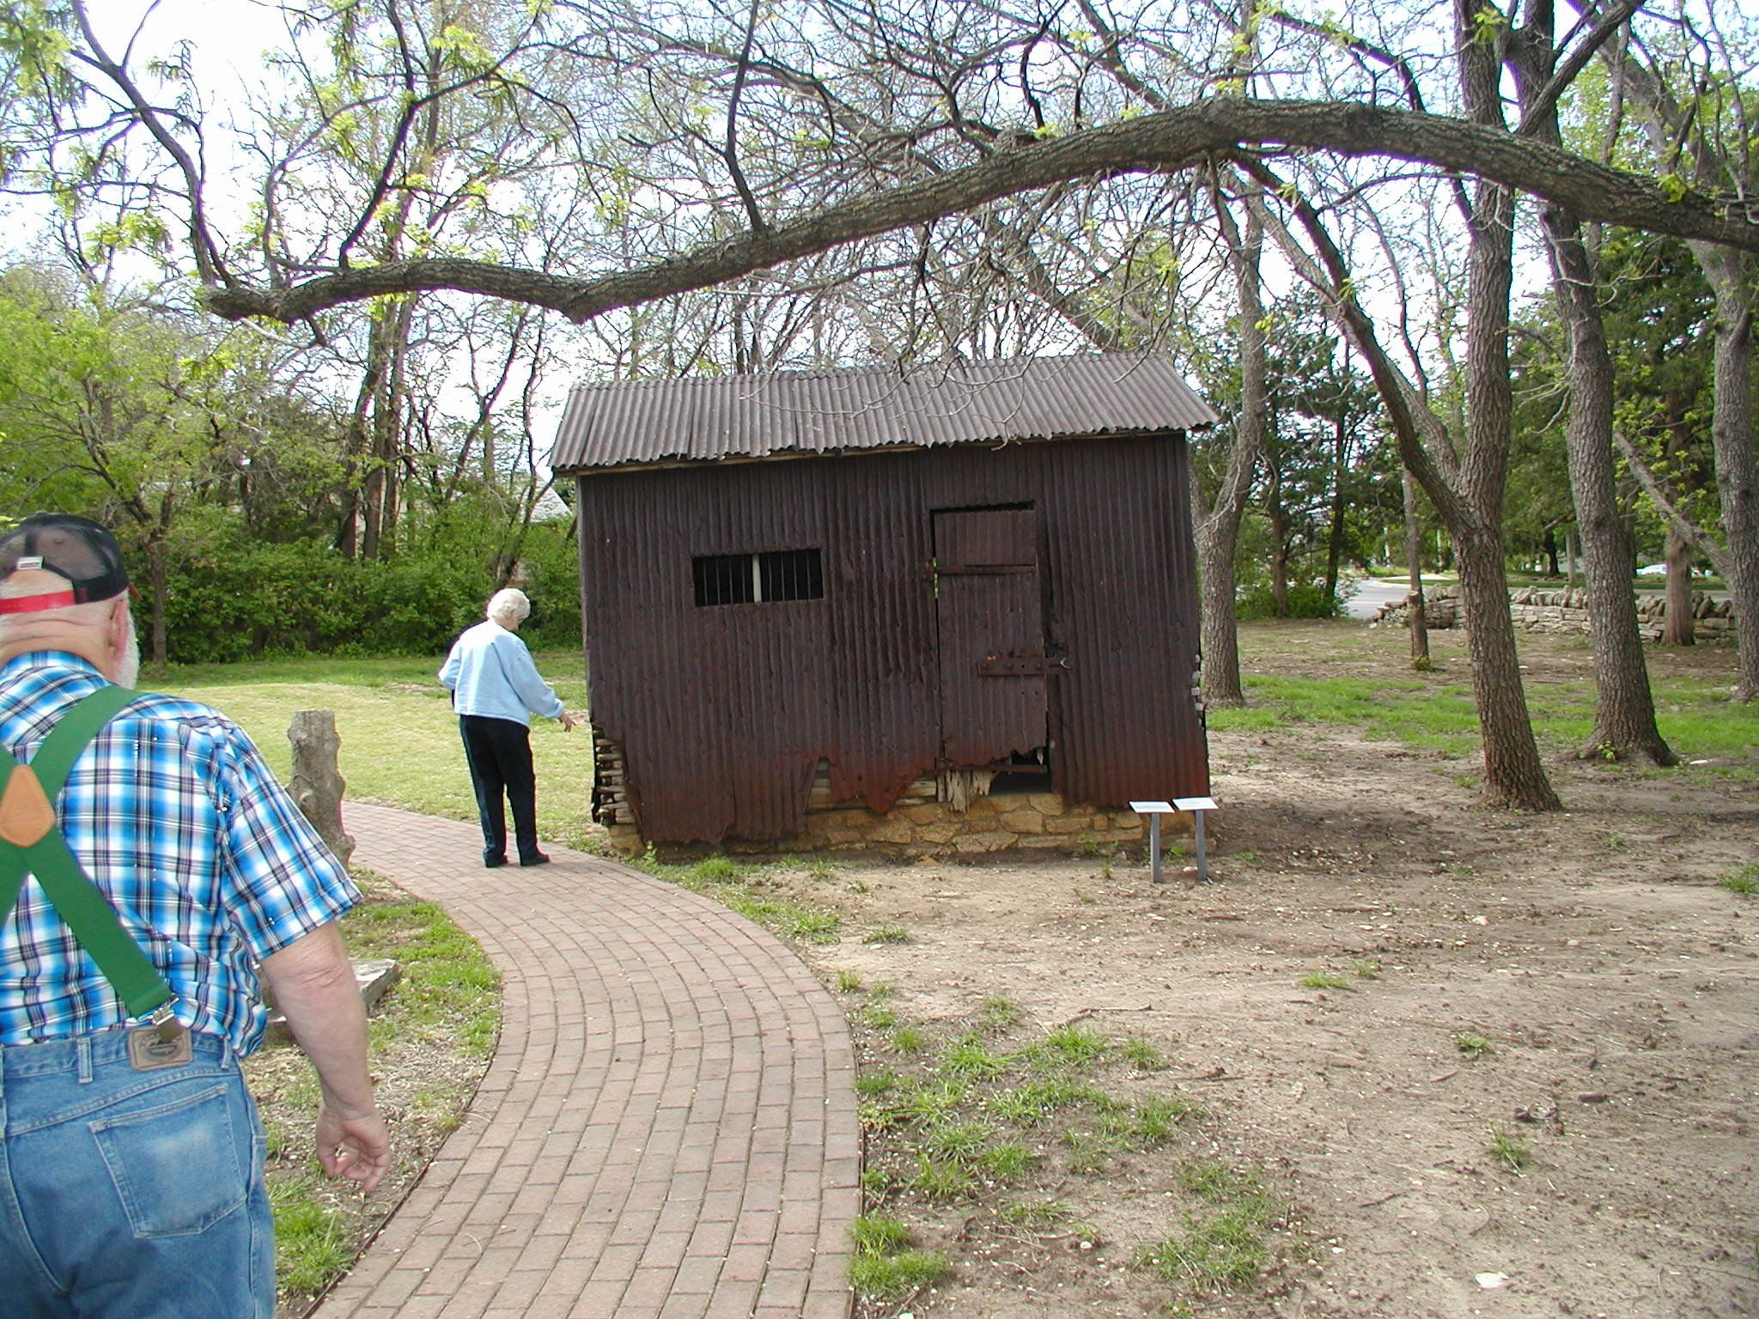

The prefabricated Hartford Home:
Another exhibit was a tour through the prefabricated Hartford Home, one of the ten to fourteen prefabricated houses brought on the steamboat Hartford to Manhattan, Kansas Territory in the spring of 1855.

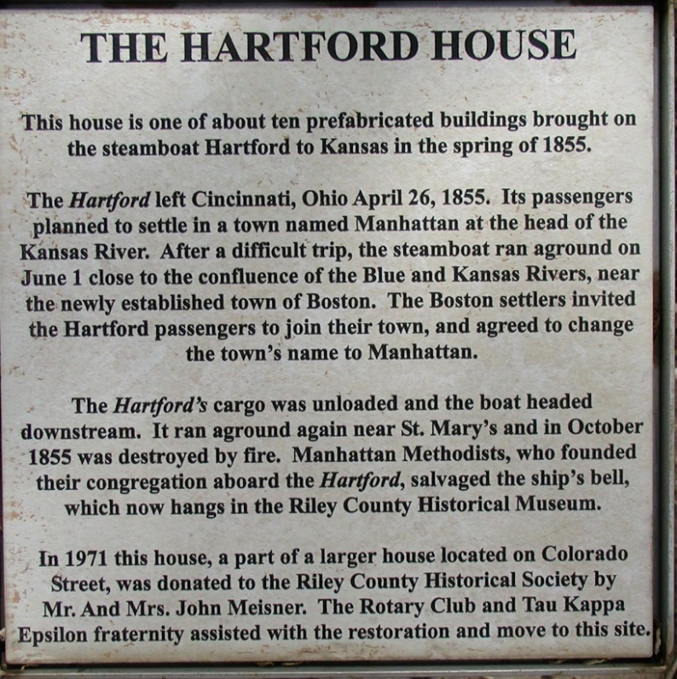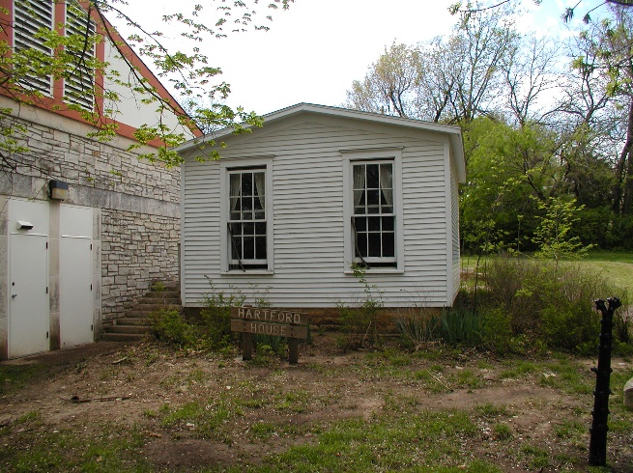
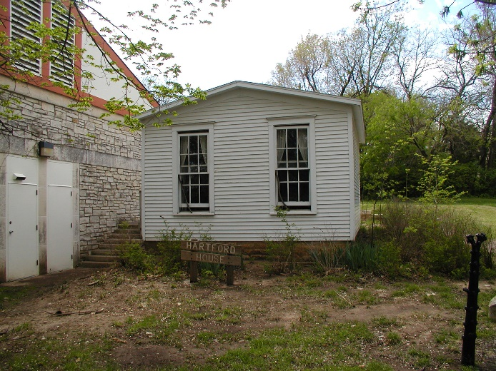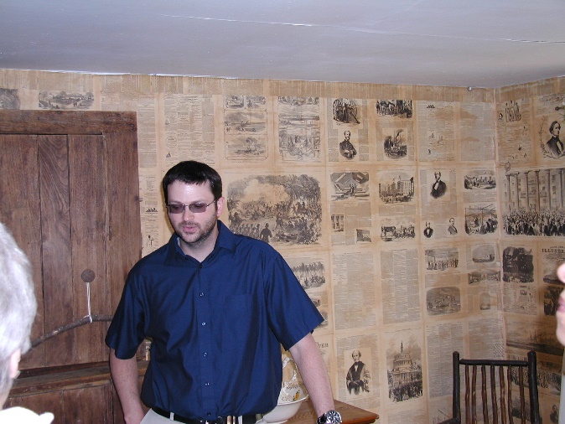

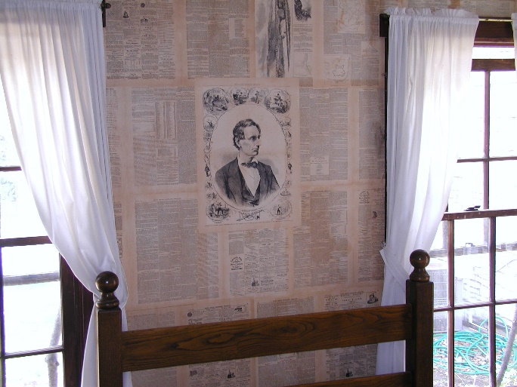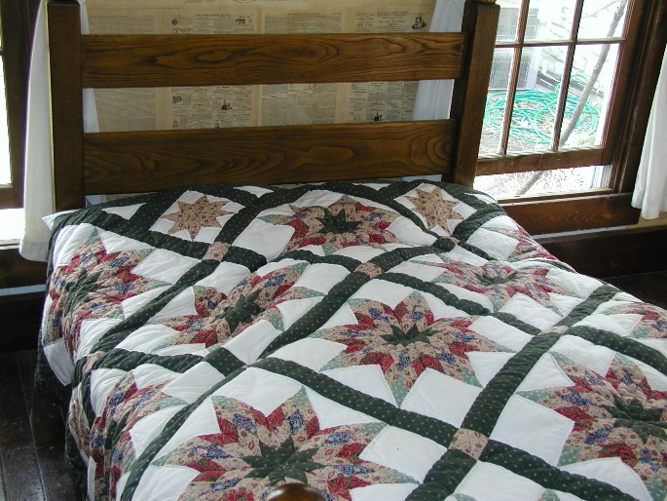

And the Isaac Goodnow House:

This included a tour of the Isaac Goodnow House, home of one of Manhattan’s founding fathers, which is on the Museum site. Mr. Goodnow established the Methodist Blue Mont Central College in 1860 and under the terms of the Morrill Land-Grant Colleges Act converted the college in 1863 to Kansas State Agricultural College (later Kansas State University)—the first Land-Grant college in the U.S. He and his wife built the stone farmhouse that the group toured.

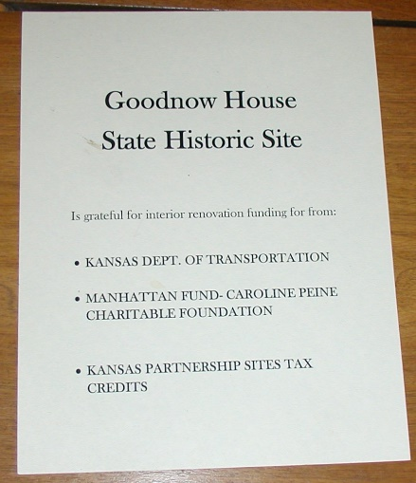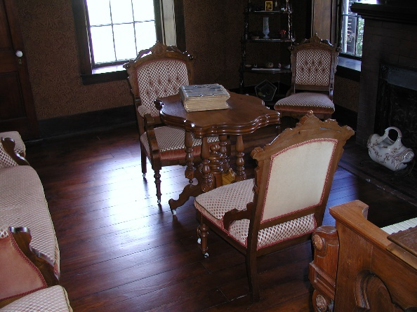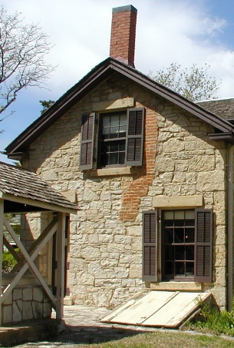
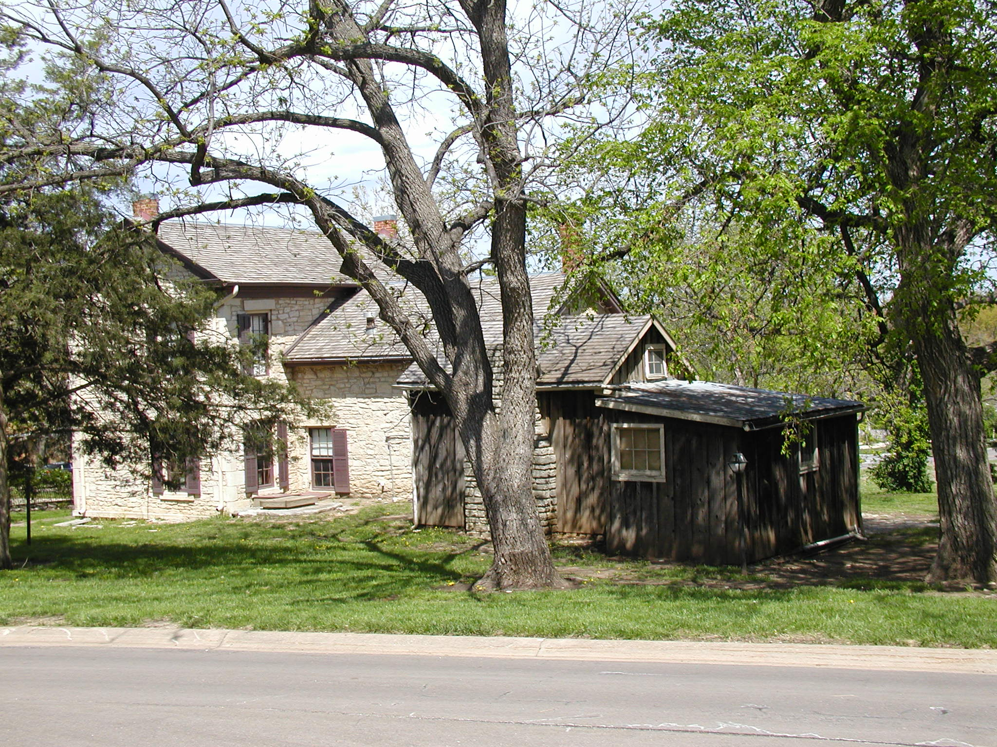

The day was pleasant, warm, and windy making for a memorable day. Members enjoyed their day’s activities very much and gave Sharon Regier, tour guide and organizer, many complements at the conclusion of the trip. Tired, but enthused members were glad to go home at the end of a long and eventfully fun day.

The group headed back to Whitewater at approximately 4:00 PM, arriving back at the high school parking lot around 7:00 PM. A tip of gratitude was collected from members and given to the bus driver before he left the parking lot.

Notes submitted by Cynthia Rhodes, Secretary
Photos by Melvin D. Epp, President

