Pictorial History of the Buildings of Whitewater School District #95
Compiled by Agnes Wiebe Harder

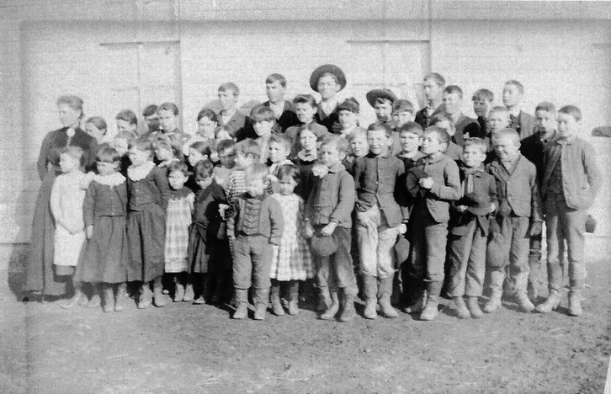
Photo source: Main Street Gallery, Whitewater

First class in District #95, Whitewater, Kansas, in 1889-1890 with teacher,
Mary M. Neiman, after the rural Holden School building was moved to town.

The Holden School was moved and located on Lots 23 and 24 in Block 9 in Whitewater. This was on B Street near the Third Street corner. Immediately, it became evident that this building was too small for the number of children in Whitewater, so during the first term the classes were held in “relays,” and later other homes and buildings were also utilized for classes. From the start, the district found itself in need of a larger schoolhouse.

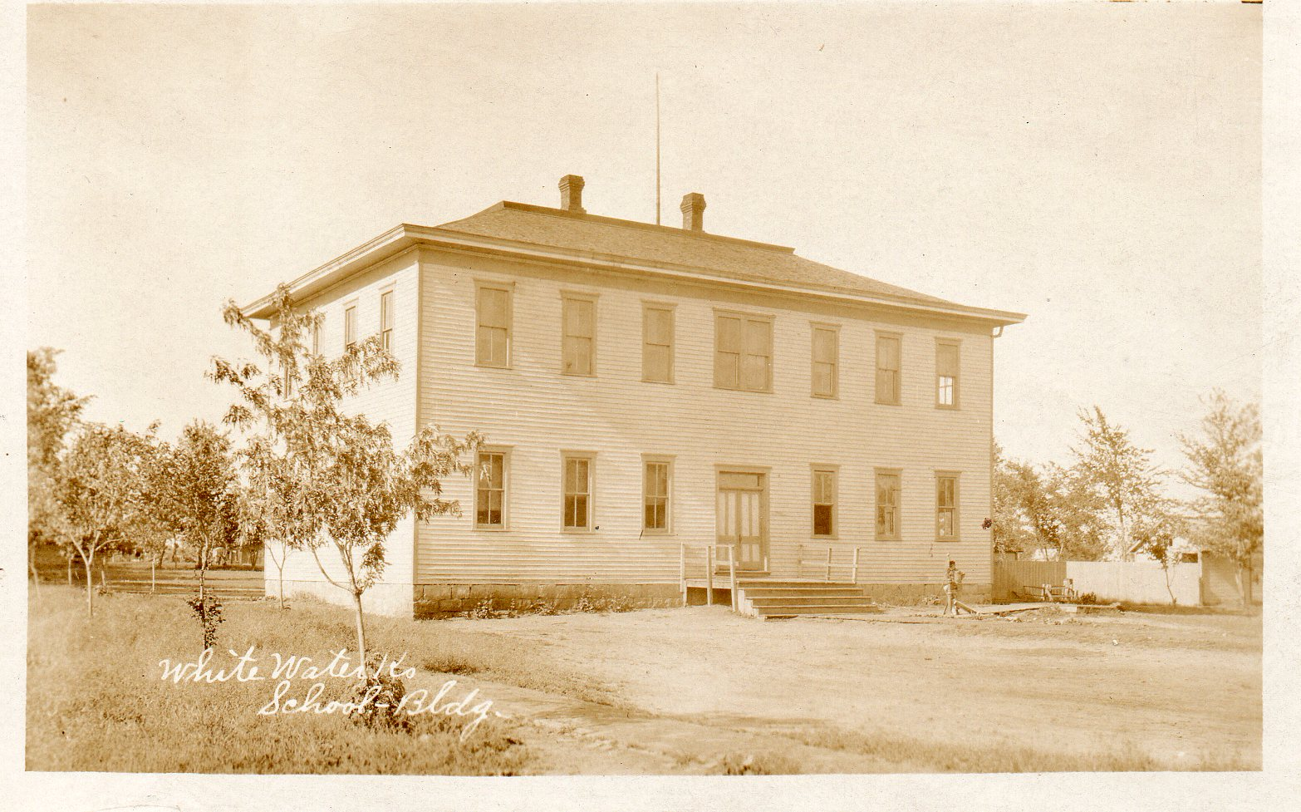
Photo source: Main Street Gallery, Whitewater
First schoolhouse built in Whitewater, Kansas, and used during 1890-1910
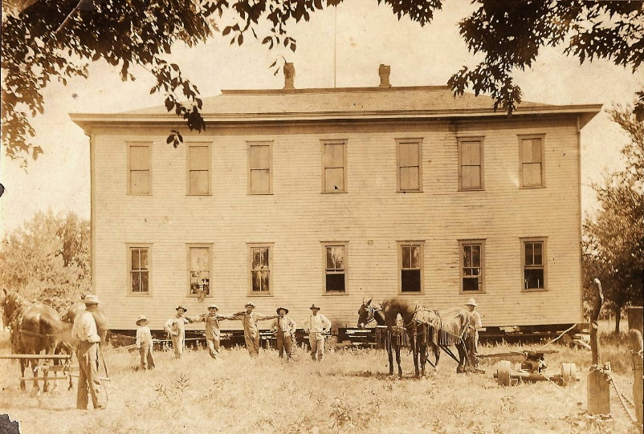
The following summer, steps were taken to buy the present school grounds (First Addition, Block 1 of the City of Whitewater) and to put up a new building. The construction of the new building was begun in the fall of 1889. By August 1889 the prospects were good that the schoolhouse bonds could be issued for the full $3,000; by September 5, 1889, bonds were voted for the erection of the $3,000 school building.
During the 1910-1911 term
this school building was put
up for sale using sealed bids;
it was moved off the school
grounds.

Photo source: FRAHS Archives

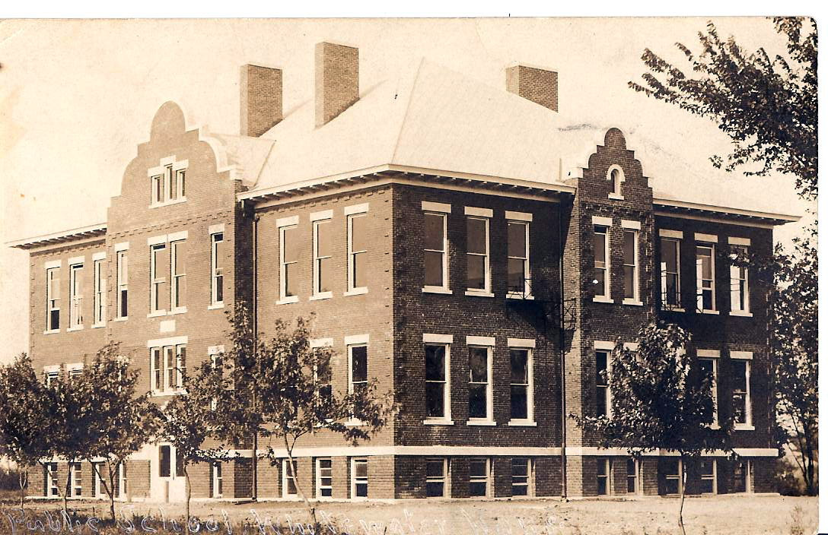

Photo source: Frederic Remington Area Historical Society Archives
Second schoolhouse built in Whitewater, Kansas, and used during 1910-1965
The second schoolhouse was located on the same city block as the previous schoolhouse. It was built in the center of the west half of Block 1, facing to the west. The local newspaper reported that the district “has a building that it is proud of and that compares favorably with buildings in some of our larger cities.” The cost of the new building was $25,000.

This building housed the elementary and secondary education programs. Grade 12 had been added in 1909. The school was under the Barns High School Law and in 1910 the tuition was free to all pupils, including those coming from outside districts to the Whitewater High School. Total enrollment for the Whitewater School in September 1920 was 165 pupil with seven teachers.

Both high school and elementary school courses were offered out of this 1910 building until the number of students exceeded its capacity and a new separate high school building was added in 1923 on the northeast corner of the school block. The 1910 building continued to house the elementary and middle schools until the building was demolished in the summer of 1965.

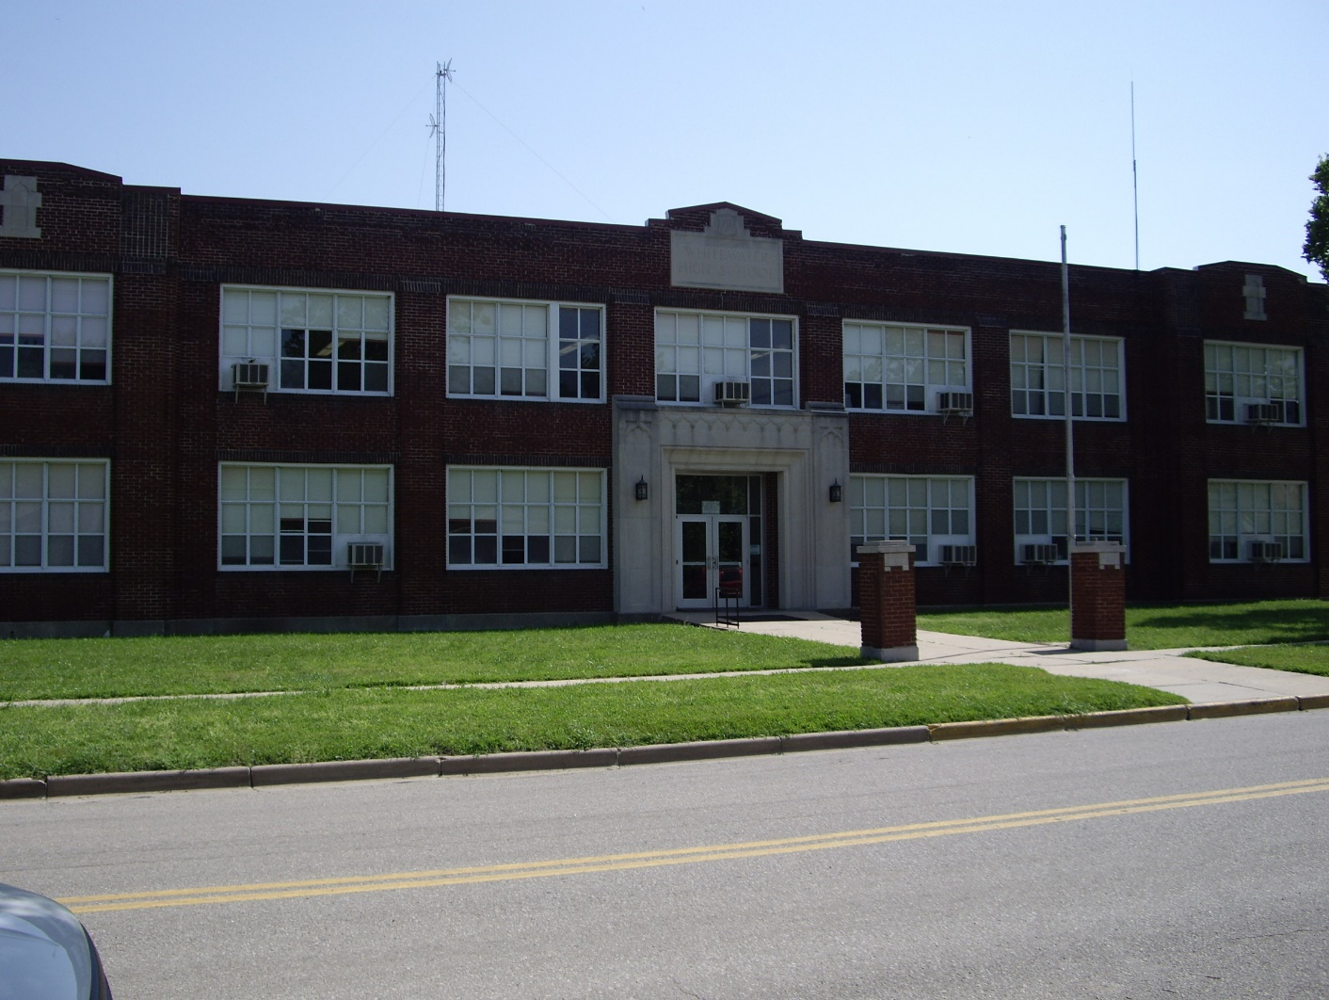

Photo source: Agnes Harder

Third School House in Whitewater, Kansas, used from 1923 – 2007
This building housed the Whitewater High School from 1923 until 1963 when the Remington High School was built on Meadowlark Road. After that the building was used for the elementary and middle school classes. This building was demolished in the summer of 2007.

For the nostalgic memories of those attending their high school years in this building, the “1923” capstone originally located high above the front door of the north entrance of the school on East Central Street and preserved during the demolition, was mounted on a stand between two original brick sidewalk pillars donated to the school by the Classes of 1929 and 1930. An historical description plaque is mounted on the left pillar and a sketch of the school by Martha Knudson is mounted on the right pillar. These are shown below and were a Spring 2012 Preservation Project of the Frederic Remington Area Historical Society.
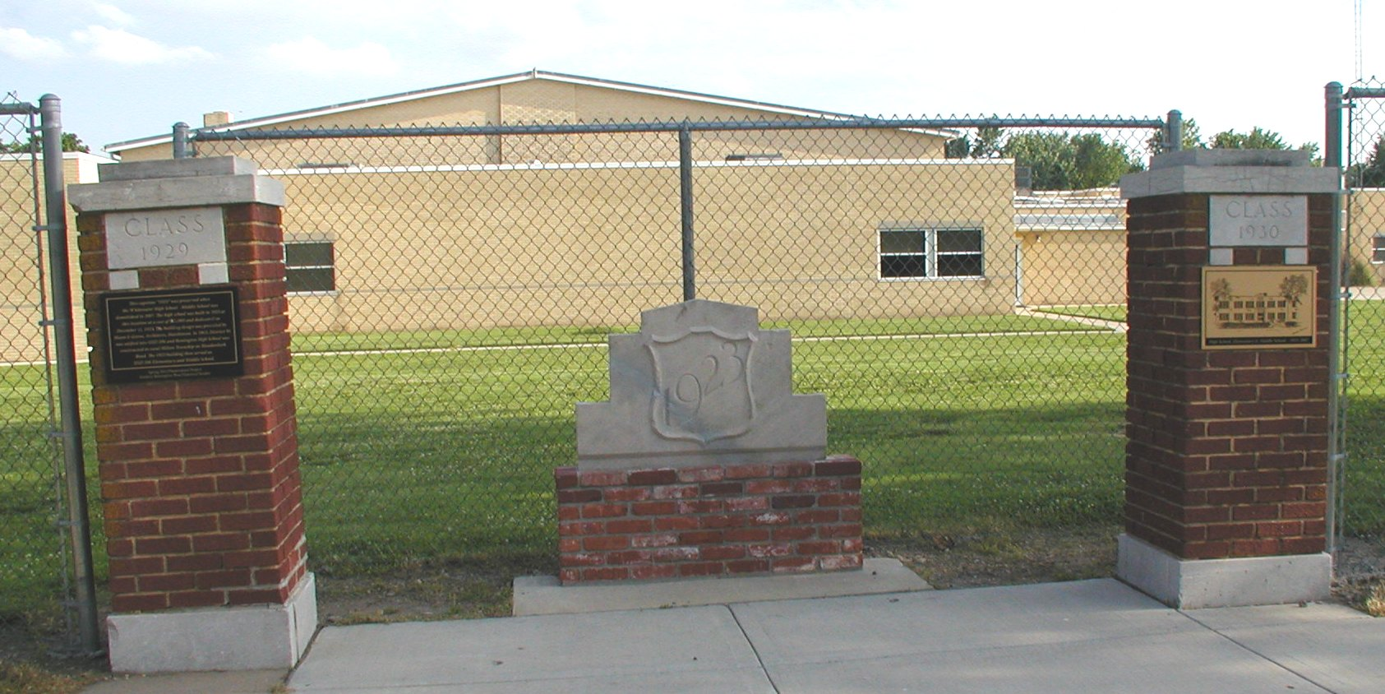

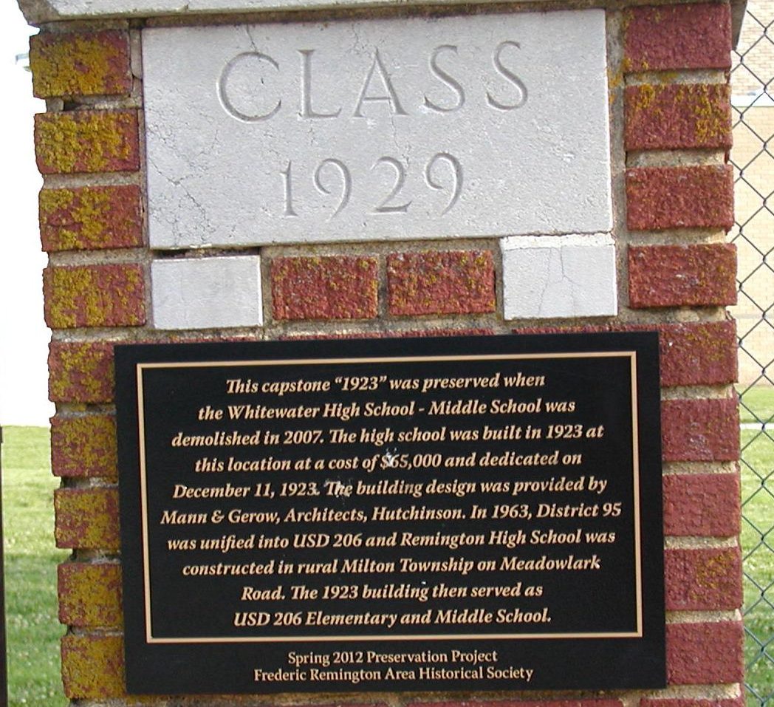

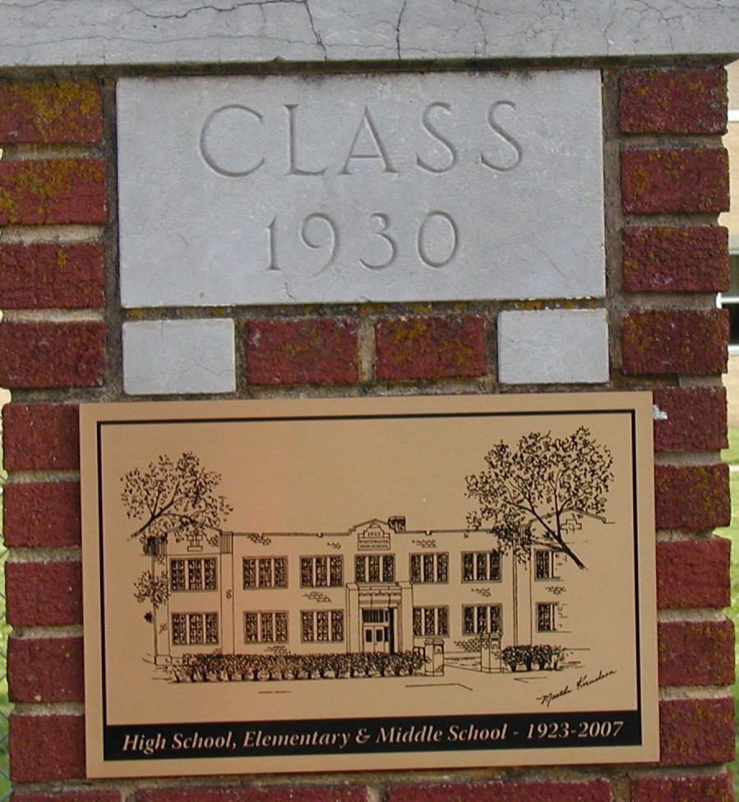

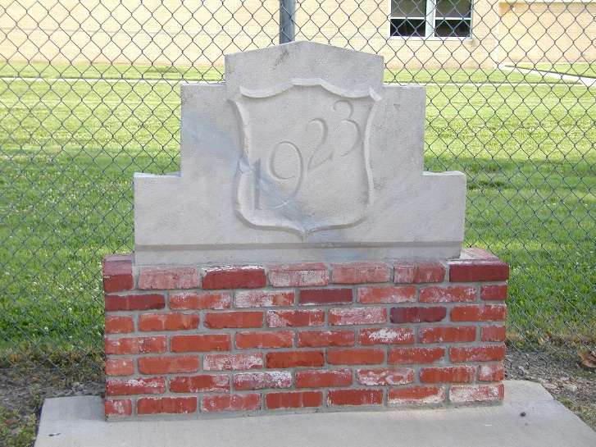

Photo sources: Frederic Remington Area Historical Society Archives

