The History of Whitewater: Accolades for Whitewater
Ancient to 1885
Had you visited the townsite of Whitewater 250 million years ago, you would have needed a boat. Kansas at that time was covered by the Western Interior Seaway.¹ Invertebrate fossils are common in the limestone deposits that formed the Flint Hills. The limestone, shale and chert (or flint) rocks were left when the seas gradually receded carving valleys out of the sea bottom. Many of the foundation stones used for the early buildings around Whitewater in the 1800s came from limestone pits near Florence, Marion County, Kansas. These stones reflect sediment of the sea bottom. Figure 1 shows an example of fossilized mollusks in a limestone used in construction. As the sea receded, many marine reptiles were also fossilized and can be seen at the Sternberg Museum of Natural History, Hayes, Kansas.
As the waters receded the rivers and hills of south central Kansas were etched into the landscape including the West Branch of the Whitewater River. This territory that was to become Kansas was in the center of the large North American continent. The soils of Kansas reflect its limestone or sea-bottom origins and tend to be alkaline. The rainfall now averages between 29-34 inches per year. The sun shines more than 250 days per year. It tends to be windy and the temperature can oscillate widely in a day from 50º to 105º F reflecting the intercontinental climate. The Whitewater area is in USDA Hardiness Zone 6a and averages 150-180 frost free days per year, ca. April 13 to October 15. The elevation is 1386 feet above sea level.
Had you come to the Whitewater area at the time that Jesus lived in Palestine, you would not have been alone. Native Americans were traversing the area and unfortunately lost a few of their projectile points. Two points have been found on Section 17 just east of town and are shown in Figure 2. These isolated finds are points chipped from Kansas Wreford chert (flint) and depict Late Archaic Williams points (ca. 1000 B.C.E. – 500 C.E.).²
Had you come to Section 18, Milton Township in 1869, you could have offered to help brothers George Peter Neiman and Isaac Howard Neiman construct their log cabin on the southwest quarter, which George homesteaded per the Homestead Act of 1862. See Figures 3 & 4 Born in Pennsylvania, they moved with their parents to Iowa as boys. As youths in their early twenties, they came by covered wagon to the then trackless prairies and became the first settlers of Harvey County in 1869. After only a few months they relocated to the east bank of the West Branch of the Whitewater River, just south of the present town-site of Whitewater.³ The grasses were as tall as the height of a horse’s back.⁴ At that time, antelope, deer, and prairie chickens were abundant. Although the Neiman brothers may have seen buffalo on the west bank of the West Branch of the Whitewater River facing their log cabin, the buffalo were slaughtered in mass between 1872-1874 for their hides and meat. By 1875, few, if any, buffalo still existed in Kansas.⁵ However, they were not the first settlers in Milton Township; Milton C. Snorf located on the northeast quarter of Section 36 in 1868. The Neiman brothers did organize the first Fourth of July celebration on the West Branch of the Whitewater River at their place in 1871. The festivities included the usual: patriotic songs, a picnic dinner, and dancing.
The Neiman brothers could have received letters from or sent messages to their concerned relatives remaining in Iowa. In 1869-1870, Towanda was the nearest post office; Towanda was an Indian Trading Post with a post office starting in 1865. A local post office, the Holden Post Office, was initiated on Section 18 in 1871 in the home of B. C. Leveredge as postmaster. After a few years, Thomas H. Storms was appointed postmaster and the office moved to his home on Section 8. Later the post office was moved to the Eton residence on Section 20 and E. T. Eton was appointed postmaster. In 1886 he moved the post office to Brainerd on Section 22 where it remained until closed in August 31, 1907.⁶ The mail was carried by horseback, wagon, or on foot.
In the late summer of 1876, a group of eight families of West Prussian Mennonites purchased land in Milton Township through C. B. Schmidt, the German-speaking General Agent of the German Department of the Topeka Land Office of the Atchison, Topeka & Santa Fe Railroad (a.k.a. Santa Fe Railroad). On January 1, 1870 about 15 per cent of the land of Kansas had been given to the railroads by the Federal government through the Land Grant Legislation of 1863 and signed into law by Abraham Lincoln. The Santa Fe Railroad had 3,200,000 acres to sell in order to finance the completion of the expansion of railroads and telegraph lines across Kansas from the Missouri River to the Colorado state line. The state granted to the railroads the odd numbered sections 10 miles on either side of the railroad track, including the Santa Fe right-of-way through Peabody and Newton. This included all of Milton Township. The even numbered sections of land were reserved for homesteading per the Homestead Act of 1862. One of these Mennonites, Bernhard Harder, Sr., purchased Section 17.⁷ See Figure 5. The Mennonites were good farmers and built large houses and barns and put out orchards and gardens.⁸ They raised noteworthy horses and cattle. Their word was as good as their bond and they believed in settling their own affairs without resorting to law. Swiss Mennonite families also located to the township and vicinity between 1881 and 1884. Each group maintained a church of their own with services in their native languages. All these people were sincerely devoted to their church and were good neighbors, upright citizens, and had large families of native born American children.⁹
1885 to 1887
Had you visited Milton Township in 1885, everyone would have been excited. The Ellsworth, McPherson, Newton, and Southeastern Railroad Company (also referred to as the McPherson branch of the Missouri Pacific Railroad) decided to build an east-west track through the heart of Milton Township with a major train station together with a stockyard siding in the center of the township, i.e. Brainerd.¹⁰ If you flagged the train when you wanted to get on or get off, it would stop where a road crossed the tracks, or you could also go to the nearest train depot. Passengers rode in the last car of the train, the caboose. Early on there were two trains, a freight train and a passenger train. Each train had a morning train going east to El Dorado and an afternoon train going west through Newton to McPherson. Several new towns were established along the track wherever a train station was built: McLains, Annelly, Brainerd and Potwin. With the establishment of these towns shopping locally was possible, rather than driving a day by wagon to get supplies from Newton, Peabody, or El Dorado, which were 20-25 miles away.
From 1885 to 1888, Brainerd was a bustling frontier town. Many business men from small cross-road establishments in the surrounding area relocated to Brainerd. The railroad was a conduit to the world. The town was platted in 1885 and by September of that year there were 180 buildings with 43 businesses and 500 inhabitants.¹¹ But in 1886 when the Chicago, Kansas & Nebraska Railroad Company, a Rock Island Railroad subsidiary, constructed a north-south track traversing the land homesteaded by George P. Neiman on the west edge of Milton Township with the first train running in August, 1887, business development began to focus on the area where the two tracks intersected. Here the Rock Island Railroad immediately established a train station with a stockyard siding, and the town of Whitewater was platted north of the junction by the Golden Belt Town Company in 1887. The Arthur L. Neiman addition to the townsite on the east was platted before Whitewater was incorporated in 1890. The Samuel R. Neiman addition to the townsite was on the north. See Figure 6. Main Street south to the section line, was not laid out or opened for traffic for several years after the town was platted.¹² The Missouri Pacific shortly erected a station there as well; their stockyard siding remained in Brainerd. Other local towns established along this Rock Island Railroad were Furley to the south and Elbing to the north. Isaac Howard Neiman was appointed the first Postmaster of Whitewater by President Grover Cleveland in 1887 with the first post office opening on May 15, 1888 in the S. L. Motter general store. Mr. Motter was the deputy postmaster. Rural deliveries began in 1902 with Isaac Neiman the mail carrier on Route 1 and George Corfman on Route 2.
If you stopped by Brainerd or Annelly in 1888, the conversation would have focused on the future impact of Whitewater on the business development of their communities. Chester Smith did not spend much time in contemplation; he moved his house the three miles east from Annelly to Whitewater in January, 1888 and is credited with establishing the first house in the town of Whitewater. Two more houses were relocated from Annelly. The three-year-old town of Brainerd was literally put on wheels and moved to Whitewater with businesses and houses disassembled, put on wagons drawn by horses, driven the 2.5 miles west to Whitewater and reassembled. An estimated 35 businesses relocated from Brainerd to Whitewater. With two railroads intersecting, the prospects for long term business development was deemed very positive—superior than locations on only one rail line. The heyday for Brainerd was over,¹³ however, the town remained an active business and residential center with 68 residents in 1890 and with the Brainerd Store remaining in business until 1953. A history of Brainerd with pictures is available on the Internet.¹⁴
Initially, the name proposed for the new town was Neiman, honoring the original owner of the land of the town site. However, George P. Neiman declined the honor, so the name was drawn from the fact that the town lay in the Whitewater River watershed.¹⁵ A pioneer tale also relates that the Whitewater River initially was called the Whitewoman River because some pioneers found the body of a white woman, massacred by Indians, floating in the river. The name was later changed to Whitewater and the “creek” just west of the town site is actually the West Branch of the Whitewater River.¹⁶
Had you ridden your horse into the Whitewater town site anytime after 1887, the hustle and bustle would have been impressive. The town developed services commensurate with the needs of the community at that time. Listed below are the names of some of the early people and their contribution to the development of Whitewater and the surrounding agricultural community.^{17,18,19,20,21,22,23}
Homage for Early Contributors
Rev. Henry Acker relocated the Evangelical Lutheran Church to Whitewater from Annelly in 1889.
Dr. Connell V. Alexander was the only dentist the town ever had. He took over the dental work from the local medical doctors.
Peter E. Ashenfelter was the first lawyer, moving to Whitewater from Brainerd.
Ben Beck was the first lineman for the Whitewater Telephone Company ca. 1903.
Morgan Marcellus Bishop opened the Bishop Hotel in late 1887. He was also an early photographer in town.
Boyd Blackford established a service station in 1946 at Main & Vine. He sold Mobil gasoline and oil until 1961. Subsequently, he sold Phillips 66, getting his products from Claassen Oil Supply Company in Newton. Blackford sold his station to Shorty Brown Oil Company in August 1978.
Fred Breising, Sr. built a small frame building (now described as a wood frame, vernacular Italiante, false fronted commercial structure) in 1888 just south of the Neuman Hardware. This was Whitewater’s first meat market. A photo of the original building on Main Street is available.²⁴
The shop sold fresh and cured meats. Breising butchered and cured his own meats. He also hauled natural ice from the creek and ponds in the winter, which was stored in a special building in back of the store. Fred Jr. served in World War I and when he returned, he worked for W.M. Nolder, the Whitewater poultry dealer. In 1924 Fred Jr. married Hazel Thompson and when Fred Sr. retired Fred Jr. took over the business with Hazel helping in the store. The meat market moved to the Penner location in the 1940s. The Breisings retired in 1952. The original building was rented to Everett Sanders Electric and later purchased by Neuman Hardware. In 1949 it was leased to the town library and in 1988 the building was relocated to the Old Cowtown Museum in Wichita.
Frank Broadstreet was the first station agent at the Rock Island Railroad depot.
Claus Henry Bruhn opened the first town blacksmith shop on the street west of Main in 1888, which became the oldest business in continued service until the shop closed on October 16, 1971.
Henry was born in Schleswig, Germany, May 20, 1864 where he learned the trade of blacksmithing. He arrived in New York with two cousins in 1887. They had tickets to Newton, Kansas but no money left to feed themselves on the trip west, so they borrowed $5 from a minister and sent the money back in two weeks. The anvil block, which Henry cut from a walnut tree along the West Branch of the Whitewater River and pushed to his shop in a hand cart, still held his anvil in 1964.²⁵
By September 15, 1888 Henry moved to Main Street and built a frame building for his shop. In 1911, he tore down the first frame building and built a two-story brick building joining his and an adjacent lot. He sold implements, buggies, and wagons. In 1904, he contracted to handle John Deere Company plows and tractors.²⁶ To help with the increased workload, son Herman quit school and went to work for his father. In 1917, Herman bought the blacksmith shop, but soon had to close it for 11 months until he returned from military duty in 1919. In 1971, Herman retired and on October 16, 1971 the oldest business in Whitewater ended. The materials and tools that had continued to hand forge items like in the horse-and-buggy days were auctioned.
As the workers were preparing for the auction, an item was found that looked like welded pipes. After closer examination it proved to be an inoperable machine gun. In the 1920s, The Peoples State Bank was located across the street from the blacksmith shop. That was an era noted for bank robberies, and to protect the bank, the bankers strategically placed guns in various shops across the street to use in the event of a robbery. ²⁷
In the days of horse-drawn equipment, a two bottom plow would run half a day (3-5 acres) and then need to make a trip to the blacksmith shop. Gustav Harder, who farmed Section 16 east of Whitewater, had four sets of plows. One set was in the field plowing. One set was on its way to the blacksmith shop for sharpening. One set was in the shop to be drawn out to a sharp edge. And the fourth was on its way back to the field after being sharpened.²⁸
Edward T. Burns built the first elevator east of the Missouri Pacific depot on the railroad siding. He was the only one to use a horse treadmill to power his elevator in the first few years. Subsequently, he used the first gasoline engine to replace it. He later consolidated with R. H. Farr who established the Whitewater Mill and Elevator Company in 1898. Mr. Burns was the first grain buyer and coal dealer in Whitewater.
C. C. Carter, established the first dray and general hauling business.
Mrs. David Cave had a millinery store.
Clinton V. Chaney and C. S. “Coon” Stuart were the first grain and livestock buyers to have an office on Main Street. They also tended the city scales.
W. D. Chaney had the first high class hotel, the Hotel Leslie venture.
Edmund Davis was the initial editor of The Independent. Previously named the Whitewater Herald, the paper changed management and was named The Independent on October 8, 1896 to reflect the independent political views of the new editor, Edmund Davis. The Independent was one of the substantial and progressive newspapers of the country in 1916.
Edmund D. “Ted” Davis, Jr. who replaced his father at The Independent was also independent and a leader like his father. He was instrumental in organizing the American Legion Post in Whitewater and was the first Post Commander of William P. Phillips Post 65. The present Legion Hall was built in 1951.
Fay Davis was the first telephone operator for the Whitewater Telephone Company ca. 1901. Since the telephone service was initiated by her father in the offices of The Independent, Fay and all of her sisters were telephone operators at various times.
Carroll B. Dean was an early livery stable operator.
John A. Dilzer was the first harness maker. He later sold out to his brother, Frank W. Dilzer, who added hardware to the business.
Eberhard, Thompson, & Francis established the first garage in 1909 selling Fuller and Gleason autos. Their first sale was a Fuller auto to Peter Zuercher. They also sold the first auto tires in town. A year later Eberhard & Golden also handled Maxwell autos with Dr. John Horner and Henry Gale as early buyers.
Mr. Eberhard was also the first real estate agent. His associate was Harry Mellor. Other agents in the early 1900s were Jas. Thompson, Frank Laughlin, and Isaac Howard Neiman.
John Eilert opened a general merchandise store in late 1887.
R. H. Farr built the Whitewater Mill and Elevator in 1898. He was joined by Burns who consolidated his mill along the Missouri Pacific Railroad with the Whitewater Mill, located adjacent to the Rock Island Railroad. In 1916, it was thought Farr had more to do with the industrial development of Whitewater in recent years than any other man.
Mr. Farr took part in the organization of the Peoples State Bank in 1908. He also established the first Electric Light and Ice Co. in 1913. The first electric light system was installed in the Whitewater Flour Mill. He is also remembered as owning the first auto in town, a Rambler.
L. Fessler of Newton owned a brickyard and kiln on the east bank of the West Branch of the Whitewater River between the Rock Island Depot and the Missouri Pacific bridge. The first building in Whitewater using Whitewater manufactured bricks was built by Gerhard W. Penner. The first brick sidewalk to replace wooden boardwalks was in front of the Bank of Whitewater in 1897.
J. Fowler was one of the original carpenters.
C. E. Francis started the mortuary in the early 1900s in his furniture store. This business was subsequently purchased by Frank Bishop and then by Harold M. Smith and his brother who bought the furniture store and mortuary in 1922. The furniture business was closed in 1930.
Frank Gronau had a Chevrolet dealership in Whitewater.
George B. Hanstine, cashier of the Peoples State Bank, was considered one of Butler County’s successful financiers. For the first 28 years of his life he was engaged in farming and cattle feeding, frequently feeding as many as five hundred head at one time. Upon joining the bank as cashier, he was the executive head of the bank. He also was the manager of the alfalfa mill; Whitewater was one of the first towns to have one.
He and Mrs. Hanstine took a prominent part in the educational and social life of Whitewater and in 1916 were numbered among its most valued and esteemed citizens. He served as president of the Whitewater Commercial Club.
Henry Heigerd ran the first furniture store in town.
Dr. H. Henderson moved his practice to Whitewater from Annelly in 1888 and, along with his practice, managed Kinney Drug Store, which was the first drug store.
Dr. John Horner was the first doctor. He was a native of Kentucky, grew up in Indiana and Illinois, and worked for a time in the steamboat business before he came to Butler County in 1870, where he filed a homestead claim one-half mile east of Whitewater on Section 18, which now adjoins the town of Whitewater. He enrolled in the Eclectic School of Practice, Cincinnati, Ohio and graduated in 1880 at the age of 51. He practiced in Brainerd before he moved to Whitewater. He was a musician and had the first organ in the community and organized an 18 member city band in 1890.
The Huguenin Brothers, early in 1905, opened a store in the Eilert building. The store stocked dry goods, shoes, and gentlemen’s and ladies’ furnishings. Above the store was a large hall known as Huguenin’s Hall. It was a meeting place for secret orders: the IOOF, AOUW, Modern Woodmen, and the DAR. Dances were also held in this hall.
James Dew Joseph was active in farming and purchased an interest in the Bank of Whitewater in 1892 and became assistant cashier on April 1, 1892. He married Whitewater’s first school teacher Mary Margaret Neiman on March 2, 1892.
Joseph organized a telephone system in 1901. The first phone office was in a lean-to on the north side of The Independent office. The first phone installed was in that office and was No. 1. The company was first organized with twenty-five phones; the shares were $25 each for towns people only. In 1903 the country lines were installed with the Mutual System and the Whitewater Telephone Company was established. Arthur J. Nigg purchased the Whitewater Telephone Company from J. D. Joseph in 1923 after moving to Whitewater from Chicago. Southwestern Bell bought the company in August 1941 and built a new building at Main and Topeka in 1961.
In 1912, J. D. Joseph was elected to the Senate of the State Legislature as a Democrat. He served for four years during which time he introduced 52 bills of which 17 became law greatly impacting bank regulations in Kansas.²⁹
Mr. Oliver Kinney ran a broom factory after the drug store moved out of their building.
James Campbell Kirkwood established a lumberyard in Annelly in 1886, but moved it to Whitewater in 1889 to a site next to the Missouri Pacific Railroad on the east side of Main Street. His son, R. G. Kirkwood, continued the business. In the 1890s, they also handled farm implements. For a time they maintained two warehouses, one storing buggies exclusively. At one time the R. G. Kirkwood Lumber Company was the oldest and largest lumber and coal yard in northwest Butler County.
William H. Lambert & Son had a grocery market in the 1890s. They were the first grocers to add a meat counter. Other firms carrying groceries and fresh meats were Penners and Breisings.
P. D. McArthur was the first resident agent at the Missouri Pacific Depot ca. 1888.
O. E. McDowell was the first barber and a part-time painter. He also ran the Hesston Creamery Company station located in the northwest part of town. In the early years farmers brought their whole milk to the skimming station, with the cream being purchased by the creamery and the skimmed milk returned to the farmer. McDowell later also operated a grocery store.
Arthur H. McLain, President of the Whitewater Bank of Brainerd moved his business to Whitewater in 1889. This bank failed in the depression of 1891 and was reorganized by G. P. and I. H. Neiman on April 3, 1891 as the Bank of Whitewater.
In 1890 the McLains also started the first waterworks system, built by John E. Ford of Newton, a waterworks contractor. The windmill-powered waterworks was purchased by the city in 1892 for use as the municipal water supply. It consisted of a tank, where any resident could get water for private use, and a watering trough.
The McLains are also credited with moving the first building from Brainerd, which was used as part of the H. H. Norris house on South Church Street.
George McSparrin was an early livery stable operator.

William Miller was the first section foreman on the Rock Island line and moved to Whitewater from Peabody.
Dr. H. H. Morris from Annelly moved his practice to Whitewater in 1888.
Mr. Morrison moved his newspaper printing press, on which he was printing the Brainerd Ensign, from Brainerd to Whitewater.
The last issue of the Brainerd Ensign (named the Brainerd Sun from October 15, 1885 to October 14, 1886) was printed on June 15, 1889. The paper was sold to the Tribune Printing Company, which issued the first Whitewater Tribune on June 20, 1889 with Al Hendee as editor. The name was later changed to the Whitewater Herald on June 22, 1893. In 1896 the Whitewater Herald paper changed management and was named The Independent on October 8, 1896 to reflect the independent political views of the new editor, Edmund Davis. In the March 7, 1935 issue of The Independent, it was mentioned that they were beginning their 51st year that week. In 1980 the newspaper was sold to the El Dorado Times and was issued as the Butler County News. Early in 1981 the Whitewater news began to appear each Thursday in the El Dorado Times.
Joe Motter opened a barber shop in 1921 and remained in business for 40 years.
Samuel Lincoln Motter opened a general store in August 1887 and was appointed the Deputy Postmaster in 1888. He was the first city clerk.
E. L. Neal was the first tinner and tank maker and opened his business in 1891. He moved to Whitewater in 1888.
George W. Neal operated the first lumberyard in Whitewater, moving his lumber and hardware from Brainerd in 1889. This store closed in 1905. From 1871 to 1884, he did business in Peabody before moving to Brainerd.
Neal & Reeves had the Ford Agency here for years on Main Street.
Neuman Hardware was started in 1925. Art (A. B.) Neuman bought the business from his father after World War II. The store was a full line hardware store and held the International Harvester franchise.
George Peter Neiman homesteaded the south half of the southwest quarter of Section 18 in 1869 and built a log cabin. Plowing the first furrow in Milton Township is attributed to him. The town of Whitewater developed on his land beginning in 1887 when a north-south railroad intersected the east-west railroad built in 1885. George P. Neiman and his younger brother Isaac Howard Neiman created the Bank of Whitewater in 1891.
Isaac Howard Neiman opened the Whitewater Post Office on May 15, 1888. He was the first postmaster, receiving his appointment from President Cleveland. The location of the post office was in Isaac H. Neiman’s building at the northwest corner of Main and Rock Island, leased to S. L. Motter for his general store.
Plowing the first furrow in Harvey County is attributed to him. He was the first Sunday School Superintendent in the Grace Reformed Church, an early stock buyer in Whitewater, and he also fed many cattle and hogs at the yards south of town.
Mary Margaret Neiman was the first teacher in the one-room grade school built in 1889 near the Rock Island Railroad. She continued teaching until she married James D. Joseph on March 2, 1892. The first school board directors of Butler-Harvey County District 95 were John Eilert, Joseph Weatherby, and Chester Smith. In 1890, a four-room, two story building was erected on the present school block. County District 95 had been initiated years earlier as the Holden School on the north edge of Section 20 just east of town and then relocated to the town site of Whitewater.
William Newbury had the first shoe cobbler shop in the 1890s. He handled cold drinks and homemade ice cream in season and was also the first city marshal.
Harley Madison Nolder was the first Whitewater poultry dealer.
Dr. Harrison H. Norris was a first settler physician and moved his practice from Annelly to Whitewater in 1888. He grew up in Peabody, Kansas and went through Peabody High School. He trained at the Eclectic School of Practice, Cincinnati, Ohio, graduating in 1885. He remained in Whitewater until 1891 and then after a period in Wisconsin, he returned in 1898 and resumed his practice in Whitewater.
George H. Otte moved from Annelly and opened a general store by August 1887. He was elected the first mayor of Whitewater in 1889.
L. M. Pace came to Whitewater from Peabody as station agent for the Rock Island Railroad. After 1899 he and his son had a hardware store and also operated the first filling station. The first moving picture show was in one of the Pace buildings.
Gerhard W. Penner was born on January 7, 1861 at Neukirch, Kr. Marienburg, West Prussia, the son of Jacob Penner, a Mennonite merchant. Gerhard worked as a merchant apprentice in a fabric and linen business in Tiegenhof for 3-1/2 years until he was almost 20 years old. Following his mandatory registration for the military reserves in June of 1883, he decided to follow his older brothers Johann ("John") and Rudolph Penner to Butler County, Kansas, arriving in 1884 and settling in the Emmaus Mennonite Church community. He married Helena Dyck in 1887, and they resided at Brainerd until 1889 when they moved to the new town of Whitewater. He served as a postmaster of Whitewater for a period of four years from May 1893-May 1897. Following the death of his widowed mother in 1898, he used his inheritance to build and stock the Penner Department Store in 1899, offering both dry goods and groceries to his customers. Within a short time he built a new building for his business; it was constructed of brick manufactured by Fessler Kiln of Whitewater. The Penner store was the first to install gas lights in a business establishment. Gerhard retired about 1921 after selling the store to his oldest son, Arthur H. ("Nix") Penner, and moved to Santa Monica, California with his wife, two daughters and youngest son, where he lived until his death on 31 October 1940. The Penner Department Store remained in operation until "Nix's" retirement in the 1950s.
E. S. Raymond moved his drug store to Whitewater from Brainerd.
Dr. William (Wilhelm) E. Regier was the son of the Rev. Jacob W. and Agathe Regier, charter members of the Zion Mennonite Church, Elbing and a grandson of Abraham Regier (1817-1890). He received his college degree in 1903 at Bethel College and his M.D. degree from University Medical College, Kansas City, MO. He began his medical career in Elbing from 1907 to 1910. Following several years of practice in Harper, Kansas and some graduate work at the Illinois Medical School, Chicago, he opened a general practice in Whitewater in 1913, which he continued until his death in 1950.
Dan Resnik was granted the Chrysler-Plymouth agency in 1934. He had initiated a blacksmith and repair business in 1931.
The Roach brothers owned a general store in 1889.
Sol Schreffler was the first section foreman on the Missouri Pacific line. He was moved to Whitewater from Brainerd.
O. C. Sharp was an early livery stable operator.
O. C. Shay, owned and operated the first livery stable. He also was the first mail carrier from the Rock Island Railroad to the post office.
Rev. D. B. Shuey organized the Grace Reformed Church in 1888. This was the first church in Whitewater.
Chester Smith moved his house from Annelly to Whitewater in January 1888. He ran a carpet weaving plant. At one time he served as a police judge.
Vern & Erma Sohnrey built Whitewater Recreation (Pub & Pool Hall) in 1945. Merton Wiens bought the place in 1967.
W. Spencer moved to Whitewater from Annelly in the fall of 1887 to build and operate the Spencer Hotel. He was also an early photographer.
Clyde Stark opened a cold storage locker plant in 1945. Blaine Bowlin bought the plant in June 1956.
W. A. Sterling was the first grain buyer and coal dealer on the Rock Island track.
C. S. “Coon” Stuart and Clinton V. Chaney were the first grain and livestock buyers to have an office on Main Street. They also tended the city scales.
Ben Todd was the first plasterer and did wall plastering.
W. F. Wakefield opened the first restaurant. He relocated from Peabody.
Henry H. Weachman was the first to deal in hardware and farm implements.
Joseph Weatherby was the first carpenter, relocating from Annelly, and erected a great many buildings in the new growing town of Whitewater. His first job in town was to build the first church, the Grace Reformed Church in 1888.
C. F. Weber built the first elevator along the Rock Island Railroad. This building was torn down ca. 1930.
W. H. Wert was an early carpenter in Whitewater.
C. White started the Chevrolet agency. The agency was sold to C. Bell and then in 1929 Frank Gronau bought the franchise and held it until he closed the agency, sold his equipment, and retired in June 1976.
T. J. Whiteside owned a general store in 1889.
Bus Williams operated the first bakery.
Charles Wilson had the first dry cleaner and hat rebuilding shop.
Prof. Guy Winn organized a Military Band in 1904.
Levi E. Zimmerman and corporation purchased the Whitewater Mill and Elevator in 1918.
1887 to 1990
After meeting some of the early town’s people, you would have without doubt asked them if they could live a somewhat normal life here on the wide open prairies. Is there a school for the children, a church for Sunday, and what do you do on a Saturday night for relaxation? The answers would have been varied, but very positive.
Education has had a long history of importance in Milton Township. Mrs. E. T. Eaton taught the first term of school in a small house built on the southwest quarter of Section 20 in what became District 95. The Holden School was built later in 1871³⁰ and was located on the north side of Section 20, just west of the half-mile hedge row. As Whitewater organized, District 95 was relocated to town and the first school building was built in 1889. It was located one block west of Main and one half block north of Rock Island Avenue (currently Topeka Street) on the east side of the street.³¹ Miss Mary Margaret Neiman was the first teacher. A high school was first opened in 1900. A brick building was erected in 1909 to house both the grade and high schools. In 1923 the north building of the Whitewater Grade School was built for the high school and served the community until Remington High School was constructed north of Brainerd in 1963.³²
Rev. D. B. Shuey organized the first church in Whitewater, the Grace Reformed Church in 1888. Rev. Henry Acker relocated the Evangelical Lutheran Church to Whitewater in 1889, which he had organized in Annelly in 1881; he built the new sanctuary for $1,400 on the site of the present Federated Church. The Federated Church was established by the merging of the Lutheran, the Reformed, and the Christian congregations in 1924.
The town also had three dance halls and three saloons on the street one block west of Main during the 1890s. Several fraternal organizations were created: the Independent Order of Odd Fellows in Whitewater, 1889; the Mason Lodge 280, ca. 1890; Ancient Order of United Workmen; Grand Army of the Republic; and the Modern Woodmen Camp 2860 was charted on May 9, 1896 with J. W. Stiger as First Consul and J. M. Pace as First Clerk. ³³ The first ladies' order was the Rebekahs; another was the Woman's Relief Corps. Baseball and softball have long been a favorite sport of the community, and local and church leagues continue to perpetuate this popular pastime.
Early on horses had such value for work and transportation that horse theft was frequent. Horse power was essential and drove the economy. The community formed a neighborhood watch group for their protection and the Whitewater Anti-Horse Theft Association at one time had 168 members.
Politics were also an important component of community development. Prior to 1890, residents of Whitewater went to Brainerd to vote in country, state, and national elections since there was only one voting precinct in the area. Dr. Horner’s band of 18 members often played at political rallies as well as other venues. ³⁴
The first street lights and church front lights were coal oil wicked, subsequently gasoline-mantle systems were used, and then electricity. The first use of wind power was by the Rock Island Railroad to pump water from the creek nearby.³⁵ Electricity was first installed in the Whitewater Mill by R. H. Farr in 1913. KG&E was granted an electricity franchise by the city in 1921.
Whitewater installed their first city sewage system in 1953. Most septic tanks in the city were closed and the residents were put on the city sewage line. In 1980 and 1981 the sewage system was updated. A larger filter tank was built and larger lines were installed.
The Whitewater Fire Department was established in 1891. The first fire station was a small building on Main Street. The next station was built in ca. 1920 and was located under the water tower and is now used to store city equipment. The present fire station was finished in 1980. In 1923 the city purchased a Model T Pumper to augment the bucket brigades; updated equipment was added as needed: a 1954 Ford LeFrance Engine (Pumper), a 1981 Ford Collins Engine, and in 2008 an American LeFrance Engine. The Whitewater firemen are all trained volunteers. The G. H. Roach barn was the first fire in town. On November 19, 1893 the Evangelical Lutheran Church burned to the ground. Another major fire was the Carter barn in which a mule burned. The next was a stable of Chester Smith in which a cow burned. The two greatest fires to date were the Korber garage/Smith Bros. furniture store in April 1930 and the last major in-city fire occurred on August 1930 when the Lamer and Neal buildings housing the Golbeck Café and Dr. Regier’s office burned to the ground.^{36,37,38}
The City Library was established about 1928 by Mrs. James A. Thompson who served as the librarian at least through 1935. The library was first located in the basement of the school building. In 1949 it moved into the frame building south of Neuman’s Hardware, which was built by Fred Breising, Sr. in 1890 for his meat market. The new Whitewater Memorial Library building was erected at Elm and Topeka in 1980.
In 1889 Whitewater had five general stores: Roach Bros., John Eilert, G. H. Otte, T. J. Whiteside, and S. L. Motter.
The first harvesting machines sold in Whitewater were: McCormick, Henry Weachman; Plano, L. H. Oldfield; Deering, Irwin Bros., E. L. Neal, agent; and Champion, Gerhard W. Penner.
The Whitewater Bank of Brainerd vacated their brick building in Brainerd in 1889 and moved their business operation to Whitewater on a farm wagon. A local farmer, wanting to make a deposit after he had sold his hogs, caught up with the “bank-on-the-move” one-half mile west of Brainerd and gave them his check for deposit. This was, no doubt, the first drive-up window with extended customer banking services.
The Whitewater Bank of Brainerd failed during the depression of 1891 and was reorganized by George Peter and Isaac Howard Neiman into the Bank of Whitewater on April 3, 1891. The first officers were J. C. Kirkwood, president; I. H. Neiman, vice-president; G. P. Neiman, cashier; and R. G. Kirkwood, assistant cashier. The first board of directors included G. P. Neiman, I. H. Neiman, T. C. Newcome, J. C. Kirkwood, A. H. Rich, J. W. Steiger, and R. G. Kirkwood.
The first bank was on the location of the present American Legion building. The present bank building was erected in 1895 (at the corner of Main & Rock Island). In 1897, the bank put down the first brick sidewalk in town using Fessler Kiln bricks, replacing the wooden boardwalks.
In 1892, James D. Joseph purchased an interest in the bank and became a director and assistant cashier on April 1, 1892. In 1920, Mr. Joseph purchased a controlling interest in the bank and became controlling officer. He served as cashier and president, and in 1949 retired from the bank having served 57 years. Through his efforts the bank got the nickname “The Biggest Little Cattle Bank in Kansas.” Mr. Joseph would make buying trips to Texas and would return with train car loads of feeder cattle, which he sold to local farmers. Arthur Nigg who married Mr. Joseph’s daughter, joined the bank in 1931. When his father-in-law retired he became president and served from 1949 until his death in 1955. Marion Joseph Nigg, his wife, then filled the presidency and served from 1955 to 1967. John C. Umbach joined the bank in 1951 and assumed the presidency in January 1967. He is the son-in-law of Marion J. Nigg and served until his retirement from banking in 1983. Bob Whitaker was elected president in 1983. Don Patry is the current president. The Bank of Whitewater is the oldest continuously operating bank in Butler County.³⁹
The Peoples State Bank was organized in 1908. A large building with a colonial type front was erected on Main Street. This was the bank that was protected by the machine gun in the Bruhn Blacksmith Shop. The banks, including the Bank of Whitewater, organized the downtown merchants into a vigilante group. They provided World War I Army rifles and sawed off shotguns with ammunition. The guns were serviced once a year. In the upstairs window of Bruhn’s Blacksmith Shop was a World War I machine gun. It was trained on the door of the Peoples State Bank. The idea was that if the bank burglar alarm went off, these vigilantes were to grab the guns, load them, and shoot the bank robbers. There is no record of any bank burglar alarm ever sounding. This group disbanded about 1940, but the guns remained with many of the merchants.⁴⁰ The bank failed after the stock market crash of 1929 and the Bank of Whitewater bought all interests.⁴¹
Another business with a noteworthy historical past is the Whitewater Mill built by R. H. Farr in 1899. By 1906, the mill had become the largest grain station in Butler County. The two leading brands of flour produced were “Home Queen” and “Whitewater Rose.” In 1918, the Whitewater Mill and Elevator were purchased by Levi Zimmerman, Paul Ross, Murray Ross, and Carl Ross. Within a year or two, they also purchased a small flour mill in Ottawa, Kansas. Levi Zimmerman and Paul Ross managed the Whitewater facility and in 1929 additional brands also included “Red Bird” and “Winner.” Of this flour, 75% was “Self Rising.” In 1934 the Whitewater Mill concrete head house was constructed; two years later the first annex was added and the second annex a few years after the first. In 1936, the group purchased the Goerz Mill in Newton; other acquisitions included the Kansas Milling Company of Wichita, the Wichita Terminal Elevator, and a flour mill in Arkansas City. Levi and his nephew Ted Zimmerman purchased the Whitewater Flour Mills Company from the other stockholders in 1954 and continued to manage the mill for 20 years. At times there were as many as 32 employees, making it the largest employer in Whitewater. In 1974, several local farmers purchased the mill for use as a country elevator, naming it Whitewater Mill, Inc. For 7 years the mill was used to make Cream-of-Wheat for the Nabisco Company. In 1987, the flour milling equipment was sold and the mill became a grain storage terminal and farm supply/feed store. In May 1989, the Whitewater Mill was sold to Farmers Grain Co-op of Walton, Kansas.^{42,43,44,45,46}
The location of businesses in 1920 Whitewater have been diagramed in Figure 7.
1990 to the Future
Had you driven into town in your gasoline-powered horse-less carriage with rubber tires to celebrate the 100th Anniversary of Whitewater in 1990, you would have perceived that the residents were proud of their town, its accomplishments and its place in history. Yet, looking around you would sense that things had changed and the needs of the community are very different now, one hundred years later. Although the population size has remained static since 1889, the train depots, the livery stables, the general mercantile stores, the hotels, the saloons, the lumberyards, the blacksmith shops, the barber shops, the hardware stores, the car dealerships, most implement dealerships, and now with time even the last remaining grocery story and service station are only historical remembrances. Driving to the shopping malls of Wichita takes less time and is considerably more convenient than driving three to five miles to town with a horse and buggy. Local shopping may now include Wichita, Newton, El Dorado, or even Kansas City. The times have changed. Most employment is out of town with the major employers located in Wichita, Newton, or El Dorado. Indeed, the times have changed and Whitewater is no longer a frontier town. Whitewater is now a bedroom town.⁴⁷
After meeting some of the current town’s people, while you took in the Centennial Celebration Parade on July 4, 1990, you would have without doubt been tempted to ask some of them during the lulls in the parade the same questions you asked 100 years earlier: could they live a somewhat normal life here on the wide open farmlands? Is there a school for the children, a church for Sunday, and what do you do on a Friday or Saturday night for relaxation? The answers would have been varied, but always very positive. But the look on the faces would have expressed—“and where are you from?”
The local schools are active and flourishing, and equipping the young people to meet the challenges of an ever changing world. Through available information technologies, the students can access the world and its large source of information. The athletic and academic programs provide endless activity and involve many people in the community. The high school is named to honor the life and work of Frederic Sackrider Remington who was a resident of the rural community from 1883-1884; a commemorative plaque was placed at the high school by the Frederic Remington Area Historical Society in 2006. See Figure 8.
Two churches, the Swiss Church and the Federated Church, continue to meet the spiritual needs of the community. Additionally, there are several more churches in the countryside.
The current library, Whitewater Memorial Library, is very busy and provides collections, services, and programs to meet the informational, educational, and recreational needs of the community patrons. The library is fully automated and has an active Friends of the Library support group.
The Whitewater Lions Club organizes the Fourth of July fireworks and the Fall Festival activities. The CJ’s (unaffiliated group formed from the disbanded Whitewater Area Jaycee Organization) are helpful with removal of yard debris from spring cleanup. The American Legion sponsors an annual Ground Hog-Pancake Dinner, and bingo in season. The Whitewater Seniors meet twice a month with a potluck lunch and fellowship on the 2nd Tuesday and a movie and popcorn on the 4th Tuesday.
The Bank of Whitewater and the Whitewater Post Office give the town continuity to earlier days and continue to provide services that are taken for granted.
There are new social and medical service within the community. Wheat State Manor was dedicated on April 7, 1974 and is a nursing home established as a shared undertaking of nine area churches to provide continued loving care and excellent support with Christian orientation for the elderly who may need nursing home care. It is a sixty-six bed home on twelve and one half acres donated by Mr. & Mrs. Donald B. Joseph. Adjacent immediately south of the manor are the Sunflower Apartments, Senior Citizen Housing. Residency requirements are 65 or older, or handicapped and the 12 units are totally electric. Main Street now also has a resident Doctor of Chiropractic Medicine.
Main Street also sports a collection of businesses vital for the 21st century Whitewater: a realtor, a café, a pizza parlor, an insurance broker, an implement dealership for hobby farmers, self-storage units, a day-care center, a mortuary, several beauticians, a floral shop, and the district school administrative offices. A bit off Main you can find a locker and cold storage, grain storage and brokerage, farm chemical sales, and an auto repair shop. There is a veterinary service nearly in the country. There also are a collection of home businesses offering activities like photography and charitable support groups.
From the past and present, it would appear that Whitewater has always attracted wonderful people who appreciate their neighbors, have a positive outlook, and relish the pace of a rural Kansas town⁴⁸. There is every reason to think that this tradition will continue for a long, long time to come.

Melvin D. Epp, Ph. D., President
Frederic Remington Area Historical Society
January 6, 2009
Also contributing:
Sylvia K. Epp, M.S.
Donald J. Martin, Ph.D.
Marilyn Nigg Umbach, B.A.
References Cited
1. Everhart, Michael J. 2005. Oceans of Kansas—A Natural History of the Western Interior Sea. Indiana University Press.
2. Blakeslee, Don. 2008. Personal Communication, August 13, 2008. Also, see www.ksartifacts.info.
3. Stratford, Jessie Perry. 1934. Butler County’s Eighty Years, 1855-1935. The Butler County News.
4. Umbach, Marilyn. 2008. Personal communication, December 18, 2008.
5. www.shgresources.com/ks/timeline/ .
6. Mooney, Vol. P. 1916. History of Butler County Kansas. Standard Publishing Company, Lawrence, KS.
7. Saul, Norman E. 1974. The Migration of the Russian-Germans to Kansas. Kansas Historical Quarterly, Vol. 40, No. 1, Spring, 1974.
8. Epp, Melvin D. 2008. The Heritage of a Garden: Replicating a West Prussian Garden among the tall grasses of Kansas. Mennonite Life, Fall 2008. Available at http://www.bethelks.edu/mennonitelife.
9. Mooney, Vol. P. 1916. History of Butler County Kansas. Standard Publishing Company, Lawrence, KS.
10. Harder, Agnes Wiebe. 1985. The History of Brainerd. Self-printed.
11. Harder, Agnes Wiebe. 1985. The History of Brainerd. Self-printed.
12. Neal, E. L. 1935. Whitewater History. The Independent, Whitewater, Kansas, March 7 and 28, 1935.
13. Whitewater Centennial Steering Committee. 1990. Whitewater, Kansas, 1890-1990. Kes-Print, Shawnee Mission, KS.
14. www.rootinaround.com/brainerd/ .
15. Melick, Etta. 1982. Whitewater History. In Whitewater Centennial Steering Committee. 1990. Whitewater, Kansas, 1890-1990. Kes-Print, Shawnee Mission, KS.
16. Neal, E. L. 1935. Whitewater History. The Independent, Whitewater, Kansas, March 28, 1935, p. 1ff.
17. Ensz, Roland H. 1970. Plum Grove, Brainerd, Whitewater, and Potwin from 1870-1900. M.S. Thesis 1970 E, Emporia State University Library.
18. Ensz, Roland H. 1954. Whitewater, Kansas: Past and Present. A manuscript, Department of Social Science, Bethel College. In Frederic Remington Area Historical Society Library.
19. Hopkins, Mike L. 1985. A Look in Whitewater’s Past. A manuscript. In the Frederick Remington Historical Society Library.
20. Melick, Etta. 1982. Whitewater History. In Whitewater Centennial Steering Committee. 1990. Whitewater, Kansas, 1890-1990. Kes-Print, Shawnee Mission, KS.
21. Mooney, Vol. P. 1916. History of Butler County Kansas. Standard Publishing Company, Lawrence, KS.
22. Neal, E. L. 1935. Old Timer Write Remembrances as Whitewater Turns 47 Years this Spring. The Independent, March 7 & 28, 1935.
23. Kansas State Historical Society at www.kshs.org.
24. Whitewater Centennial Steering Committee. 1990. Whitewater, Kansas, 1890-1990. Kes-Print, Shawnee Mission, KS., p. 28.
25. Meyer, Ruth. 1964. The Blacksmith of Whitewater. Wichita Eagle and Beacon Magazine, November 22, 1964, p. 4.
26. Reichenberger, Larry. 2003. Forging a Community. John Deere Tradition, October 2003, p. 20.
27. Anonymous. 1971. Oldest Whitewater Businesses Ends. The El Dorado Times, October 16, 1971, p. 1.
28. Meyer, Ruth. 1964. The Blacksmith of Whitewater. Wichita Eagle and Beacon Magazine, November 22, 1964, p. 4.
29. Mooney, Vol. P. 1916. History of Butler County Kansas. Standard Publishing Company, Lawrence, KS.
30. Stratford, Jessie Perry. 1934. Butler County’s Eighty Years, 1855-1935. The Butler County News.
31. Neal, E. L. 1935. Old Timer Write Remembrances as Whitewater Turns 47 Years this Spring. The Independent, March 7, 1935.
32. Melick, Etta. 1982. Whitewater History. In Whitewater Centennial Steering Committee. 1990. Whitewater, Kansas, 1890-1990. Kes-Print, Shawnee Mission, KS.
33. Melick, Etta. 1982. Whitewater History. In Whitewater Centennial Steering Committee. 1990. Whitewater, Kansas, 1890-1990. Kes-Print, Shawnee Mission, KS.
34. Ensz, Roland H. 1970. Plum Grove, Brainerd, Whitewater, and Potwin from 1870-1900. M.S. Thesis 1970 E, Emporia State University Library.
35. Neal, E. L. 1935. Old Timer Write Remembrances as Whitewater Turns 47 Years this Spring. The Independent, March 28, 1935.
36. Melick, Etta. 1982. Whitewater History. In Whitewater Centennial Steering Committee. 1990. Whitewater, Kansas, 1890-1990. Kes-Print, Shawnee Mission, KS.
37. Neal, E. L. 1935. Old Timer Write Remembrances as Whitewater Turns 47 Years this Spring. The Independent, March 7, 1935.
38. Claassen, Darryl. 2009. Personal Communication, January 8, 2009.
39. Whitaker, Bob. 1990. Businesses, The Bank of Whitewater. In Whitewater Centennial Steering Committee. 1990. Whitewater, Kansas, 1890-1990. Kes-Print, Shawnee Mission, KS.
40. Eberhard, Roland. 1990. Whitewater Memoires—Remember? In Whitewater Centennial Steering Committee. 1990. Whitewater, Kansas, 1890-1990. Kes-Print, Shawnee Mission, KS.
41. Melick, Etta. 1982. Whitewater History. In Whitewater Centennial Steering Committee. 1990. Whitewater, Kansas, 1890-1990. Kes-Print, Shawnee Mission, KS.
42. Wiebe, Wilbert. 1990. History of the Whitewater Mill. Presented to the Frederic Remington Area Historical Society, March 5, 1990. On file in the Frederic Remington Area Historical Society Library.
43. Duncan, Laura. 1929. Whitewater Mill. American Miller, July 1, 1929. In Whitewater Centennial Steering Committee. 1990. Whitewater, Kansas, 1890-1990. Kes-Print, Shawnee Mission, KS.
44. Wiebe, Wilbert. 1990. Whitewater Mill. In Whitewater Centennial Steering Committee. 1990. Whitewater, Kansas, 1890-1990. Kes-Print, Shawnee Mission, KS.
45. Zimmerman, T. T. 1990. Whitewater Flour Mill. In Whitewater Centennial Steering Committee. 1990. Whitewater, Kansas, 1890-1990. Kes-Print, Shawnee Mission, KS.
46. Wohlgemuth, Marge. 1990. Whitewater Milling and Elevator Co., 1906. In Whitewater Centennial Steering Committee. 1990. Whitewater, Kansas, 1890-1990. Kes-Print, Shawnee Mission, KS.
47. Eberhard, Roland. 1990. Whitewater Memoires—Remember? In Whitewater Centennial Steering Committee. 1990. Whitewater, Kansas, 1890-1990. Kes-Print, Shawnee Mission, KS.
48. www.city-data.com/city/Whitewater-Kansas.html.

Illustration with Legends
Figure 1. Mollusk fossils in a limestone foundation rock obtained from Florence, Kansas and used on the Bernhard Harder Farm beginning in 1876 on Section 17, Milton Township, one mile east of Whitewater. Source: Private collection. Author’s photo.
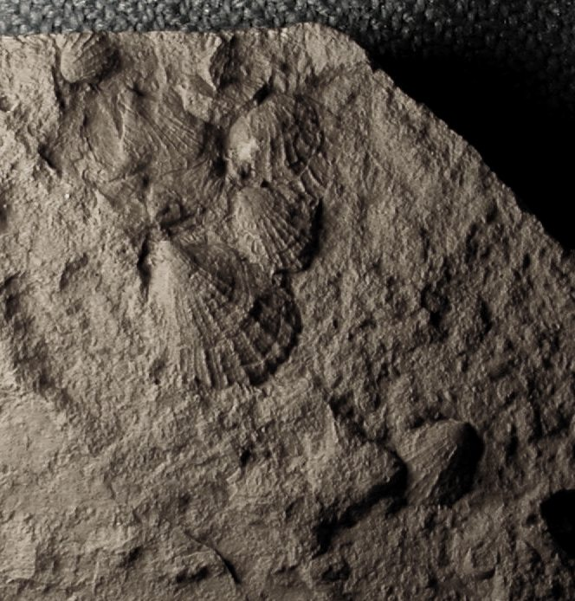

Figure 2. Native American artifacts collected from Section 17, Milton Township between 1950 - 1970. Photo 2a shows a projectile point 6.75 cm from tip to base, picked up on the southwest quarter of the section. Photo 2b shows a point 10.25 cm long collected on the southeast quarter. Since Section 17 is not traversed with a creek where points are normally found, these points may have been dropped and lost as the hunters traveled through the area or the points were carried in animal bodies (most likely bison) until they perished. Source: Private collections. Author’s photos.
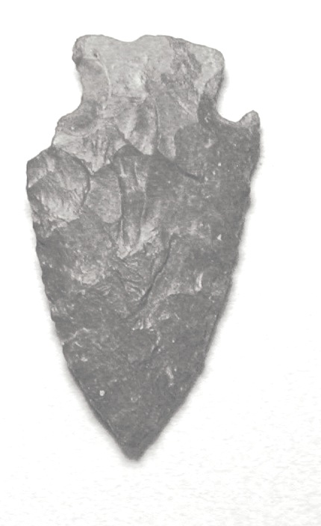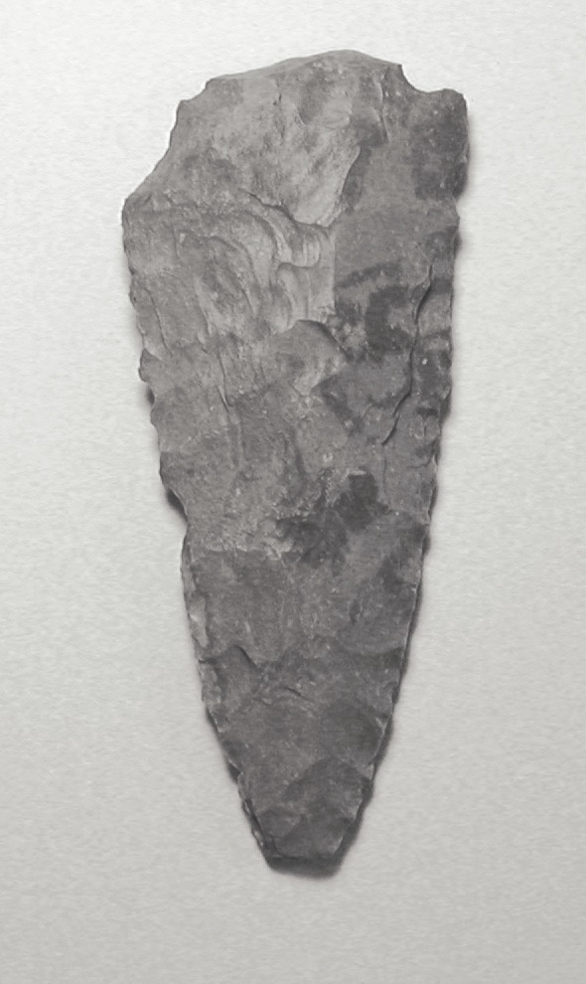

Figure 3. An example of a Homestead Certificate deeding the south half of the NW Quarter of Section 18, Milton Township to George P. Neiman. The certificate reads: Homestead Certificate No. 976. Application 2644. THE UNITED STATES OF AMERICA, To all to whom these presents shall come, Greetings: Whereas There has been deposited in the General Land Office of the United States a Certificate of the Register of the Land Office at Wichita, Kansas, whereby it appears that, pursuant to the Act of Congress approved 20th May, 1862, “To secure Homesteads to actual Settlers on the Public Domain,” and the acts supplemental thereto, the claim of George P. Neiman has been established and duly consummated in conformity to law, for the South half of the North West quarter of Section Eighteen in Township Twenty four South of Range Three East in the District of lands subject to sale at Wichita, Kansas containing Eighty acres and seventy eight hundredths of an acre (Excess paid as per Receiver’s Receipt No. 1348) according to the Official Plat of the Survey of the said land, retained to the General Land Office by the Surveyor General. Now know ye, That there is, therefore, granted by the United States unto the said George P. Neiman the tract of Land above described: To have and to hold the said tract of Land, with the appurtenances thereof, unto the said George P. Neiman and to his heirs and assigns forever. In Testimony whereof, I, Ulysses S. Grant, President of the United States of America, have caused these letters to be made Patent, and the Seal of the General Land Office to be hereunto affixed. Given under my hand, at the City of Washington, the fifteenth day of May, in the year of our Lord one thousand eight hundred and seventy six, and of the Independence of the United States the One Hundredth. BY THE PRESIDENT U. S. Grant by D. D. Cone, Secretary. J M Armstrong, Recorder of the General Land Office. adicterim Recorded, Vol. 2, Page 450. Source: Marilyn Nigg Umbach Collection. Author’s photo.
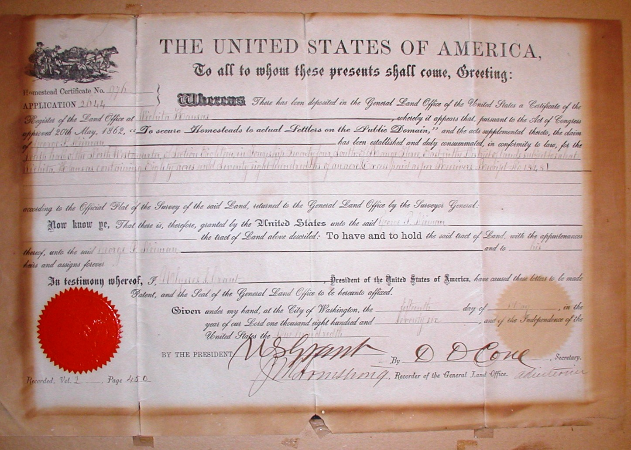

Figure 4. First home in Whitewater area—1869, built by George P. Neiman. A picture of an oil painting by L. Schroeder, created from a sketch drawn by Arthur L. Neiman. The location of this first log cabin is thought to have been in the middle of Main Street right in front of the home of John and Marilyn Umbach and not within the original 1887 plat of Whitewater. Source: Marilyn Nigg Umbach Collection. Author’s photos.
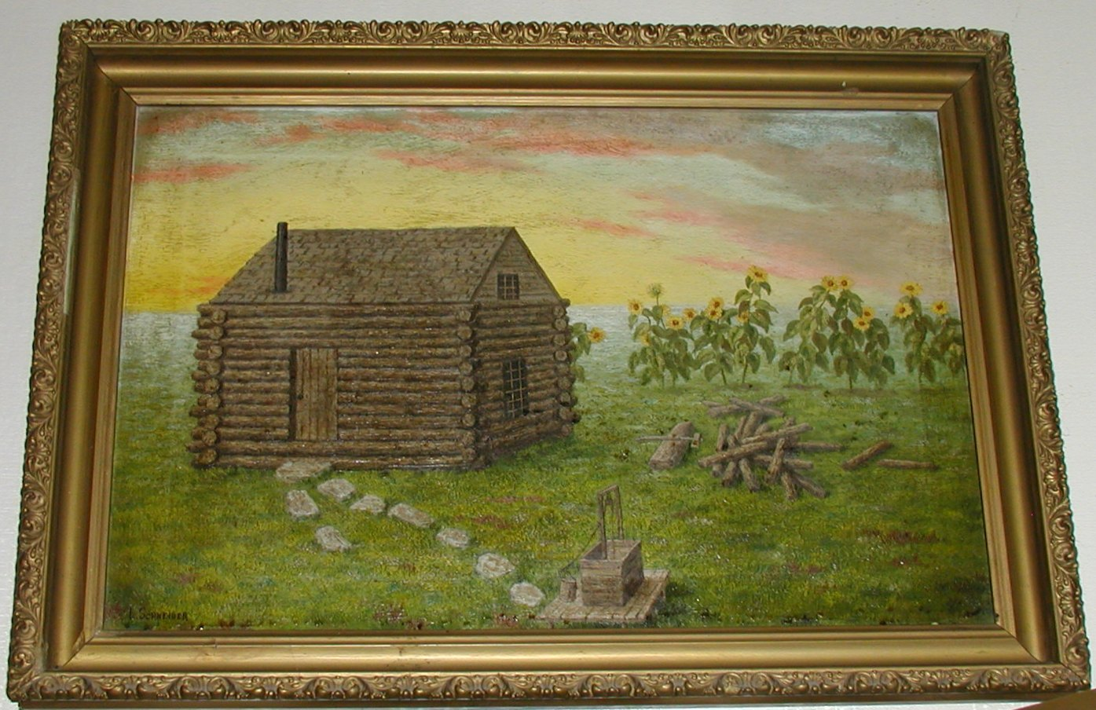

Figure 5. Deeding of the railroad land from the US government to Bernhard Harder Sr. in 1876 who purchased Section 17, Milton Township. Source: Office of the Register of Deeds, Butler Country Court House. Author’s collection.
Section Seventeen (17) Township Twenty-four (24) South, Range 3 East.
______________________________________________________________________
UNITED STATES OF AMERICA
TO
STATE OF KANSAS

Land Grant by Act of Congress approved March 3, 1863, entitled an act for a Grant of Lands to the State of Kansas in alternate sections to aid in the Construction of certain Railroads and Telegraphs in said State of Kansas accepting said Grant. Approved February 9, 1864.
______________________________________________________________________
STATE OF KANSAS
TO
Atchison, Topeka & Santa Fe Railroad Company

Consideration – Act of Legislature. Dated. May 19, 1873. Filed for record May 1, 1880 and recorded in Volume “V” of Deeds at page 216 of the records of Butler County, Kansas.
______________________________________________________________________
Atchison, Topeka and Santa Fe Railroad Company
F.H. Peabody, Vice President
E. Meder, Secretary
George C. Lord, O.W. Peabody, F.H. Peabody, Joseph Nickerson, Trustees
TO
Bernhard Harder

Consideration -- $4198.40. Dated November 29, 1876. Filed for record June 1, 1877 and recorded in Volume “O” of Deeds at page 198 of the records of Butler County, Kansas.

Description – All of Section No. Seventeen (17) in Township No. Twenty four (24) South, of Range No. Three (3) East of the Sixth Principal Meridian containing Six Hundred and forty (640) acres more or less, according to the United States Survey.

DEED RECITES: Reserving however to the said Atchison, Topeka and Santa Fe Railroad Company all that portion of the land hereby conveyed (if there be any such) which lies within lines drawn parallel with the fifty feet on each side distant from the center line of its Railroad as now constructed or hereafter to be constructed and any greater width where necessary permanently to include all their cuts embankments and other works necessary to secure and protect the main line of said Railroad.

WRITTEN IN THE BODY OF DEED: The Atchison, Topeka and Santa Fe Railroad Company, a corporation doing business under the laws of the State of Kansas and Thomas Nickerson, Oliver W. Peabody and George C. Lord, F. H. Peabody, Joseph Nickerson and A. I. Benyon.
____________________________________________________________________________________
Figure 6. A 1977 plat map of Whitewater modified from Figure 4-A in Comprehensive Development Plan, 1977-1995, City of Whitewater, Kansas. In Frederic Remington Area Historical Society Library. The original area within the 1887 plat is outlined on the map. The location of the original log cabin is marked with a house; early on Main Street going south did not go through to the section line or K196.
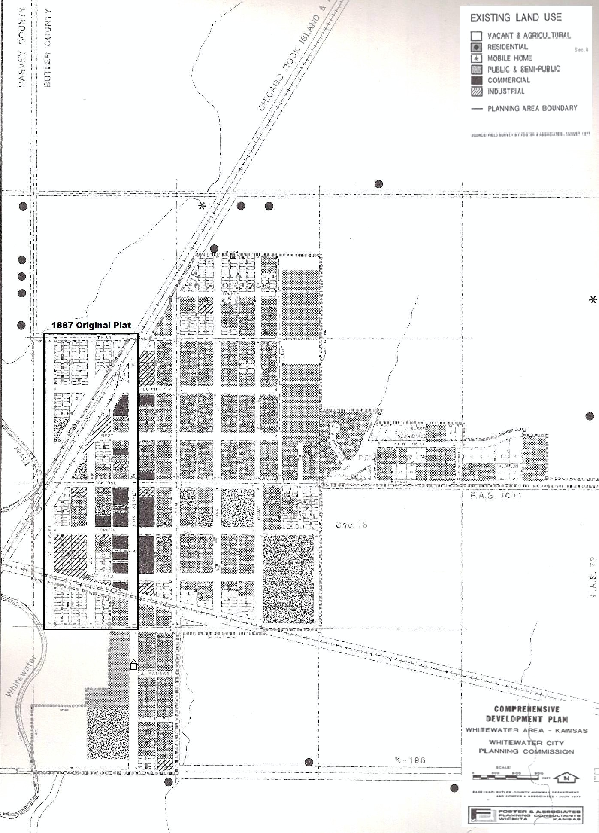
Figure 7. The location of businesses in the Whitewater of 1920. Adapted from Mike L. Hopkins’ A Look in Whitewater’s Past, May 5, 1985. In Frederic Remington Area Historical Society Library.
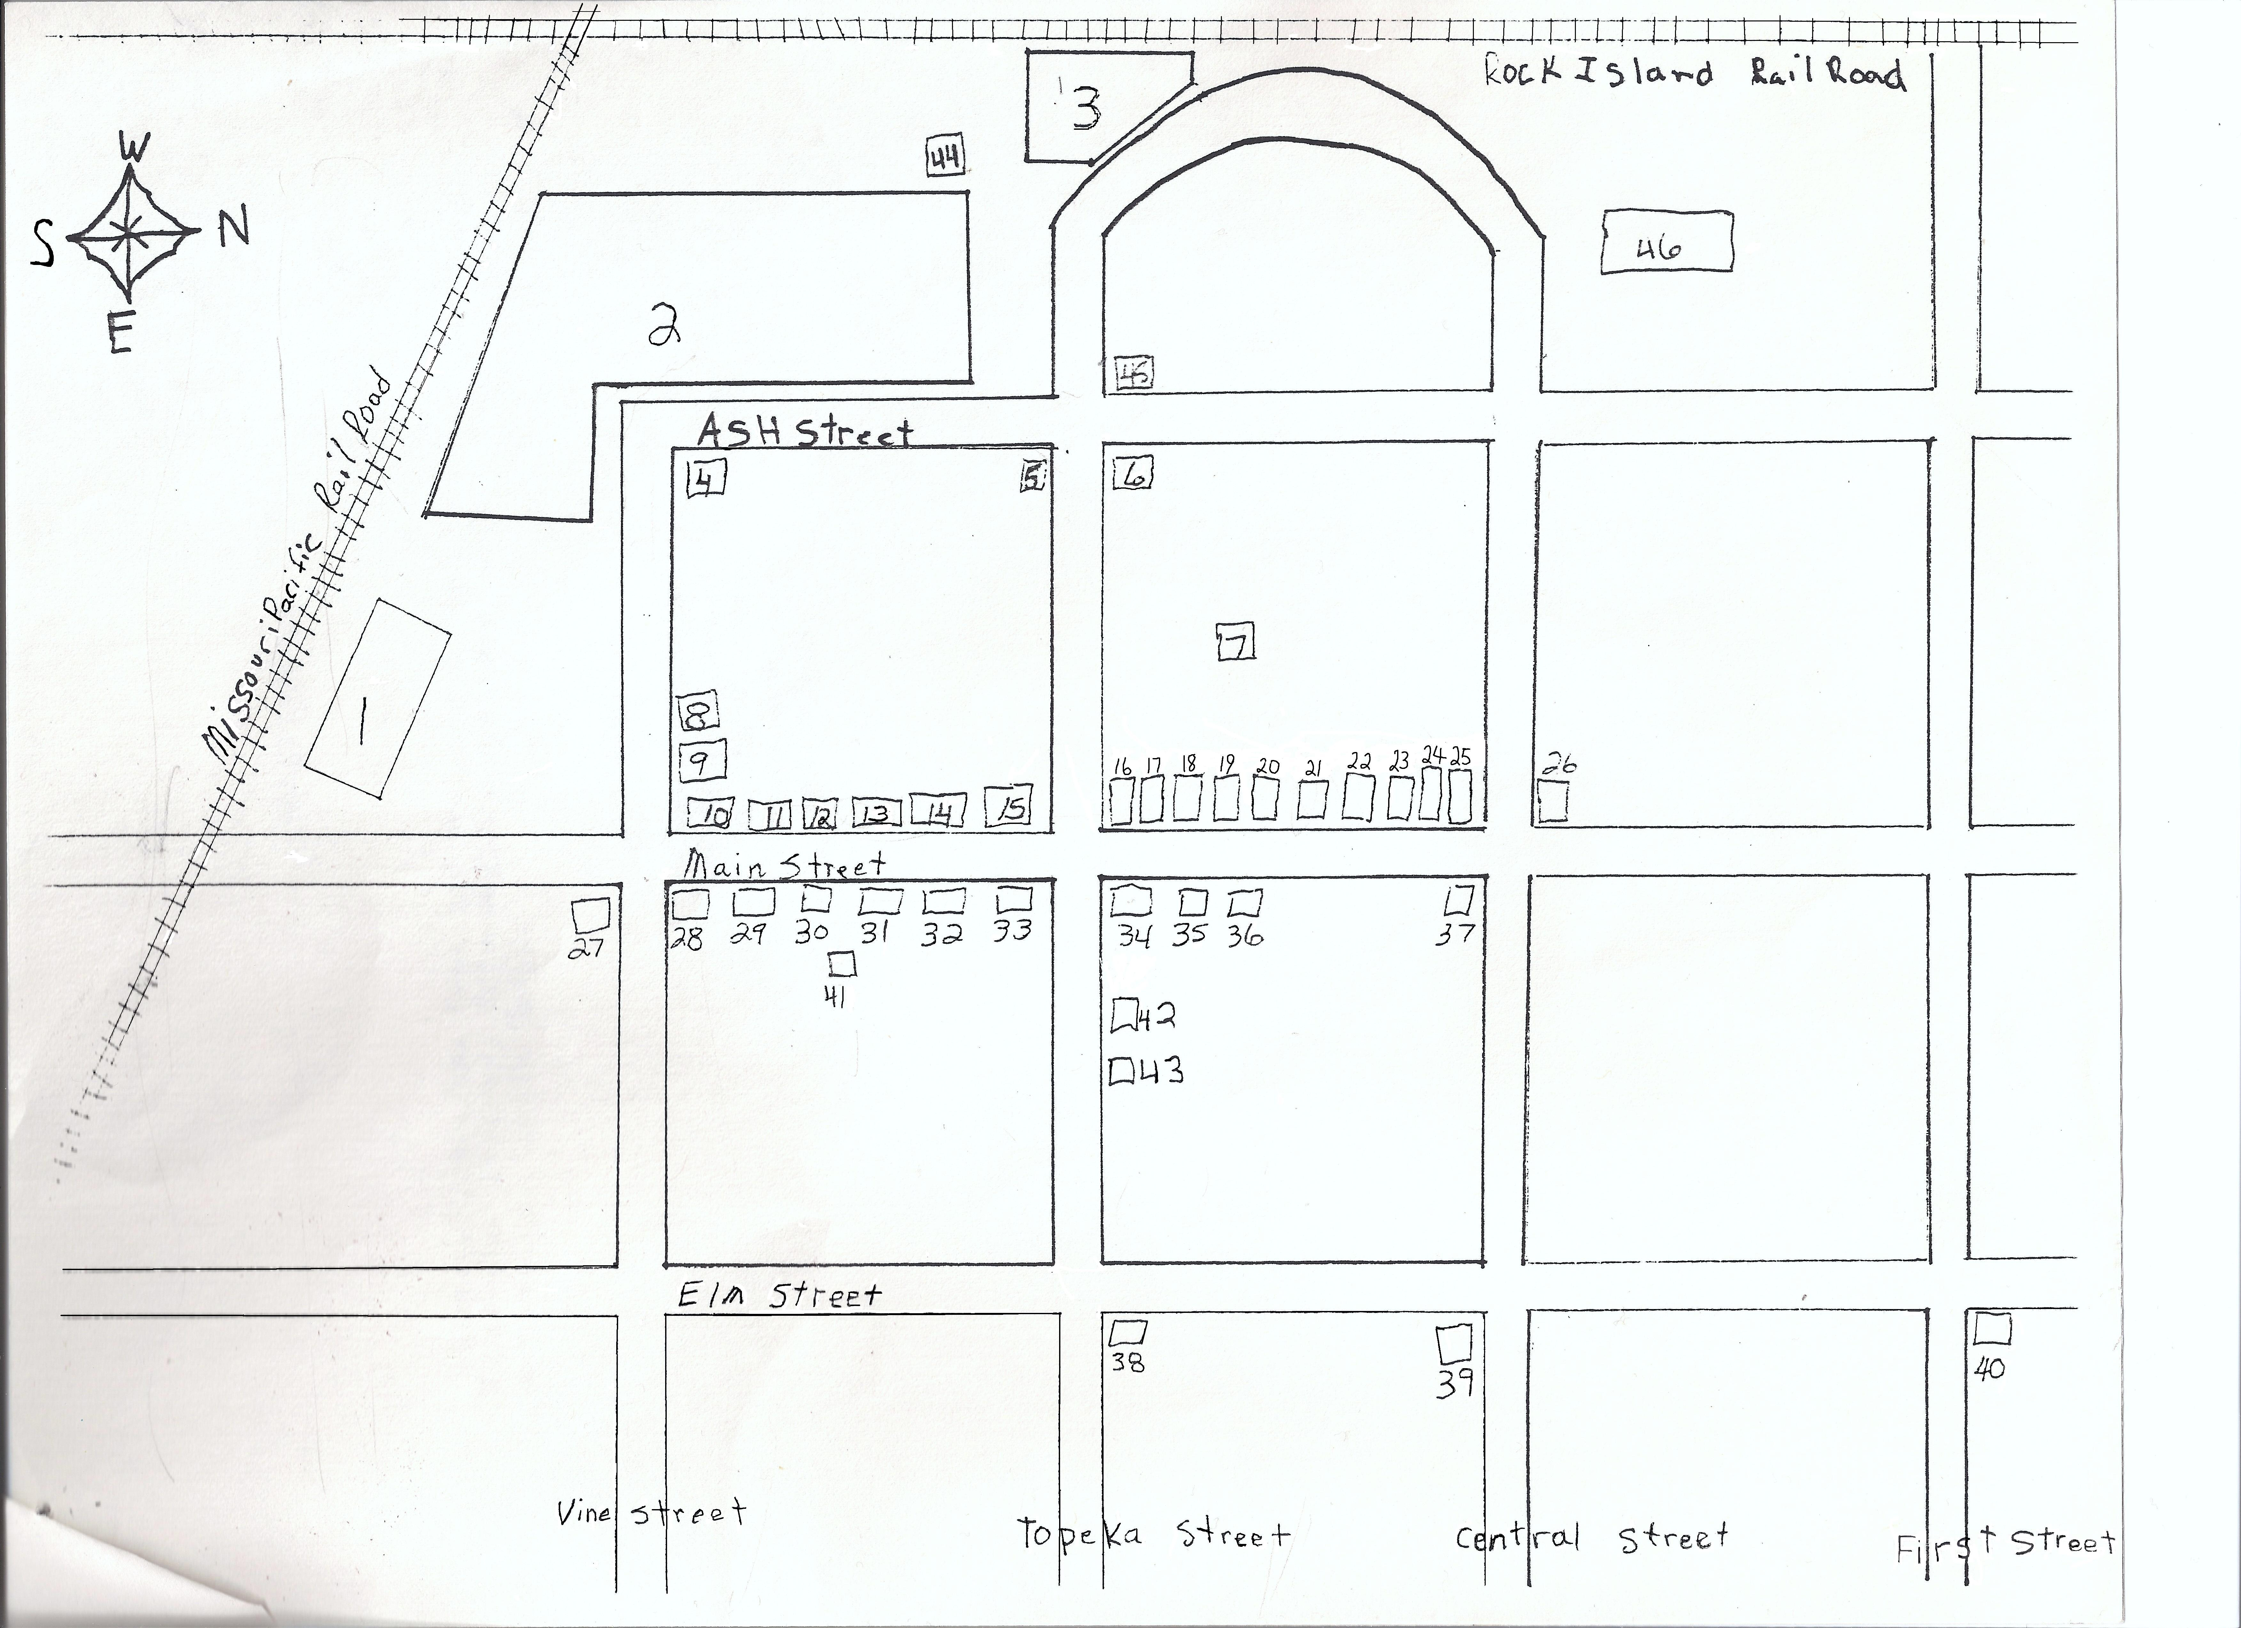

- Missouri Pacific Depot
- Whitewater Mill
- Rock Island Depot
- Eskridge Hotel
- Hotel
- Pace Hardware Store
- Whitewater Jail
- Delivery Stable
- Telephone Office
- Newspaper Office (The Independent)
- People’s State Bank
- Neil Pool Hall
- Hazlett Drug Store
- Penner Department Store
- Lowther Hardware Store
- Neil Tin Shop
- Motter Barber Shop
- Mellor Real Estate Office
- Lambert Grocery Store
- Café
- Post Office
- Gladfelters Bakery
- Breising Meat Market
- Nothing But Storage
- Hidgon Home
- Breising Home
- Kirwood Lumber Yard
- Smith Filling Station
- Bruhn Implement Store
- Neil And Lauther Hardware Store
- Golbeck Cage
- Dr. Nossman Office
- Lamour Filling Station
- Bank of Whitewater
- Smith Mortuary and Furniture Store
- Grouan Garage
- Nolder Poultry
- Reform Church
- Evangelical Lutheran Church
- Methodist Church
- Dr. Regier’s Office
- Dentist Office
- Fire Station
- Stuart Grain Bin
- Spencer Hotel Down
- Alfalfa Mill

Figure 8. The Remington Rock Plaque. Author’s photo.


