***Rainbow Salad with Ginger Tahini Dressing***

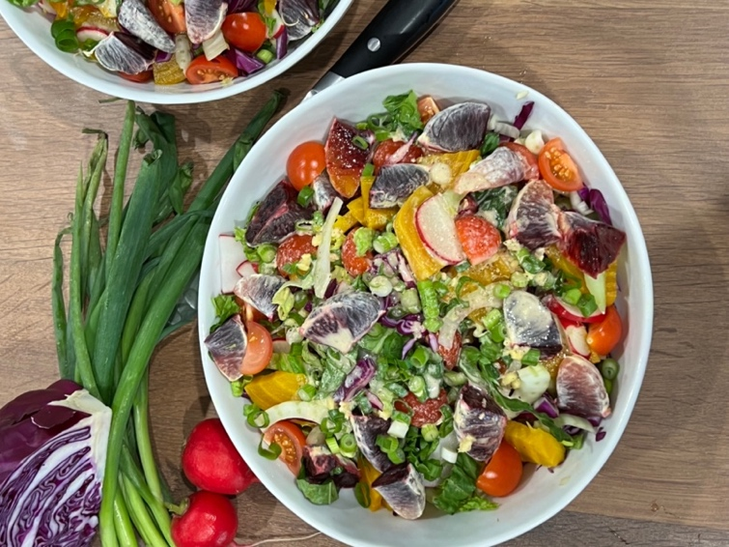

This recipe serves 2 people

|  |
| --- |
| **Ingredients:⁠**   * 1head romaine lettuce * 1 bulb fennel * ¼ cabbage red * grape tomatoes (I used about 12 cut in half) * 4 watermelon radish * 1 golden steamed beet * 2 green onions * 2 blood oranges   **Toppings:**   * Fresh basil * sesame seeds * or any kinds of nuts   **Dressing:**   * 2 lemon squeezed * 2 minced shallots * 2 Tbs. coconut aminos * 1inch ginger minced * 2 Tbs. tahini * 2 Tbs. Extra virgin olive oil * Sea salt and black pepper |

**Instructions**:

1. Steam the golden beet the night before and refrigerate.
2. Cut romaine lettuce, cabbage and fennel in fine stripes. Then cut all the rest of the vegetables and mix everything together. Top with basil sesame seeds and anything else you desire.
3. Squeeze the lemons add the minced ginger, aminos, olive oil, tahini and salt and pepper into a bullet and mix well for just 12-15 seconds.
4. Pour the dressing over the salad and enjoy.