DATE Opponent Location JVB JVA Varsity
Lady Bees Basketball 2025-2026
Nov. 4 Harker Heights (Scrimmage) Away 5:00 5:00 6:15
Nov. 7 Leander Glenn Home 5:00(MS) 5:00(HS) 6:15
Nov. 11 Salado Away 5:00 5:00 6:15
Nov. 13 & 15th Jarrell JV & 9th Tournament Away TBA TBA
Nov. 14 Marble Falls Home 5:30
Nov. 18 Taylor Home 5:00 5:00 6:15
Nov. 21 Lorena Away 5:00 6:15
Nov. 25 Jarrell Away 11:00 11:00 12:30
Dec. 2 Hamilton Away 5:00 6:15
Dec. 4-6 Academy Varsity Tournament Home TBA
Dec. 4-6 Cameron JVB Tournament Away TBA
Dec. 9 San Saba Home 5:00(MS) 5:00(HS) 6:15
Dec. 11-13 Jarrell Varsity and JV Tournament Away TBA TBA
Dec. 16 Rogers* Away 5:00 (HS) 6:15
Dec. 19 Cameron* Home 7:30(MS) 5:00 (HS) 6:15
Dec. 29-31 Brownwood Christmas Tournament Away TBA
Jan. 2 Lexington* Away 6:15
Jan. 6 Rockdale* Home 5:00 (HS) 6:15
Jan. 9 Schulenburg Home 5:00 (HS) 6:15
Jan. 13 Franklin* Away 7:30 5:00 (HS) 6:15
Jan. 16 Thrall*(JH Night) Home 5:00 (HS) 6:15
Jan. 17 Granger JVB Tournament Away TBA
Jan. 20 Rogers* Home 5:00 (HS) 6:15
Jan. 23 Cameron* Away 7:30(MS) 5:00 (MS) 6:15
Jan. 27 Lexington* Home 6:15
Jan. 30 Rockdale* Away 5:00 (MS) 6:15
Feb. 3 Jarrell (JVB Only) Home 5:30(HS)
Feb. 6 Franklin* Home 7:30(MS) 5:00 (MS) 6:15
Feb. 10 Thrall* Away 5:00 (MS) 6:15
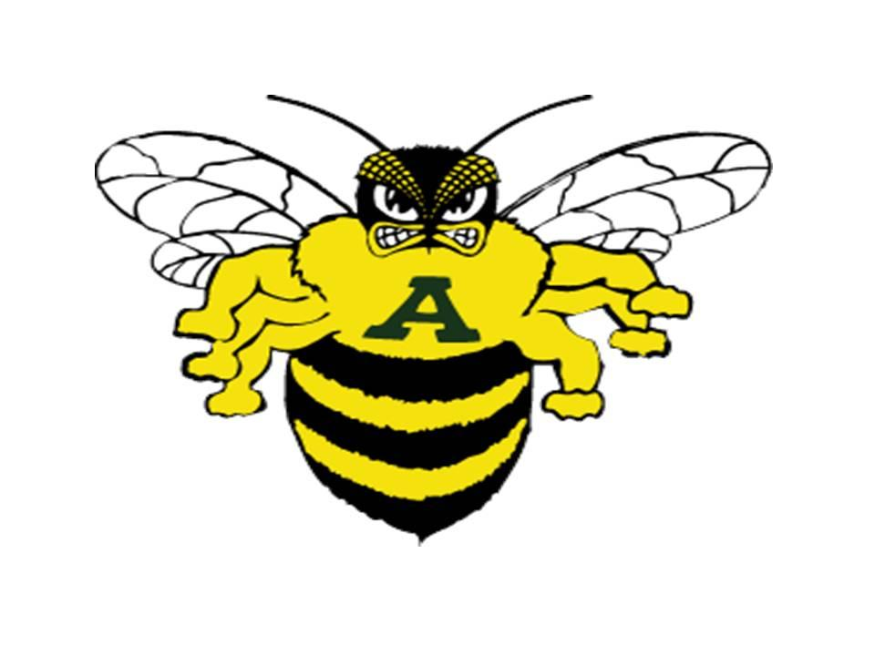
*Denotes District Games
Feb. 12-14 Tiebreaker dates
Feb. 16-17 Bi-District Playoffs
Feb. 19-21 Area Playoffs
Feb. 23-24 Regional Quarterfinals
Feb. 26-28 Regional Tournament
March 2-3 State Semi-Finals
March 5-7 State Finals
Coaches: Brian Pursche, Sydney Eary, Ryan Neece
Pictures November 17th at 3:00 p.m.

