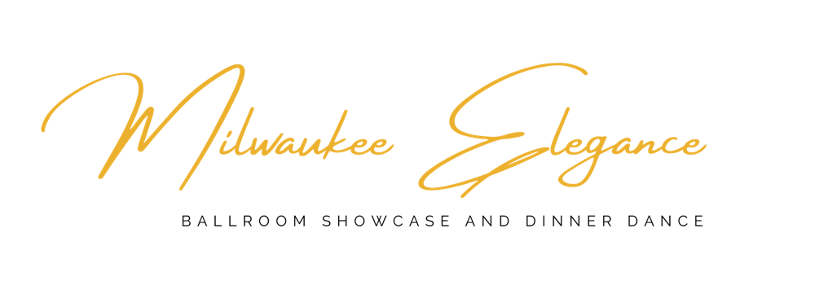
Saturday, September 14, 2024
AM Registration  - Event Entry  - Lunch  - Dinner and Dance  - Pro Show | $125
PRO Registration  - Event Entry  - Lunch  - Dinner and Dance  - Pro Show  Professionals with 50+ entries will be given FREE registration. | $60
FREESTYLES | $25
COLLEGE/JR FREESTYLES | $15
SOLO | $30
Spectator | $20
Spectator with Lunch | $35
Spectator with Dinner | $95
Spectator with Lunch, Dinner, Dance and Pro Show | $125

Payment is due in full by August 23, 2024.
Payments may be made by check written out to MK Ballroom and mailed to:
MK Ballroom
1923 East Belleview Place, Milwaukee, WI 53211
mkballroom@gmail.com

LEVELS AVAILABLE: Newcomer, Beginning Bronze, Intermediate Bronze, Bronze,
Beginning Silver, Intermediate Silver, Silver,
Beginning Gold, Intermediate Gold, Gold, Open
Dancers may register in up to 3 levels

AMERICAN RHYTHM
Lead Name: _______________________AM/PRO Studio Name: ________________________
Follow Name: ______________________AM/PRO Studio Email: ________________________
 | LEVEL | ChaCha | Rhumba | Swing | Mambo | Bolero | 3 Dance CRS | 5 Dance CRSMB

AMERICAN SMOOTH
Lead Name: _______________________AM/PRO Studio Name: ________________________
Follow Name: ______________________AM/PRO Studio Email: ________________________
 | LEVEL | Waltz | Tango | Foxtrot | V. Waltz | 3 Dance WTF | 4 Dance WTFVW

NIGHTCLUB
Lead Name: _______________________AM/PRO Studio Name: ________________________
Follow Name: ______________________AM/PRO Studio Email: ________________________
LEVEL | Hustle | Salsa | NC2 | Samba | Mer. | Bachata | WC Swing

LEVELS AVAILABLE: Newcomer, Beginning Bronze, Intermediate Bronze, Bronze,
Beginning Silver, Intermediate Silver, Silver,
Beginning Gold, Intermediate Gold, Gold, Open
Dancers may register in up to 3 levels.

INTERNATIONAL LATIN
Lead Name: _______________________AM/PRO Studio Name: ________________________
Follow Name: ______________________AM/PRO Studio Email: ________________________
 | LEVEL | ChaCha | Samba | Rhumba | Paso | Jive | 3 Dance CSR | 5 Dance CSRPJ

INTERNATIONAL BALLROOM
Lead Name: _______________________AM/PRO Studio Name: ________________________
Follow Name: ______________________AM/PRO Studio Email: ________________________
 | LEVEL | Waltz | Tango | Foxtrot | V. Waltz | Quickstep | 3 Dance WTF | 5 Dance WTFVWQ

SOLOS
Solos may be a maximum of 2.5 minutes in length. Dancers may register for a maximum of two solos.

AM Dancer Name: ______________________________________ Lead or Follow
Pro Dancer Name: ______________________________________ Lead or Follow
Name of Song: _________________________________________ Dance Style: ___________

AM Dancer Name: ______________________________________ Lead or Follow
Pro Dancer Name: ______________________________________ Lead or Follow
Name of Song: _________________________________________ Dance Style: ___________

Registration Summary

Studio Name ________________________
Pro Name ________________________

ITEM | NUMBER NEEDED | SUB-TOTAL
AM Registration | ________ @ $125
PRO Registration | ________ @ $60
FREESTYLES | ________ @ $25 ea
COLLEGE/JR FREESTYLES | ________ @ $15
SOLO | ________ @ $30
Spectator | ________ @ $20
Spectator with Lunch | ________ @ $35
Spectator with Dinner and Social Dance | ________ @ $95
Spectator with Lunch, Dinner and Social Dance | ________ @ $125
 | TOTAL

Payment is due in full by August 23, 2024.
Payments may be made by check written out to MK Ballroom and mailed to:
MK Ballroom
1923 East Belleview Place, Milwaukee, WI 53211
mkballroom@gmail.com

