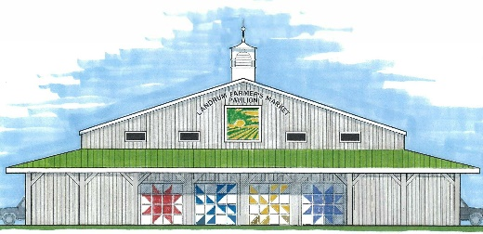
2023
Rules & Information

- The Landrum Farmers Market (LFM) functions as a “producer’s market.” This means that to participate as a vendor, you must grow, cook or produce your product.

- As a vendor, you agree to allow Market representatives to visit your farm, kitchen, or craft area for inspection.

- All vendors are required to be in compliance with state laws and permitting regulations, specifically SC Law 44-1, commonly referred to as SC Cottage laws.

- Resales of produce purchased from others, yard sale items, resale of food items, is not allowed.

- Craft vendors will be limited to 20% of the total number of vendors at the market. (Initially six (6) craft vendors will be allowed).

- All Vendors over the age of 16 selling at the LFM are required to purchase and obtain and/or hold a current Landrum Business License.

- All Vendors selling at the LFM are required to complete a LFM Vendor Application & Certification form.

- Dates for the 2023 Regular Market Season are Saturdays, April 1 until Saturday, October 28, rain, or shine.

- The Market will open to Vendors at 7:00am to begin setup.

- Customer hours for the 2023 Market Season will be 8:00am – Noon.

- Vendor Parking will be on a RESERVED basis. Only 1 truck or automobile is allowed in each parking spot. Vendors with inside spaces are allowed to pull-in and unload but must move automobiles to the parking area as soon as possible.

- Fees for the 2023 Market will be as follows:
$15.00 per week (Farm producers, food producers & crafters)
$2.00 per week (children 16 and under)
$250.00 for 2023 season if paid in full by April 1, 2023

- Vendors who find that they will miss a Saturday market are required to call, text or email the Market Manager so that the space can be filled.

- Vendors are encouraged to stay for the full duration of the market (8:00am – Noon). Vendors who sell out of items are not required to stay the full time.

- Vendors with live animals to sell or to ‘entertain’ are required to keep animals in the back end of their vehicle. Animals are not allowed on the Market floor. Optionally, vendors with live animals can set up in the designated area outside the Farmers Market pavilion.

- Pets will be allowed if on a leash and provided that owners clean-up any waste made by the pets.

- Vendors must provide their own tables for their goods. Electricity is provided at every other pull-in spot.

- All Vendors are responsible for clean-up of their individual spaces at the end of each Saturday market. This could include the moving and storage of inside tables used.

