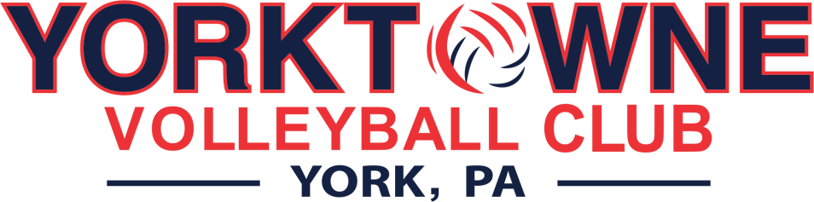

**2024-2025 Girl’s Volleyball Club Season**

Yorktowne Volleyball is in the Keystone Region and is a member of USA Volleyball and AAU Volleyball.

This season will mark the boys 30th season and the girl’s 24th season.

# Club Directors Info

* Josh Brenneman | 717-654-6061 | yorktownevb717@gmail.com
* Nate Ocasio | 717-817-2732 | ytvball@gmail.com

**Tryouts Info:**

All tryouts will be held at the York Learning Center. Please plan to arrive 30 minutes prior to tryout start time on registration day to ensure proper time to process your athlete’s registration and for your athlete to be on the courts ready to begin promptly. You will need to bring copies of the following documents to turn in at registration:

1. KRVA Tryout Membership email receipt
2. Medical Release Form

# Tryout Details

All tryouts will be run by the Yorktowne Coaching Staff. There are two days of tryouts for each age group, and we recommend that all players attend both sessions. If you are unable to attend one of the time slots, please notify us.

Teams will be selected on Sunday night following tryouts. Official offer letters will be sent out via the email address on file for your athlete on Wednesday, 10/23. The offer letter will include team name, practice times, deposit amount and a link to accept the offer, among other details. Athletes will have 48 hours from the time an offer is received to accept or decline the offer.

Please note, Yorktowne will post player numbers that have been offered a spot or are being waitlisted on our website Sunday night following tryouts. If you see your tryout number listed under the team’s name that you tried out for, you will be offered a spot. Per KRVA regulations, we are not permitted to send official offer letters until Wednesday, 10/23.

**Club Season** (except 14 Blue)

Girl’s Club Season will run from December through the beginning of April. Please refer to the Team Guides on our website for tournament details.

**Practices** (except 14 blue)

All practices will be held at the York Learning Center as follows:

* Tuesdays – 5:30-7:30
* Sundays – 4:00pm-6:00pm
* 14 Blue will run Monday and Wednesday nights, 5:30-7:30 or 7:30-9:15

Weather Alerts – If a practice is canceled due to inclement weather, you will receive an email regarding cancelations. Cancelations will also be posted on our Yorktowne Facebook page.

**Travel Events** (certain teams apply)

Yorktowne will book blocks of hotel rooms for Stay to Play events for the parents and players. Parents will be responsible for calling the hotels directly to claim one of the reserved rooms and make payment. Details regarding stay to play events will be forwarded at a later date.

# Club Dues and Payments

Payment schedules are listed on our Team Guides, which can be found on our website and will also be emailed to each athlete once teams are selected. Club fees will be finalized once all events are posted and selected.

* You will receive a PDF at the start of the season for the club dues with the payment dates listed on the form along with cost breakdown for the season.
* **DO NOT give your payments to the coach. Please mail if you choose that payment method.**
* Any credits you have at the end of the season can be held for next year, transferred to a sibling, refunded, or donated to the club.
* We do offer fundraising almost each month to help offset the cost.
  1. Whatever you and your athlete raise will go directly to your own personal club account.
  2. Fundraising credits will be applied to payment #4 first, followed by payment #3, then payment #2 and finally payment #1.
  3. You may fundraise up to, but not over your total season dues amount. If payments have been made, a refund will be given at the end of the season.
  4. Credits can be used towards nationals (if applicable).

# Uniform Packages

Uniforms are paid for separately from club fees. Athletes will receive a link following team selection where they will be able to choose their size options and pay for their uniforms.

# Spirit Store

We will run a spirit store where there will plenty of optional gear for athletes, families, and fans to purchase!

**LIU/Policies** – Please note that our practice facility, the York Learning Center (LIU), is part of a school system. At no time are we permitted to prop the doors open. Additionally, there is no smoking permitted on school grounds.