AUGUST ‘25  S M T W Th F S  1 2  3 4 5 6 7 8 9  10 11 12 13 14 15 16  17 18 19 20 21 22 23  24 25 26 27 28 29 30  31 | 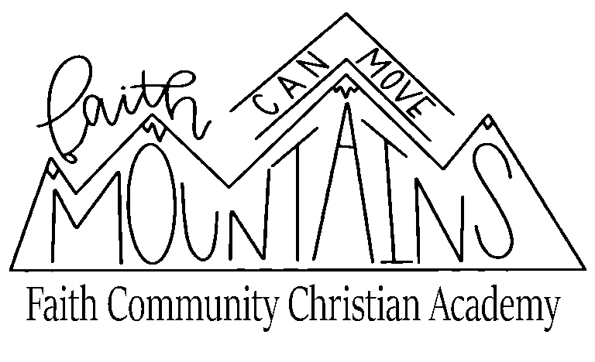  5 – Open House 6-7pm  11- First Day of School  29- Pace Test #1 |  | FEBRUARY ‘26  S M T W Th F S  1 2 3 4 5 6 7  8 9 10 11 12 13 14  15 16 17 18 19 20 21  22 23 24 25 26 27 28 | 12-Pace Test #8  13 - Half day - Early Release 12:30  16- Presidents Day (no school)
SEPTEMBER ‘25  S M T W Th F S  1 2 3 4 5 6  7 8 9 10 11 12 13  14 15 16 17 18 19 20  21 22 23 24 25 26 27  28 29 30 | 1 – Labor Day (no school)  18-Pace Test #2  19- Records Day (no school) |  | MARCH ‘26  S M T W Th F S  1 2 3 4 5 6 7  8 9 10 11 12 13 14  15 16 17 18 19 20 21  22 23 24 25 26 27 28  29 30 31 | 2-4 Iowa Testing  6- Pace Test #9  7-14 – Spring Break  19- 3rd Qu. Awards 1pm  20- - Records Day (no school)
OCTOBER ‘25  S M T W Th F S  1 2 3 4  5 6 7 8 9 10 11  12 13 14 15 16 17 18  19 20 21 22 23 24 25  26 27 28 29 30 31 | 3- CGACS Teacher Convention – No school  10- Pace Test #3  16- 1st Qu. Awards 1pm  17- Teacher Work Day (no school)  31- Pace Test #4 |  | APRIL ‘26  S M T W Th F S  1 2 3 4  5 6 7 8 9 10 11  12 13 14 15 16 17 18  19 20 21 22 23 24 25  26 27 28 29 30 | 2- Pace Test #10  3- Good Friday (no school)  24- Pace Test #11
NOVEMBER ‘25  S M T W Th F S  1  2 3 4 5 6 7 8  9 10 11 12 13 14 15  16 17 18 19 20 21 22  23 24 25 26 27 28 29  30 | 19- Pace Test #5  21- Half day - Early Release 12:30  22-30- Thanksgiving Break (no school) |  | MAY ‘26  S M T W Th F S  1 2  3 4 5 6 7 8 9  10 11 12 13 14 15 16  17 18 19 20 21 22 23  24 25 26 27 28 29 30  31 | 15 – Pace Test #12  15 – Graduation  20 – End of Year Awards 1pm  21- Last Day of School
DECEMBER ‘25  S M T W Th F S  1 2 3 4 5 6  7 8 9 10 11 12 13  14 15 16 17 18 19 20  21 22 23 24 25 26 27  28 29 30 31 | 18- Pace Test #6  19- Half day - Early Release 12:30  20-31- Christmas Break (no school) |  | JUNE ‘26  S M T W Th F S  1 2 3 4 5 6  7 8 9 10 11 12 13  14 15 16 17 18 19 20  21 22 23 24 25 26 27  28 29 30 | 19 Juneteenth
JANUARY ‘26  S M T W Th F S  1 2 3  4 5 6 7 8 9 10  11 12 13 14 15 16 17  18 19 20 21 22 23 24  25 26 27 28 29 30 31 | 1-4 –- Christmas Break (no school)  5- Records Day (no school)  9- 2nd Qu. Awards 1pm  19- Martin Luther King Jr. Day (no school)  23- Pace Test #7 |  | JULY ‘26  S M T W Th F S  1 2 3 4  5 6 7 8 9 10 11  12 13 14 15 16 17 18  19 20 21 22 23 24 25  26 27 28 29 30 31 | 04 Independence Day

FCCA 2025-2026 CALENDAR
School Calendar Te

