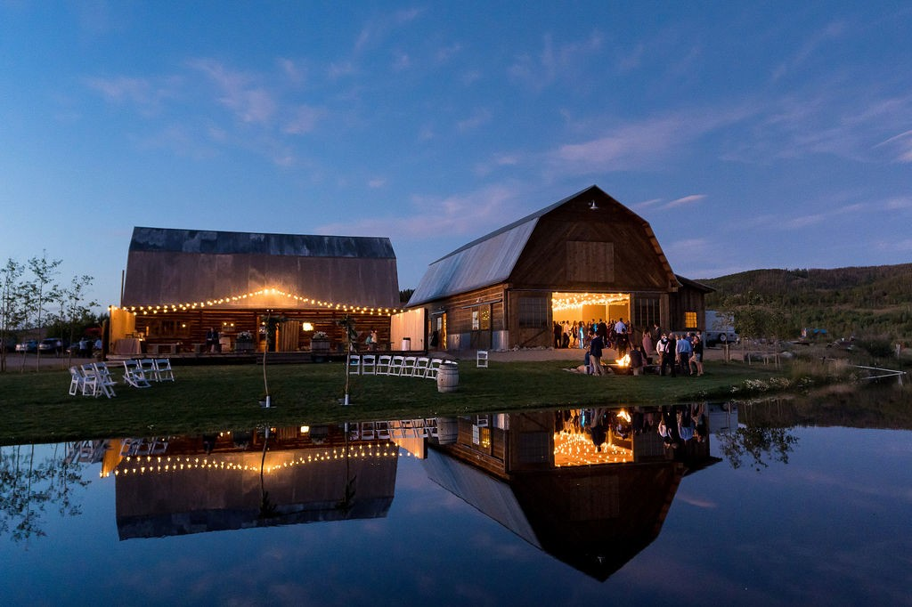

Strawberry Creek Ranch 9N

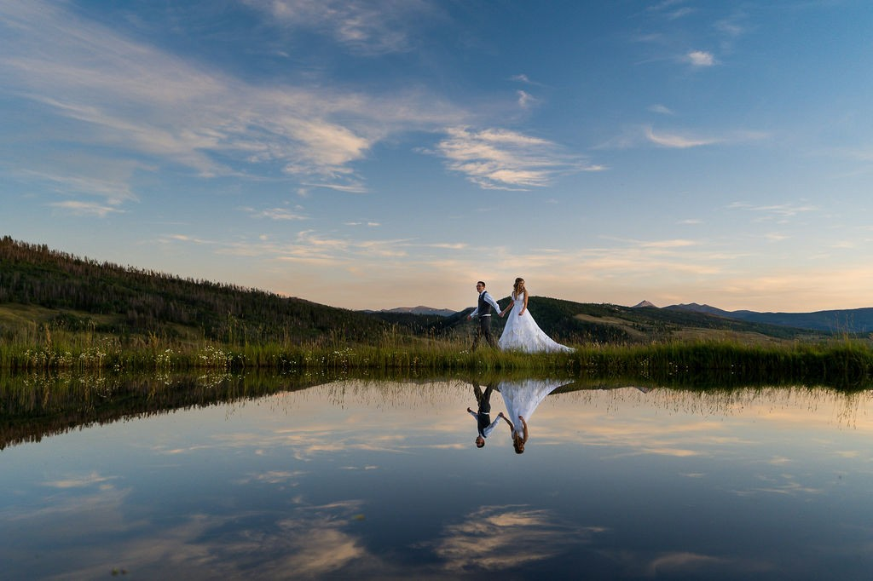
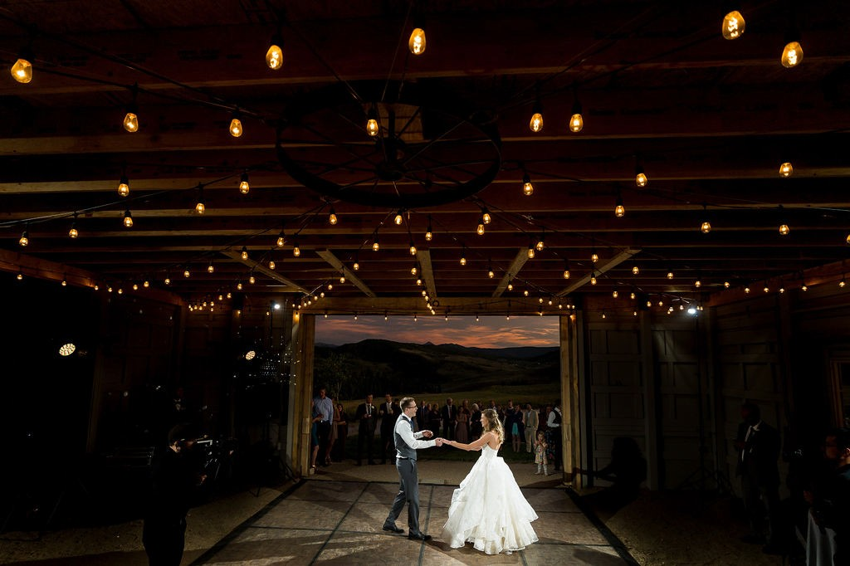

Welcome to Strawberry Creek Ranch, a family owned property situated on 300 pristine acres nestled in the heart of the Rocky Mountains. Our beautiful wedding venue is the perfect place to say “I Do” surrounded by scenic views, sunny skies, amazing sunsets and privacy for you and your guests. Dine in our newly constructed Outback Barn and dance the night away under the stars on our Homestead Deck that is attached to a historic homestead barn that dates back to the 1870’s. Your guests will be in awe of the hospitality, history and beauty of SCR9N.

Offerings and Pricing
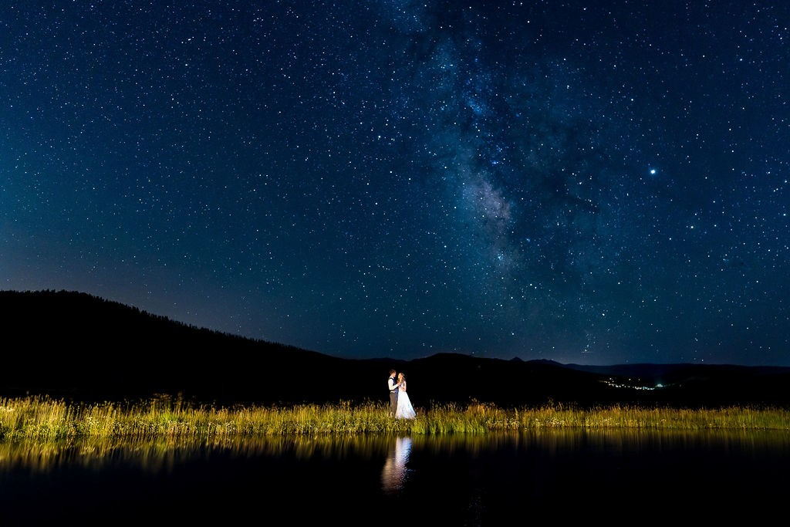

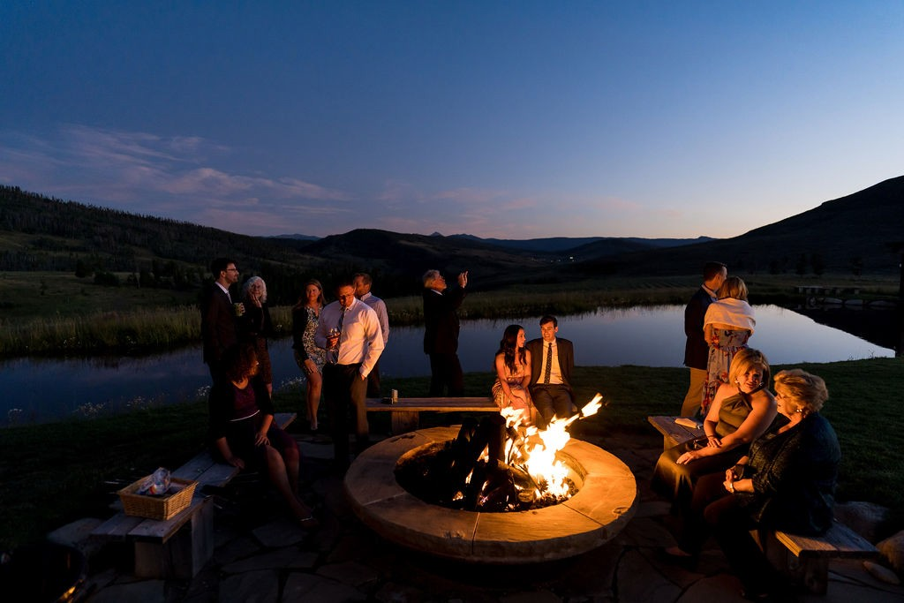

2023 Pricing
Friday- Sunday (only) $12,500.00

Rental is from 12:00pm-12:00am, this must include all set up and breakdown during this time.

We only host one wedding per day and are limited to just 25 events per season.
(we do not host winter weddings)

Private homestead cabin for getting ready

Changing room in the Old Homestead Barn

Gas firepit

Propane heaters

Market lighting in all indoor areas and on the deck

Three farm tables

25 5’ round tables and 200 white padded chairs

To book a tour reach out to Rami Carter 970-531-2479 or email at pickmeweddings@gmail.com

