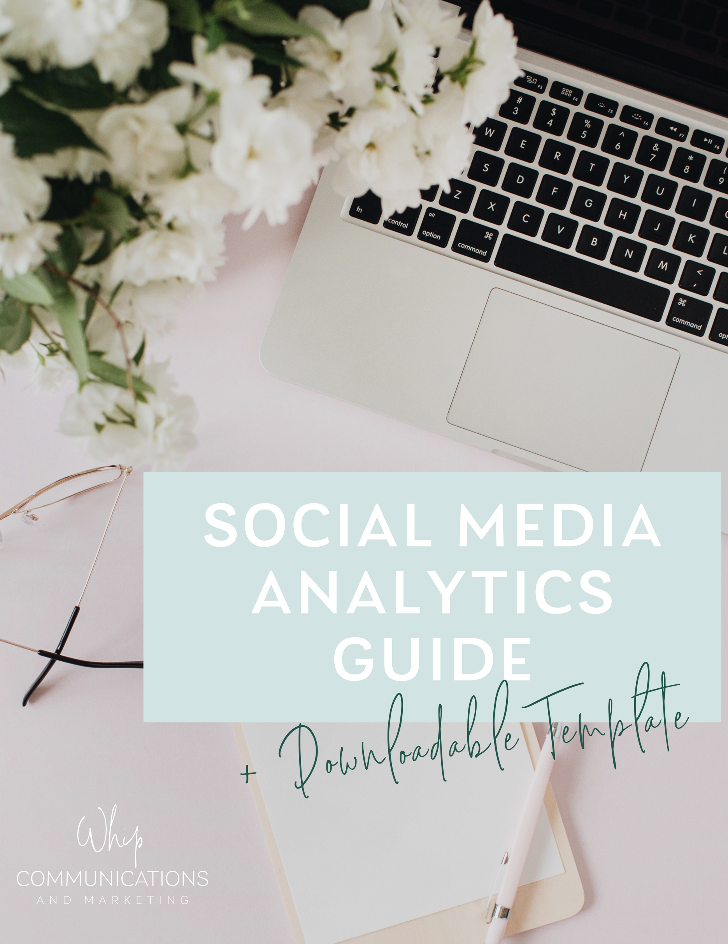

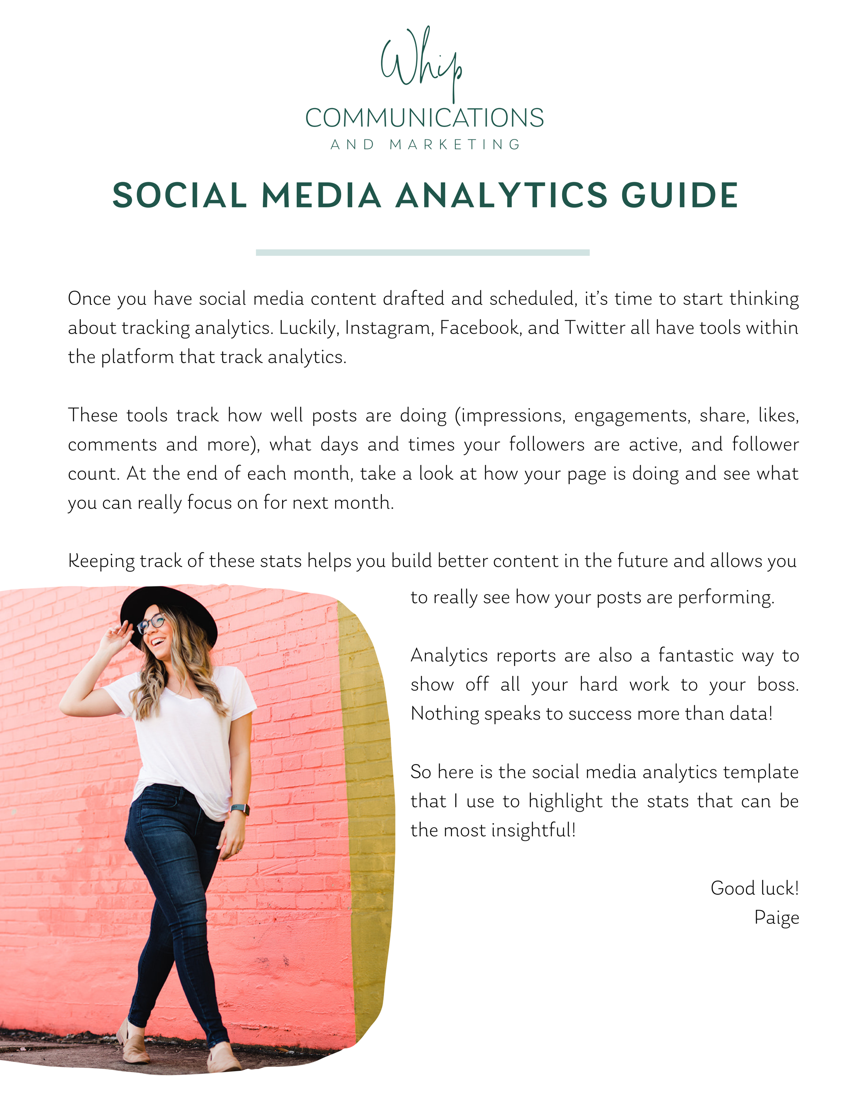
WHIP COMMUNICATIONS
SOCIAL MEDIA ANALYTICS REPORT
JANUARY 1, 2021 – JANUARY 31, 2021

Facebook:
For a step by step guide on how to access Facebook analytics, click here.

- Page views:
- Page likes:
- Page followers:
- Top organic post: Daily reminder graphic
  - People reached:
  - Engagements:
- Top boosted post:
  - People reached:
  - Engagements:

Twitter:
For a step by step on how to access Twitter analytics, click here.

- Impressions:
- Profile visits:
- New followers:
- Top tweet:
  - Impressions
  - Likes
  - RTs

Instagram:
For a step by step on how to access Instagram analytics, click here.

- Visitors:
- New followers:
- Accounts reached:
- Impressions:
- Top post:
LinkedIn:
For a step by step guide on how to access LinkedIn analytics, click here.
- Page views:
- Unique visitors:
- Top post:
  - Impressions:
  - Reactions, comments, shares: (add the number up):

Summary:

