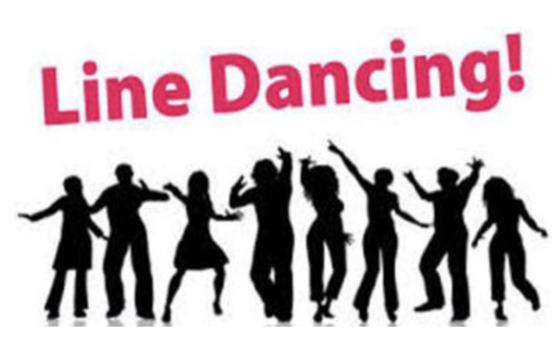

Line Dancing … Not Just for the Country Music Lover

Join us for a Four-Week Session of Line Dance Classes!

Learn traditional and modern line dance routines from Hip-Hop, Top 40, Country and more!
Line dancing is great fun and includes all types of music! Dancing is a perfect combination of physical activity, social interaction, and mental stimulation. It’s a full body workout for the mind, body and spirit.

Each dance is broken down first, demonstrated, and then danced to contemporary music that you will enjoy! Dance to some of the old favorites, and also add some of the newest line dances. No need to have a partner; this is something for everyone, and no experience is necessary!

May 23 through June 13
Thursday Evenings
7:00-8:00pm
$75.00

The instructor, Paul Hughes, is a Line & Ballroom Dance Instructor and teaches group classes at various Recreation & Community Centers throughout the Boston area. His mission, purpose and passion in life is to offer something of value and meaning to others that will enhance and transform people's lives for the better through sharing the many positive physical, mental and social benefits of dancing.

