T
Lamb Exhibitor
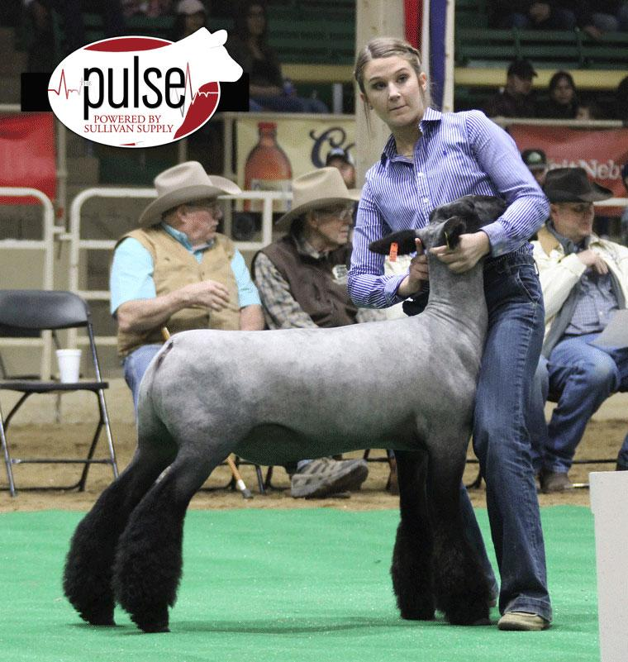
Handbook

Name ______________________________________

(Updated 4-1-19)

Purpose

The purpose of this handbook is to assist you in successfully raising a market animal project. The information contained in the following pages will act as a guideline. It must be understood that this material is not the only information you will need to raise your animal, but it does cover the most common aspects of the project. Should any questions arise concerning you project, don’t hesitate to contact your project advisor for help. If it is an emergency contact your local veterinarian!

Good luck on your endeavor of raising a market animal. With hard work and dedication, your project will be a success!

The Ultimate Goal

Grand Champion!

The goal of every junior exhibitor is Grand Champion. There can be nothing more exciting to a young exhibitor than to experience the feeling of accomplishment and pride when a Judge selects their animal as the overall Grand Champion of a show. It should be understood that the opportunity to experience that feeling of exaltation is not an accident. It is the culmination of many weeks of extremely hard work. The winning edge is something that is earned by hard work and dedication to a well-constructed plan. A plan that includes a quality animal selection, proper facilities, superior management, correct feeding and appropriate showmanship training. By incorporating the basic principles discussed in this booklet you can greatly enhance your chance to experience that winning feeling of a Grand Champion!

“Champions aren’t made in the ring, they are merely recognized there. If you want to see a champion, look at their daily routine.” Evander Holyfield

Table of Contents

What you should know before buying a project …………………….…..…… 1

Getting ready for your project ……………………………………………..… 1

Purchasing you animal ……………………………………….………………. 1-2

Common sheep breeds ……………………………….……………………..… 2

Parts of a Lamb ………………………………………………………………. 2

Selection of a show lamb …………………………………………………….. 3-4

What To Look For In A Show Lamb …………………………………………. 4-5

Proper Feet & Legs …………………………………………………………… 5-6

Starting off right ……………………………………………………………... 6

Feeding you market animal ………………………………………………...… 6-8

Suggested Guidelines For Lambs On Feed …………………………………… 8

Strategies for Feeding Show lambs …………………………………………… 9

Caring for your market animal ……………………………………………….. 9-10

Fair Time ……………………………………………………………………… 10

Successfully Slick Shearing Show Lambs ……………………………………. 10-12

Showmanship ……………………………………………………….………… 12-13

Showmanship questions …………………………………………………...….. 13-15

Supplies & Equipment ………………………………………………………… 15-16

How much will this project cost? ……………………………………..…….… 16

Estimated income from the project ………………………………………….… 16

How do I sell my project? …………………………….. …………………….... 16-18

Duties of a exhibitor .……………………………………………….…….…… 18

How To Show Your Lamb At The Fair ……………………………………….. 18-20

Changing Positions In The Ring ……………………………………………….… 20-21

Teaching Your Lamb To Brace ………………………………………………….. 21

How To Brace Your Lamb ……………………………………………………….. 22-23

Setting Yourself Up ………………………………………………………………. 23-24

Isometric Exercise ………………………………………………………………… 24-26

Show Lamb Diseases ……………………………………………………………… 26-27

Sample buyers letter ……………………………………………………….….……28

Retail lamb cuts ………………………………………………………………….…29

Record keeping …….…………………………………………….….…...…………30

Exhibitors Contract .………………………………….…………….……………….31-36

What You Should Know Before Buying A Lamb Project.

- A lamb project can be very exciting and rewarding experience or a very frustrating and discouraging project depending on the amount of time and energy you put into the project.
- The duration of a market lamb project is anywhere from 3-4 months. It is important that as much attention be given to your project during the last months as is given during the first months.
- Raising a market lamb is not a hit and miss proposition, you must be consistent in how you raise your animal. Achieving maximum results requires maximum input from you. In other words, you get out of your project what you put into it.
- It is critical that a person understand that the animal will be dependent on you for every aspect of its well being including feed, water, shelter, health, exercise, etc. You must be willing to provide for each of these areas on a daily basis for the duration of the project.

Getting Ready For Your Lamb Project.

- If you are housing your animal at home, make sure your pen is properly prepared prior to receiving your project. The pen should meet the following requirements:

  - It should be large enough to allow your animal to exercise. (About 15’ x 20’ is adequate and should be at least 5’ tall to prevent jumping out.)
  - Shelter must be provided in the pen for shade purposes and to prevent wind and rain from being on your animal all the time.
  - Make sure to have shavings for bedding during cold spells.
  - Adequate feeding and watering facilities must be provided.
    - An automatic waterer can be placed on the end of a garden hose allowing fresh clean water at all times.
  - The fencing should be free of loose wires, protruding nails, loose boards, etc. The floor should also be boards free from wire, nails, etc.
  - It should be sturdy enough to prevent the animal from getting out. If you can shove over or open or down an area it will not hold your animal in.
  - It should be clean of weeds, trees and grass.

- You should purchase your feed 1-2 days prior to receiving your animal. Check with your advisor on the options of feed to purchase and from whom. Be prepared to attend feeding seminars starting in December. In 2019 there will be a feeding seminar at the Douglas County Cooperative Extension Office (1134 Douglas Ave.)on February 13, 2019 from 6:30 to 8:30 pm.
- If you are raising multiple animals, they should be able to be fed separately from each other and all other animals. Otherwise one animal will overeat and one won’t get enough feed.

Purchasing Your Animal.

- There are different ways to purchase a lamb project. No one way is right or wrong. You need to determine what is best for you in terms of your budget. The most common ways of buying animals are:

  - Purchase an animal on your own. Your advisor will recommend various sheep producers to select and purchase market animals from. You must have advisor approval to do this.
  - Purchase your animal through a sale. Sometimes you find good deals at sales, but usually you end up paying a little more for your animal.

- Whichever way you choose to purchase your animal, make sure that you consult with your project advisor prior to buying it. You should obtain a bill of sale from the seller to keep for your records.

Common Sheep Meat Breeds

Hampshire – Black faced with a wool cap, medium frame
Suffolk – Black faced with no wool on head, face or legs, medium frame
Southdown – White to light brown face with wool on legs, small to medium frame
Dorset – White faced with wool on legs

Common Sheep Wool Breeds

Merino – White faced, fine wool breed
Rambouillet – White faced, fine wool, large rugged breed
Lincoln – Bluish white face, wool on head and legs, forward pointing ears
Cotswold - White faced, wool on legs, and long fiber with natural curls

Common Dual Purpose Breeds

Columbia – White face with wool on legs, hardy & fast growing
Corriedale – White faced, prolific & good mothers
Polypay – White faced, good mothers

Parts Of A Lamb

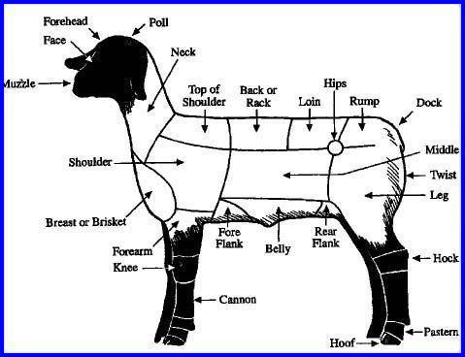
The judge will ask you parts of a lamb. This will also help you in the proper selection of your market animal.

Selection Of A Show Lamb

Muscle
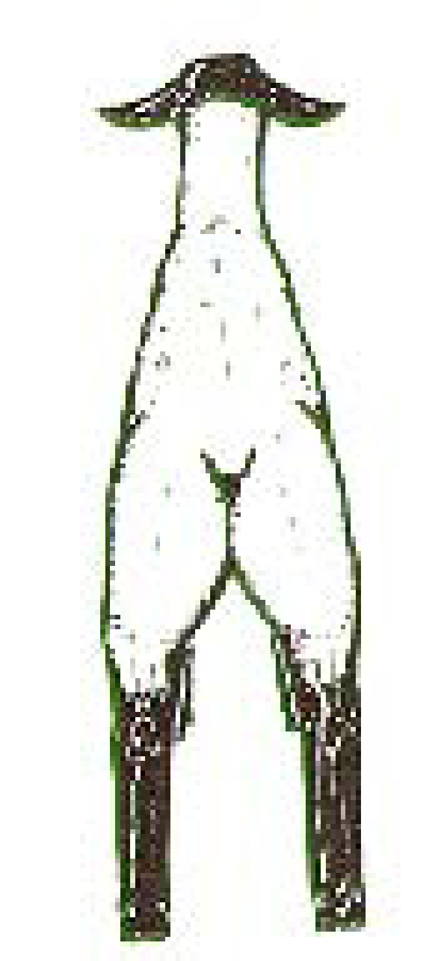
Select show lambs with good expression of muscle. Pick a lamb that has firm, hard muscle tone in the legs, loin, and rump, where the higher priced cuts are located. Look for muscle from different views and areas.

From the Rear

Leg – The widest portion should be through the center of the leg or stifle area. A larger outside muscle right above the stifle joint is very desirable. A muscular lamb will stand and walk wide. This requires good development of inside leg muscle. A lamb can stand wide and not have a lot of inside muscle. They may just be structurally wide. Be sure to check for inside muscle.

Top – A lamb needs to be wide across the top. The loin needs to be large and muscular. Look for a large rib cage, which indicates a lot of capacity. Width is an indicator of muscle. However, be sure to feel your lamb to be certain that it is not fat. Feel down the backbone to determine the expression of the loin muscle (butterfly). A good indicator of muscle is when you can feel a groove down the top of young lambs. This is like feeling the groove between your fingers when they are close together.
A B
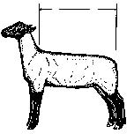
From the Side AB
Choose a lamb that has proper length in the areas of the higher priced cuts, legs, loin and rump. The back portion of the top or hind saddle (B) should be longer than the front part, rack or back (A). To calculate this, measure from the last two ribs to the pin bones, (where the tail connects to the body). This should be two or more inches longer that the front part, depending on the lamb’s size. Length of the loin is important. Measure from the last two ribs to the hook bone. Length and width of the loin are important. Short bodied, compact animals are undesirable. Be careful not to get carried away with length. If you select a lamb that is too long it may be weak topped.

From the Front
A bulging muscle from the knee to the shoulder is desirable. Large bone circumference of the cannon bone is a gauge of muscle, too. The larger the bone, the more area there is to attach muscle to. Select a lamb with a relatively long, thick cannon bone. The shoulder should be slightly prominent. Avoid getting a lamb with too large a shoulder as this will take away from a smooth, balanced appearance.

Structural Correctness
Show lambs should be correct in their skeletal or bone structure. The lamb’s neck should be erect and extend out of the top of the shoulder. The top line should be long, level and straight. The legs should have a large circumference or diameter of bone. Its pasterns should be strong, and it should stand with its feet and legs wide apart. When it walks it should move with long, smooth steps, and track out wide. Do not select lambs that are open shouldered, weak topped and have steep rumps.

Style & Balance
These two characteristics describe how a lamb blends together. The front and rear ends should match. Looking at the lamb from the side view, it should have a clean, trim chest.
The shoulder should be smooth while the top line should be long and level. A trim middle is desirable. Because lambs are shown with less than ¼ inch wool, it is desirable that they have a tight, wrinkle free hide. The most noticeable lamb in a pen holds its head up and looks long and straight with a level hip. Its walk is proud and wide based with a thick leg.

Look for Potential
Select a lamb that shows good potential. Large framed, long bodied lambs, with a long neck, cannon bone, and thick loin show the most potential for growth. Lambs that are long in the loin and level in the rump have an advantage over others in the show ring.

What To Look For In A Show Lamb

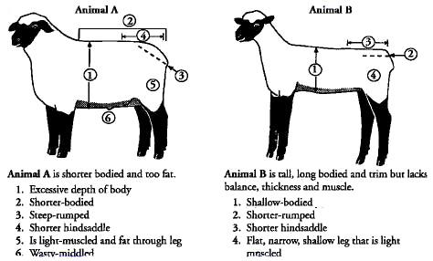

Proper Feet & Legs

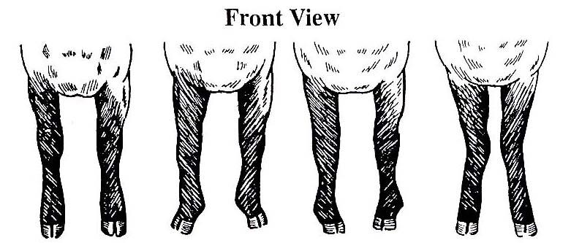
Correct Splay Footed Pigeon Toed Knock Kneed
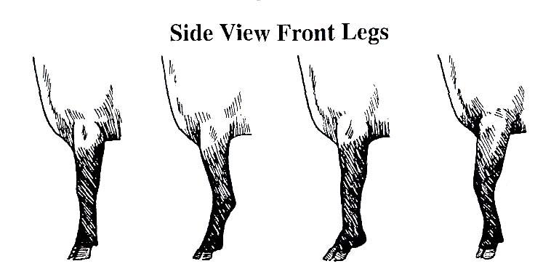
Correct Calf Kneed Weak Pastern Buck Kneed

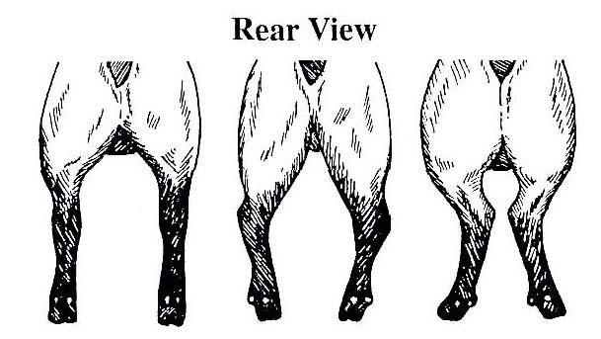
Correct Bow Legged Cow Hocked

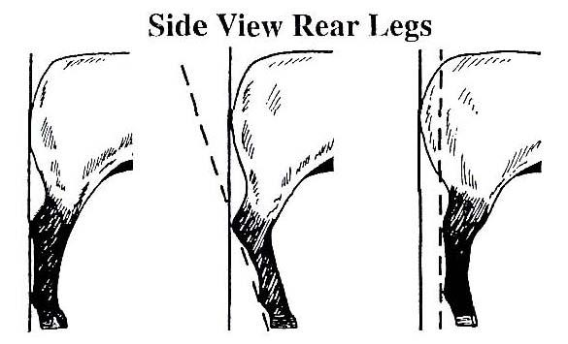
Correct Sickle Hocked Post Legged

Starting Off Right.

- As soon as you get your animal, it is imperative that you observe your animal closely for any signs of illness. Generally, if lambs are hauled a long distance, the chance of illness is greater that those hauled shorter distances. Signs to watch for include runny eyes and or nose, droopy head and inactivity. It will take a few days for the animal to acclimate itself to its surroundings.
- Your animal may not want to eat the first day or so. This is normal. However, if it is not eating by the second day, you should contact your advisor. (Refer to the section on feeding for more information.)
- Training the animal as early as possible is important. The quicker the animal can be gentled down and work for you the better. It is much easier to teach a smaller animal to work than larger one. DON’T WAIT!

Feeding Your Market Lamb Project.

- Nutrition is the single most important aspect of raising a quality market animal. Consistency is the key word when feeding lambs with regards to the type of feed, amount, and feeding schedule. A proper feeding program can make the difference between a high quality animal and a poor quality animal.
- One of the most overlooked elements of a good feeding program is water. The water your animal drinks should be fresh, clean and cool at all times. Dirty or stagnant water can have an affect on the health of your animal. The water trough should be cleaned on a regular basis, preferably daily. A good rule of thumb on water is if you wouldn’t drink it, your animal probably wouldn’t drink it either if given a choice. If you are using an automatic watering system, make sure the pipes are not in direct sunlight, as this will warm the water.
- Your advisor will direct you on how to feed your animal. Feed recommendations are based on individual differences in weight, rate of gain and conformation. It is important to know exactly how much you are feeding so that accurate average daily gains can be calculated. This information will tell you whether you are on track to meet the desired projected weight for your animal.
- There are two types of rations for market lamb projects. These are grower rations and finisher rations and are defined below:

Grower: Grower rations are lower in energy (TDN) than finisher rations. These rations are designed to help young lambs grow and develop at a proper level, rather than “pushing” the lambs. These rations contain more roughage (over 50%) as compared to finisher rations.
Finisher: Finisher rations are higher in energy (TDN) than grower rations. These are rations used to finish the feeding period to help achieve optimum body composition at the end of the project. These rations contain more concentrates (over 60%) as compared to grower rations.

- If you are raising your animal at home, or hand feeding, it very important to set feeding times in the morning and evening and then stick to them. There should be no more than a 15-minute variation in feeding times from day to day. Drastic changes in feeding times can have adverse affect on your animal in terms of appetite and health.
- A scale should be used to accurately measure the amount of feed you are feeding. “Coffee Cans” do not work. You must know the actual weight fed. As a general rule a lamb should receive 3-4% of its bodyweight to gain ½ lb a day.
- Whenever a new feed or increase in feed is introduced, the change should be made gradually over a period of time. Never change brands or feed quantities without checking with your advisor.
- Make sure that the animal is eating all the feed at each feeding. Feed that is not consumed by the next feeding should be removed and the amount fed should be reduced in proportion to the amount left over. Increase the amount any time the feed is completely consumed by the next feeding, but increases should be limited to one half pound per day.
- If your animal goes off feed for more than one day, contact your advisor or veterinarian immediately. Generally lack of appetite is one of the first signs of illness. The sooner the illness is detected, the easier it is to treat. Any type of illness will cause a decrease in the daily gain and could affect the desired end weight.
- It may be necessary to add a feed supplement to the ration. The supplement will help in increasing growth, appetite, feed efficiency, health and stress resistance. Check with your advisor before adding a supplement to your feeding program.
- Feed your lamb in a feeder, not on the ground. Hay should be given after the grain is cleaned up.
- Weekly shots of b-complex are highly recommended. See your advisor for more information.
- Feed wet: we want lambs to have a trim appearance to them. One thing to do to help the cause is to add water to our lambs feed. Watch a lamb after it eats a lot of dry grain. Its first inclination is to take a large drink of water, which will push out the middle of the lamb. Our goal is to add enough water to the feed where it reaches the consistency of soup. Start slowly by spraying the feed with water to moisten it. Increase the amount every day until it reaches a soupy consistency. This will help in adding supplements and show shakes to the feed at fair.
- A few weeks before fair you will want to split their feedings into three separate rations. For example, if you were to feed 3 pounds of feed in a day, a ration would be spilt to one pound in the morning, afternoon and evening. This will help tighten up the lines of the lamb and get rid of the belly. This will in addition, help the metabolism hold weight on larger animals.
- Alfalfa and long stemmed roughage is needed for ruminants like sheep. Without the scratching inside the rumen the lamb is prone to acidosis. Make sure to feed a handful of hay at each feeding.

Suggested Guidelines For Bringing Lambs On Feed

Live Weight Pounds Grain/Day Pounds Hay/Day Total Pounds/Day
60 1-1.5 0.5-1 1.5-2.5
70 1.5-2 0.5 2-2.5
80 2-2.5 0.5 2.5-3
90 2.5-3 0.25 2.75-3.25
100 3-3.5 Handful* 3-3.5
110 3.5-3.75 Handful* 3.5-3.75
120 3.6-4 Handful* 3.6-4
130 4 Handful* 4
*After a lamb weighs 100 pounds, feed a handful of good quality grass hay or alfalfa hay in addition to the grain.

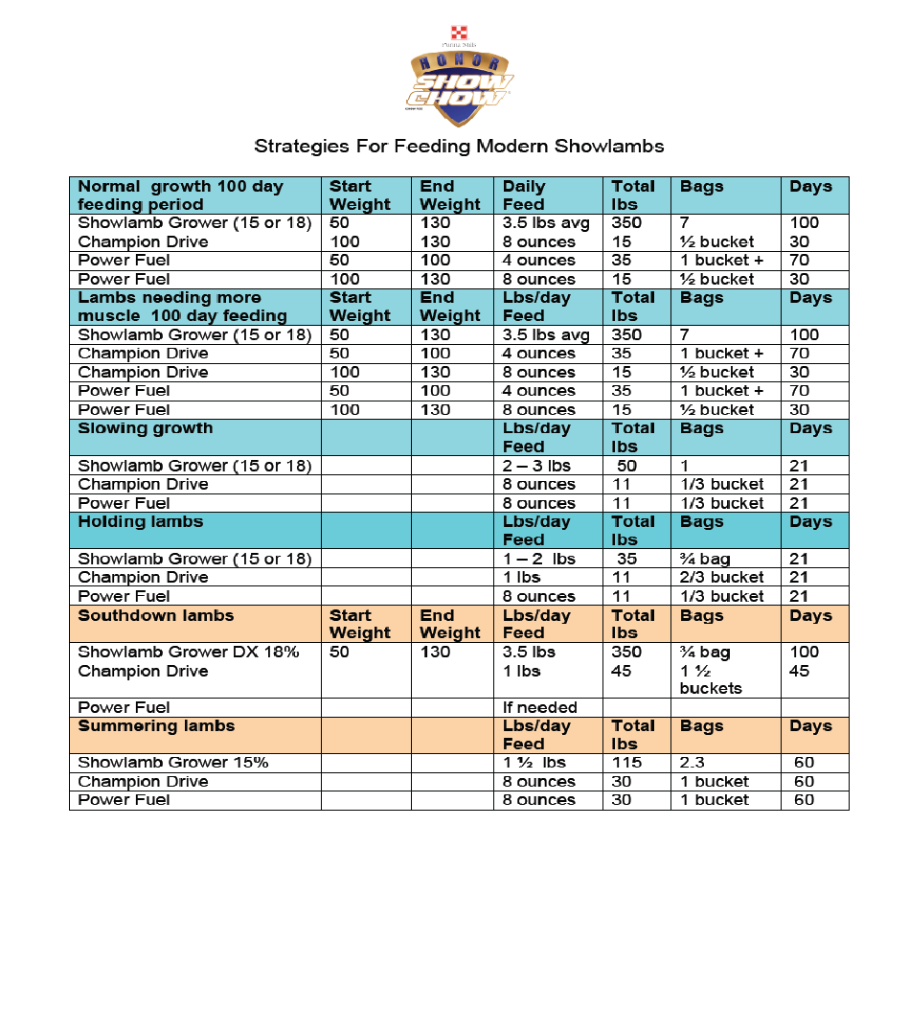
- Deworm lambs about every 30 – 45 days throughout the feeding period.
- Feed lambs ¼ lbs (double handful) of loose good quality alfalfa per day.
- Always allow access to clean fresh water at all times.
When feeding HONOR® Show Chow® Showlamb feeds, there is no need to supplement with additional mineral.

Caring For Your Market Animal

- At least once a day, look your animal over carefully to see if everything is all right. Check the way it walks, for sores or cuts, for scours or for runny nose or fast breathing. If any of these occurs, consult your advisor immediately. If your advisor is unavailable consult your veterinarian.
- Clean you pen at least once a day. Make sure the water is clean and the feed is okay.
- As soon as possible, start to walk your animal. This is for exercise and to practice showmanship. Do this once a day before feeding.
- Observe your animal for any signs of sickness or weight loss. Listed below are four main disease symptoms you could encounter:

  - Respiratory
  - Scours
  - Change in body condition
  - Fever
Going off feed and changes in behavior precludes most disease symptoms. When in doubt take the lambs temperature and notify your advisor if it is high. A lamb’s temperature should be 102F-103F degrees.

- Do not administer any medications without consulting your advisor or a veterinarian first.

Fair Time

Just prior to Fair – Daily washing and rinsing after exercise with a moisturizing shampoo and a conditioner helps revitalize dry skin on the animal. A very close accurate weight of the animal should be maintained to finish up the project in time for fair.

During the Fair – Maintaining a clean display, well-groomed animals and an all for one & one for all mentality, will demonstrate to other FFA chapters that we mean business. Once again, this is the time to shine and show pride in our chapter. Other rules applying to barn duty, set up/clean up will be discussed at fair meetings. Students are expected to feed animals and clean their pens daily. You are required to have an educational display at the fair for your species.

“Successfully Slick Shearing Show Lambs”

Many shows around the country require market lambs to be shown in a fleece no longer than one-fourth inch and uniform in length over the entire body, with the exception of the lower legs (below the hocks and knees) and the top of the head and face, which may be longer. The main reason for slick shearing is to place emphasis on conformation of the lamb. “Slick shearing” lambs for show requires more than simply shearing them. Typical market lambs receiving adequate nutrition grow approximately one-third inch of wool per month. Therefore, to obtain a fleece of less than one-fourth inch, shear the lamb a week to ten (10) days before the show date.

Steps to successfully slick shear a lamb for show:
1) To ensure a smooth shear job and more attractive lamb, shearers should use a pair of
electric clippers fitted with a 20- tooth goat comb and 4-point cutters, 23-tooth comb and 9 point cutter, or the slick shearing clippers. The use of these clippers and blades will decrease the chance of nicking or cutting the lamb. Many youth can successfully use the 23-tooth blades or clippers with proper supervision.
2) Having the owner wash the lamb prior to shearing will allow the shearer to get a closer, smoother clip on the lamb. A close smooth shear job makes a lamb feel “tight hided” or firm to the touch.
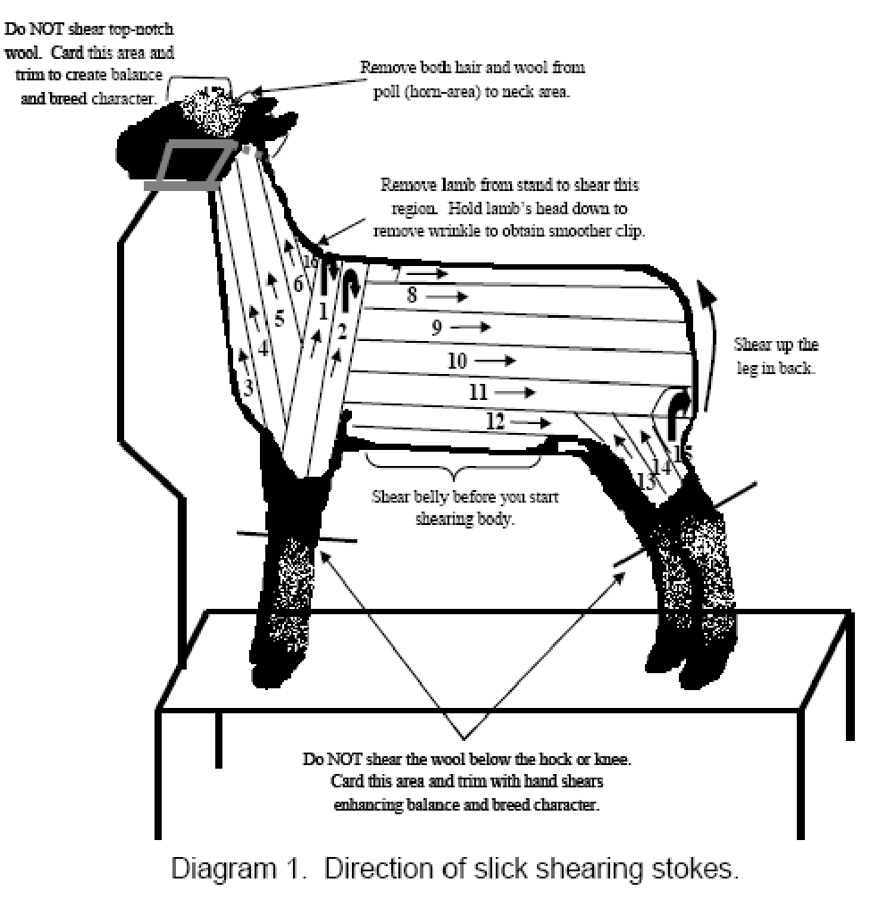
3) Lambs should be positioned on a fitting stand in the typical show position, back of neck and shoulders should be at a 90-degree angle with feet positioned squarely under the lamb. It is critical to clip the lamb, as it would stand in the show ring. This will help train the lamb, obtaining the desired overall balance, uniformity and eye appeal needed of a
show lamb. (Diagram 1)
4) Belly. The belly may be sheared on the fitting stand or by positioning the lamb in the typical shearing position (on their rump). Keep the skin stretched to remove existing wrinkles. This will allow the shearer to obtain a smoother shear job and prevent nicking or cutting the lamb. Pay close attention not to cut or nick the sheath (penis), teats, or fore and rear flanks.
5) Shoulder Region. Begin shearing the body by making two upward shearing strokes from the base of the foreleg over the top of the shoulders. Depending upon the size of the lamb and clipper head more than two strokes may be required. Upward strokes will make the lamb look taller and trimmer.
6) Neck Region. The strokes on the neck should be lengthwise to emphasize the length and trimness of the lamb. To shear the region at the base of the neck and shoulders, remove lamb’s head from the stand and hold the head down. Again pull the skin tight to obtain a smooth and uniform clip. The top-notch or wool on the top of the head in front of the poll should not be sheared on breeds that require wool for breed character. The long wool should be carded and trimmed to create uniformity and balance to the overall appearance of the lamb.
7) Body Region. Start shearing the lamb’s body by making a lengthwise pass down the back of the lamb over the spinal column. Continue shearing down the lamb’s body toward the belly with lengthwise strokes to make the lamb look longer, trimmer and more balanced. Keep the skin pulled tight to remove wrinkles and obtain a smoother shear job.
8) Lower Back Legs (above the hock). When shearing the lower back legs use upward shearing strokes. This will help add definition to the hindquarter and lower leg. Leave the wool on the legs below the hocks and knees to create an impression of a heavy or thick boned lamb and to preserve breed character. Longer leg wool should be carded and trimmed to create an over-all appearance of balance. Follow this same procedure to shear the other side of the lamb. Remember to card and trim the wool on the lower legs and top-notch to successfully and correctly complete the slick-shearing process.

Showmanship

- The main purpose of showmanship is to present your animal to the judge in a manner that will make your animal look it’s best. Showing can emphasize strong points and de-emphasize weak points of the animal.
- Success in showing begins at home. You and your animal cannot learn proper showing techniques at the last minute. It is important that you practice as often as possible. Showing can be a very rewarding experience if you take the time to learn how to show. When starting out, not only the animal must be trained, but the exhibitor must also be trained well.
- Listed below are a few general characteristics of a good showman.

A good showman:

  - Is confident in his/her abilities
  - Understands the importance and purpose of proper showing techniques
  - Is alert in the show ring
  - Knows where the judge is at all times
  - Is conscience of the appearance of his/her animal at all times
  - Works the animal calmly and smoothly
  - Is prepared to answer questions about his project to the judge
  - Is not distracted by people or events outside the show ring
  - Starts showing from the time he/she enters the ring until he/she leaves the ring at the conclusion of the class
  - Is courteous to the other exhibitors in the ring
  - Displays good sportsmanship by congratulating the winners and accepting congratulations graciously.
  - Gives his/her best effort every time he/she is in the show ring

- Listed below are a few general characteristics of a good lamb showman.

A good lamb showman:

- Is clean and well groomed
- Grooms his/her lambs wool in the natural direction
- Clips his/her lamb in a correct manner
- Cleans his/her lambs ears
- Applies polish to lambs hooves
- Keeps his/her lamb between himself and the judge
- Has his/her lambs feet trimmed to stand well if needed
- Shows their lamb with a slow walk
- Immediately stops his/her lamb if requested by the judge
- Continues to show the lamb and watch the judge after being placed.
- Exhibits the lamb as close to its natural state as possible

Sheep Showmanship Questions

Beginning level questions

Is your lamb a ewe or a wether?
Be sure to use the correct terminology when answering this question. Respond with ewe or wether not male/female because it doesn’t look as professional.

How much does your lamb weigh?
Most shows have a weigh-in prior to the show so be sure to remember how much your lamb weighs.

When was your lamb born or how old is your lamb?
Obviously the answer to this question depends on each individual lamb. Know ahead of time all of your lamb’s important information. If you are asked this question and don’t know the answer, just make one up that is close to when it should be. A judge has no way of knowing if it isn’t true. Already have the date in your head so that when you are asked you can confidently give the judge the date.

What kind of feed do you use?
Surprisingly most exhibitors don’t know the answer to this question because their parents buy their feed and kids feed the lambs. If you don’t know, ask your parents ahead of time. If you mix your own feed, be prepared to tell a little about it. Hint: If you are buying your feed the best thing to do is rip the tag off of the bag.

How much feed do you use?
Again, most exhibitors don’t know the answer to this question because their parents tell their kids how much to feed the lambs. If you don’t know, ask your parents ahead of time. It always sounds better if you use units when describing the amount you feed.
For example don’t say “a coffee can” Or “a scoop”. Instead, tell the weight of the feed.

What breed is your lamb?
Obviously the answer to this question depends on each individual lamb. Know ahead of time all of your lamb’s important information.

What is your lamb’s name?
If your lamb doesn’t have a name, make one up. Some judges don’t like it when exhibitors don’t name their lambs.

Who was your lamb’s breeder?
Again, be prepared to tell the judge whom you bought your lamb from. If you don’t know ask your parents before hand.

What is the most important nutrient sheep need?
Water

How many parts are there to a lamb’s stomach and name them?
4; rumen, reticulum, abomasums, omasum

Name some meat breeds?
Suffolk, Dorset, Southdown, Hampshire

Name some wool breeds?
Merino, Lincoln, Cotswold, Romney

Name some dual-purpose breeds?
Corriedale, Polypay, Columbia

What are the 4 main cuts of a lamb?
Loin, leg of lamb, rack, and brisket

Do lambs have teeth on their top jaw?
Yes, in the back

Why did you pick this lamb?
Answers may very. Be prepared to tell the judge details as to why you picked your lamb. Don’t say something like “I thought he was cute.” Say something more professional like “I chose this lamb because it has a lot of depth through its hip that extends into the leg.”

What is the perfect weight of a market lamb?
130-145 lbs.

Advanced level questions
What type of exercise program is your lamb on?
Explain to the judge what type of exercises you do, how often you do them and how long each exercise lasts.

What would you change about your lamb?
Judges frequently ask this question. This is to see how well you know your lamb. Give your lamb a good looking at before the show and be prepared to give lots of details on your answer.

What is the best feature of your lamb?
Judges frequently ask this question. This is to see how well you know your lamb. Give your lamb a good looking at before the show and be prepared to give lots of details on your answer.

Where is the (name of body part) on your lamb?
Exhibitors are accustomed to knowing certain parts of a lamb on a diagram, but rarely practice on a live animal. Get with your parents or sheep group and practice naming the parts of the lamb on a live lamb to better prepare you if you are asked where something is. When asked this question be sure to point and touch directly to the spot on your lamb where the part is located. Never say and point “around here somewhere”.

What is the average amount of back fat on a lamb?
.255

How much do you work your lamb daily?
Explain to the judge how long you spend working your lamb daily.

How is the yield grade determined?
Back fat x 10 +4

What are the top 3 lambs in this class and why?
Answers may very. Be prepared to give details (reasons) as to why you chose the lambs that you did. Also, make sure that if asked this type of question you state the placement of each lamb and then your reasoning.

What is the most expensive cut on a lamb?
The rack

How many teeth does a sheep have?
32

What is the purpose of a scrapies tag?
To trace the (bacteria/sickness) scrapies back to the farm where the lamb was bought.

Supplies & Equipment

The following is a list of supplies and equipment needed for your project.

- Nylon or Rope Halter with lead
- Brush
- Wool Card #4 or #5
- Plastic hanging feed pan
- Spandex Lamb “Slinky or Tube” (FFA will provide blankets)
- Water Bucket
- Several rags
- 99% Alcohol
- Water hose and nozzle
- Show Products
  - Black Hoof Polish
  - Sullivan’s Freshen Up
  - Sullivan’s Cool Blue
  - Sullivan’s Silk
  - Whitening Shampoo
- Sheep Clippers (may be provided by the chapter)
- Hoof Trimmers
- Show uniform (white shirt, white pants, FFA Jacket, Tie/Scarf)
- Small tack box (you may share with a friend)

How Much Will The Project Cost?

Listed below are the common items and their approximate costs of a market animal.

- Cost of lamb ($275 ea) $275
- Feed (10 sacks @ $18 ea) $180
- Shavings (10 bags @ $9 ea) $90
- Equipment & Supplies $75
- Veterinary Supplies $25
- Insurance $15
Total $646

Estimated Income From Your Project.

Sale of finished market lamb 135lb.
Average market lamb price $6.75 $912

Total Income ($912 x 2) $912
Total Profit $266

Note: Profit shown is based on average market price from the Douglas County Fair. If students are motivated and get additional financial backings through add-on’s, there is potential for more profit.

How Do I Sell My Project?

- One of the first questions most new exhibitors ask is “How much money can I make on my project?” This question is a valid one. Most students figure that if you spend a great deal of money on the project, the returns should also be great. Unfortunately, this statement is not always accurate. The animal will be sold at the fair through public auction with the animal being sold to the highest bidder. These buyers are under no obligation to support and buy these livestock projects. It is your job to find buyers for your animal. You must remember that you are selling a product and you must approach this part of your project as a salesman. The buyers will not come to you, you must go to them.
- Before you approach a prospective buyer, you must first understand how the process works so that you can accurately answer any questions that may arise in your conversation with the buyer. You begin by calculating your break-even price. By dividing the estimated fair weight of the animal into the total cost, you will know how much per pound you need to break even. The next part of the process is to know what the buyer’s options are with the animal once it has been sold. The following are three options buyers have:

  - The most common option used is the resale or buy back. The buyer simply pays the difference between the current market price and their bid. The fair then sells the animal to a commercial packer for the current market price. The buyer does not take possession of the animal.
  - In the second option the buyer takes possession of the animal or carcass. The custom processing option allows the buyer to choose where the animal will be processed. The animal is taken to this location by the fair and the buyer then picks up the cut and wrapped meat.
  - The third option is live pick up. This option allows the buyer to take possession of the live animal from the fair.

- You must also be able to explain to the buyer what benefits they receive form buying your project. A buyer basically receives two benefits – advertising at the auction and a tax deduction. The only amount of the purchase price that can be deducted is any amount paid over and above the current market price.
- Armed with this information you can begin your search for buyers. Anyone can buy an animal at the fair, but the most common buyers are local businesses. The two most common methods of finding buyers are through personal contact or by writing letters to prospective buyers. Personal contact is a much more preferred method because the buyer has the chance to meet the owner of the animal and ask any questions concerning the project or selling process. The letter writing method does not afford these opportunities. When meeting with a buyer, the student should approach the buyer in a business like manner, calling ahead and making an appointment with them, dressing in the official uniform, being prepared, etc.
- Above all, be persistent in your search for a buyer. You may be turned down many times before finding someone willing to buy your animal. Don’t give up. The financial success of your project depends on you finding a buyer. You may want to find more than one buyer in the event one of them does not show up at the auction.
- Another key element to successfully selling your animal is to approach buyers early. Don’t wait until just before fair to start contacting people. You will not be the only person at the fair selling an animal. Begin several months prior to the fair. Many buyers buy from the first person that contacts them. Avoid the rush, start early.
- To find out more specific information concerning the auction process, approaching buyers, commonly asked questions, etc. contact your project advisor.
- Things you should include in your buyer letter:

  - Information about yourself
  - Information about your project and chapter
  - The fair dates
  - The sale dates, times & locations
  - Explain how to participate as a buyer
  - Inform them where they can get more information
  - Personally sign each letter
  - Add a picture of you and your animal
  - Proper grammar and spelling
  - A sample is included in this handbook!

- Thank you letters are required by the fair to pick up your check and insure support the next year. For more information read your fair book.

Duties Of Lamb Exhibitors

- Follow all instructions given to you by your advisor. Communication is the key to a successful project.
- Clean your pen. Scrape up manure and wash down the pen daily.
- Makes sure you animal does not go without feed or water. Plan ahead!
- Practice showing your animal on a regular basis. This will train your animal and give you confidence when you enter the show ring.
- All exhibitors will be required to meet with their advisor periodically to discuss the progress of their animal, to weigh the animal and for informational meetings. All meetings with the advisor will be scheduled as much as possible around the student’s schedule. The advisor may make unannounced visits to make sure that the animals are being properly cared for.
- A “three strikes” system is in place for anyone not abiding by the rules and/or guidelines set forth in this handbook. You will receive a “strike” for each violation. After three “strikes” you will be unable to show your project under Roseburg FFA.
- If you encounter any problems at all concerning you market animal or someone else’s animal or facilities, please contact your advisor immediately!
- A record book must be maintained and kept up to date at all times.

How To Show Your Lamb At The Lamb Show First Saturday in June
(June 1, 2019)

As a sheep showman, your primary goal is to develop, groom, and present your animal so that it will make the best impression possible on the judge. At the same time, you must be courteous to other exhibitors and follow the instructions of the ring steward and the judge.
When exhibiting sheep in a showmanship contest or in breeding and market classes, the exhibitor must have total control of the animal at all times. The judge will expect certain other attributes in his top showmen – quiet, “unshowy” calm handling; evidence of having trained the animal to smooth, quiet actions, and properly posing the animal. The judge will also expect your animal to be clean and properly groomed, and he will expect you to be neatly dressed.
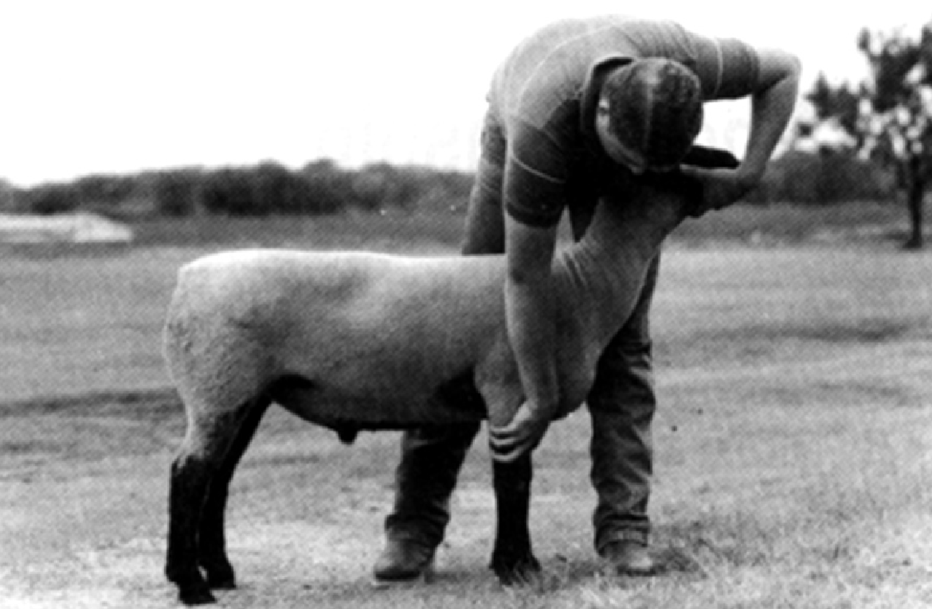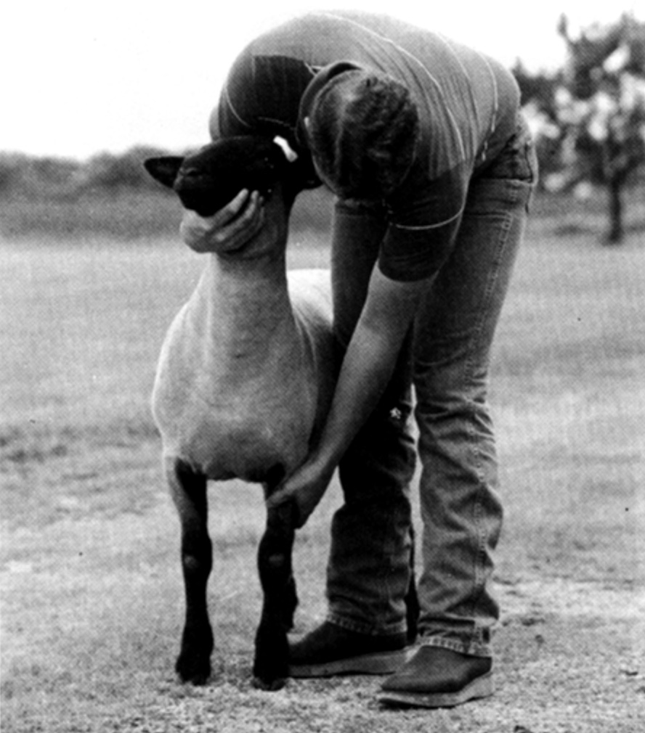
Placing the animals right front leg Placing the animals left front leg

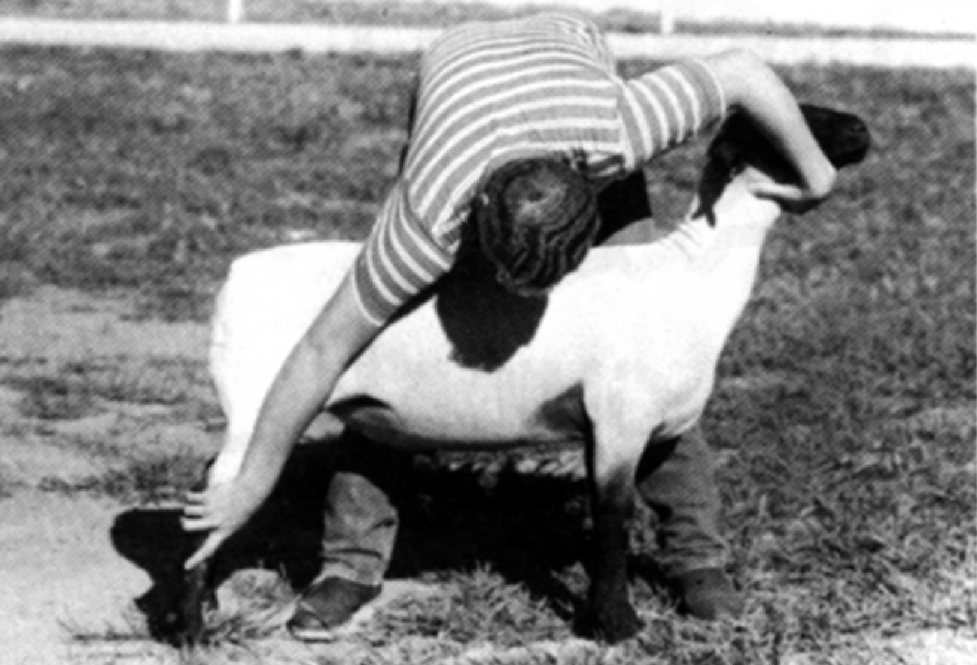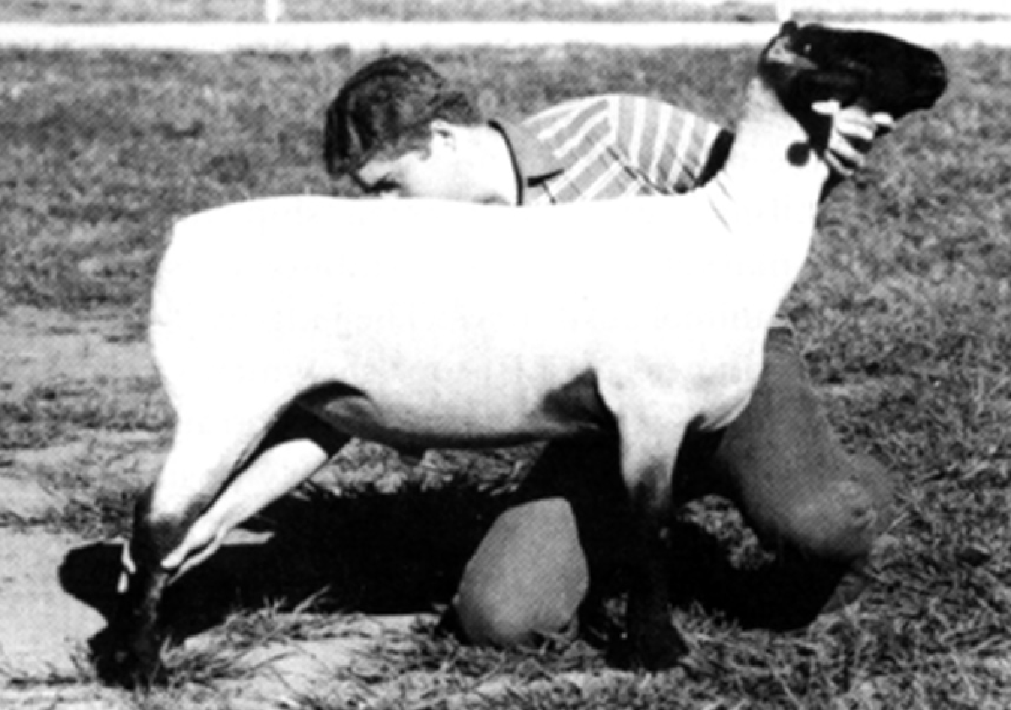
Placing the right rear leg Another way to place the right rear leg

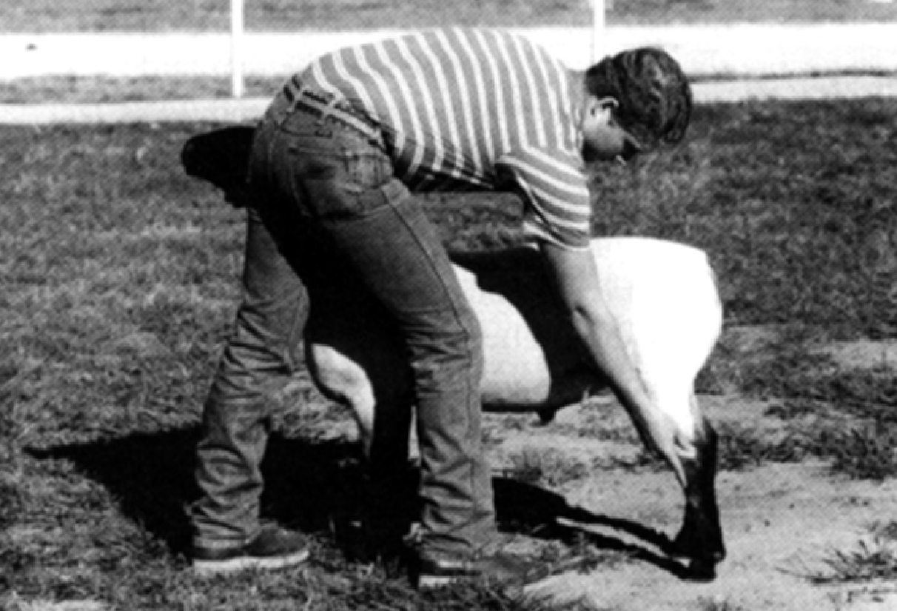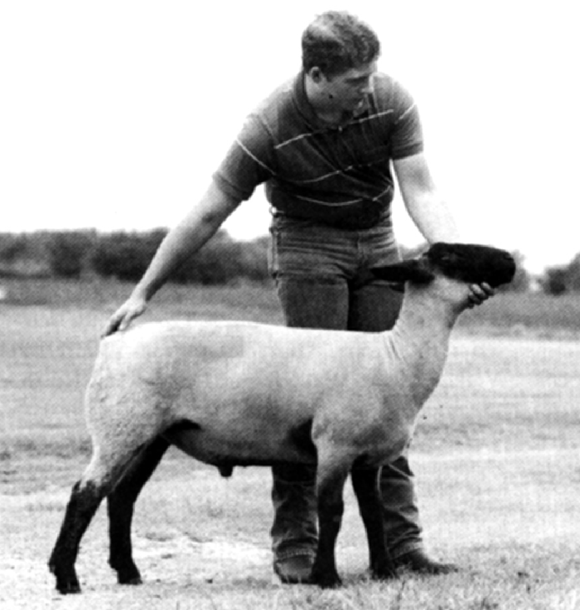
Placing the left rear leg Moving the animal with the dock
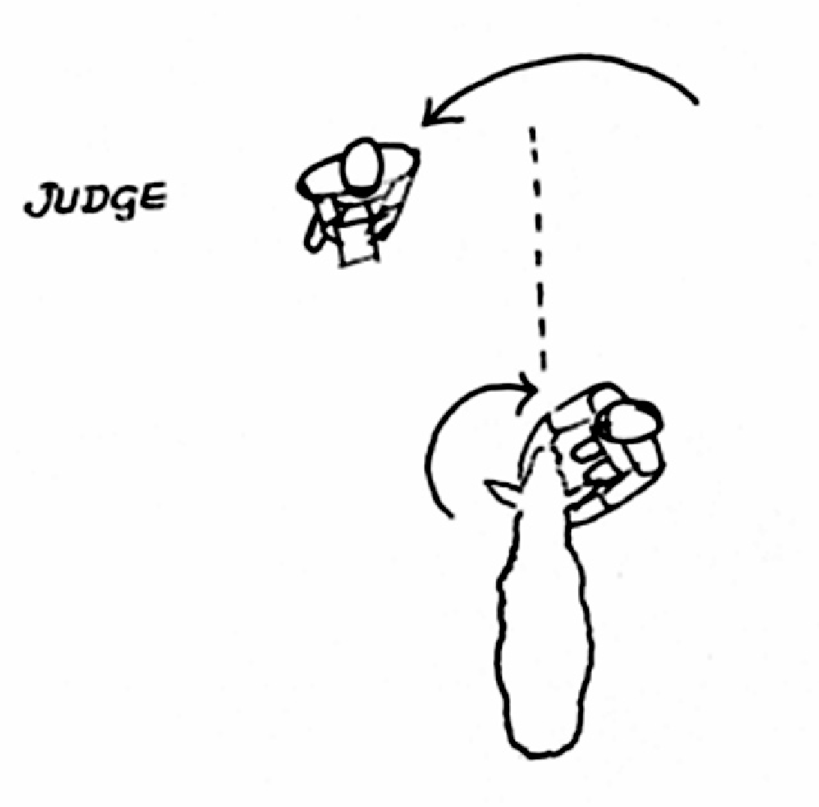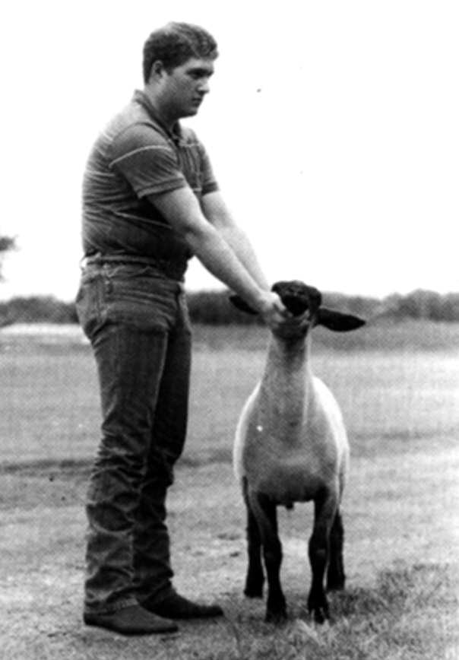

Movement of the exhibitor from Judges view when in front of exhibitor
one side to the other

Changing Positions In The Ring

As you show your lamb, you will be asked to move to a variety of positions. First, you will need to move around your animal to always keep the animal between you and the judge. The following figure shows where the showman (S) should be relative to the judge (J):
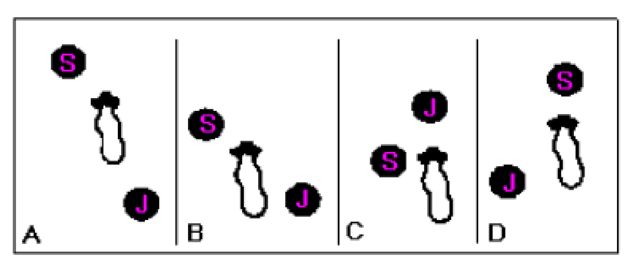

To help remember when to move, imagine a line down the spine of your animal. If the judge crosses that line onto the same side you are, move to the other side. ALWAYS MOVE AROUND THE FRONT OF YOUR LAMB, NEVER BEHIND YOUR LAMB! This is a common beginner mistake. Moving around the front always allows you to maintain control of your animal! Second, you will need to be able to change positions with in a line. There are proper ways to change positions – the following diagrams describe various situations you will find yourself in.

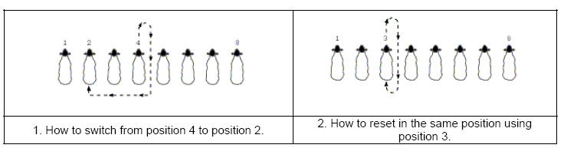

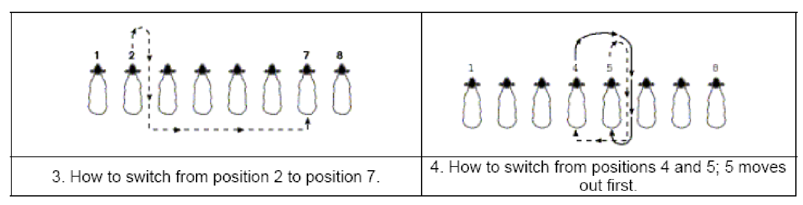

Teaching Your Lamb To Brace

- Backing the lamb off a ledge such as a blocking stand or trailer loading dock—by slowly pushing the lamb back, they will be scared of falling, causing them to drive into you. Don’t actually push the lamb off, but letting one foot step off might do the trick.

- Backing the lamb into water—a ditch or something of that sort works great to back a lamb against because they do not like water. If they get water on their feet they will try to get away from it by driving into you.

- Backing the lamb into a wall or fence—when the lamb has nowhere else to go, it will push forward.

- Set the lamb on a steep hill—having the lamb’s front end on the top of the hill will make the lamb brace in fear that it will fall down the hill.

How To Brace Your Lamb

A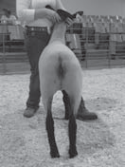 B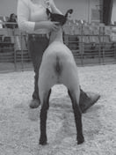 C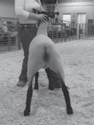

D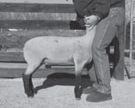 E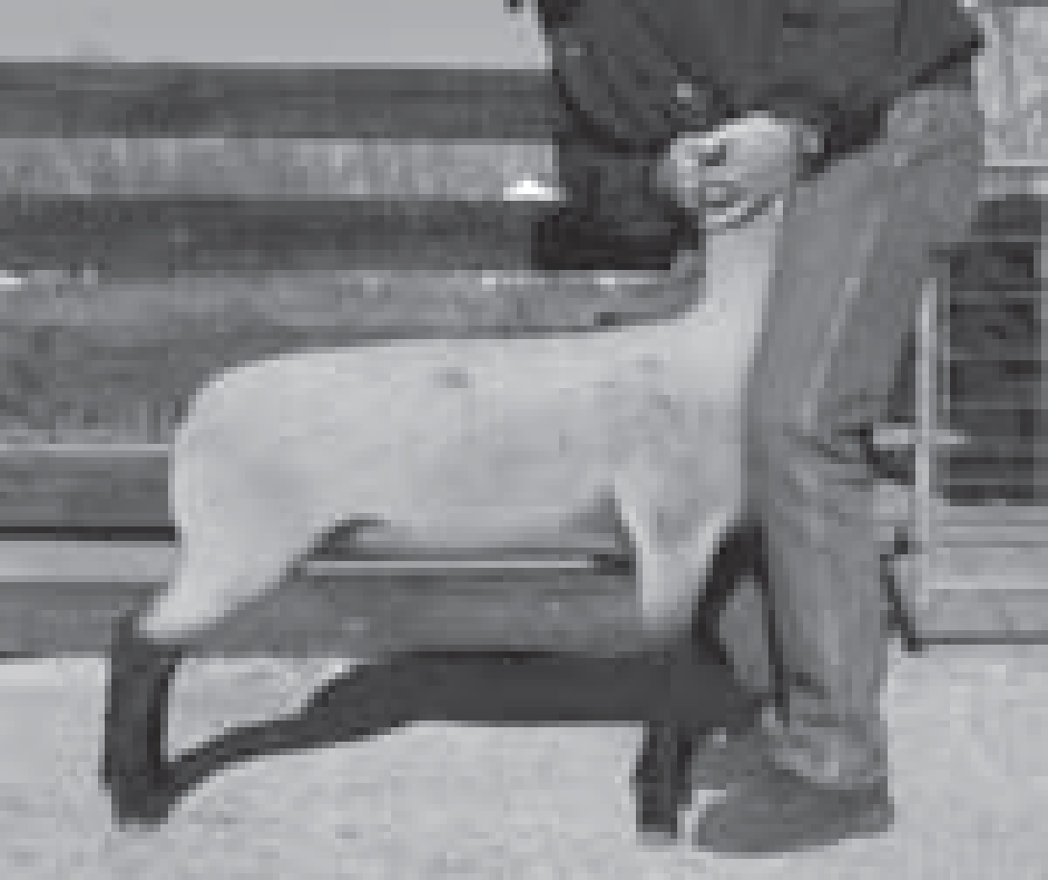 F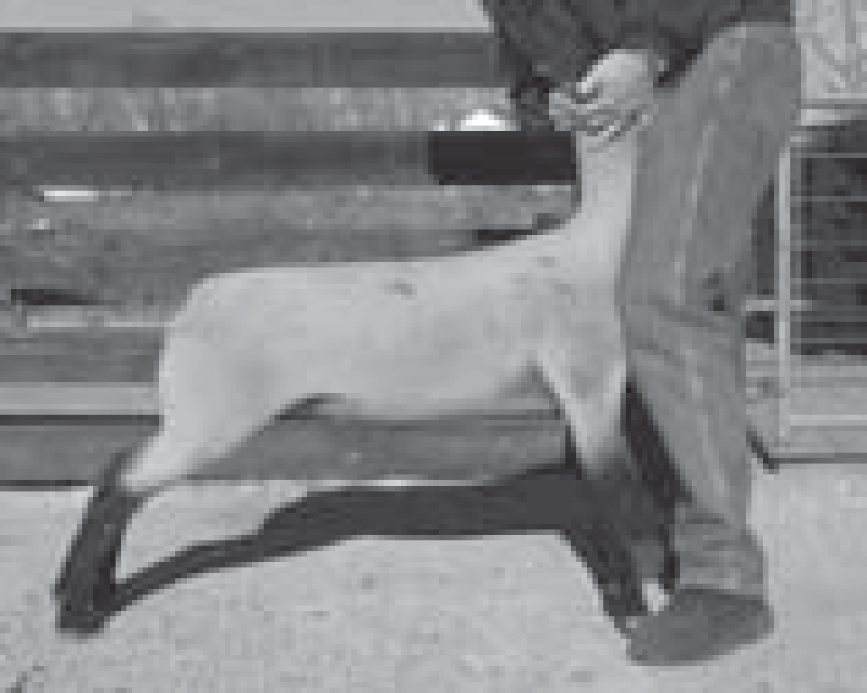

Correctly place each leg on the four corners of the lamb’s body. Head-in or rear view: A = too narrow, B = ideal, C = too wide. Profile or side view: D = too short, E = ideal, F = too stretched.

A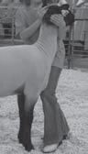B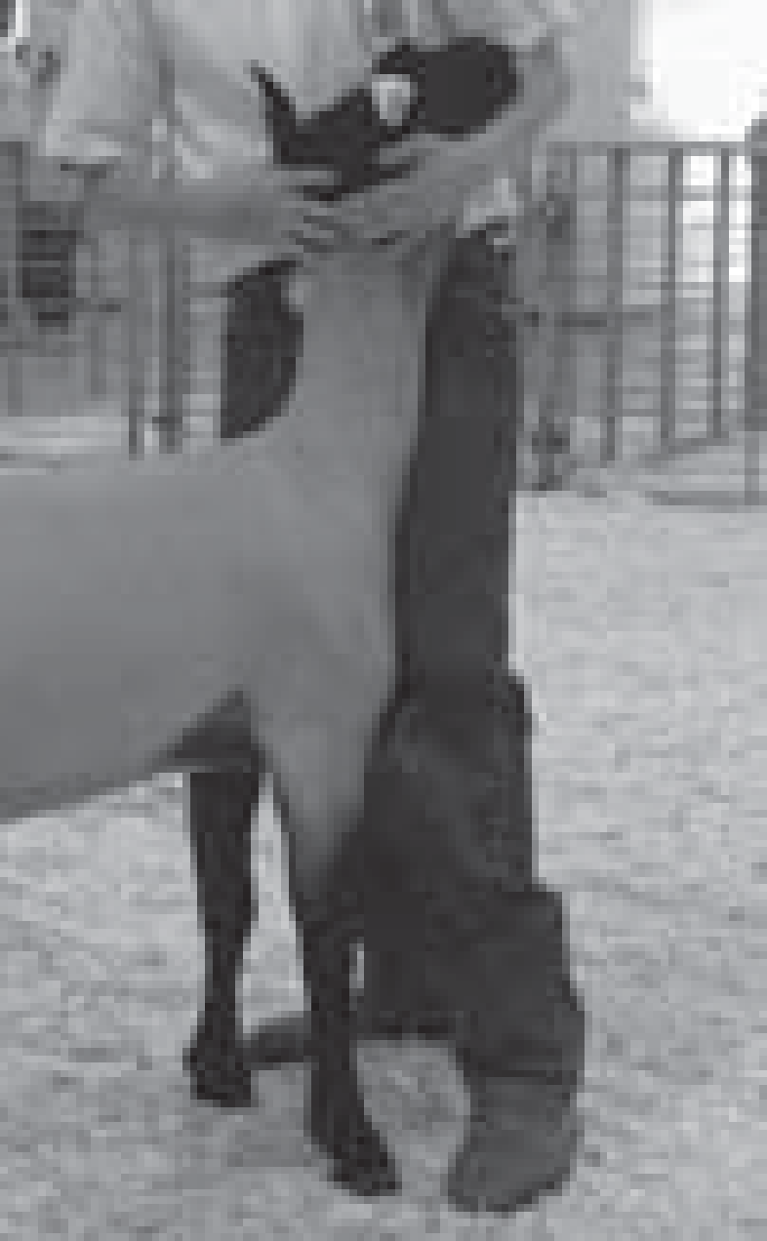C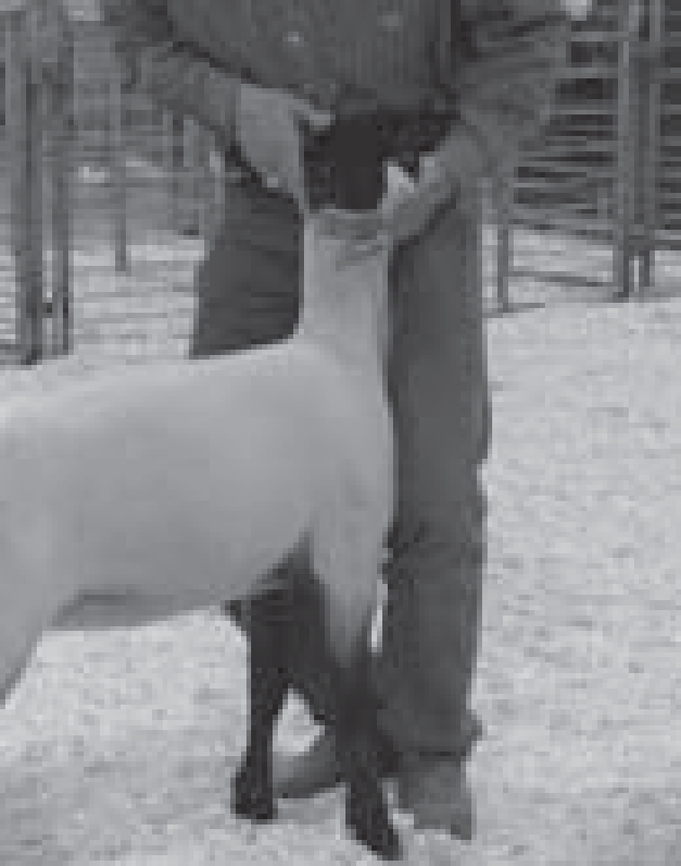D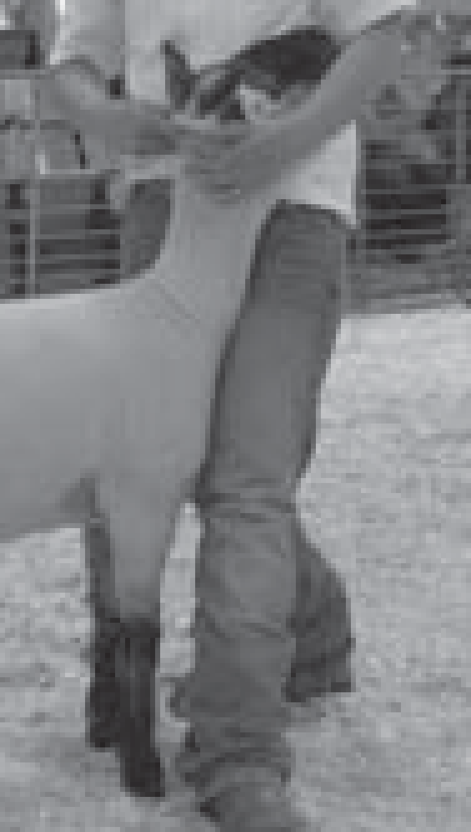E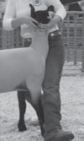

Correct hand, knee, and feet placement by the showman is critical to effectively brace a lamb. A = ideal for smaller showman, B = ideal for intermediate showman, C = ideal for larger showman, D = hands and knees are correct, keep feet in next to front feet of lamb and E = Incorrect, keep feet in front of lamb and flat instead of potentially sticking out in the way of the judge or other showmen.

AB 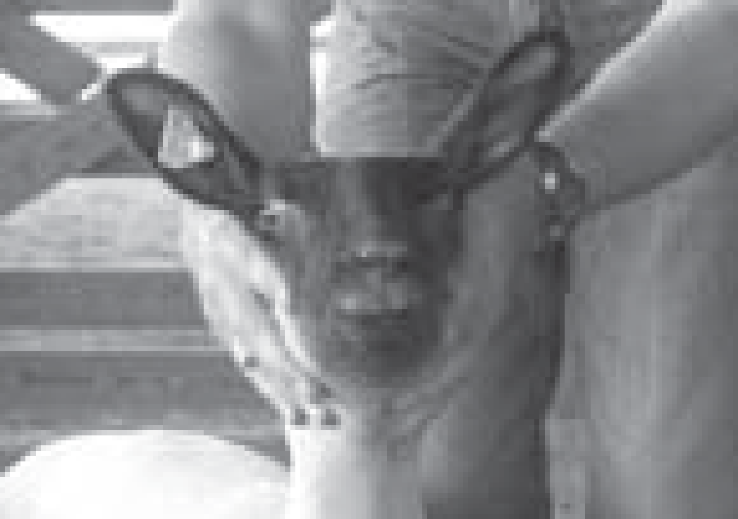C 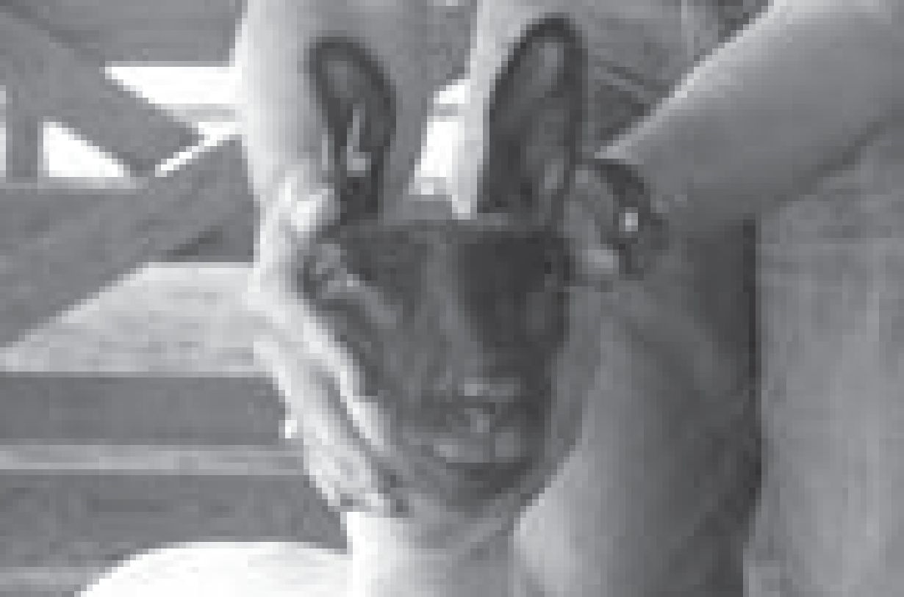

Ears should be held parallel to the ground unless the breed is noted for erect ears. A = ideal ear placement, B = unacceptable, C = unacceptable because this placement is not natural.

The head and nose should always be parallel to the ground and pointing straight forward.

The back should always be level. If a lamb’s back has a bulge, a gentle pinch over the last rib will make the lamb flatten out.

Setting Yourself Up

- In order to show your lamb correctly, you must be in the correct position. This can be frustrating and tiresome, but once you understand the basics, it is a lot of fun! In sheep showmanship 90% of it is with your legs and lower body.
- Heal to Toe, Toe to Toe

  - I will refer to your two legs in the following ways.

    - Opposite Leg: The leg furthest from the judge
    - Near Leg: The leg closest to the judge

  - On the leg and foot facing the judge (near leg), place the heel of your foot at the lamb’s toe. This should cause you inner thigh of your near leg to rest on the far end of the lambs brisket. Your leg should not be touching the throat of the lamb, as this will make the animal cough. If done correctly, you will be pointing you toe towards the judge and feeling the lamb brace into your inner thigh. There should be no room between the lamb and your thigh.
  - Opposite leg: Place your opposite toe pointing towards the lamb’s opposite hoof. This will make your inner thigh and knee rest against the lambs shoulder. This can only be learned through hands on instruction, so see your advisor.

- You should cradle your lamb’s head in your hands. The lambs jaw should rest on the forearm that is closet to the judge with the hand away from the judge supporting the lamb’s ear.
- Your shoulders should face the judge with a slight bend backwards in your posture.
- Eye contact is essential. Keep an intense confidant, but friendly look to you.
- Practice right. Walk you lamb forward and set it up in 5 seconds with a perfect brace. If your lamb can do this 5 times in a row perfectly, put the animal up for the night.

Isometric Exercises

If used correctly your lamb will gain great definition to its stifle and loin. In addition, it builds up stamina in the show ring by creating higher tolerances to lactic acid build up. This tolerance will allow your animal to maintain brace longer than other lambs resulting in a better lamb during the last and most important stages of market and showmanship classes.

Shaping Up: The Benefits of Isometric Exercise For Your Show Lamb

While club lamb enthusiasts have been on a quest to increase muscle mass and firmness in their show lambs by chasing after the latest in feed supplements or by looking towards high tech methods of exercise, I feel that we have neglected a very simple, but very productive means to building maximum muscle tone, shape and volume.

Muscle structure is much the same in any animal. The basic muscle physiology of a cat is similar to that of a horse, and that of our show lambs is akin to our own body. With these close similarities, I see every reason to look towards human exercise techniques, mainly those used by body builders (people who are acutely concerned with muscle size and tone) to further understand and enhance our show lambs' exercise routine.

What I am referring to is a simple program of isometrics. This form of exercise involves muscular contractions, during which no shortening or lengthening of muscle occurs. In other words, there is no movement, but a constant and equal force or strain is placed on the muscles. This strain is achieved through pushing, pressing, or pulling against an immovable object. When performed properly, isometric exercises are capable of producing a deep level of muscular development. They burn calories, strengthen and tone muscle groups, improve the ability to hold a contraction, and increase muscle size. The key to applying the concepts of isometric exercise to our club lamb workout program is finding a way to adapt the techniques of isometrics to the unique needs of our animals. We need to find ways to isolate the target muscles with specific exercises that can be done with sheep.

Where isometrics differ from our usual exercise and strength training is that instead of repetition (isotonic exercise), duration is emphasized. For example, instead of performing ten push-ups, one would push off the floor to a bent arm position and hold for ten seconds. We are looking for equal and sustained resistance

So how does this apply to your lamb and your program? How do you get your lamb to perform isometric exercises? I believe our exercise programs need to be two tiered; the first involves conditioning and calorie burning, the other is more focused on building and defining muscle. Since the muscle groups should be warmed up before performing isometrics, we suggest that you focus on calorie burning and conditioning as your "warm-up". Whether you track, treadmill, or walk your lambs, isometric exercises should be performed after your usual workout. The reason is that isometrics deals with a constant pressure on the muscles, and since it is the tearing of these muscle fibers and the rebuilding of them that leads to increased bulk and definition, we want the muscles of our show lambs to be stretched and warm before we put this force on them. As with any athlete, after strenuous exercise, there must be a cool down period. This could be as simple as a leisurely walk home, allowing the lamb's respiration and heart rate to return normal

Now that we know when to perform isometric exercise, how do we do them and which muscle groups shall we target? The exercise that I describe targets the loin and leg. I suggest that you find a hill, slant, or a lamb stand at about a forty-degree incline. Place the lamb's front legs on level ground at the top of the incline. Gently push the lamb's hind end down the incline so that he is now facing uphill. Be sure that the lamb is not overextending his hind legs or that he is "breaking" at the loin, as this can damage the muscle group over the loin

To start off, we push on the lamb's brisket with one hand while holding the head in the other. Allow the lamb to drop its head somewhat, as this helps to tense the muscles over the top line. At this point, the lamb should be pushing into your hand, wanting to get to the top of the hill or incline. Offer just enough resistance to hold the lamb steady in its place. When starting out, push for a count of five to ten seconds and then release. Keep in mind, we are teaching the lamb at this stage as well as working the muscles. Try ten "sets" of this, with short rest periods in between, then allow the lamb on its final set to make its way up the hill and return to level ground

Each day you should increase the duration of each set and decrease the number of sets. For example, after a week or two you could be working on three or four sets of a minute or two each. These numbers are not set in stone but will vary somewhat with the strength and condition of each lamb. Notice how your lamb's heart and respiration rates increase as he works against the static pressure of your hand. Just as your muscles may "quiver" as you reach muscle fatigue, so will the lambs. This is your indication to stop the set and provide a rest period. When we were still showing, we would be working several lambs, alternating them so that each lamb would have a rest/recovery period back on level ground of a minute or two. After your last exercise, a short walk of three to four minutes should cool him down and stretch his muscles

Once you understand the concept of working isolated muscle groups through isometrics, you will find new ways to work selected muscles that you target. Some experimentation and close observation on your part will allow you to tailor an exercise program to your lamb's specific needs. One word of caution should be mentioned here. Lambs that may be prone to prolapse need to be watched carefully when trying these exercises. Not only are you on a slant, which can put pressure on the rectum, but you are asking the lamb to strain his muscles in this position. If you are at all concerned that your lamb may have this tendency to prolapse, you can perform these exercises on flat ground, and ask for less effort with each set. Again, adapt these exercises to your unique needs and situation

In addition to building muscle mass and increasing definition, isometrics have other benefits. Since the heart and respiratory rates are increased, extra calories that would ordinarily be converted to fat and extra gain will be burned. It will also prepare your lamb for the work to be done in the show ring. In the ring, your lamb must be able to sustain a hard brace for long periods of time. As with any exercise, when muscle groups are strained there is a lactic acid build up. (Lactic acid is what causes the burning in your muscles that you feel during exercise). Isometrics teaches the body to handle this lactic acid build-up so your lamb will be able to push harder and longer, and will show less fatigue in the show ring

So what are the benefits of integrating isometrics into your daily exercise program? With time, you will notice increased definition and muscle mass. You will find the lamb converting feed into lean muscle instead of additional fat. And finally, after a long day of showing, in that final drive, your lamb will have the endurance to keep a hard brace when it matters most.
Show Lamb Diseases

Enterotoxaemia
One of the main causes of death in club lambs is enterotoxaemia, or overeating disease. Symptoms are seldom exhibited. A clostridial organism normally present in the intestine of most sheep causes the disease. Lambs that experience abrupt changes to their feeding schedules or that consume large amounts of grain are subject to enterotoxaemia.
These changes cause the clostridial organism to grow rapidly and produce a powerful toxin that causes death in a few hours. There is a combination vaccine for types C and D enterotoxaemia. All club lambs should be vaccinated with the combination vaccine, and a booster vaccine should be administered 2 to 3 weeks later. Additional boosters
can be given at 2- to 3-month intervals.

Internal parasites
Internal parasites are a continual problem. New lambs should be drenched for internal parasites immediately. A second drenching should follow about 3 weeks later.

Soremouth
Soremouth is a contagious disease that causes the formation of scabs on the lips and around the mouths of lambs. A virus that can affect humans, so use caution when working with lambs with soremouth. Iodine can be rubbed into lesions after the scabs are removed and this will help dry up the area and reduce the infection.

Tetanus
Lambs affected with tetanus seldom recover and there is no satisfactory treatment. If tetanus has been a problem in your area, or if you use elastrator bands to dock tails, you should vaccinate for tetanus. There are combination vaccines for tetanus and enterotoxaemia.

Ringworm
Ringworm can become a serious problem because it is contagious and can be transmitted from lamb to lamb, from lamb to human, or from infected equipment to lamb. A good prevention program is necessary. The following products have been used with varying results:
• Fulvicin® powder — as a bolus or used to top dress feed;
• Nolvasan® — 3 ounces per gallon of water sprayed on lambs, equipment and premises;
• Bleach — 10 percent solution sprayed on lambs, equipment and premises.

Rectal prolapse
Rectal prolapse, or protrusion of the rectum, is believed to be inherited. It also is associated with concentrate feeding, short docking of the tail or excessive coughing induced by dusty conditions. Prompt treatment by a veterinarian is recommended. If unattended, the prolapsed rectum will become swollen, inflamed and covered with crusted blood, fibrin and feces. If a lamb is in otherwise good physical condition,
salvage by slaughter may be the most economically feasible approach.

Polyarthritis
Chlamydial polyarthritis, or stiff lamb disease, most commonly affects lambs from 3 weeks to 5 months of age. Affected lambs are inactive, reluctant to rise or move, and lose weight or gain weight slowly. If forced to move, they move with a stiff gait as though in extreme pain. After moving for a few minutes, however, the lambs will appear almost
normal as the lameness or stiffness diminishes. Treatment relies on the use of tetracycline antibiotics as prescribed by a veterinarian.

Sample Buyer Letter Format

Your Name
Street address
City, State, Zip Code

Business Name
Street Address
City, State, Zip Code

Today’s Date

Dear _________________,

In the first paragraph talk about your self and what you have done in FFA and your chapter. Go on to tell them why you are writing the letter.

In the second paragraph talk about your project (species, breed, gender, what you have learned). Additionally include information about your self and how raising an animal is helping your reach your goals.

In the third paragraph tell them when the fair is and the auction information. Invite the buyer to the fair. Encourage the buyer to go to the auction. Also advise the buyer of the showmanship and market show dates and times. If they are unable to attend the auction advise them that someone else can bid for them. Additionally, if they do not want to purchase an entire animal they can purchase half with another party.

In the fourth paragraph, tell the buyer that you hope to see them at the fair and hoper they will consider buying your animal.

Sincerely,

Double space for signature & sign in black ink

Type your name
Roseburg FFA

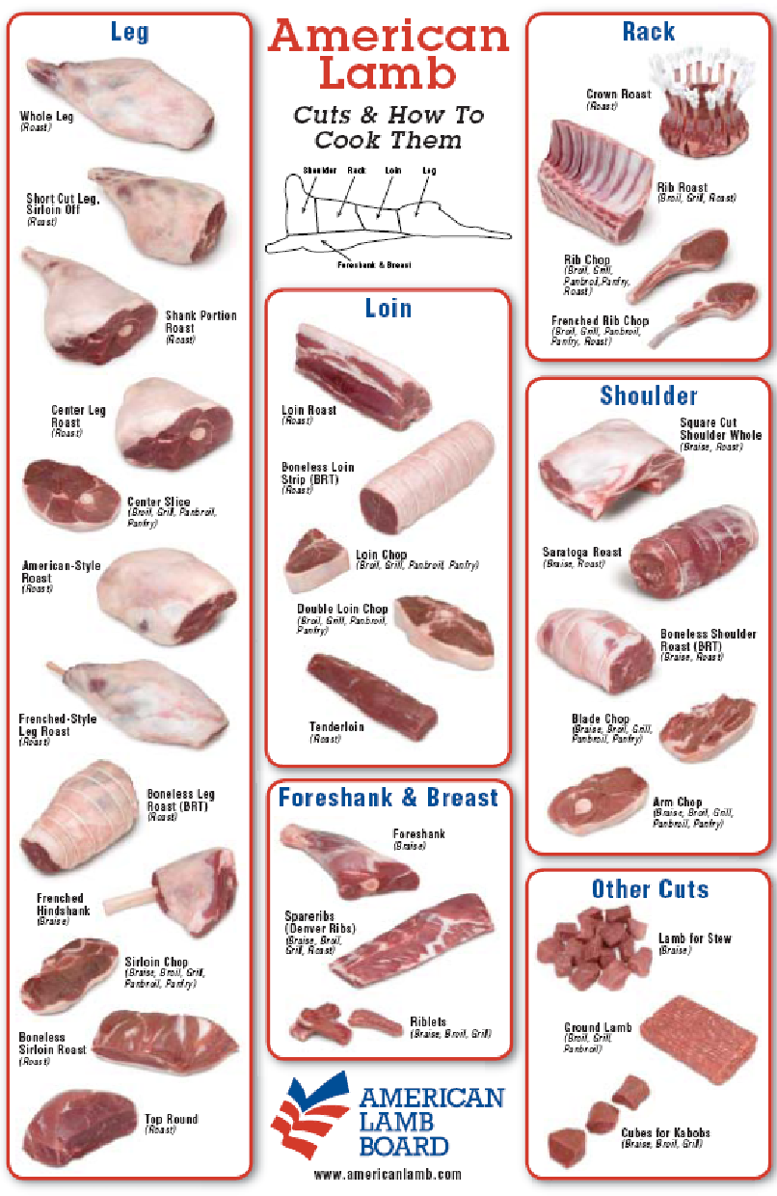

Record Keeping

Starting Out

Desired Weight at Fair ______________ pounds

Starting Weight ______________ pounds

Weight Gain Needed ______________ pounds

Days to Fair ______________ pounds

Desired Average Daily Gain ______________ pounds
(Weight gain/days to fair)

Results

Finish Weight ______________ pounds

Start Weight ______________ pounds

Gain ______________ pounds

Days on Feed ______________ pounds

Average daily gain ______________ pounds

Weight Record

Date | Weight | Gain | ADG | Fair Weight #
  - Gain = current weight – previous weight
  - ADG = gain/number of days since last weight
  - #Fair Weight = (ADG x days to fair) + current weight

Roseburg High School Agriculture Department
Exhibitor Contract

FFA members have the opportunity to raise animal projects to exhibit at the Marin County, Douglas County Fair. These projects require a student to take on a great deal of responsibility. In order for all students to learn and work together, the following requirements are expected of each exhibitor regardless of where the animal is housed or species being raised.

Participating in the fair is a school activity. All school and fair rules and policies apply. Failure to follow the rules will prevent you from participating in all further fair events (showing and selling of your project).

In the event that a student is not able to exhibit their animal(s) at the fair, the animal will remain the responsibility of the student (feeding, care of, maintenance, accommodations, etc) as well as, financially until the termination of the project.

Pre-Fair
- Grades: In order to exhibit an animal as a member of the Rosburg FFA chapter, a Grade Point Average of a 2.0 must be earned as shown on the Spring Semester Report Card and they must have a 2.0 GPA minimum and no F’s in their enrolled agriculture classes. If a student does not have a minimum GPA of a 2.0 he/she will not be able to show under Roseburg FFA. Students must not have any “F” grades as per district policy.

- Entries: Entries are the responsibility of the exhibitor.

- FFA Record books: Students must have an up to date record book before the advisor will sign any fair entry forms. If a student is a second, third or fourth year member they are required to have their current book and all of their past books completed before the advisor will sign fair entry forms.

- Uniform: Have a complete FFA show uniform (FFA jacket, FFA tie/scarf, white pants, white collared shirt, black or brown shoes and a black or brown belt).
*The uniform will be worn on market show & showmanship days and at the
auction.

- Preparation of animals: Be sure that your animal is shorn, clipped, etc. PRIOR to haul in date. If an animal is sick, is prolapsing, has fungus, or any other problem that will not enable a student to show the animal (as set by the fair) then it is the student’s responsibility to take care of the animal(s).

- Equipment: Have all specified (as stated by advisor) tack and show supplies, soap, halters, show sticks, towels, feeders, water buckets, etc. ready.

- Feed and Bedding: Order any needed grain and/or hay needed for the fair. Bedding is the responsibility of the student. Sheep: Shavings Hogs, Dairy, Goats: Straw

- Meetings: You must attend all exhibitor meetings called by the advisor. These will occur prior to the start of the fair and during the fair.

- Transportation: Transportation of animals is the responsibility of the students. Please be sure to make arrangements prior to the haul in date and tell the advisors your plans to ensure that all animals get to the fair. Be sure to have rides to the fair every day to care for your animals and meet the responsibility requirements set. If there is a problem contact the advisor.

During Fair

- Clothing: Wear appropriate clothing during loading, exhibiting and loading out at the fair (long pants, short sleeve or long sleeve shirt, socks and closed toe, closed back shoes). School dress code must be followed.

- Feeding and Barn Duty: You must be present at required feeding times. You must stay at our barn area during scheduled barn duty times. During barn duty you are to complete all required responsibilities. Keep personal areas as well as the chapter area clean and swept at all times.

- Showmanship: Showmanship is an opportunity to demonstrate your knowledge of your project. All exhibitors will be required to participate in showmanship.

- Etiquette: You are a representative of the FFA, your school, community and the agriculture industry. Be sure to be a positive representative. Be courteous and respectful to fair patrons, fellow exhibitors and guests at the fair. Inappropriate behavior will not be tolerated. For example: swearing, inappropriate dress, fighting, etc. All school rules apply at the fair. In the event that school or fair rules are broken at the fair, you forfeit the privilege of selling your animal at the auction.

- Chapter Group: Chapter group is an opportunity to exhibit five animals in each species. The advisor will determine the animals that will be selected to be exhibited in the chapter group category. ALL students must be present to aid in showing the group and to provide support.

- Auction: Prior to Auction Day every exhibitor is to write thank you letters with an envelope and stamp. See fair premium book for guidelines. YOU WILL NOT RECEIVE A CHECK WITHOUT A THANK YOU LETTER.
  - Auction Day: Be at the fairgrounds by 8am, in uniform and ready to meet some potential buyers.
  - No Animal Accessories: No glitter, paint, flowers, etc. on your animal.

- Buyers: It is not the responsibility of the advisor to find a buyer for your animal, although I try to make contacts with you in mind. It is your responsibility to secure a buyer. You may send buyer letters to community supporters (must be approved by the advisor). You may also be asked by the advisor to talk with some potential buyers before the auction takes place while at the fair. Be willing and ready to discuss your project with some members of the agricultural community.

Post-Fair

- Thank You Letters: See guidelines in the fair book. They must be turned into the fair office within 14 days of the completion of the fair.

- FFA Record Books: If you are interested in earning your Chapter FFA Degree, State Farmer Degree or applying for a proficiency award, be sure to see your advisor for help to complete your record books. The sooner you get them done the better and less stress come application time!

Questions or concerns?
Contact Mrs. Chenoweth (541) 817-7153

I, _________________________, have read and understand the rules and expectations as stated above. I understand that if these rules are broken or expectations are not met I will accept the consequences.

Student Date

Parent Date

Advisor Date
Roseburg High School Agriculture Department
Exhibitor Contract

FFA members have the opportunity to raise animal projects to exhibit at the Marin County, Douglas County Fair. These projects require a student to take on a great deal of responsibility. In order for all students to learn and work together, the following requirements are expected of each exhibitor regardless of where the animal is housed or species being raised.

Participating in the fair is a school activity. All school and fair rules and policies apply. Failure to follow the rules will prevent you from participating in all further fair events (showing and selling of your project).

In the event that a student is not able to exhibit their animal(s) at the fair, the animal will remain the responsibility of the student (feeding, care of, maintenance, accommodations, etc) as well as, financially until the termination of the project.

Pre-Fair
- Grades: In order to exhibit an animal as a member of the Roseburg FFA chapter, a Grade Point Average of a 2.0 must be earned as shown on the Spring Semester Report Card and they must have a 2.0 GPA minimum and no F’s in their enrolled agriculture classes. If a student does not have a minimum GPA of a 2.0 he/she will not be able to show under Roseburg FFA. Students must not have any “F” grades as per district policy.

- Entries: Entries are the responsibility of the exhibitor.

- FFA Record books: Students must have an up to date record book before the advisor will sign any fair entry forms. If a student is a second, third or fourth year member they are required to have their current book and all of their past books completed before the advisor will sign fair entry forms.

- Uniform: Have a complete FFA show uniform (FFA jacket, FFA tie/scarf, white pants, white collared shirt, black or brown shoes and a black or brown belt).
*The uniform will be worn on market show & showmanship days and at the
auction.

- Preparation of animals: Be sure that your animal is shorn, clipped, etc. PRIOR to haul in date. If an animal is sick, is prolapsing, has fungus, or any other problem that will not enable a student to show the animal (as set by the fair) then it is the student’s responsibility to take care of the animal(s).

- Equipment: Have all specified (as stated by advisor) tack and show supplies, soap, halters, show sticks, towels, feeders, water buckets, etc. ready.

- Feed and Bedding: Order any needed grain and/or hay needed for the fair. Bedding is the responsibility of the student. Sheep: Shavings Hogs, Dairy, Goats: Straw

- Meetings: You must attend all exhibitor meetings called by the advisor. These will occur prior to the start of the fair and during the fair.

- Transportation: Transportation of animals is the responsibility of the students. Please be sure to make arrangements prior to the haul in date and tell the advisors your plans to ensure that all animals get to the fair. Be sure to have rides to the fair every day to care for your animals by 7 am and meet the responsibility requirements set. If there is a problem contact the advisor.

During Fair

- Clothing: Wear appropriate clothing during loading, exhibiting and loading out at the fair (long pants, short sleeve or long sleeve shirt, socks and closed toe, closed back shoes). School dress code must be followed.

- Feeding and Barn Duty: You must be present at required feeding times. You must stay at our barn area during scheduled barn duty times. During barn duty you are to complete all required responsibilities. Keep personal areas as well as the chapter area clean and swept at all times.

- Showmanship: Showmanship is an opportunity to demonstrate your knowledge of your project. All exhibitors will be required to participate in showmanship.

- Etiquette: You are a representative of the FFA, your school, community and the agriculture industry. Be sure to be a positive representative. Be courteous and respectful to fair patrons, fellow exhibitors and guests at the fair. Inappropriate behavior will not be tolerated. For example: swearing, inappropriate dress, fighting, etc. All school rules apply at the fair. In the event that school or fair rules are broken at the fair, you forfeit the privilege of selling your animal at the auction.

- Chapter Group: Chapter group is an opportunity to exhibit five animals in each species. The advisor will determine the animals that will be selected to be exhibited in the chapter group category. ALL students must be present to aid in showing the group and to provide support.

- Auction: Prior to Auction Day every exhibitor is to write thank you letters with an envelope and stamp. See fair premium book for guidelines. YOU WILL NOT RECEIVE A CHECK WITHOUT A THANK YOU LETTER.
  - Auction Day: Be at the fairgrounds by 8am, in uniform and ready to meet some potential buyers.
  - No Animal Accessories: No glitter, paint, flowers, etc. on your animal.

- Buyers: It is not the responsibility of the advisor to find a buyer for your animal, although I try to make contacts with you in mind. It is your responsibility to secure a buyer. You may send buyer letters to community supporters (must be approved by the advisor). You may also be asked by the advisor to talk with some potential buyers before the auction takes place while at the fair. Be willing and ready to discuss your project with some members of the agricultural community.

Post-Fair

- Thank You Letters: See guidelines in the fair book. They must be turned into the fair office within 14 days of the completion of the fair.

- FFA Record Books: If you are interested in earning your Chapter FFA Degree, State Farmer Degree or applying for a proficiency award, be sure to see your advisor for help to complete your record books. The sooner you get them done the better and less stress come application time!

Questions or concerns?
Contact Mrs. Chenoweth (541) 817-7153

I, _________________________, have read and understand the rules and expectations as stated above. I understand that if these rules are broken or expectations are not met I will accept the consequences.

Student Date

Parent Date

Advisor Date

