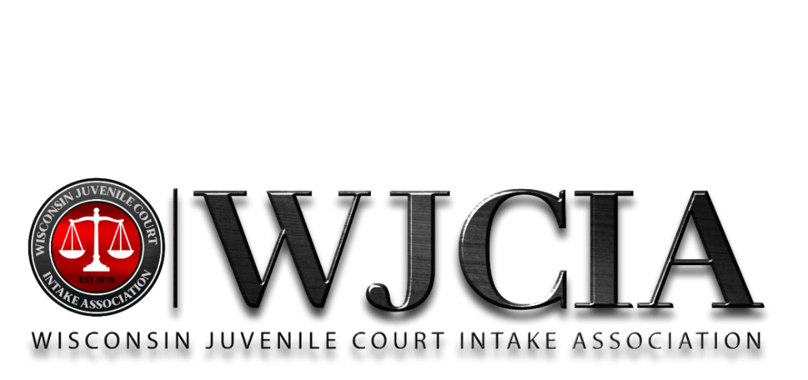

www.wjcia.org
2024 – 2025
BOARD OF DIRECTORS

STACY LEDVINA
President
Manitowoc County

BARB HOLT
President Elect
Sheboygan County

CATHRINA DUNNUM
Secretary
Vernon County

KATHLEEN BELL
Treasurer
Iowa County

KARI MCKENNA
Monroe County

KENNY CYRACUS
Outagamie County

KATHY GOURDINE
Fond du Lac County

KERRY KRISTA
Chippewa County

JOYLYNN GEORGE
Pierce County

MELISSA WILLIAMS
Washburn County

JODI PETERSEN
Portage County

SARAH SOCHA
Price County

LINZI LUCK
La Crosse County

KIM SCHWARZ
Langlade County

TRACY ERICKSON
Dunn County

ASHLEY TIMMERMAN
Jefferson County

RACHEL JOHNSON
St. Croix County

JACOB HANIFL
Dane County

JASON HALBACH
Brown County

MORGAN DOTY
Grant County

WJCIA Annual Agenda
September 17th, 2025; 12pm

- Call to Order – President
  - President Stacy Ledvina called the annual meeting to order at 12:09pm.

- Secretary’s report - Cathrina
  - Stacy provided this report on behalf of Cathrina. Cathrina reported minutes from last annual meeting (September 2024) are posted on WJCIA website, along with all other board meetings minutes.

- Treasurer’s Report - Kathy
  - Katie is out on family leave. Stacy provided the report on behalf of Kathy and Katie to help save time passing the mic.
  - The financial reports are available to any member upon request.
    - If you would like to review the statement of accounts, send an email to Katie Bell or Kathy Gourdine.

- Committee Reports
  - Grant: Stacy reported Grant committee is completing year 2 of our innovation grant. We have been able to train 8 individuals to be able to provide ART training.
    - There is one more training scheduled for ART this year (2025) on October 27 and 28 in Madison.

- Nomination/Election – Secretary
  - The membership was asked for nomination from the floor on three separate times per By-Laws.
    - No additional nominations were received from the floor.
  - The ballots were explained that they were currently sitting on the tables.
    - This year it is necessary to hold an election as there is more than 20 individuals interested in being on the board of directors for the 2025-2026 year.
    - Please vote for up to 20 individuals. You can vote for less, but any ballots with more than 20 votes will be invalid.
    - Ballots will be picked up and will be counted by Michelle Buehl in a separate location and results will be posted.

- Transition between President Elect and President – Stacy and Barb

          - Stacy introduced Barb Holt to the membership as our 2025-2026 president. Stacy talked about working closely with Barb this past year, and the membership will be in good hands.
          - Barb Holt Thanked Stacy for the past year and presented her with a plaque.
        - Announcements
          - Hospitality will be held in condo 1203
          - Live Music will be held after hospitality
        - Adjournment
          - Kathy made a motion to adjourn the board meeting at 12:30. The motion was seconded by Cathrina as well as the full board.

  - The ballots were provided to Michelle Buehl, and she was provided with the key fob to the boards storage room to count the ballots. 199 ballots were collected, and results are below
    - *153 - Kenny Cyracus – Outagamie
    - *152 – Kathy Gourdine – Fond du Lac
    - *149 – Kerry Krista - Chippewa
    - *148 – Stacy Ledvina – Manitowoc
    - *141 – kari McKenna – Monroe
    - *140 – Jason Halbach – Brown
    - *137 – Jodi Petersen – Portage
    - *137 – Rachel Johnson – St. Croix
    - *136 – Katie Bell – Iowa
    - *135 – Morgan Doty – Grant
    - *135 – Jacob Hanifl – Dane
    - *133 – Cathrina Dunnum – Vernon
    - *132 – Sarah Socha – Price
    - *129 – Jennifer Vlasrik – Polk
    - *127 – Tracy Erickson – Dunn
    - *119 – Linzi Luck – La Crosse
    - *118 – Ashley Timmerman – Jefferson
    - *117 – Tiffany McWhorter – Racine
    - *113 – Rebecca Guetzkow – Winnebago
    - *92 – Marissa Widgren – Pierce
    - 90 – Brienna Metko – Rawhide
    - 70 – David Guetzkow – St. Charles Inc.

