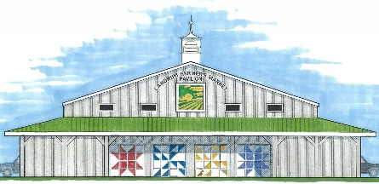
LANDRUM FARMERS MARKET
2023 Market Dates
SATURDAYS – April 1, 2023 – October 28, 2023

VENDOR APPLICATION & CERTIFICATION
The Landrum Farmers Market is a producer’s market. You must produce your product to participate and sell at the Landrum Farmers Market. In order to protect Market credibility, you are asked to sign this certification of your products. By signing this application and certification, you understand that if your product is questioned, your farm, kitchen or workshop will be subject to inspection by members of the Landrum Farmers Market or Landrum city officials.
You must list any primary and/or secondary products. You will only be allowed to sell products you list on this application and certification form.
PLEASE PRINT
I/we do certify that all products I/we offer for sale at the Landrum Farmers Market have been produced on my/our farm, kitchen, nursery, or workshop.
NAME: ________________________________ PHONE: _______________________
ADDRESS: ________________________________ EMAIL: _______________________
________________________________
FARM or BUSINESS NAME: __________________________________________________
FARM or BUSINESS WEBSITE: ________________________________________________
If accepted into the market, do you want a link to your website from the Landrum Farmers Market website? _____YES _____NO

PRIMARY PRODUCTS: _______________________________________________________
_________________________________________________________________________
List any other products you may want to sell: ___________________________________

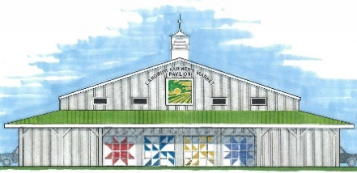
LANDRUM FARMERS MARKET

VENDOR FEE STRUCTURE
Field and Kitchen products $15.00 each market
Vendors can prepay for entire season for $250.00. Vendors that prepay will be featured with links on our new Landrum Farmers Market website.

Crafts (initially limited to 6 vendors) $15.00 each market
Youth (16 and under) $2.00 each market

All vendors must also obtain and/or hold a City of Landrum Business License which is renewed annually as of April 1. This license can be purchased at City Hall during normal working hours. You must keep a copy of your Landrum Business License with you at the market for review.

PRIORITY & PARTICIPATION
In all cases, market priority is for farm producers and space will be assigned to farm producers before food and craft vendors.
Early and later in the market season, spaces will be filled as needed with food and craft vendors.
Please indicate your anticipated start date, if you plan to start any date other than the first Saturday – April 1, 2023. START DATE: ____________________
Please indicate below your desired level of participation in the Landrum Farmers Market:
_____ Every Saturday _____ 1 Saturday per month _____ 2 Saturdays per month

SIGNATURE: ________________________________ DATE: __________________________

FOR CRAFTERS ONLY
The Landrum Farmers Market will host a monthly craft market in the field across from the Farmers Market Pavilion.
If you are interested in participating in these monthly craft markets, please indicate ______YES ______NO
MAIL to: Landrum Farmers Market SCAN & PDF, EMAIL to: landrumfm@gmail.com
C/O Landrum City Hall
100 Shamrock Ave.
Landrum, SC 29356

