SPONSORSHIP FORM

Business Name _____________________________________________________________________________________

Contact Name ______________________________________________________________________________________

Email Address ______________________________________________________________________________________

Business Address ___________________________________________________________________________________

SPONSOR LEVEL

Hole (sign at a tee box) $ 100

Bronze (sign at a tee box, name on volunteer t-shirts & banner at clubhouse) $ 250

Silver(sign at prime tee box location, name on volunteer t-shirts & enhanced banner at clubhouse) $ 500

Gold (announcement recognition, sign at prime tee box location, name on volunteer t-shirts & enhanced acknowledgement on banner at clubhouse) $1000

For design requirements, contact Lancaster Signs at jeremy@lancastersigns.com

Invoice provided for payment and receipt.
SUBMIT PAYMENTS Via mail to Carthage Area United Way, P.O. Box 250, Carthage MO 64836 referencing Golf Tournament
or pay online via credit/debit card at https://give.classy.org/cauwgolf or scan the QR Code below

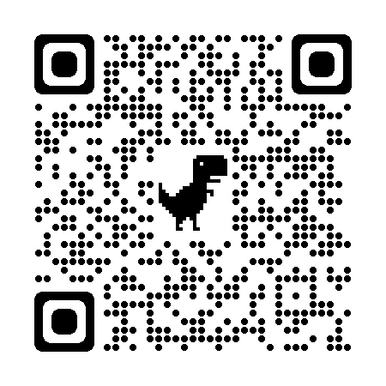

**Payment must be received by Friday, September 15th.**

