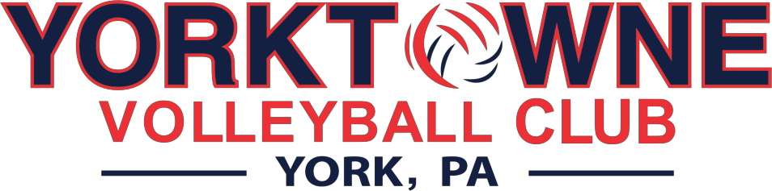

**PROGRAM HIGHLIGHTS & Information**

# Additional Skills Sessions

In addition to the standard 2 team practices per week, Yorktowne will offer additional small group skill breakdown training opportunities to our athletes, Tuesdays from 7:30-9:30pm. Our coaches are committed to elevating individual volleyball skills and maximizing the potential of all our athletes.

# Recruiting Assistance

We are excited to offer college recruiting assistance to our athletes who have a goal of continuing their volleyball careers in college! This year, we are pleased to welcome Selene Gentzler to Yorktowne, where she will provide 1on1 and small group recruiting guidance to any of our athletes that are interested in utilizing this benefit. Selene is the author of two books, Club Volleyball 101 & Recruit Buddy Jr., and has 13 years of experience in the volleyball industry as a coach, recruiting coordinator, volleyball parent and parent educator.

# Sports Performance Training

Just as important as dedicating your time to practices where you develop your volleyball skills, preparing your body for the season is just as essential. As a Yorktowne athlete, you will also train once per week with a Certified Sports Performance Coach from S3 Performance Academy. These sessions will focus on strength, quality, movement patterns, speed & agility; all of which assist in reducing the risk of injury and enhancing athleticism.

# Hudl & Hudl Assist

Yorktowne will provided Hudl to our athletes to assist in the recruiting process and breakdown of film. Hudl is the server to which we will upload our tournament matches to where then our players can watch film and create highlights reels to send to college coaches. Hudl will also breakdown stats for our players and coaches to view.

# Tournament Schedule

Yorktowne offers a competitive tournament schedule. We will enter both USAV and AAU tournaments throughout the course of a club season. We feel that competing in tournaments for multiple organizations will allow our athletes to have exposure to various competitive team levels from many different volleyball clubs and will allow for maximum exposure to different college coaches. We will never select a tournament schedule based on price, only exposure and quality of competition.

# Community Service

Giving back to our community is something Yorktowne takes pride in! Yorktowne athletes will be involved with local programs that enrich the community in which we live, work and play. Our community service efforts will be led by Heather Shoemaker.

# Social Media

We will keep all our families connected and up to date on what is happening with our program. Josh Brenneman, will lead this charge, spreading the word and connecting our families and teams.

# Team Activities

Yorktowne athletes will not just connect on a competitive level, but also a personal level. Cohesion is one of the 7 C’s of Championship Team building and we feel it’s an essential quality for our athletes to have in order to be running on all cylinders come competition day. Our athletes will perform as a team, both on and off the court.

# Master Coaching Implementation

At Yorktowne, our athletes will be coachable, no matter who is leading a practice session. Our coaching staff will have every athlete in the gym in mind when in the practice gym. Players will learn and grow from all of the Yorktowne coaching staff during their practice sessions.