How to bath a corgi
Beckie Williams, Coventry
Please note, this is just how we do our basic baths. Show baths are different.

Equipment:
Corgi
Grooming table (Amazon or Chewy)
Towel
Wash cloth to wash the face and the inside of the ear flap
Shampoo (any dog shampoo but I like purepet and Isle of dogs 20)
Power Dryer (Double K or Chris Christanson, you can’t use a people dryer, it gets too hot and you won’t be able to get your corgi completely dry or blow out dead hair)
Poodle comb see Amazon
Fine comb see Amazon
Rake (Amazon)
Dremel for Nails
Scissors for the hair between the pads on the bottom of the feet
Tub or Hose (See Booster Bath, or if someone can hold you can bath on the grooming table)

- Get you dog completely wet. Warm water is nice but cold water is fine. It takes some effort to get your corgi wet down to the skin. Their top coat, especially, repels water. Until you and your dog are more experienced, I would hold the base of the ears and only get from the ears back wet. Getting water in the ears can cause infection and is not very pleasant for the dog. Tubs are nice, you can do it on the ground but it is very hard on your back and your dog is unlikely to hold still. The grooming table, especially if the top is waterproof can be used, but until your dog will stay on the table, someone will need to hold.
- YOU MUST DILUTE the shampoo according to the instructions. Undiluted shampoo is wasteful and almost impossible to rinse out. Do a section at a time, and place shampoo on your corgi and rub it down to the skin. I start on the back, as this is the densest coat, then do the rear, the sides and each foot individually. I do the neck and chest, then the underside. If someone is holding, they can gently hold the pet up but the front legs to get the underside. If you are having trouble getting the shampoo to penetrate or suds, spray on a little water. The underside of a corgi is hard to get to, as their legs are so short, so being on a table helps. Most of our dogs can be gently placed with their front legs on the side of the tub and this helps to get to the underside.

You can use a whitening shampoo on the feet and the rear. If so, wash these areas first and let the shampoo stay on the feet longer.

The longer you scrub the cleaner your dog will be, and once they get used to it, most dogs enjoy it. After you have shampoo all over, use a wet cloth to clean the face and inside the ear flaps, but don’t let any water go down the ear canal.

- Rinsing is perhaps the most important step. If you don’t get all the shampoo out you will not be happy with the end result and your corgi is likely to get a skin infection. Rinse until the water coming off runs clear, then rinse another 10 minutes, perhaps an exaggeration, but many times I think I have them rinsed completely, only to find shampoo underneath or on the side as I am drying them. Between the front and back legs is the hardest area to rinse.

- Towel Drying is next. Carry your corgi to the grooming table and towel dry them for a few minutes, concentrate on the underside and on the feet and legs. Sometimes it is helpful to not towel right away, but let the dogs shake a few times. This reduces the drying time.

- Drying

Before we start, some things about the power dryer. Many dogs are scared of the noise, not the airflow, so try to avoid moving the dryer in such a way that it makes more noise. That means avoid moving the nozzle more that necessary. Avoid the face and front until your dog is more comfortable with the dryer. In the case of puppies, you always need a holder.

For show dogs we start at the base of the rear, where the tail would be and dry forward until the back and shoulders are completely dry. This is a good way to get your dog used to the dryer, but it is faster if you start in the middle of the back and blow as much water as you can off the coat in the direction of the hair. Starting at the rear and working forward dry the hair backwards and forwards until your corgi is dry all over, down to the skin. Expect about 20 minutes for a puppy, with assistance, 40 minutes for most adults. Towel dry the face. The feet take the longest.

For puppies, have someone hold the front, even with the towel, and start at the rear. You may not be able to get the puppy completely dry around the neck the first time, but be persistent and be sure at take a break, 30 seconds, if needed. Leave the dryer on during the break, just not directed at the puppy. ALWAYS stop on a good note.

- Nails with the Dremel were covered when you picked up your puppy. We do adults the same way. Some points to remember, no dog likes their nails done. Clipping the nail smashes it before it cuts and you are more likely to go too short. It is best that you Dremel your dog’s nails on a regular basis, rather than some stranger with clippers. Once a week means your dog has a chance to get used to it and makes it less stressful, rather than waiting until they are very long and take a long time to grind down.

- Use scissors to cut the long hairs between the pads on the bottom of the feet. Corgis should never be shaved or have their pants trimmed. Their hair never grows back the same and they shed just as much. Rarely a corgi needs a little bit of the hair around the rectum clipped to prevent feces from getting stuck on their rears.

Most corgis need baths once or twice a month. If your corgi is shedding excessively, and they will, combing and brushing before bathing is helpful, even between baths.
Poodle comb or butter comb
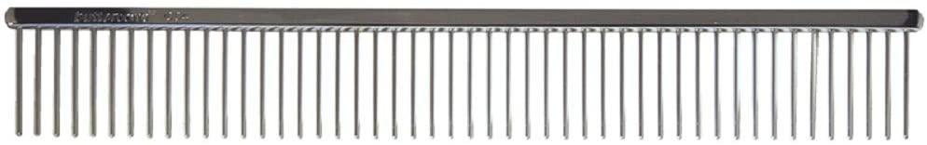

Pin (Pen) Brush

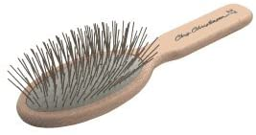
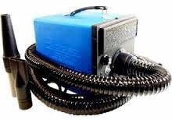Power dryer, they are expensive but last forever. We use them to blow leaves, dry the car, spray out dust.
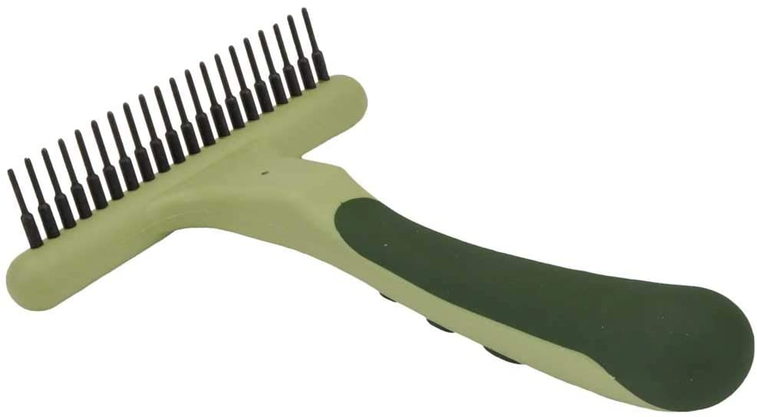Rake
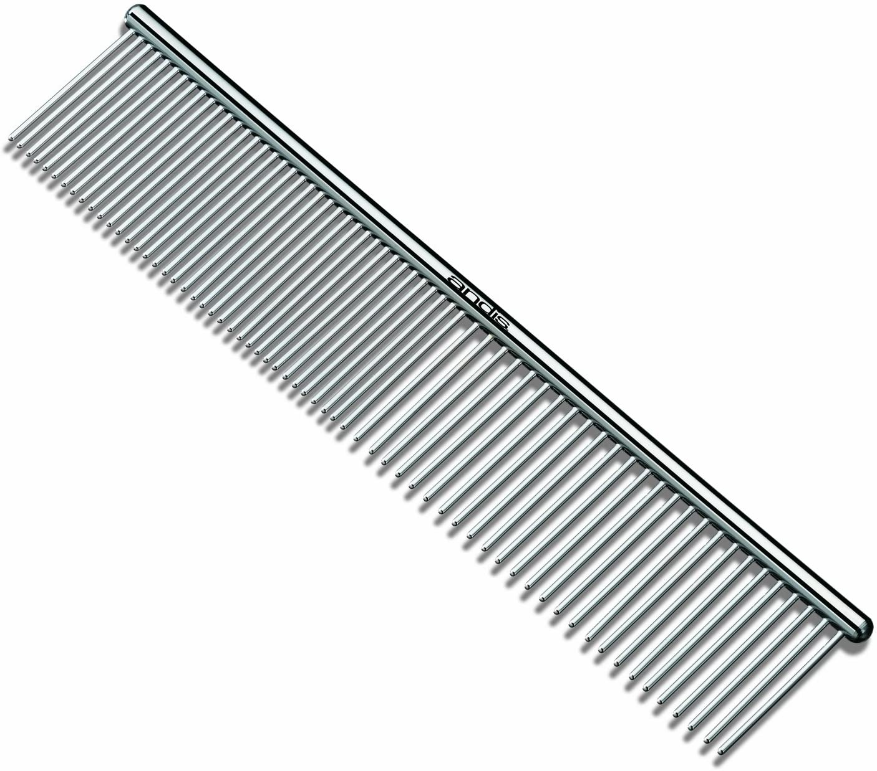Fine comb
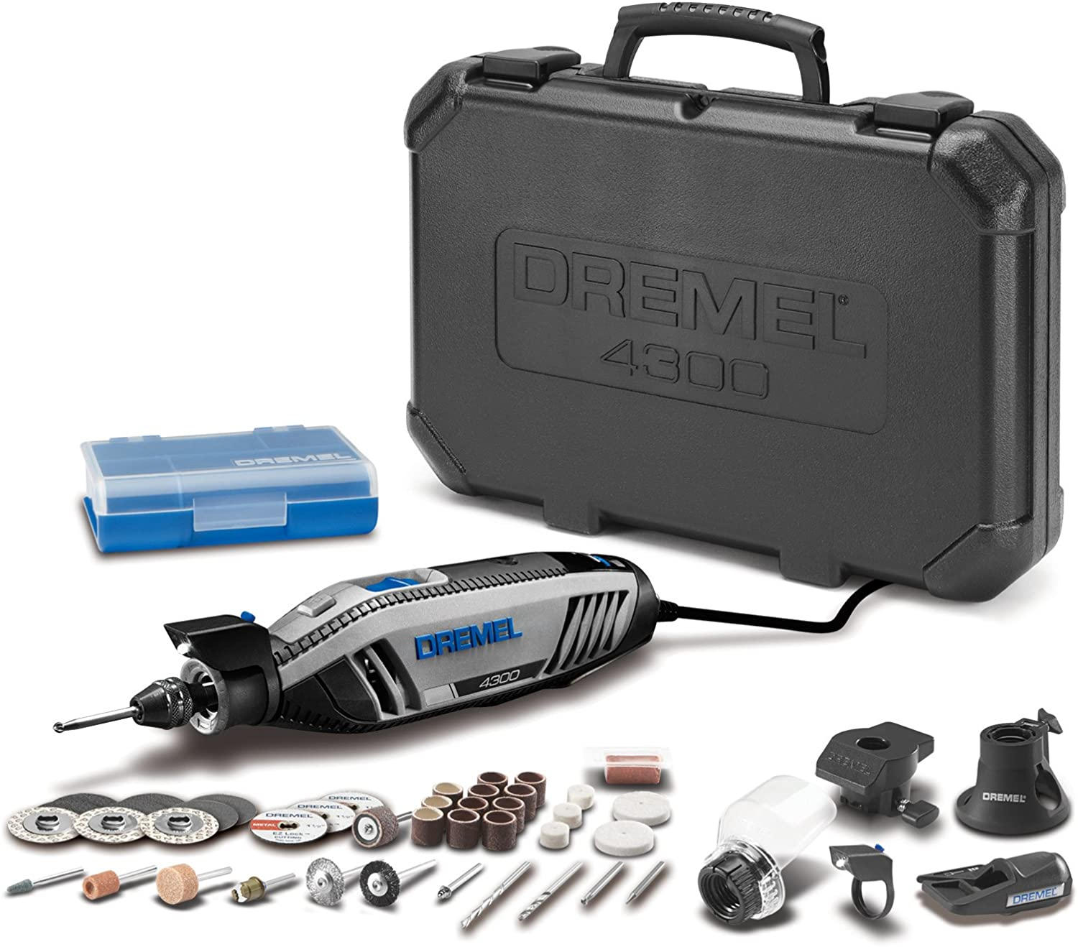Dremel. You don’t need all the accessories. I like the rechargeable cordless ones but COVID has make them hard to find
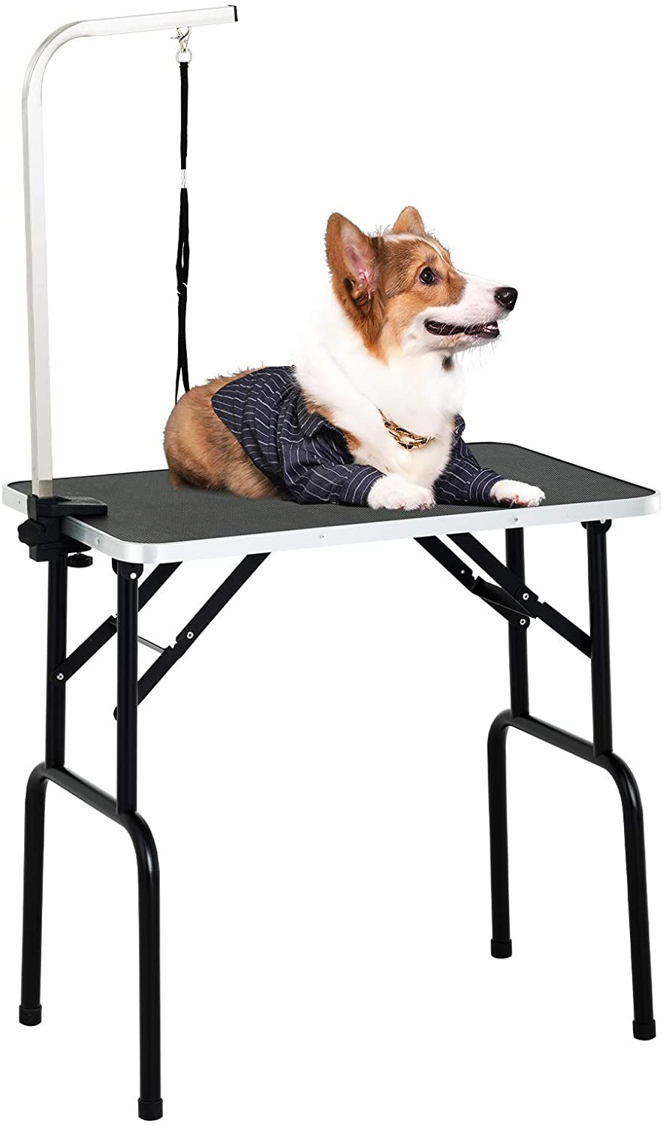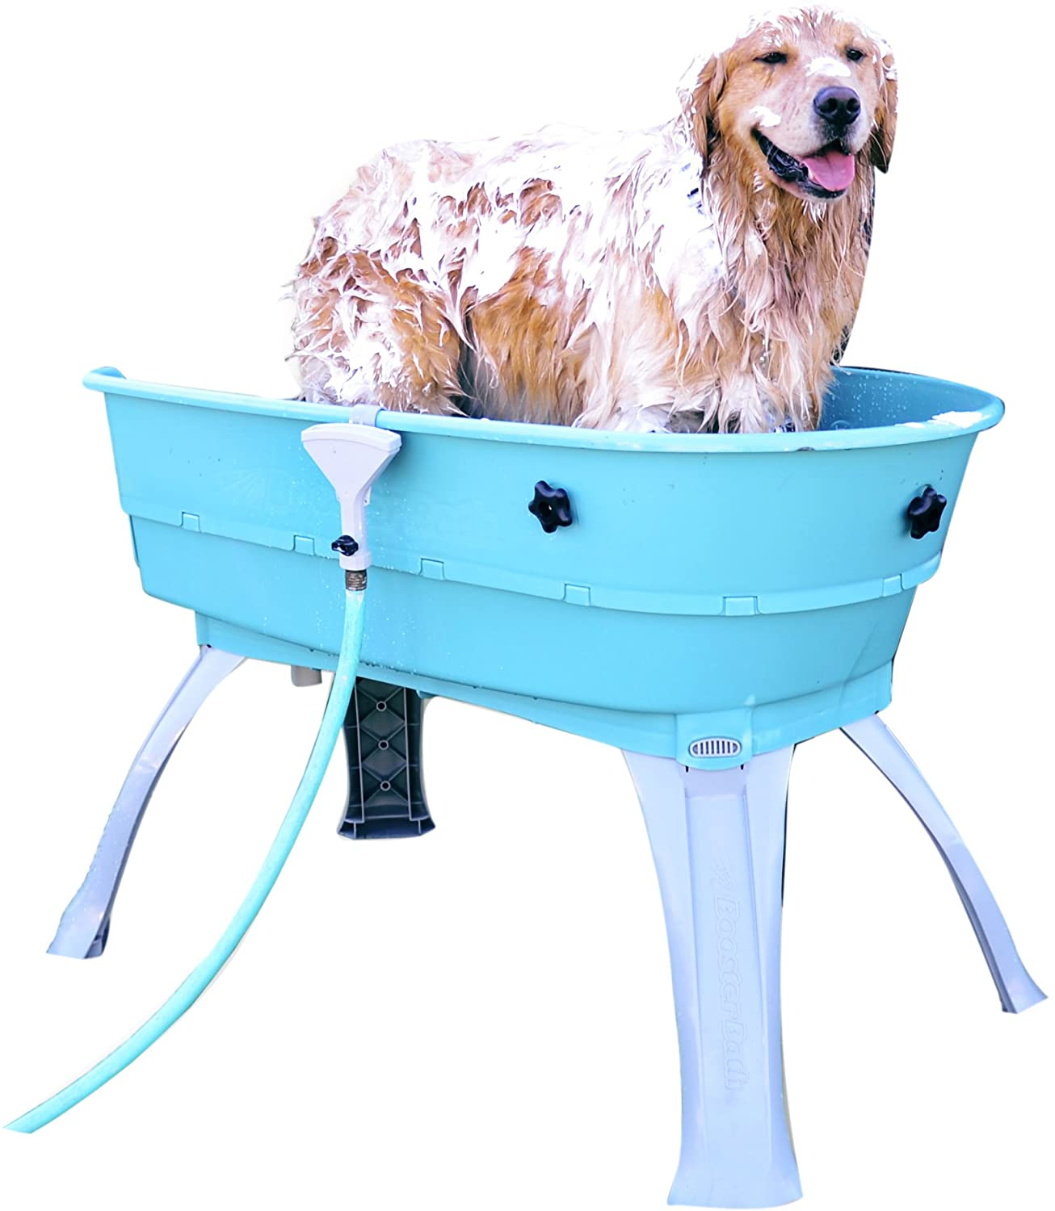Grooming table, there are many available. The grooming arm helps but you have to make sure your dog is comfortable with it and he can’t be left unattended. The booster bath is very hand and is a back saver.

