Haven Riviera Cancun
Group Rates for Angella & Brooks Destination Wedding
These rates are valid from February 21 to 27, 2022

Angella & Brooks will be getting married on Saturday, February 26, 2022.
The couple’s special wedding group rates have been secured and rooms have been blocked off, waiting for you to book your stay! The room categories and their rates are listed below.

Room Categories in Room Block
- Junior Suite Garden View
- Junior Suite Partial Ocean View
- Serenity Club Junior Suite Swimout Ocean Front

Please note there are only a certain number of rooms available in each category and they are available on a first come, first serve basis. If you are interested in a particular room category in the block – or one that is not in the block (our Travel Agent MarieSam can get discounted rates for all categories at the resort) -- we highly encourage you to book your reservation ASAP.

What is Included in Price?
- Room taxes
- Unlimited Luxury including All-Inclusive Food & Beverage/Alcohol and 24-hour room service
- Roundtrip Airport Transfers via AMStar Shuttle Service

What is NOT Included in Price?
- Airfare. You are responsible for reserving your own flights. If you'd like to include flights in your reservation, please let our travel agent MarieSam at mariesam@wrighttravelagency.com know when you contact her.
- Trip Insurance (prices below): All payments are non-refundable unless you have purchased travel insurance with your package. We highly recommend getting insurance but you have the option to decline when making your room reservation.

In-Room Amenities
In-Room Amenities
All rooms booked at Haven Riviera Cancun include:
✓ Electronic door bell
✓ Do not disturb button
✓ Celling fan
✓ Individually controlled A/C for personalized climate control
✓ King size bed (300 thread linen sheets)
✓ Aromatherapy menu (four choices)
✓ Sitting area
✓ Balcony or terrace with sitting area with Jacuzzi (no Jacuzzi for Swim-out categories)
✓ Bottle of Mezcal Blanco for private welcome toast
✓ Nightly courtesy
✓ Nespresso machine with capsules of your choice, 4 choices
✓ Daily restocked personalized mini bar
✓ Room service box
✓ 24 hrs room service
✓ Electronic safety deposit box with charging station (able to fit 15” laptops and tablets)
50” Flat screen TVs (including Surround system, Bluetooth and USB access)
✓ Cable television channels
✓ Radio alarm clock with smartphone docking station
✓ Complimentary WIFI access
✓ Direct dial telephone with multi lines and voice mail option
✓ Walk-in closet
✓ Full body mirror
✓ Rain drop shower
✓ 2 individual sinks
✓ Premium toiletries
✓ Vanity mirror
✓ Hairdryer
✓ Bathrobes and slippers
✓ Scale
✓ Umbrella
✓ Steam equipment for clothes
✓ Maid service 2 times daily including nightly turn down service.

ROOM RATES FOR HAVEN RIVIERA CANCUN

What are the extra perks with a Serenity Club Suite at Haven Riviera Cancun?
Elevate your stay at Haven in one of our most exclusive Serenity Club Oceanfront Suites. The moment you arrive you’ll be greeted at a private check-in lounge and escorted to one of the very best suites on the property. Throughout your stay as a Serenity Club customer you’ll be surrounded by exclusive VIP services and premium amenities. You’ll rest comfortably in a luxurious king bed with a premium pillow menu and sleep-well kit. You’ll stay refreshed with a premium mini-bar and an exclusive Serenity Club Lounge offering premium wines, spirits and various finger food presentations throughout the day. You’ll be indulged with butler service, premium Aromatherapy menu for personal wellness and serenity, and the finest toiletries. Serenity Club customers also enjoy a daily exclusive a la carte breakfast option served overlooking the ocean or pool, an invitation only weekly manager’s cocktail reception and special VIP treats served daily by the hotel Chef’s and nightly by the General Manager of the resort.

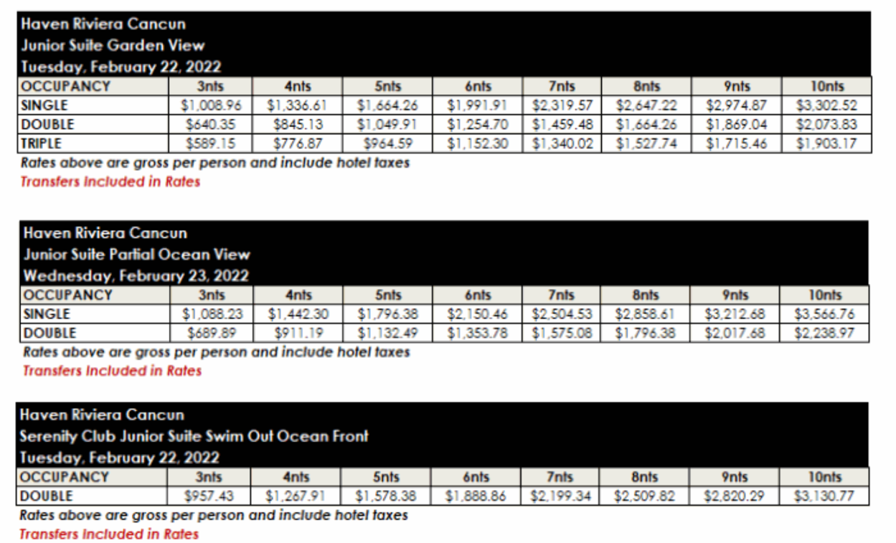

Rates are arrival date specific based off of the contracted room block. Rates may vary when bookings guests for alternative check-in dates.

Above rates are based on US dollars and are only valid for citizens of the United States. Prior notification of any NON-US Citizen traveling with group will be required and may be subject to increased rates

Travel Insurance Rates

Travel Insurance is not included in the room rates listed above.

The Insurance offered is from a 3rd party and is not part of Wright Travel Agency.

You will have to option to accept or decline the insurance during the reservation process.
If you initially decline the insurance but would like to add it back, you have that option up until 7 days after you place your reservation deposit. Insurance must be requested in writing.

• IMPORTANT: This comprehensive travel protection plan provides the enrolled client with either a full travel credit or refund in the event they need to cancel their trip for any reason right up to the departure time of the flight. Prices are indicated below.

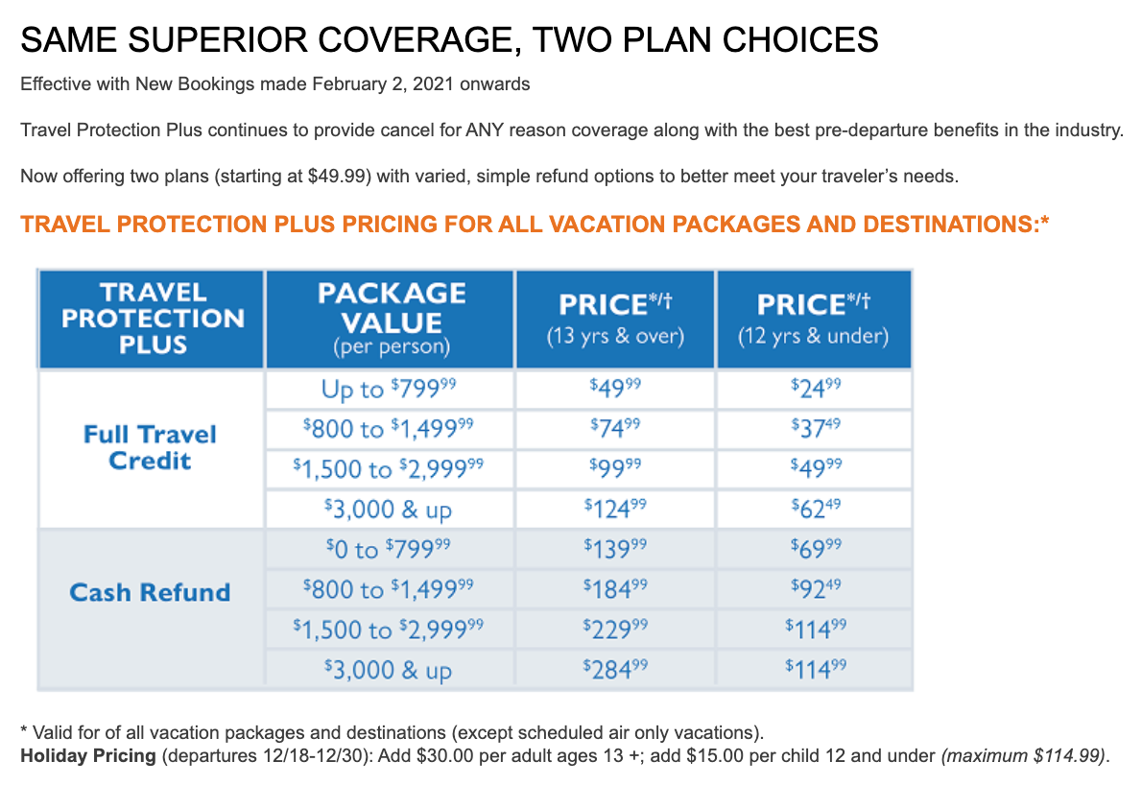

Important Deadline Dates

Any reservations requested after these deadline dates are strictly based on availability and not guaranteed.

October 15, 2021 | A $300 deposit per each room reservation is due. Your deposit may increase if you purchase a flight & hotel package or travel insurance.
December 15, 2021 | All final payments on flight & hotel reservations are due.

Are you Ready to Book?

If you're ready to make your reservation or have any questions about booking your stay for our wedding celebration, please contact our travel planner:

MarieSam Sanchez of Wright Travel Agency
mariesam@wrighttravelagency.com
Mobile: (562) 619-4446
Office Hours: Monday to Friday 10 a.m. to 6 p.m. (Pacific Standard Time)

