Feb2024 | SERVICE MINISTRY  HAPPENINGS
Many are the plans in a person’s heart, but it is the Lord’s purpose that prevails.  Proverbs 19:21 | To All,  What a busy year it has been for our Service Ministry!  We are truly thankful for the blessings God has bestowed upon us to share. Your dedication and commitment to our various programs have been invaluable. Together, with the generous support of our church family, we are making a meaningful difference in our community and beyond.  - Through our weekly Little Free Pantry, monthly Carpark meals programs, St. Mark’s Food Pantry collections and the Lenten Drive, we offer nourishment to those facing food insecurity, reminding them they are not alone.  - By sponsoring children to attend Camp Stevens through our Father’s Day Pie Sale, we provide more than just an experience; we help them build confidence, forge friendships, and encounter God’s love.  - Our Vida Joven Fiesta and fundraising campaign enabled us to sponsor meals for five orphanages in Mexico.  - Through the Backpack Drive, we provided children with school supplies, empowering them to attend school and develop friendships and support systems.  - In our Thanksgiving Drive, we partnered with local organizations to provide holiday meals for families in need. This initiative not only filled plates but also fostered joy and togetherness during a season of gratitude.  - Our Advent Angels program ensures that children experience the joy of the season. By providing new toys and gifts, we help create memorable moments that remind them they are cherished and loved.  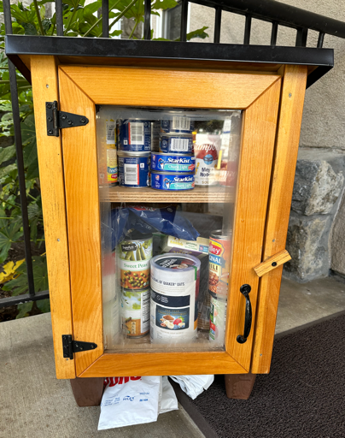  LITTLE FREE PANTRY  Thank you for generosity in filling our pantry!  1st Week: Kathleen I. and Kathy F.  2nd Week: Sudie W. and Susy P.  3rd Week: Pat E. and Julie Y.  4th Week: Sarah S. and Nancy F.  5th Week: Karen L. and Pat B.  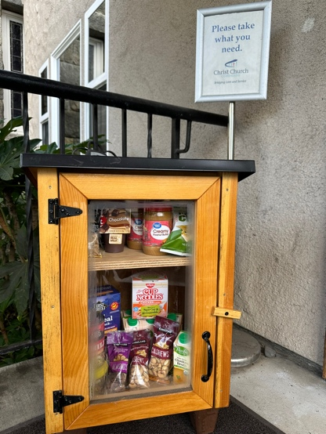  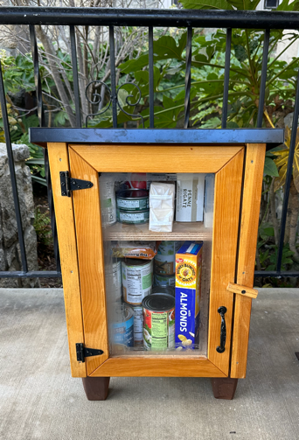  ST. MARK’S FOOD PANTRY  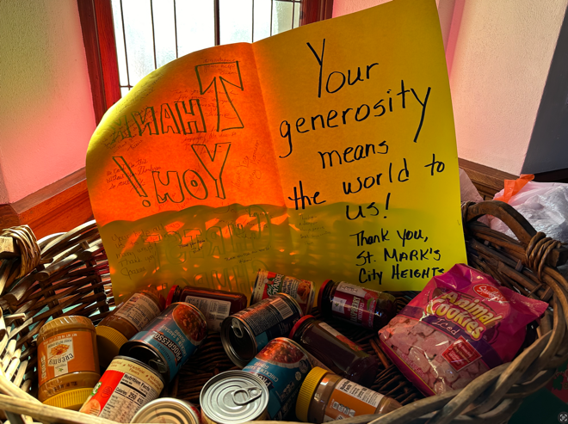  Thank you to all who donate the much needed items. Thank you also to Kathy and Glover F. for delivering the collected items to St. Mark’s!  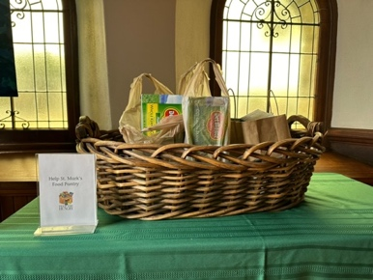

For I was hungry  and you gave me something to eat . . .  Matthew 25:35 | DREAMS FOR CHANGE DINNERS / CARPARK  Thank you to the teams who prepared the monthly meals (totaling about 60 meals) for vetted families who stay overnight in the New Life Assembly of God church parking lot.  1st Tuesday of the Month: Team Leaders - Karen C. and Pat B  2nd Monday of the Month: Team – Leaders - Pat E. and Nancy F.  Our chefs!  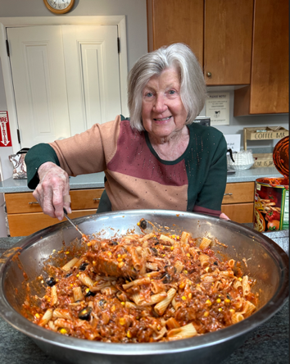  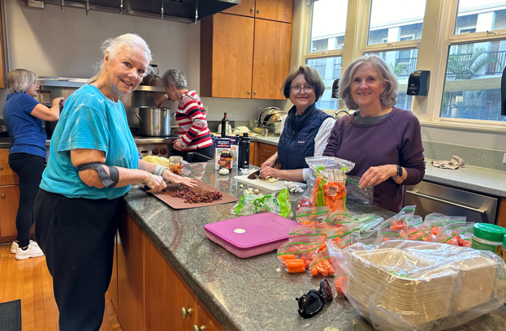  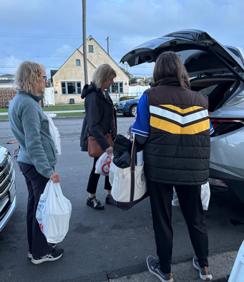  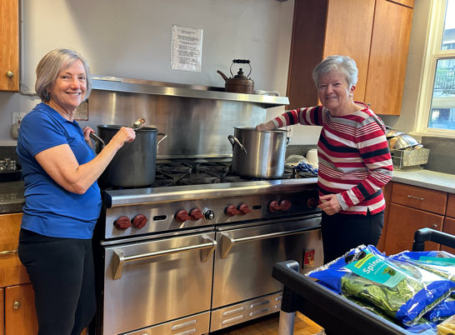  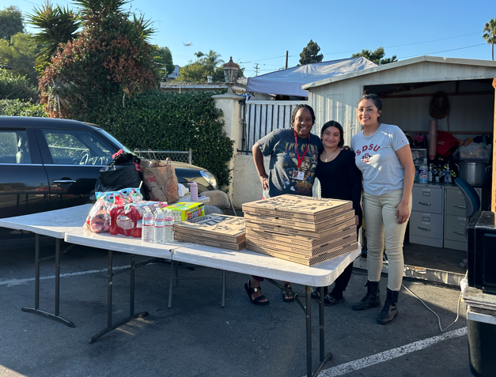  Parking lot staff!

And my God will meet all your needs  according to  the riches of his glory  in Christ Jesus.  Philippians 4:19 | LENTEN DRIVE  RECEPIENT: ST. MARK’S FOOD DRIVE  Thank you Scott and Marti H. for leading this fundraising project!    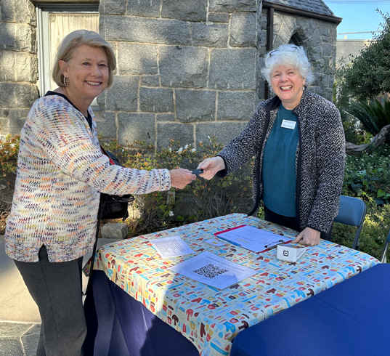  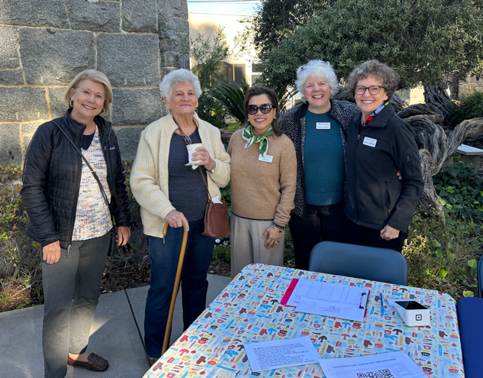  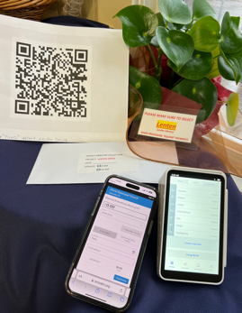  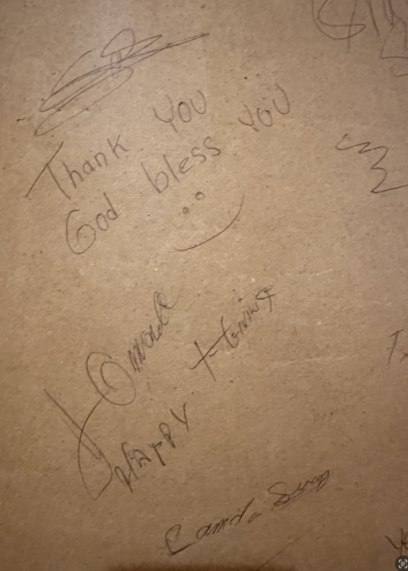    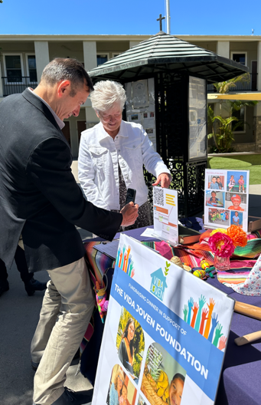  VIDA JOVEN  RECEPIENT: VIDA JOVEN ORPHANAGES  Thank you to all who helped with the fundraising and fiesta.  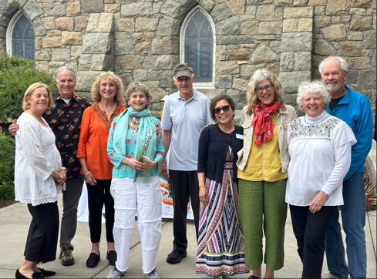  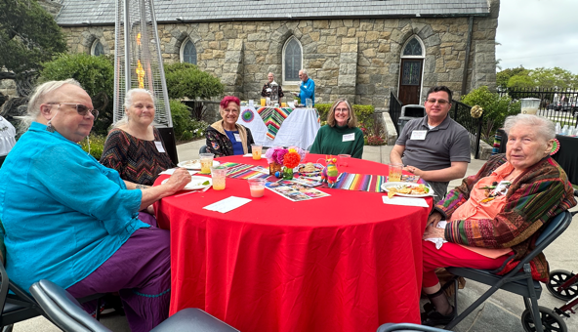  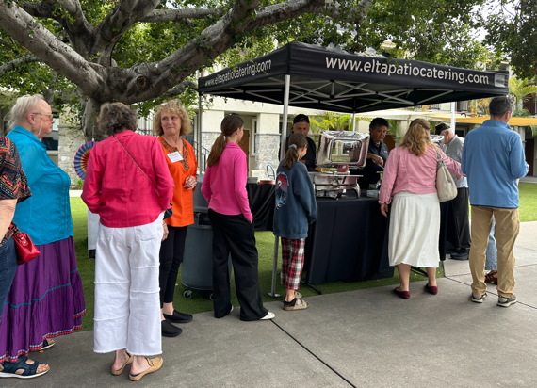  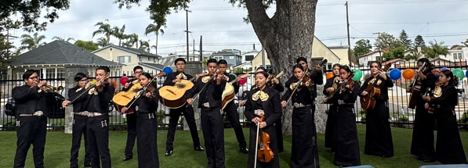  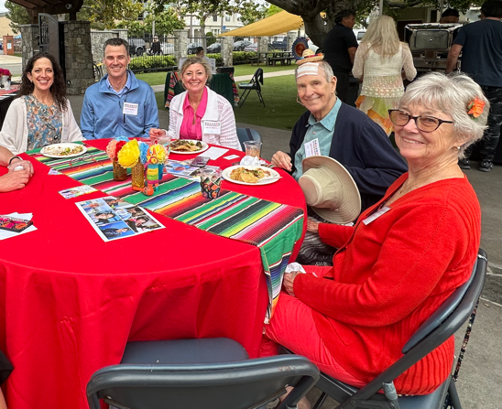  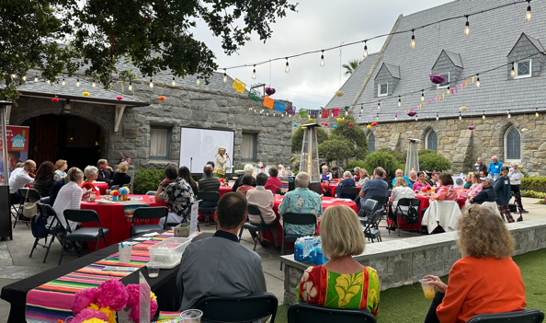    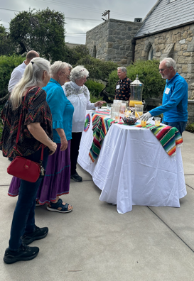  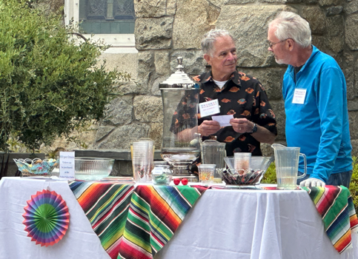  FATHER’S DAY PIE SALE  Thank you Kathleen I. and Kathy F. for leading the fundraising for RefugeeNet.  Once again, our bakers made wonderful pies for us to enjoy!  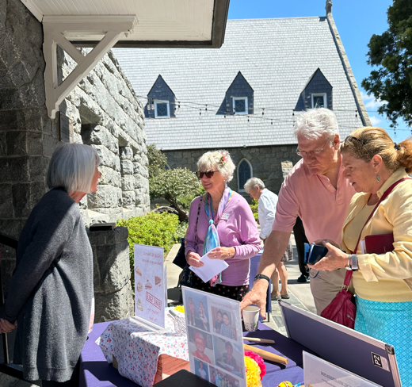  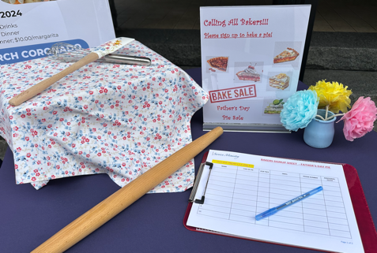  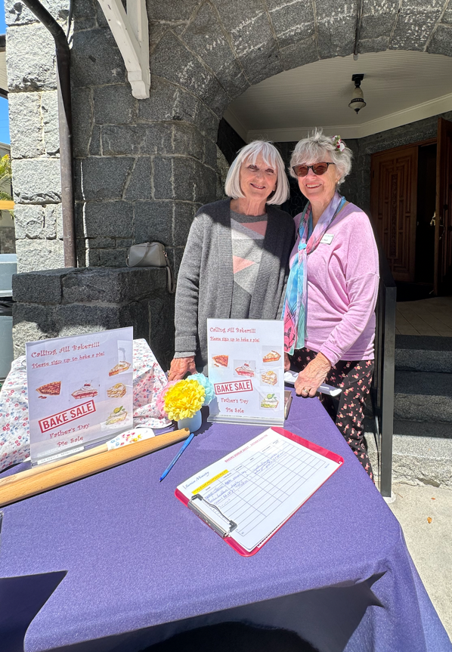    SUMMER KITCHEN CLEANOUT  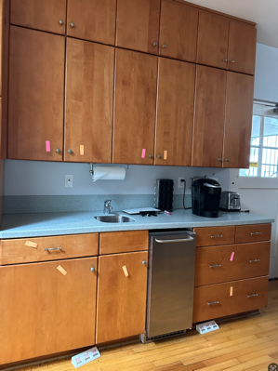  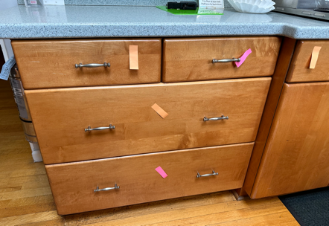  Thank you to all those who helped in organizing our church kitchen!  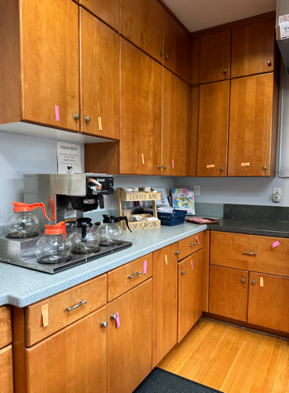  Done  and  tagged as  completed!  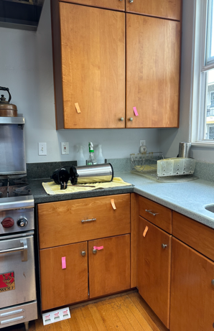  COLLECTION OF TOILETRIES FOR CARPARK  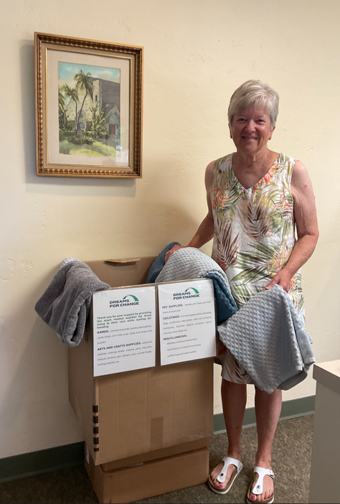  Thank you Pat E. for leading this project. Thank you to all those who donated! It was a great success!  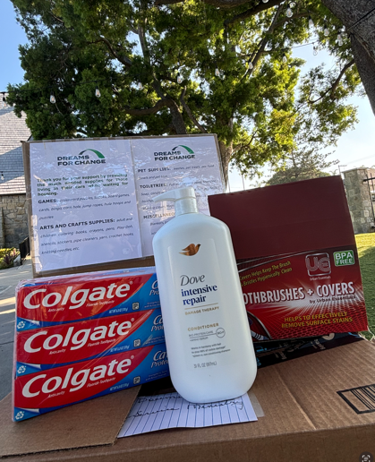  THANKSGIVING FOOD DRIVE  Thank you Nancy F. and Patty C. for your dedication to leading such a large project! Your attention to detail and management of all the moving parts of this initiative made it a great success!  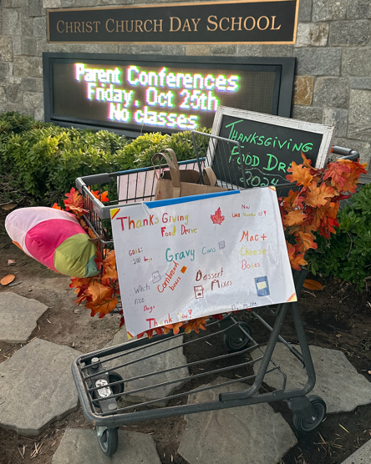  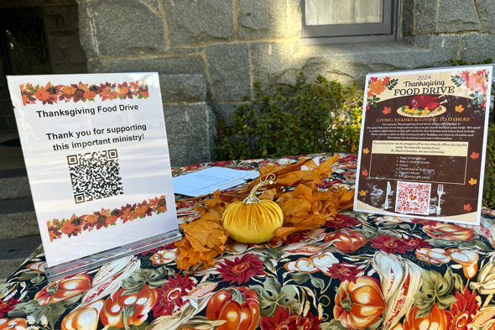  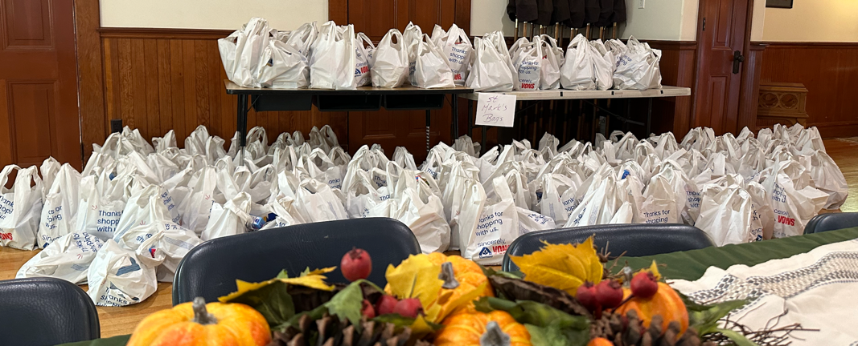    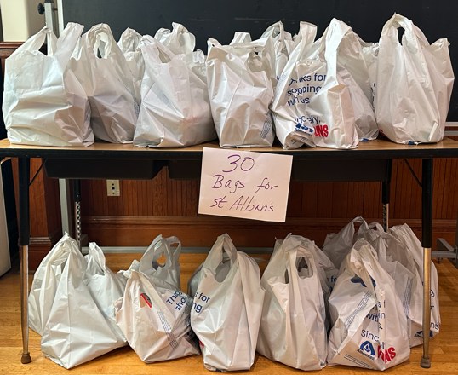  200 bags of food given St Mark's (170) and St Alban's (30)  $3,000 donated to St Mark's to purchase chickens and fresh foods  30 grocery gift cards ($20 each) donated to St Alban's  $500 donated to Uptown Community Services  Advent angels  Thank you Pat E. for leading this campaign!  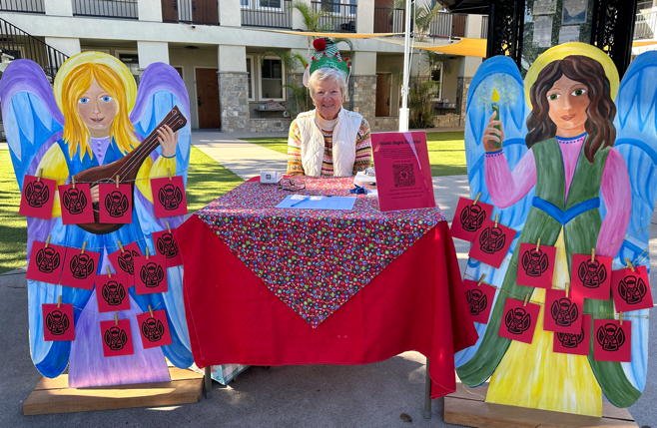  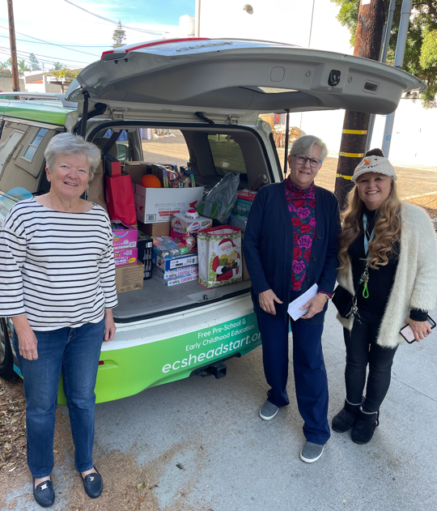  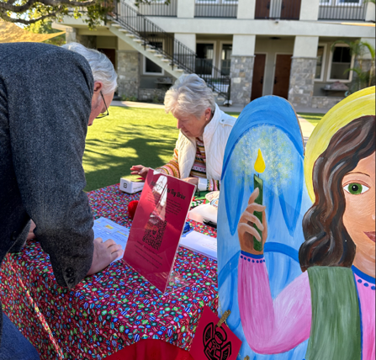    Christmas toys for 150 preschoolers were donated to the Episcopal Community Services Head Start program.  'Truly I tell you, whatever you did for one of the least of these brothers and sisters of mine, you did for me.'  Matthew 25:40  Thank you for your dedication, commitment and generosity  in serving others!  We are grateful to you  and our generous  Christ Episcopal Church Family!  May God bless you always!
Lea Holt and Karen Laedlein
Service Ministry Co-Chairs
Karen: 619.753.1089
Lea: 949.636.5123

