When planning your year with the Connection Curriculum, plan one lesson a week based on your school’s vacation and testing calendar. See below for an example that runs Labor Day through mid-June. If you would like help planning your calendar, please don’t hesitate to let us know!

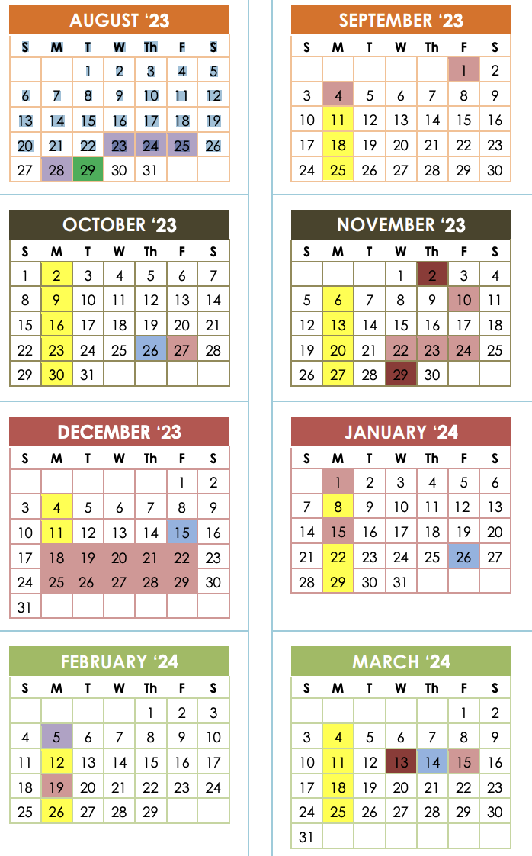 | Week of 9/11: Intro Lesson, initial survey  Week of 9/18: Personal Story Lesson 1  Week of 9/25: Sammy’s story
Week of 10/2: Connection Challenge #1  Week of 10/9: Personal Story Lesson 2  Week of 10/16: Kelly’s story  Week of 10/23: Connection Challenge #2 | Week of 11/6: Personal Story Lesson 3  Week of 11/13: Kevin’s story
Week of 12/4: Connection Challenge #3 | Week of 1/8: Personal Story Lesson 4  Week of 1/15: Apruoopa’s story  Week of 1/22: Connection Challenge #4  Week of 1/29: Personal Story Lesson 5
Week of 2/5: Chris’ story  Week of 2/12: Connection Challenge #5  Week of 2/19: Personal Story #6  Week of 2/26: Mike’s story | Week of 3/4: Connection Challenge #6  Week of 3/18: Personal Story #7  Week of 3/25: Lorie’s story
Week of 4/8: Connection Challenge #7  Week of 4/15: Personal Story #8  Week of 4/22: Tyler’s story  Week of 4/29: Connection Challenge #8 | Week of 5/6: Personal Story #9  Week of 5/13: Abby’s story  Week of 5/20: Connection Challenge #9
Week of 6/3: Personal Story #10  Week of 6/10: Wrap Up, final survey | 