`
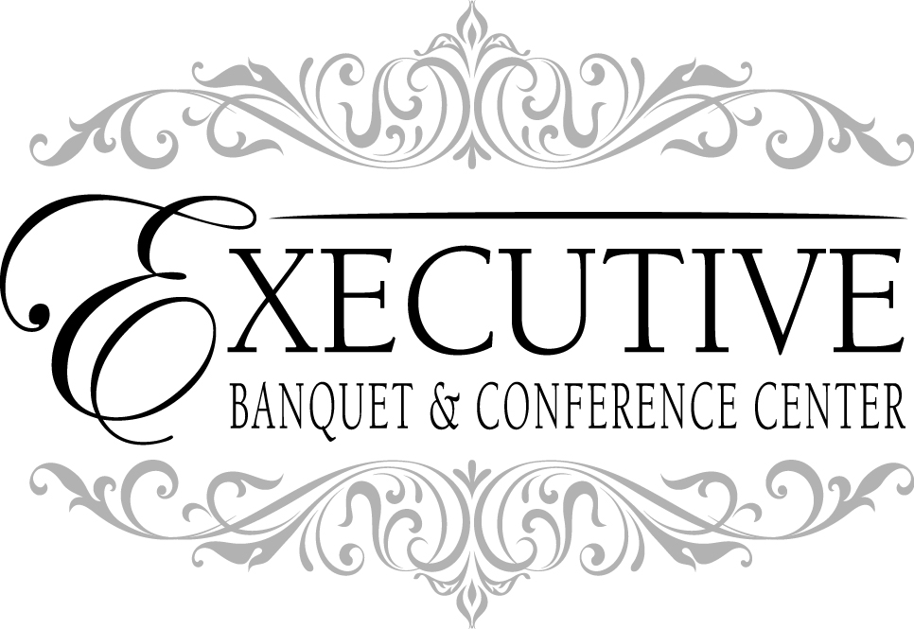

www.executivebanquets.com
executivebanquets@comcast.net
Tel. 302.731.1800
205 Executive Drive
Newark, Delaware 19702

Executive Memorial Lunch Package
Welcome to the Executive Banquet & Conference Center, located just off I-95 in Newark, Delaware. Memorials & Funerals are a very difficult time for family & friends. At the Executive Banquet & Conference Center, we try to make your luncheon a stress-free & easy process. You will find everything you need included in our Memorial Buffet Package:

* Three Hour Event *
* All Non-Alcoholic Beverages *
* Bar Packages Available Upon Request *
* Choice of Colored Table Cover & Napkin *
* State of the art Audio/Visual Equipment *
* Room Capacity 450 *
* Coat Check (seasonal) *
* Award Winning Cuisine *

EBCC 9/14

$36.00 per person and 22% gratuity
**Pricing based upon a minimum of 75 guests**

Buffet Includes:
Choice of One Salad

Choice of Two Entrees
Choice of One Pasta
Choice of One Starch
Choice of One Vegetable
Dessert & Coffee Station

Salad Selections
(Stationed)

Classic Caesar Salad
Crisp California Romaine Lettuce, Shredded Romano Cheese and Home-Made Garlic Croutons tossed with a Creamy Caesar Dressing

Capozzoli’s Salad
This Original Salad is Comprised of Assorted Greens, Topped with Tomatoes, Cucumbers, Garbanzo Beans, Dried Cranberries & Aged Cheddar Cheese, topped with a House Made Signature Dressing

Spring Mix Salad
Baby Leaf Field Greens, Strawberries, Candied Walnuts, Crumbled Gorgonzola Cheese and with a Raspberry Vinaigrette Dressing

Executive Garden Salad
Fresh Seasonal Greens accompanied with Cherry Tomatoes, Black Olives, Cucumbers, Sweet Red Onion and Herbed Croutons with Our Own Balsamic Vinaigrette

Entrees:
Choice of Two Entrees, add a third entrée for $3.00 per person

Herb Roasted Chicken
Chicken Breasts, Thighs, Legs & Wings, Roasted with Fresh Herbs, Seasonings & White Wine

Balsamic Chicken
Chicken Breasts, Thighs, Legs & Wings, marinated in a Balsamic Vinegar Marinade Then Roasted & Finished with Banana Pepper Rings

Chicken Alexa
Boneless Breast of Chicken, Topped with Baby Spinach, Red Peppers & Provolone Cheese, in a Cabernet Demi-Glace

Chicken Marsala
Boneless Breast of Chicken with a Mushroom & Marsala Wine Sauce

Chicken Parmigiano
Breaded Chicken Breast Topped with our Basil Marinara & Mozzarella Cheese

Homemade Meatballs
Our Homemade Recipe is Made with Pork, Veal & Beef, Simmered in our Basil Marinara Sauce

Roast Pork Loin
Slow Roasted Pork Loins, Sliced Thin, Served in a Pan Gravy with Fresh Rolls & Horseradish

Italian Sausage & Peppers
Sweet Italian Sausage Sauteed with Peppers & Onions

Teriyaki Salmon
Fresh Atlantic Salmon, Topped with a Sweet Teriyaki Glaze and Fresh Chives

Crab Cakes
Our Homemade Crab Cake Recipe is made with Lump & Claw Crab Meat, Served with Cocktail & Tartar Sauce

Roasted Cod
Fresh Atlantic Cod, topped with a Fresh Herbed Crust & Baked, Topped with Butter & Lemon

Roasted Turkey Breast
Slow Roasted Turkey Breast, Sliced and Topped with a Homemade Pan Gravy

Roast Sirloin of Beef
Slow Roasted Beef, Thinly Sliced, Served with a Homemade Gravy & Horseradish

Pasta Selections
(Choice of One)
Penne alla Vodka
Penne Pasta with Romano Cheese & Pancetta in a Vodka Sauce
Baked Penne
Our Traditional Baked Penne is Tossed with a Blend of Cheese & Basil Marinara Then Baked
Tortellini Alfredo
Fresh Tri-Colored Tortellini Tossed in a Cream Alfredo Sauce
Stuffed Shells
Cheese Filled Pasta Shells Baked in a Basil Marinara Sauce
Cheese Filled Ravioli Tossed in a Marinara Sauce
Macaroni & Cheese
Rotini Pasta Tossed in a Creamy Cheddar Cheese Sauce & Baked

Starch Selections
(Choice of One)
Red Bliss Potatoes
Steak Cut French Fries
Au Gratin Potatoes
Mashed Potatoes
Rice Pilaf

Vegetable Selections
(Choice of One)
Broccoli Florets
Green Beans
Italian Mixed Vegetables
Green Beans & Carrot Blend
Corn

Dessert
Assorted Italian Pastries, Homemade Cookies & Brownies
Assortment of Miniature Pastries, Homemade Cookies & Chocolate Chip Brownies, Decoratively Displayed on a Table

Coffee Station
To accompany your dessert, freshly brewed 100% Columbian coffee, and decaf coffee will be stationed along with hot water and a wide selection of specialty Bigelow teas.

Bar Packages
All Non-Alcoholic Beverages are included with your Package. There will be a $150.00 Beverage Service Fee added to the final food & beverage bill
Full Open Bar - $30.00 per person
* 4 Full Hours of Open Bar Service
*Eight Draft Beers *Bottled Non-Alcoholic Beer
* Wine: Pinot Grigio, Chardonnay, Moscato, White Zinfandel, Riesling, Merlot, Cabernet Sauvignon, Pinot Noir
* Liquors to include: Dewars, Tito’s Vodka, Absolut Vodka, Tanqueray Gin, Bombay Sapphire, Bacardi Rum, Captain Morgan, Malibu Rum, VO, Seagram’s 7, Fire Ball, Jack Daniels, Jim Beam, Old Grandad, Southern Comfort, Peach Schnapps, Hornito’s Tequila, Amaretto, Kahlua, Crown Royal
*Bartender Fees are waived

Open Beer & Wine Bar - $23.00 per person
* 4 Full Hours of Open Beer & Wine
* Mixed Drinks can be made available for Cash Sales
*Bartender Fees are waived

Consumption Bar
* Full-Service Bar will be available to you and your guest, Drinks will be Charged on Consumption, and client will be required to pay balance at the end of the affair
* Drink Prices Range from $4.00 - $12.00 per drink
* $150.00 Bartender Fee will apply per bartender

Cash Bar
* Full-Service Bar will be available to you and your guests for Cash Sales
* Drink Prices Range from $4.00 - $12.00 per drink
* $150.00 Bartender Fee will apply

* Absolutely NO alcohol may be brought into the facility on the day of the event *

