`
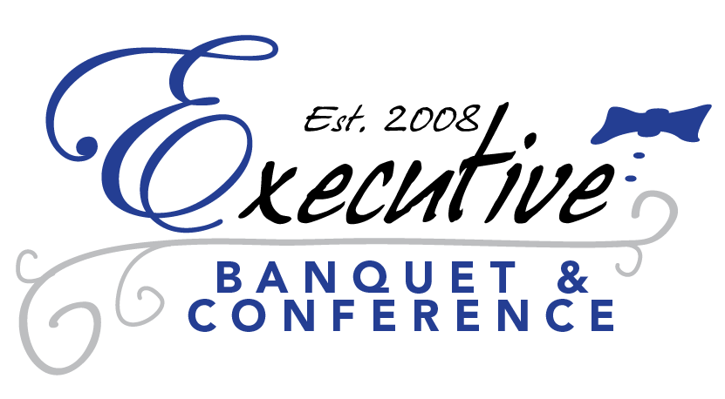

www.executivebanquets.com
executivebanquets@comcast.net
Tel. 302.731.1800
205 Executive Drive
Newark, Delaware 19072

Executive Day Meeting Package
Welcome to the Executive Banquet & Conference Center, located just off I-95 in Newark, Delaware. We are equipped to accommodate any size meeting,
banquet, conference or convention request. A dedicated conference/meeting planner will be available to assist you with all of your meeting requirements to ensure a successful event.

Highlights of our Day Meeting Package:

* Free use of ALL Audio/Visual Equipment *
*Variety of Food Packages for all types of meals *
* Small & Large Rooms available *
* Bar Packages Available Upon Request *
* Room Capacity Ranges from 15 up to 500 *
* Coat Check (seasonal) *

$45.00 per person and 22% gratuity
*Based on a Minimum of 25ppl, pricing will be adjusted accordingly for smaller groups
** $1,500.00 minimum spending

Food Services Include:

All Day Beverage Service:

100% Columbian Regular & Decaf Coffee and bottled water will be provided the entire day.

Assorted Juices to include, Orange Juice, Apple Juice & Cranberry Juice will be provided
for your morning sessions.

Assorted Sodas, Iced Tea & Lemonade will be provided for the afternoon sessions

Breakfast Service

All Full Continental Breakfast will be provided and refreshed through your first morning
break, your breakfast will include……

The Continental Breakfast
Choice of 2 Breakfast Pastry/Breads
Assorted Bagels
Fresh Doughnuts
Assorted Mini Fruit & Cheese Danish
Jumbo Homemade Muffins
Sticky Buns
Apple Crumb Cake
Breakfast also includes:
* Fresh Fruit Salad – Made with fresh seasonal fruits
* Fresh Assorted Yogurts

**We have many other breakfast menus for you to choose from, pricing will vary depending on your selections.
Please ask your Sales Person for more information

Lunch Service
Please choose from the list of menus below to create your custom lunch

All-American Meal
This menu is inspired by the comfort foods we enjoy right here in America:
Choice of 2 Entrees:
Thin Sliced Roast Beef, au jus
Thin Sliced Roast Pork, au jus
Homemade Meatloaf
Cajun Chicken or Tilapia
Buffalo Chicken Wings
Roasted Turkey Breast with Gravy
Herb Roasted Chicken

Lunch also includes:
Mashed Potatoes
Broccoli Florets
Garden Salad
Apple Pie Slices or Fudge Nut Brownies

Express Lunch
This menu is designed to please almost every pallet:
Garden or Caesar Salad

Chicken Alexa
Topped with Spinach, Red Peppers & Provolone Cheese

Meatballs Pomodoro

Capozzoli’s Baked Penne

Oven Roasted Potatoes

Italian Mixed Vegetables

Chef’s Choice Dessert

Tuscan Delight
Choice of 2 Entrees:
Chicken Parmigiano
Chicken Abruzzi
Marinated Grilled Chicken, Topped with Roasted Red Peppers
Chicken Saltimbocca
Topped with Prosciutto, Sage & Mozzarella Cheese
Chicken Siciliano
Seared Chicken Topped with a San Marzano Tomato Cream Sauce
Chicken Marsala
Seared Chicken Topped with Wild Mushrooms & Marsala Wine
“Baccala”
Fresh Atlantic Cod, Baked with an Herbed Crust with Lemon & Butter
Meatballs Pomodoro
Eggplant Parmigiano

Choice of 1 Pasta:
Penne alla Vodka
Rigatoni Bolognese
Cheese Ravioli Marinara

Lunch also includes:
Caesar Salad
Green Beans with Red Peppers & Pine nuts
Cannoli & Éclairs

Taste of Philly

Beef or Chicken Cheesesteaks

Assorted Hoagies
Italian, Turkey & Roast Beef topped with all the “fixins” on a fresh baked Liscio Roll
Sausage with Peppers & Onions
Herr’s Potato Chips
Soft Pretzels
Assorted Tastykake’s
Goldberg’s Peanut Chews

Hoagies, Not Subs!!
Assortment of Hoagies Prepared on Fresh Italian Rolls:
Assortment Includes:
Italian, Turkey, Roast Beef & Tuna

Additional Hoagie Selections:

Grilled Vegetable Hoagie

Lunch also includes:
All Condiments
Assorted Potato Chips
Potato Salad
Pasta Salad
Homemade Brownies

Wrap It Up!
Choose from a variety of our Freshly Prepared Wraps on Assorted Jumbo Flour Tortillas:
Italian
Italian Meats & Provolone
Turkey Club
Turkey, Swiss, BLT
Turkey
Cooper Sharp, Cran. Mayo, Lettuce & Tomato
Smoked Ham
Cheddar, Honey Mustard, L & T
Tuna Salad
American Cheese, Lettuce, Tomato
Grilled Vegetable
Seasonal Vegetables, Balsamic Vinegar
Oven Roasted Beef
Provolone, Horseradish, Red Onion & Lettuce

Lunch also includes:
Assorted Potato Chips
Pasta Salad
Garden Salad
Chef’s Choice Dessert

