Dear families,

This year we are sharing the Only7Seconds Connection Curriculum during class to help students feel more connected in their lives. Earlier this year, the US Surgeon General released an advisory detailing the loneliness epidemic in our nation. Only7Seconds is a non-profit working to end loneliness in the world; they are on a mission to inspire intentional and meaningful connections.
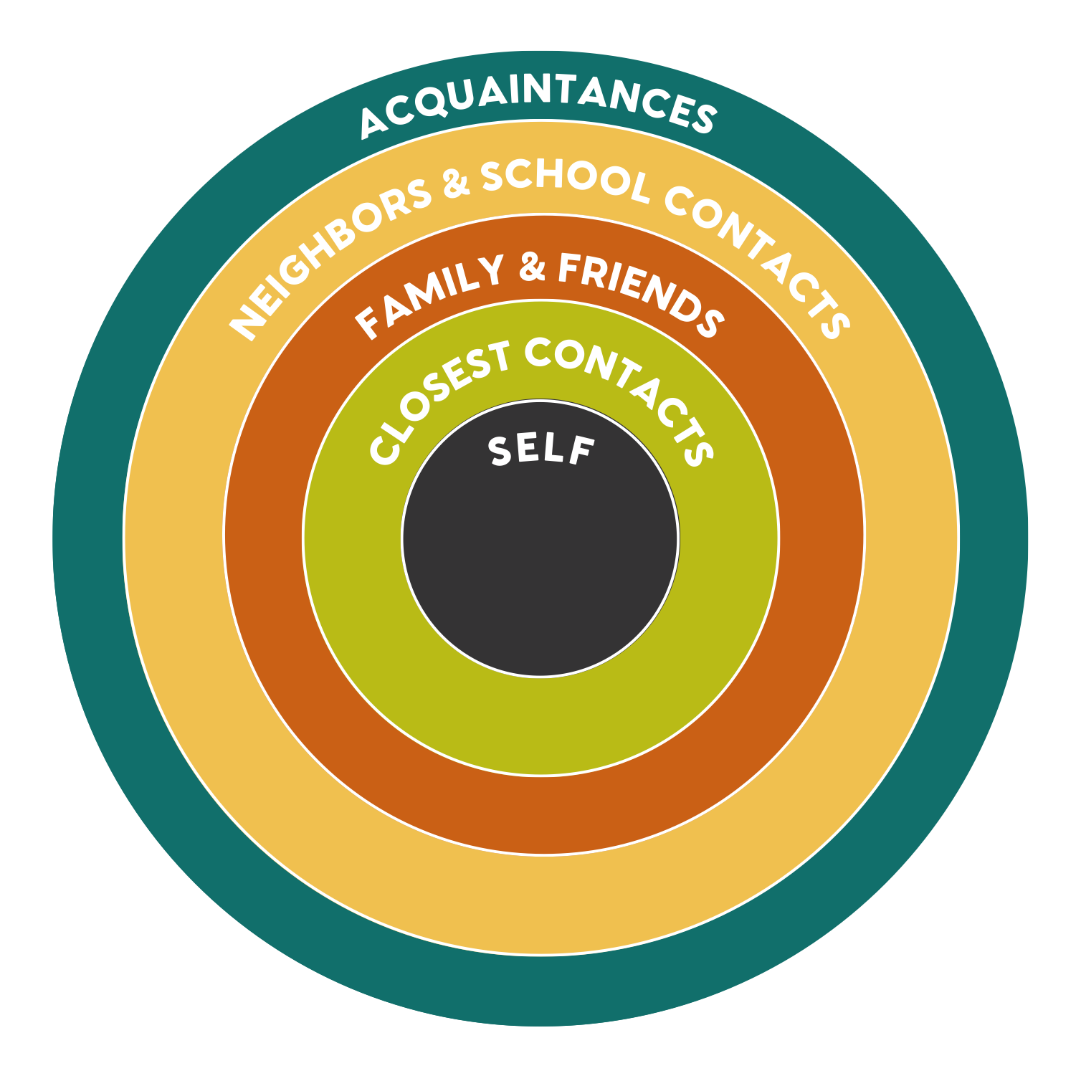
In the Connection Curriculum, there are 30 lessons in which students will engage with content focused on the Circles of Connection. Starting with the student at the center, the lessons begin with time dedicated to students learning about themselves and providing opportunities for them to share their own stories. Research tells us that when people can know themselves, they are better at connecting with others.

Next, there are 9 video lessons where Only7Seconds storytellers share their experiences with loneliness. In class, we will have a conversation about each story to help students build empathy. Only7Seconds focuses on the three types of empathy—cognitive, emotional, and behavioral.

Said more simply, those types of empathy ask the questions: What does each story make you think about? How does it make you feel? What does it make you want to do?

After the conversation to build empathy, students will be encouraged to reach out and connect with someone in their life to let them know they are thinking about them. Each story from this series is free to the public and can be used to enhance relationships in your own home. You can watch each short video and listen to the extended version in podcast form through the I Know Lonely Project on www.only7seconds.com.

Finally, we will complete 9 Connection Challenges over the course of the year. These are specific activities designed for students to connect with people in the different circles in their lives—starting in their closest circle moving out to the world at large and then moving back in.

As the Surgeon General shared, social connection is vital to individual health as well as community health. Using the lessons provided by Only7Seconds, we will focus on building community through storytelling, empathy, and connection. We hope you will join in as well!

In you have any questions or would like to learn more, please visit their website at www.only7seconds.com.

Very sincerely,

