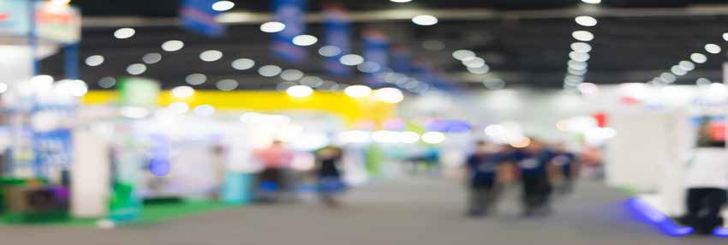

# EXHIBITOR ORDER FORM

**EXHIBITOR INFORMATION**

**EVENT NAME**

**___**

**____**

**____________**

**____**

**___**

**____**

**____**

**____**

**___**

**EXHIBIT DATE**

**BOOTH LOCATION AND NUMBER**

**COMPANY/EXHIBITOR**

**CONTACT NAME**

**E-MAIL ADDRESS**

**COMPANY ADDRESS**

**CITY PROV/STATE**

**PHONE NUMBER POSTAL CODE/ZIP CODE**

**EXHIBITOR ORDER FORM**

**BOOTH ACCESSORIES**

All rates are for the full duration of the show.

All claims/discrepancies must be settled PRIOR to show closing. REFUNDS will not be given on any orders changed or cancelled on site.

All materials remain the property of Hahn Rentals and will be removed upon show close.

**PRE-SHOW PRICING ON-SITE PRICING TOTAL**

|  |  |  |  |  |  |  |  |  |
| --- | --- | --- | --- | --- | --- | --- | --- | --- |
| **1** | **Padded arm chair** | | | | **15.75** | **19.69** |  |  |
| **2** | **Director’s chair - 30” high** | | | | **19.65** | **24.56** |  |  |
| **3** | **Metal & Wood bar stool with back** | | | | **19.65** | **24.56** |  |  |
| **4** | **Brown folding chair** | | | | **4.85** | **6.05** |  |  |
| **5** | **Carpet: Red Blue Grey Green Black**  **Booth Carpeting per sq. ft. 3/8” Foam Underpad per sq. ft.**  **(Ex. 10’ x 10’ = 100 sq. ft., 8’ x 8’ = 64 sq. ft.)** | | | | **1.25 sq. ft.**  **.70 sq. ft.** | **1.50 sq. ft.**  **.84 sq. ft.** |  |  |
| **6** | **Undraped Plain Tables**  **30” wide by 4’ 6’ 8’** | **18” wide by 4’ 6’** | **8’** |  | **22.00** | **27.50** |  |  |
| **7** | **30” Height Round Pedestal table - 30” across the top** | | | | **44.00** | **52.80** |  |  |
| **7a** | **42” Height Round Cruiser table - 30” across the top** | | | | **44.00** | **52.80** |  |  |
| **7b** | **43” Height Round Stainless Steel Cruiser table - 24” across the top** | | | | **50.00** | **60.00** |  |  |
| **8** | **Black spandex table cover 30” high 42” high Black Red** | | | | **22.00** | **26.40** |  |  |
| **9** | **Skirted tables (includes table, plastic tablecloth, front & 2 sides skirted) 30” wide by 4’ 6’ 8’ long**  **18” wide by 4’ 6’ 8’ long**  **Navy Blue White Black Burgundy Gold Red Royal Blue** | | **Teal** | **Green** | **65.60** | **78.60** |  |  |
| **10** | **\*\*\*To skirt all 4 sides of table OR onsite table exchange** | | | | **25.00** | **30.00** |  |  |
| **11** | **Leg extenders (elevates table height to 42”)**  **42” height skirting available Royal blue White Black** | | | | **17.88** | **22.34** |  |  |
| **12** | **Easels** | | | | **21.00** | **26.25** |  |  |
| **13** | **Sign Stand - 22” x 28”** | | | | **21.00** | **26.25** |  |  |
| **14** | **Coat Tree** | | | | **12.65** | **15.81** |  |  |
| **15** | **Coat Rack with 25 hangers** | | | | **19.65** | **24.55** |  |  |
| **16** | **Waste Basket** | | | | **12.00** | **17.25** |  |  |
| **17** | **2’-3’ Live Plants** | | | | **42.00** | **NOT AVAILABLE** |  |  |

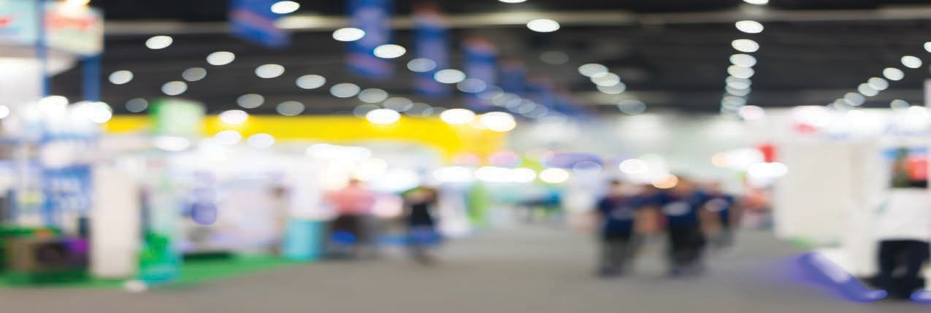

|  |  |  |  |  |  |  |
| --- | --- | --- | --- | --- | --- | --- |
| **Flatscreen LCD TVs - TV’s cannot play video from USB** | | **1 DAY USE** | **2 DAY USE** | **3 DAY USE** |  |  |
| **18** | **32” Flatscreen LCD** | **165.00** | **247.50** | **330.00** |  |  |
| **19** | **42” Flatscreen LCD** | **247.50** | **371.25** | **495.00** |  |  |
| **20** | **50” Flatscreen LCD** | **330.00** | **495.00** | **660.00** |  |  |
| **21** | **67” TV Stand on wheels** | **85.00** | **127.50** | **170.00** |  |  |
| **22** | **HDMI Cables / VGA Cablesc/w adapter** | **16.00** |  |  |
|  |  | |  |  |  |  |
| **23** | **Microwave oven** | **100.00** |  |  |  |  |
| **24** | **Bar Fridge** | **100.00** |  |  |  |  |

# EXHIBITOR ORDER FORM

**OCTANORM PACKAGES**

All rates are for the full duration of the show.

All claims/discrepancies must be settled PRIOR to show closing. REFUNDS will not be given on any orders changed or cancelled on site.

All materials remain the property of Hahn Rentals and will be removed upon show close.

## PACKAGE #1 (10’ X 10’ Booth)

Booth consists of basic system 3 lights - 1 arm chair, 1-30” pedestal table

Pre-show $1,216.00 Onsite $1,470.00

**Carpet ** Red  Blue  Grey  Green

**Panels ** Grey  Black  White

Black

Company name on display header logo extra (call for quote)

## PACKAGE #2 (10’ X 20’ Booth)

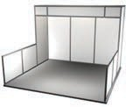

Booth consists of basic system 3 lights - 1 arm chair, 1-30” pedestal table

Pre-show $2,224.00 Onsite $2,730.00

**COUNTERS** Counter sizes vary between rectangular, square and 1/2 round and comes with matching colour wood top and sliding door

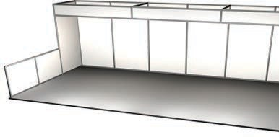

**Carpet**

**Panels**

Red

Grey

Blue

Black

Grey

White

Green

Black

Company name on display header logo extra (call for quote)

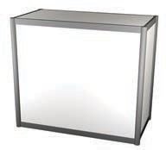**Panels ** Grey  Black  White

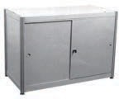 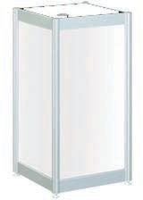

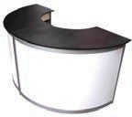

21” x 21” x 38.5” H

$154.00 Onsite $192.50

Display Case Cabinet c/w clear top

41” x 21”x 38.5” H

$200.00 Onsite $225.50

29.5” x 21”x 38.5”

$131.00 Onsite $151.25

1/2 Round 21” x 42”

$181.50

Onsite $226.88

Qty. Total

**OCTANORM SHELVES** (comes with brackets) Description

Price

8” x 24” White 11.00

8” x 36” White 13.00

18” x 36” White 18.00

**Subtotal: HST %:**

**ADD $7.50 FOR US CHEQUES:**

**Total:**



# EXHIBITOR ORDER FORM

**CREDIT CARD AUTHORIZATION FORM**

**I AUTHORIZE HAHN RENTALS TO CHARGE MY PROVIDED CREDIT CARD FOR:**

**EVENT NAME**

**____**

**_____**

**_____**

**____**

**____**

**_____**

**_____**

**_**

**EXHIBIT DATE**

**TYPE OF CARD - NO AMEX**

**CARD HOLDER NAME**

**CARD HOLDER ADDRESS**

**CARD NUMBER**

**EXPIRATION DATE CVV TOTAL ESTIMATED CHARGES**

**SIGNATURE DATE**

**IF PAYING BY COMPANY CHEQUE - TO GUARANTEE YOUR ORDER PLEASE NOTE THE CHEQUE NUMBER THAT WILL BE MAILED TO: HAHN RENTALS**

**95 BAFFIN PLACE WATERLOO, ONTARIO N2V2C1**