T
Swine Exhibitor
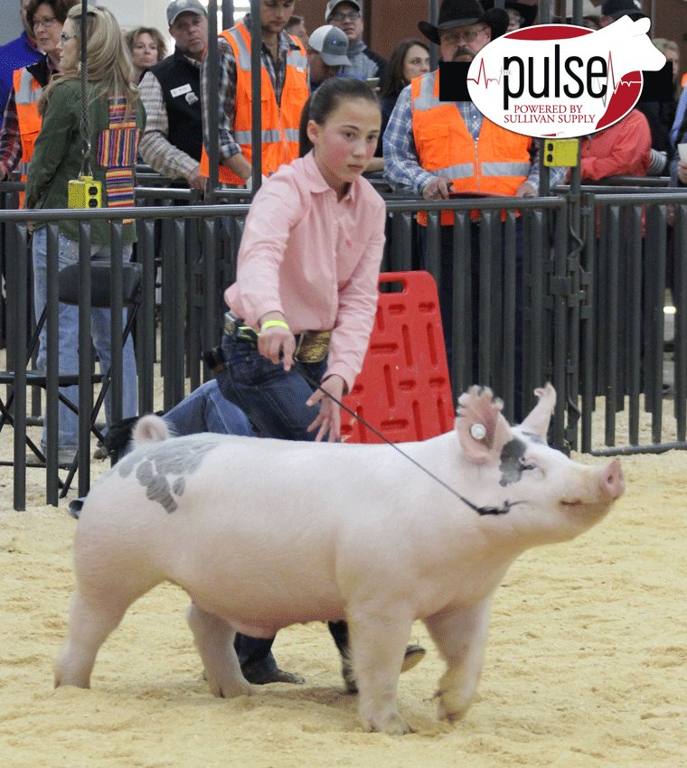
Handbook

Name ______________________________________

(Updated 4-26-19)
Purpose

The purpose of this handbook is to assist you in successfully raising a market animal project. The information contained in the following pages will act as a guideline. It must be understood that this material is not the only information you will need to raise your animal, but it does cover the most common aspects of the project. Should any questions arise concerning your project, don’t hesitate to contact your project advisor for help. If it is an emergency contact your local veterinarian!

Good luck on your endeavor of raising a market animal. With hard work and dedication, your project will be a success!

The Ultimate Goal

Grand Champion!

The goal of every junior exhibitor is Grand Champion. There can be nothing more exciting to a young exhibitor than to experience the feeling of accomplishment and pride when a Judge selects their animal as the overall Grand Champion of a show. It should be understood that the opportunity to experience that feeling of exaltation is not an accident. It is the culmination of many weeks of extremely hard work. The winning edge is something that is earned by hard work and dedication to a well-constructed plan. A plan that includes quality animal selection, proper facilities, superior management, correct feeding and appropriate showmanship training. By incorporating the basic principles discussed in this booklet you can greatly enhance your chance to experience that winning feeling of a Grand Champion!

“Champions aren’t made in the ring, they are merely recognized there. If you want to see a champion, look at their daily routine.” Evander Holyfield
Table of Contents

What You Should Know Before Buying A Project ……….….……….………1

Getting Ready For Your Project …………………………………………...… 1

Purchasing Your Animal ……………………………………………………... 1-2

Common Swine Breeds ………………………………………………..………2

The Ideal Show Pig ……………………………………..………………...….. 2-3

Parts Of A Hog …..………………………………………………………..…. 3

Selection Of A Show Pig …..……………………………………………….... 4-6

Starting Off Right ………………………………………………………….... 6

Feeding You Market Animal ……………………………………………...… 5-6

Feeding Strategies ……………………………………………………………. 7

Caring For Your Market Animal …………………………………………….. 8

Fair Time …………………………………………………………..………… 8

“Clipping Show Pigs” ……………………………………………………….. 9-10

Showmanship ………………………………………………………...……… 10-11

Showmanship Questions …………………………………………………….. 12

Ear Notches ………………………………………………………….……… 12

Driving Your Pig ……………………………………………………………. 13

Locations To Tap Your Pig ……………………………………….………… 13

Penning Your Hog ……………………………………..……………………. 13

Supplies & Equipment …………………………………..………………..… 13-14

How Much Will This Project Cost? ……………………….……….……..… 14

Estimated Income From The Project ……………………………….……..… 14

How Do I Sell My Project? …………………………………………...…….. 14-16

Duties Of A Exhibitor .……………………………………………….……... 16

Sample Buyers Letter ………………………………………………….……. 17

Hog Carcass Breakdown/wholesale Cuts ……………………………….……18

Retail Pork Cuts …………………………………………………………...… 19

Record Keeping …….…………………………………………….…...……… 20

Exhibitors Contract .………………………………….………………………. 21-26

What You Should Know Before Buying a Swine Project.

- A swine project can be very exciting and rewarding experience or a very frustrating and discouraging project depending on the amount of time and energy you put into the project.
- The duration of a market swine project is anywhere from 3-4 months. It is important that as much attention be given to your project during the last months as is given during the first months.
- Raising a market swine is not a hit and miss proposition, you must be consistent in how you raise your animal. Achieving maximum results requires maximum input from you. In other words, you get out of your project what you put into it.
- It is critical that a person understand that the animal will be dependent on you for every aspect of its well being including feed, water, shelter, health, exercise, etc. You must be willing to provide for each of these areas on a daily basis for the duration of the project.

Getting Ready For Your Swine Project.

- If you are housing your animal at home, make sure your pen is properly prepared prior to receiving your project. The pen should meet the following requirements:

  - It should be large enough to allow your animal to exercise. (About 10’ x 20’ is adequate)
  - Shade/Shelter should be provided in the pen (over a concrete slab)
  - Make sure to have straw for bedding during cold spells.
  - Adequate feeding and watering facilities must be provided.
    - An old hot water heater tank cut in half makes a great feeder.
    - An automatic waterer called a Lixit can be placed on the end of a garden hose allowing fresh clean water.
  - The fencing should be free of loose wires, protruding nails, loose boards, etc. The floor should also be free boards, wire, nails, etc.
  - It should be sturdy enough to prevent the animal from getting out.
  - It should be clean of weeds, trees and grass.

- You should purchase your feed 1-2 days prior to receiving your animal. Check with your advisor on the kind of feed to purchase and from whom. Remember that large companies develop pig genetic lines and most do better when fed a specific feed brand.
- If you are raising multiple animals they should be able to be fed separately.

Purchasing Your Animal.

- There are different ways to purchase a swine project. No one way is right or wrong. You need to determine what is best for you in terms of your budget. The most common ways of buying project animals are:
  - Purchase you animal through your advisor. Your advisor will travel to various swine producers to select and purchase market animals. He then brings them to school where students will then select their animals.
  - Purchase an animal on your own. You must have advisor approval to do this.
  - Purchase your animal through a sale. Sometimes you find good deals at sales, but usually you end up paying a little more for your animal.
- Whichever way you choose to purchase your animal, make sure that you consult with your project advisor prior to buying it. You should obtain a bill of sale from the seller to keep for your records.

Common Hog Breeds

Hampshire – Black with white belt
Yorkshire – White with erect ears
Duroc – Red with droopy ears
Landrace – white with a long body, droopy ears
Berkshire –Black and white, erect ears
Spotted – White with black spots, droopy ears
Chester – White with droopy ears
Poland China - Black and white, droopy ears

The Ideal Show Pig

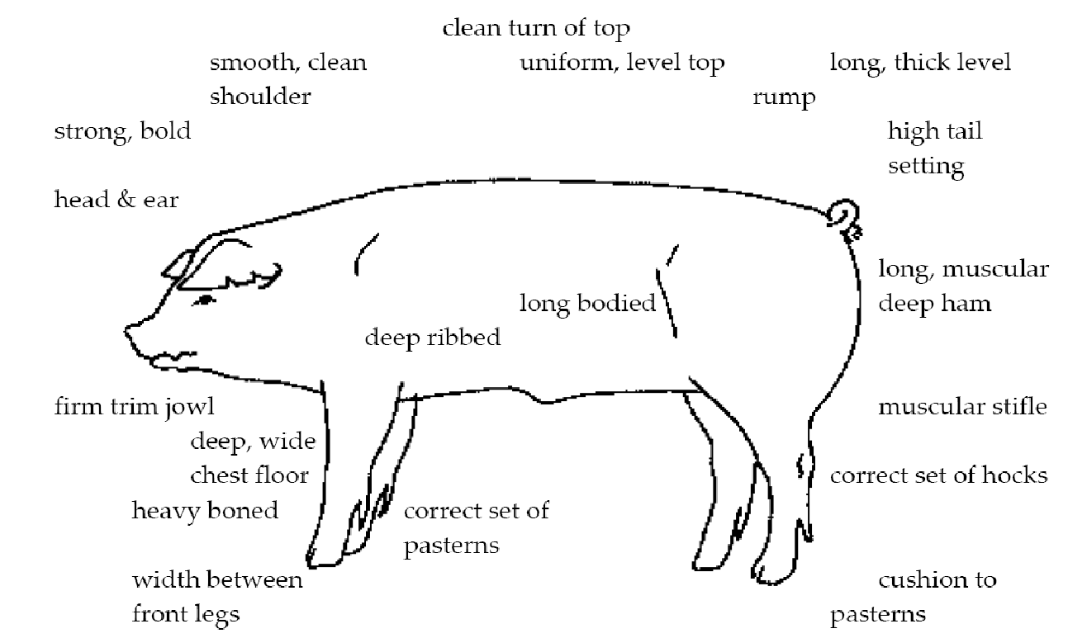
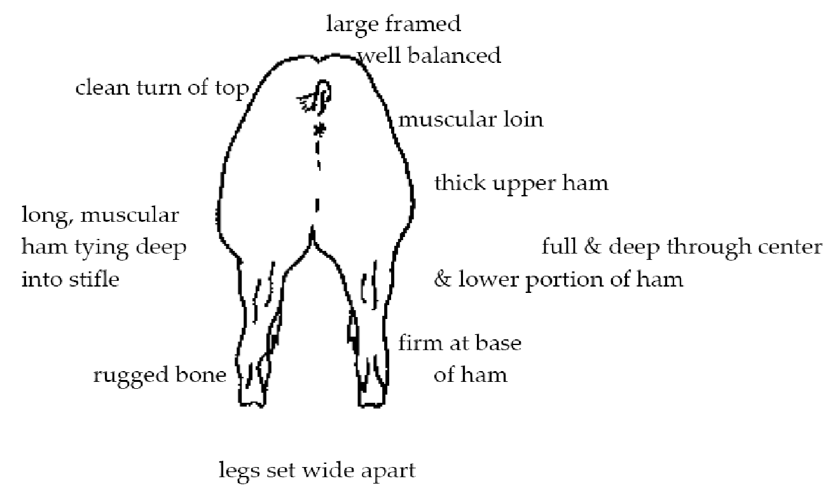

Parts Of A Pig
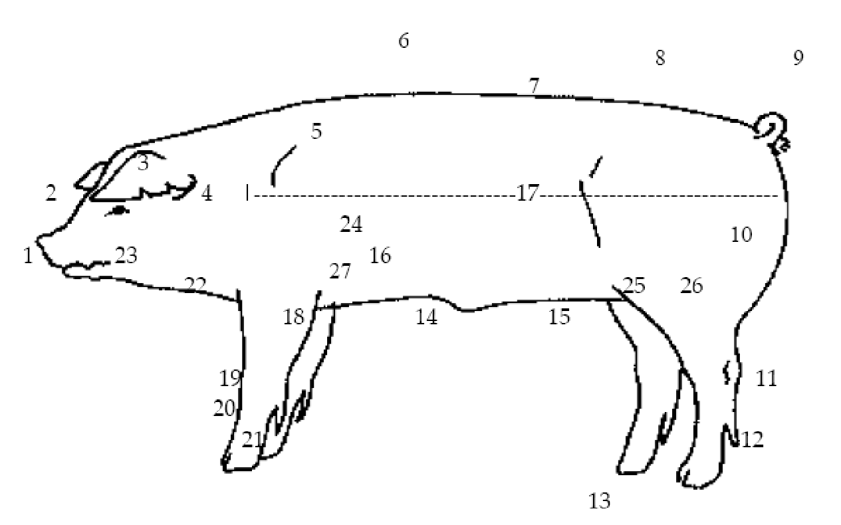

- Snout 15. Teats
- Face 16. Belly
- Ear 17. Side
- Neck 18. Elbow
- Shoulder 19. Knee
- Back 20. Cannon bone
- Loin 21. Pastern
- Rump 22. Jowl
- Tail 23. Mouth
- Ham 24. Rib
- Hock 25. Flank
- Dew claw 26. Stifle
- Toe 27. Elbow pocket
- Sheath (Barrows & Boars)

Selection Of A Show Pig

There are basic areas that need to be considered when selecting your show pig. They are
muscle, structural correctness, capacity, frame and style and balance.
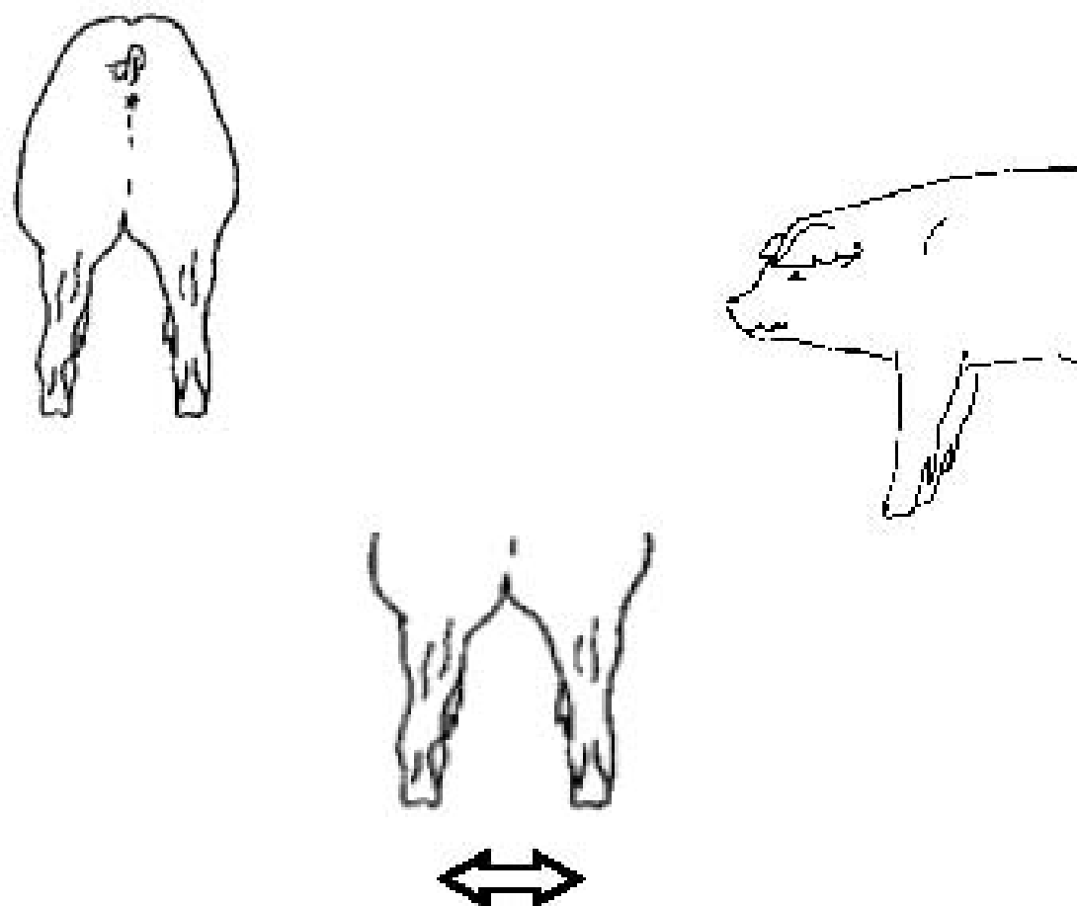

Muscle
There are several indicators of muscle in pigs. The first place to look for muscle is the ham.
The widest portion should be through the center of rump and ham. Select a pig that has a bulging forearm.

Well-muscled hogs are wide based and large boned.

When viewed from the top, look for an hourglass shape to the top. This will be a trim,
heavy muscled hog. It should be long and full in the rump, with the center of the ham being the widest part of the body. The shoulders should be wider than the loin, but not as thick as the ham. The loin will be uniform in width. When the hog walks there should be no evidence of fat over the top of the shoulders and the shoulders should move freely. Also, there should be no fat behind the shoulders or elbow pocket.

Structural Correctness
Structural correctness refers to how a pig’s skeleton is put together, more specifically the
bone structure. To be sure your pig is structurally correct, pick a pig that moves with ease
and smoothness. Pigs should take long strides. They also should have a proper angle to the pasterns and have flex to the joints like the hock, knee and shoulder. These joints should flex and the pig should take a long, flexible, fluid stride.

The pasterns should have an angle of 45 degrees and the hock should be at about a 22-degree angle for the best possible movement off the back end. Strong legs are important in market hogs. The bone should be large and the legs should be clean and solid looking.

Proper hind leg structure Poor hind leg structure

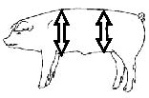
Capacity
Pigs need to have adequate capacity to allow their internal organs to function properly and efficiently. They need to have a wide chest floor, a good spring of rib, and be deep sided in both the fore and rear flank. Remember that a deep-sided hog can still be trim and neat in appearance.

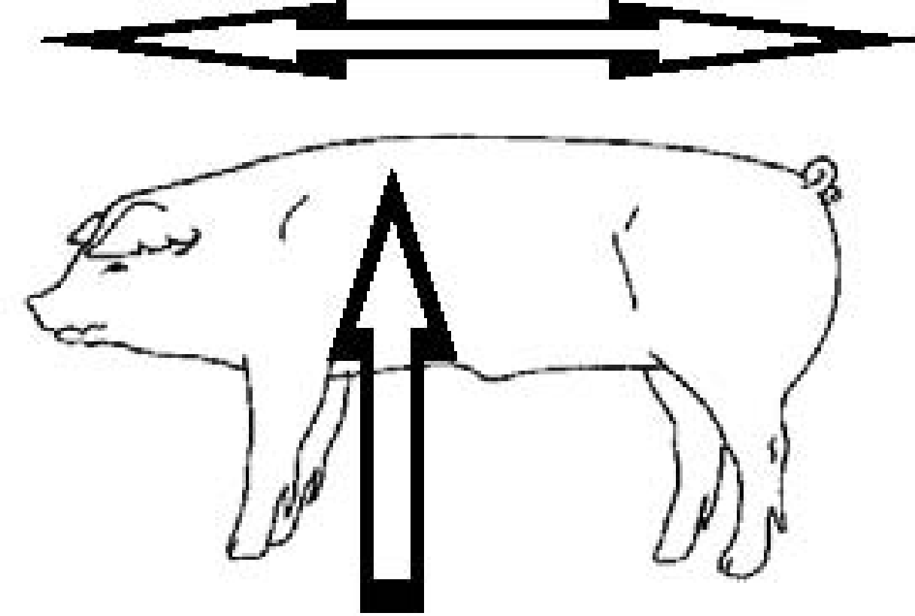
Frame
A moderate framed hog will grow well and have adequate size. Select a long bodied, tall hog that stands well on its feet and legs. It should be large boned and show a lot of capacity, being boldly sprung at the ribs.

Style and Balance
A hog that has style and balance is one that holds its head up when it walks, and is smooth in its overall appearance. It will be clean in the shoulder blades, jowl and underline. Hogs that are balanced, stand wide and tall on straight legs, are uniform in the arch of their back, and their shoulder blades are close together.

Select a trim hog that is free of excess fat. Fat gives the appearance of smoothness and shortness. A trim hog is clean behind the shoulders and down the top. The base of the ham should be firm. At the base of the hams you should see a cut up or v-shape with the tail setting high, and the tail head prominent.

Starting Off Right.

- As soon as you get your animal, it is imperative that you observe your animal closely for any signs of illness. Generally, if swine are hauled a long distance, the chance of illness is greater that those hauled shorter distances. Signs to watch for include runny eyes and/or nose, droopy head and inactivity. It will take a few days for the animal to acclimate itself to its surroundings.
- Your animal may not want to eat first day or so. This is normal. However, if it is not eating by the second day, you should contact your advisor. (Refer to the section on feeding for more information.)
- Training the animal as early as possible is important. The quicker the animal can be gentled down and work for you the better. It is much easier to teach a smaller animal to work, than larger one. DON’T WAIT!

Feeding Your Market Swine Project.

- Nutrition is the single most important aspect of raising a quality market animal. Consistency is the key word when feeding swine with regards to the type of feed, amount, and feeding schedule. A proper feeding program can make the difference between a high quality animal and a poor quality animal.
- One of the most overlooked elements of a good feeding program is water. The water your animal drinks should be fresh, clean and cool at all times. Dirty or stagnant water can have an affect on the health of your animal. The water trough should be cleaned on a regular basis, preferably daily. A good rule of thumb on water is if you wouldn’t drink it, your animal probably wouldn’t drink it either if given a choice. If using an automatic watering system, make sure the pipes are not in direct sunlight as this will warm the water.
- Your advisor will direct you on how to feed your animal. Feed recommendations are based on individual differences in weight, rate of gain and conformation. It is important to know exactly how much you are feeding so that accurate average daily gains can be calculated. This information will tell you whether you are on track to meet the desired projected weight for your animal.
- If you are raising your animal at home, or hand feeding, it very important to set feeding times in the morning and evening and stick to them. There should be no more than a 15-minute variation in feeding times from day to day. Drastic changes in feeding times can have adverse affect on your animal in terms of appetite and health.
- A scale should be used to accurately measure the amount of feed you are feeding. “Coffee Cans” do not work. You must know the actual weight fed.
- Whenever a new feed or an increase in feed is introduced, the change should be made gradually over a period of time. Never change or feed quantities without checking with your advisor.
- Do not use a self-feeder for your pigs. This allows pigs to eat when they want to, thus not gaining weight. Hand feed your pigs in a feed pan. Do not leave feed in the pen for more than 15 minutes. This will train your pig to eat quickly and help them gain weight. This also allows the use of supplements to be added closer to fair. Make sure that the animal is eating all the feed at each feeding. Feed that is not consumed should be removed and the amount fed should be reduced in proportion to the amount left over. Increase the amount any time the feed is completely consumed, but increases should be limited to one half pound per day.
- If your animal goes off feed for more than one day, contact your advisor or veterinarian immediately. Generally a lack of appetite is one of the first signs of illness. The sooner the illness is detected, the easier it is to treat. Any type of illness will cause a decrease in the daily gain and could affect the desired end weight.
- It may be necessary to add a feed supplement to the ration. The supplement will help in: increasing growth, appetite, feed efficiency, health and stress resistance. Check with your advisor before adding a supplement to your feeding program.
- Do not feed your pig any type of food scraps or restaurant/bakery waste! These are show animals and must be kept on a commercial feed.

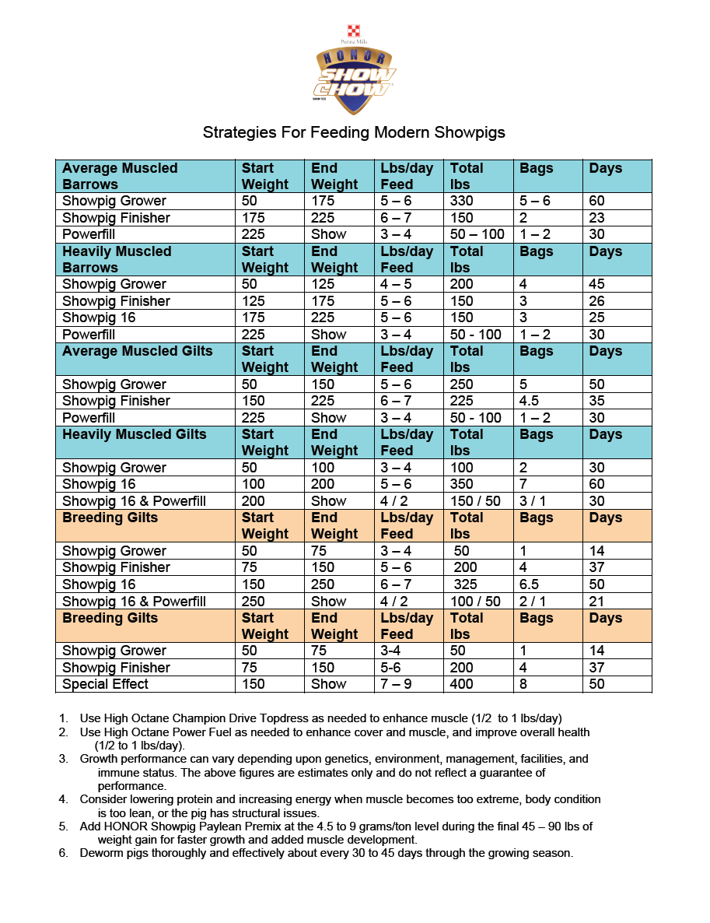
Caring For Your Market Animal

- At least once a day, look your animal over carefully to see if everything is all right. Check for the way it walks, for sores or cuts, for scours or for runny nose or fast breathing. If any of these occurs, consult your advisor immediately. If your advisor is unavailable consult your veterinarian.
- Clean your pen at least once a day. Make sure the water and feed is okay.
- As soon as possible, start to walk your animal. This is for exercise and to practice showmanship. Do this once a day before feeding.
- Observe your animal for any signs of sickness or weight loss. Listed below are four main disease symptoms you could encounter:
  - Respiratory
  - Scours
  - Change in body condition
  - Fever
Going off feed and changes in behavior precludes most disease symptoms. When in doubt using a livestock thermometer, take the pigs temperature and notify your advisor if it is high. A pig’s temperature should be 101F-102F degrees.
- Do not administer any medications without consulting your advisor or a veterinarian first.

Fair Time

Just prior to Fair – Daily washing and rinsing after exercise with a moisturizing shampoo and a conditioner helps revitalize dry skin on the pig. You may need to use sunscreen on white pigs to avoid sunburn. Make sure to test a small spot on the pig first in case of sensitivity to the product. A very close accurate weight of your pigs should be maintained to finish up the project in time for fair.

During the Fair – Maintaining a clean display, well-groomed animals and an all for one & one for all mentality, will demonstrate to other FFA chapters that we mean business. Once again, this is the time to shine and show pride in our chapter. Other rules applying to barn duty, set up/clean up will be discussed at fair meetings. Students are expected to feed animals and clean their pens daily. You are required to have an educational display at the fair for your species.

“Clipping Show Pigs”

Some shows do not allow clipping of show pigs. Some shows allow clipping, but a minimum hair length is enforced. Please first check to see if your show or fair has rules or regulations regarding clipping to make sure you comply.

First, the pig must be clean to get the most durable use out of a set of clipper blades, and to ensure a clean cut. We use a waterless hand cleaner to wash the pig’s body and especially the feet and legs.

The feet and legs can be quite challenging to get clean, so we start with a hand cleaner like Go-Jo, or Fast Orange. We then wash the pig with Mane and Tail, and then apply conditioner leaving it on the pig for 5 – 7 minutes. A white pig, or a pig with white markings such as Hampshire’s, Poland’s, or Spots, will need to be washed with a “bluing” shampoo such as Shimmer Lights, or another shampoo that whitens as it cleans. Once the animal is clean, we towel dry the pig and then clip. We use only our hands when washing pigs. A brush, or excessive scrubbing can leave a white pig with red skin. This is undesirable, and uncomfortable for the pig.

There are many methods of clipping pigs. Some people prefer to “slick shear” their pigs about 30-45 days prior to showing to have a fresh growth of hair. Some exhibitors prefer to use a clipper with a “plucking” blade. We prefer to use a variable speed clipper with clipper guards. Others may prefer to “snare” the pig and then clip it.

The object of clipping is to remove old, stale, or unmanageable hair, and clip the hair as short as possible, but yet make the pig look like it has not been clipped. We start with a 0A guard, clipping first down the top. Once the top is done, we clip one side at a time moving from the ham, to the side, to the shoulder. Once at the shoulder, if the pig is a Hampshire, we blend the hair into the neck by using a 0 guard. Then once we get to the face, jaw, and jowl areas, we use a 00 guard. The secret is blending the hair to give a fluid appearance, while making the pig’s neck look extended and slender.

The areas under the jaw, chest, and belly are clipped without a guard attachment, and are “slick” sheared to provide a cleaner appearance. The long hairs around the pig’s nose and mouth are clipped short. The area between the pig’s hams (or twist) is clipped without a guard to give a clean, fat free appearance. The belly is clipped up to about the bottom of the elbow, and up to the flank region. In other words, clip all the hair down to the skin from under the chin, through the chest floor, and off the belly. This will initially leave a very apparent line. Use the 00 guard to blend between the pig’s side and belly. Clip on top of the line between side and belly to feather or blend the hair.

Do this on both sides. Also use the 00 guard to blend the areas on the hams and twist. The key is blending the hair to remove signs of apparent clipping.

We generally clip the ears and tail with the 0 or 00 guards. Again, the purpose here is to give the pig a fresh appearance, and remove long hair that would give the judge the impression that the pig has been clipped. (Long hairs here and there in contrast to short clipped hair are evidence that the pig has indeed been clipped). Most pigs today have been tail docked. The remaining end of the tail will grow longer hair, much like a switch on an undocked tail. The switch, whether the tail is docked or undocked, should not be clipped as short as the other parts of the body. Again, this is to give the illusion that the pig has not been clipped, but merely has a short, fresh, natural growth of hair.

We generally try to clip down the legs as far as possible. Again, if you leave too much hair on the legs, it will be apparent the pig has been clipped. The area immediately behind the elbow is sometimes difficult to clip. You may have to use different angles with the clippers to properly clip this hair.

During clipping you will need a clean brush to remove clipped hair. Immediately after clipping, the pig’s entire body (at least where the hair has been clipped) should be grill bricked. A grill brick is a 3” x 3” x 10” block of pumice used to clean barbecue and other grills. Cut off a piece of grill brink that is approximately 2-3 “ thick, and use it as a brush. The secret to clipping is grill bricking. This will prevent split ends and stray unmanageable hairs.

On pigs with pigment (dark colored pigs), we start oiling or applying oil to the hair and skin about 2 weeks prior to show. This will condition the hair and skin, but more importantly it will soak into the skin and darken it. Then at the show you may only have
to apply water to get a fresh, natural glow and shine out of the skin and hair, while leaving the skin dark. We also use a product called REVIVE, manufactured and sold by Sullivan’s Show Supplies. This product is excellent for just what its name implies, reviving dried, stale hair. Once at the show, we wash and dry the pig the morning of the show, and apply one coat of REVIVE. Let the REVIVE dry and brush in, and then apply water when going into the show ring. Use a hand sprayer to apply water to the pig. The result is a very eye pleasing hair coat.

Here are some important points for clipping:

1. The pig must be clean
2. Wash with hand cleaner, then a quality shampoo or a human product, then use conditioner
3. The clipper blades must be sharp
4. Oil the clippers often for maximum performance
5. Use the proper clipper guards for the respective areas of the pig
6. Clip against the grain of the hair
7. Use a grill brick after clipping
8. Brush and grill brick with the grain of the hair

Other Quick Clipping Hints:

- Ears – clip inside and out,
- Tail – leave a switch 2 inches long at the end
- Underline – clip to horizontal line,
- Body – clip to ½ inch
- Face – clip to 1/8 inch, from ears forward, blend into body

Showmanship

- The main purpose of showmanship is to present your animal to the judge in a manner that will make your animal look it’s best. Showing can emphasize strong points and de-emphasize weak point of the animal.
- Success in showing begins at home. You and your animal cannot learn proper showing techniques at the last minute. It is important that you practice as often as possible. Showing can be a very rewarding experience if you take the time to learn how to show. When starting out, not only the animal must be trained, but the exhibitor must also be trained well.
- Listed below are a few general characteristics of a good showman.

A good showman:

  - Is confident in his/her abilities
  - Understands the importance and purpose of proper showing techniques
  - Is alert in the show ring
  - Knows where the judge is at all times
  - Is conscience of the appearance of his/ her animal at all times
  - Works the animal calmly and smoothly
  - Is prepared to answer questions about his project to the judge
  - Is not distracted by people or events outside the show ring
  - Starts showing from the time he/she enters the ring until he/she leaves the ring at the conclusion of the class
  - Is courteous to the other exhibitors in the ring
  - Displays good sportsmanship by congratulating the winners and accepting congratulations graciously.
  - Gives his/her best effort every time he/she is in the show ring

- Listed below are a few general characteristics of a good pig showman.

A good pig showman:

- Is clean and well groomed
- Grooms his/her pigs hair in the natural direction
- Clips his/her pig in a correct manner
- Lightly dusts a white pig with powder
- Lightly oils a dark pig
- Stays between 15-20 feet from the judge and away from the pack
- Keeps his/her pig between himself and the judge
- Has his/her pigs feet trimmed to stand well if needed
- Shows their pig with a slow walk and stays about 3 feet from the pig near its hind flank
- Immediately stops his/her pig if requested by the judge
- Carries a cane in only one hand
- Never forces his pig to make abrupt turns in the ring
- Uses a light stick or cane to direct his/her pig. The pig should respond to light taps near its face. Never knee or shove your pig.
- Continues to show the hog and watch the judge after being penned.
- Exhibits the pig as close to its natural state as possible

Swine Showmanship Questions

Beginner Level Questions

1. What is your pig’s ear notch?
2. How much does your pig weigh?
3. What kind of feed do you feed your pig?
4. What breed is your pig?
5. How much do you feed your pig each day?
6. What does the NSR stand for? (National Swine Registry)
7. What is your favorite part about showing pigs?
8. Where does the bacon come from?
9. Where does the ham come from?
10. Why do we ear notch pigs?

Advanced Level Questions

1. What does LEA mean and what size LEA does your pig have? (Loin Eye Area)
2. Are pig’s monogastric or ruminants?
3. Picture in your mind the average market hog today. How could the average market hog
be made better?
4. What might you tell another young person considering having a 4-H or FFA livestock
project?
5. What does each ear notch mean on your pig?
6. Can you name the 5 main cuts of meat on a pig?
7. What is the most expensive cut of meat per pound?
8. What is the most valuable cut of meat in the pork industry?
9. According to symbol III what is the ideal market weight? (270lbs.)
10. If you had to convince someone to raise and exhibit an animal at their county fair,
who has never shown livestock, what would you tell them?

Reading Ear Notches

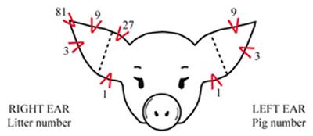

Driving Your Hog In The Ring
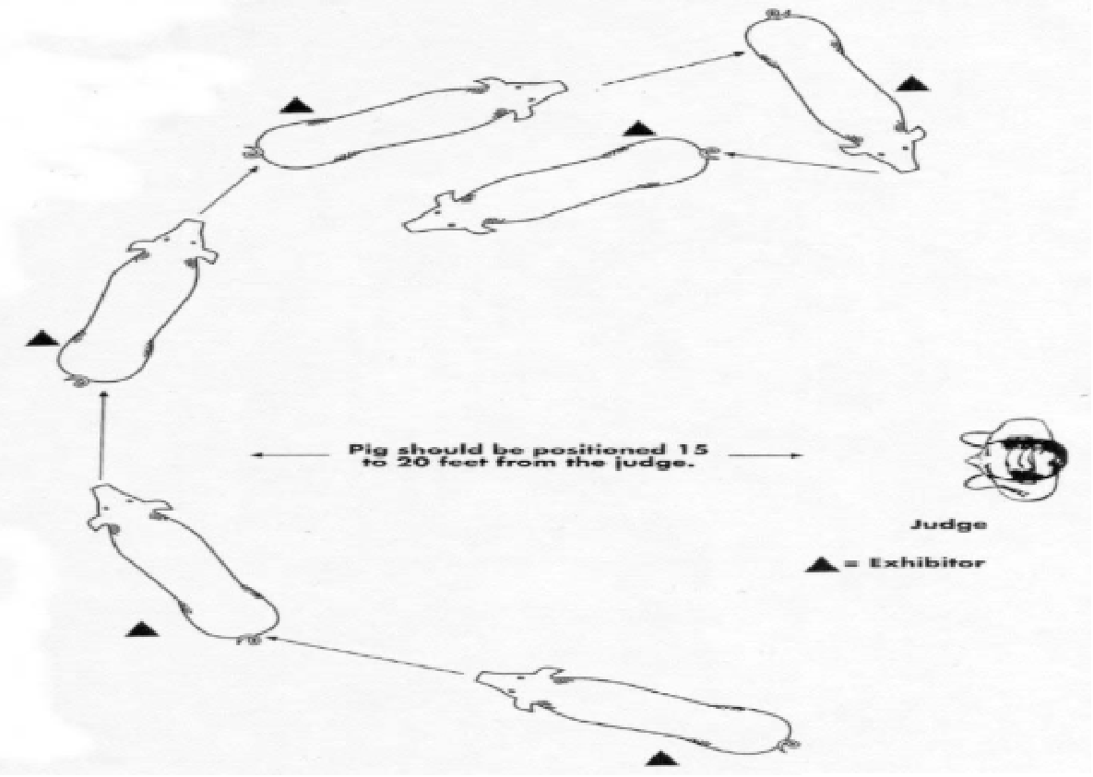
Driving the Pig:

- Stay 15-20 ft from judge in the middle of the ring
- Avoid corners
- Keep pig moving unless judges asks
- Always keep the pig between you and the judge

Locations To Tap Your Hog In The Ring

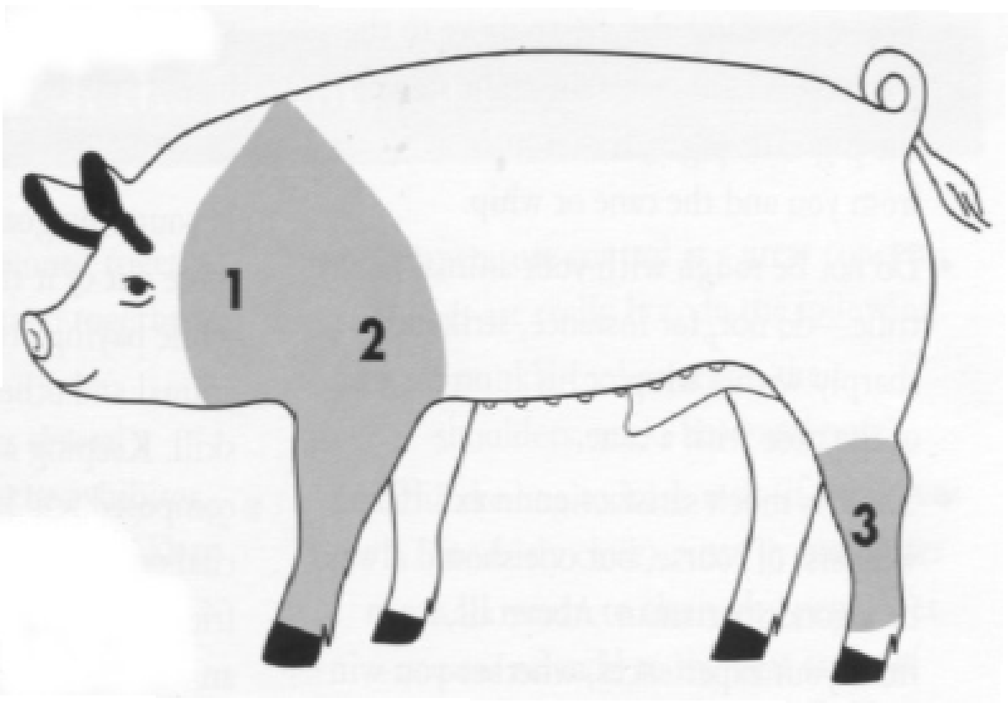

Penning Your Hog

Practice penning you pig with treats at home several weeks before the fair

Pen Placement – brush down your hog, keep its head towards gate, keep eye contact with judge, display the underline on gilts, and make sure to lock gate when entering & leaving

When do you brush your pig – when the pig gets dirty, the judge handles pig and in the pen

Supplies And Equipment

The following is a list of supplies and equipment needed for your project.

- Plastic hog cane or hog whip
- Small Nylon brush with handle
- Livestock soap
- Hair conditioner
- Pressurized spray bottle
- Rubber feed pan
- Water pan or tube
- Show Products
  - Sullivan’s Swine Shine for home
  - Sullivan’s Sudden Impact for home
  - Sullivan’s Hog Heaven or Absorbine’s Showsheen for show day
- Several rags
- Alcohol
- Sorting Panel
- Water hose and nozzle
- Show uniform (white shirt, white pants, FFA Jacket, Tie/Scarf)
- Small tack box (you may share with a friend)

How Much Will The Project Cost?

Listed below are the common items and their approximate costs of a market animal.

- Cost of Hog (2 @$275 ea) $550
- Feed (20 sacks @ $18 ea) $360
- Straw (5 bales @ $7.00 ea) $35
- Tack/Equipment $75
- Veterinary Supplies $25
- Insurance $15
Total $1060

Estimated Income From Your Project.

Sale of finished market pig 250lb.
Average market hog price $4.25 $1062.50

Total Income $2125
Total Profit $1065

Note: Profit shown is based on average market price from the Douglas County Fair. If students are motivated and get additional financial backings through add-on’s, there is potential for more profit.

How Do I Sell My Project?

- One of the first questions most new exhibitors ask is, “How much money can I make on my project?” This question is a valid one. Most students figure that if you spend a great deal of money on the project, the returns should also be great. Unfortunately, this statement is not always accurate. The animal will be sold at the fair through public auction with the animal being sold to the highest bidder. These buyers are under no obligation to support and buy these livestock projects. It is your job to find buyers for your animal. You must remember that you are selling a product and you must approach this part of you project as a salesman. The buyers will not come to you, you must go to them.
- Before you approach a prospective buyer, you must first understand how the process works so that you can accurately answer any questions that may arise in your conversation with the buyer. You begin by calculating your break-even price. By dividing the estimated fair weight of the animal into the total cost, you will know how much per pound you need to break even. The next part of the process is to know what the buyer’s options are with the animal once it has been sold. The following are three options buyers have:
  - The most common option used is the resale or buy back. The buyer simply pays the difference between the current market price and their bid. The fair then sells the animal to a commercial packer for the current market price. The buyer does not take possession of the animal.
  - In the second option the buyer takes possession of the animal or carcass. The custom processing option allows the buyer to choose where the animal will be processed. The animal is taken to this location by the fair and the buyer then picks up the cut and wrapped meat.
  - The third option is live pick up. This option allows the buyer to take possession of the live animal from the fair.
- You must also be able to explain to the buyer what benefits they receive form buying your project. A buyer basically receives two benefits – advertising at the auction and a tax deduction. The only amount of the purchase price that can be deducted is any amount paid over and above the current market price.
- Armed with this information you can begin your search for buyers. Anyone can buy an animal at the fair, but the most common buyers are local businesses. The two most common methods of finding buyers are through personal contact or by writing letters to prospective buyers. Personal contact is a much more preferred method because the buyer has the chance to meet the owner of the animal and ask any questions concerning the project or selling process. The letter writing method does not afford these opportunities. When meeting with a buyer, the student should approach the buyer in a business like manner, calling ahead and making an appointment with them, dressing in the official uniform, being prepared, etc.
- Above all, be persistent in your search for a buyer. You may be turned down a few times before finding someone willing to buy your animal. Don’t give up. The financial success of your project depends on you finding a buyer. You may want to find more than one buyer in the event one of them does not show up at the auction.
- Another key element to successfully selling your animal is to approach buyers early. Don’t wait until just before fair to start contacting people. You will not be the only person at the fair selling an animal. Begin several months prior to the fair. Many buyers buy from the first person that contacts them. Avoid the rush and start early!
- To find out more specific information concerning the auction process, approaching buyers, commonly asked questions, etc. contact your project advisor.
- Things you should include in your buyer letter:
  - Information about yourself
  - Information about your project and chapter
  - The fair dates
  - The sale dates, times & locations
  - Explain how to participate as a buyer
  - Inform them where they can get more information
  - Personally sign each letter
  - Add a picture of you and your animal
  - Proper grammar and spelling
  - A sample is included in this handbook!
- Thank you letters are required by the fair to pick up your check and insure support the next year. For more information read your fair book.

Duties Of Swine Exhibitors

- Follow all instructions given to you by your advisor. Communication is the key to a successful project.
- Clean your pen. Scrape up manure and wash down the pen daily.
- Makes sure you animal does not go without feed or water. Plan ahead!
- Practice showing your animal on a regular basis. This will train your animal and give you confidence when you enter the show ring.
- All exhibitors will be required to meet with their advisor periodically to discuss the progress of their animal, to weigh the animal and for informational meetings. All meetings with the advisor will be scheduled as much as possible around the student’s schedule. The advisor may make unannounced visits to make sure that the animals are being properly cared for.
- A “three strikes” system is in place for anyone not abiding by the rules and/or guidelines set forth in this handbook. You will receive a “strike” for each violation. After three “strikes” you will be unable to show your project under Roseburg FFA.
- If you encounter any problems at all concerning you market animal or someone else’s animal or facilities, please contact your advisor immediately!
- A record book must be maintained and kept up to date at all times.
- The fair contract at the end of this handbook is required to be filled out for all exhibitors and is to be turned in to the project advisor.

Sample Buyer Letter Format

Your Name
Street address
City, State, Zip Code

Business Name
Street Address
City, State, Zip Code

Today’s Date

Dear _________________,

In the first paragraph talk about your self and what you have done in FFA and your chapter. Go on to tell them why you are writing the letter.

In the second paragraph talk about your project (species, breed, gender, what you have learned). Additionally include information about your self and how raising an animal is helping your reach your goals.

In the third paragraph tell them when the fair is and the auction information. Invite the buyer to the fair. Encourage the buyer to go to the auction. Also advise the buyer of the showmanship and market show dates and times. If they are unable to attend the auction advise them that someone else can bid for them. Additionally, if they do not want to purchase an entire animal they can purchase half with another party.

In the fourth paragraph, tell the buyer that you hope to see them at the fair and hoper they will consider buying your animal.

Sincerely,

Double space for signature & sign in black ink

Type your name
Roseburg FFA

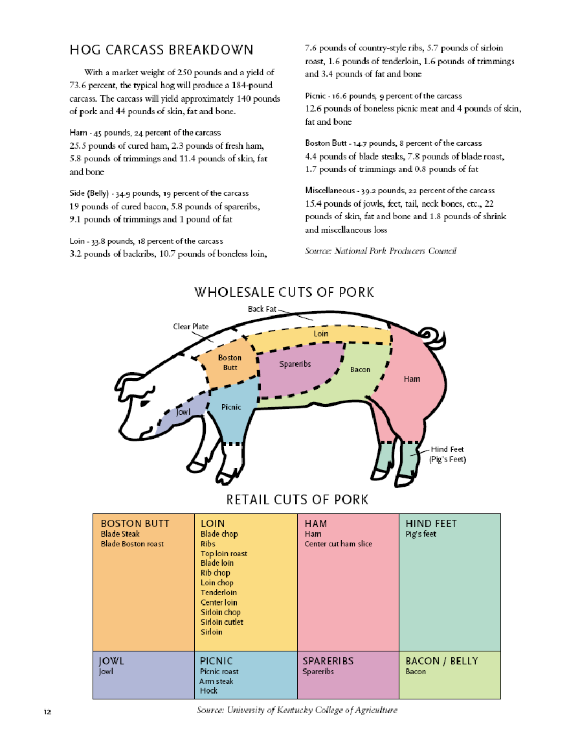
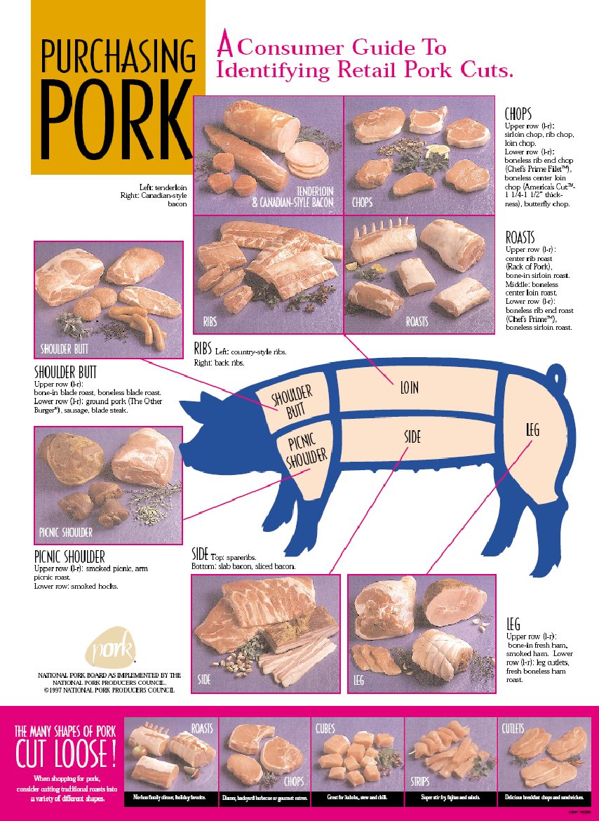

Record Keeping

Starting Out

Desired Weight at Fair ______________ pounds

Starting Weight ______________ pounds

Weight Gain Needed ______________ pounds

Days to Fair ______________ pounds

Desired Average Daily Gain ______________ pounds
(Weight gain/days to fair)

Results

Finish Weight ______________ pounds

Start Weight ______________ pounds

Gain ______________ pounds

Days on Feed ______________ pounds

Average daily gain ______________ pounds

Weight Record

Date | Weight | Gain | ADG | Fair Weight #
  - Gain = current weight – previous weight
  - ADG = gain/number of days since last weight
  - #Fair Weight = (ADG x days to fair) + current weight

Roseburg High School Agriculture Department
Exhibitor Contract

FFA members have the opportunity to raise animal projects to exhibit at the Marin County, Douglas County Fair. These projects require a student to take on a great deal of responsibility. In order for all students to learn and work together, the following requirements are expected of each exhibitor regardless of where the animal is housed or species being raised.

Participating in the fair is a school activity. All school and fair rules and policies apply. Failure to follow the rules will prevent you from participating in all further fair events (showing and selling of your project).

In the event that a student is not able to exhibit their animal(s) at the fair, the animal will remain the responsibility of the student (feeding, care of, maintenance, accommodations, etc) as well as, financially until the termination of the project.

Pre-Fair
- Grades: In order to exhibit an animal as a member of the Roseburg FFA chapter, a Grade Point Average of a 2.0 must be earned as shown on the Spring Semester Report Card and they must have a 2.0 GPA minimum and no F’s in their enrolled agriculture classes. If a student does not have a minimum GPA of a 2.0 he/she will not be able to show under Roseburg FFA. Students must not have any “F” grades as per district policy.

- Entries: Entries are the responsibility of the exhibitor.

- FFA Record books: Students must have an up to date record book before the advisor will sign any fair entry forms. If a student is a second, third or fourth year member they are required to have their current book and all of their past books completed before the advisor will sign fair entry forms.

- Uniform: Have a complete FFA show uniform (FFA jacket, FFA tie/scarf, white pants, white collared shirt, black or brown shoes and a black or brown belt).
*The uniform will be worn on market show & showmanship days and at the
auction.

- Preparation of animals: Be sure that your animal is shorn, clipped, etc. PRIOR to haul in date. If an animal is sick, is prolapsing, has fungus, or any other problem that will not enable a student to show the animal (as set by the fair) then it is the student’s responsibility to take care of the animal(s).

- Equipment: Have all specified (as stated by advisor) tack and show supplies, soap, halters, show sticks, towels, feeders, water buckets, etc. ready.

- Feed and Bedding: Order any needed grain and/or hay needed for the fair. Bedding is the responsibility of the student. Sheep: Shavings Hogs, Dairy, Goats: Straw

- Meetings: You must attend all exhibitor meetings called by the advisor. These will occur prior to the start of the fair and during the fair.

- Transportation: Transportation of animals is the responsibility of the students. Please be sure to make arrangements prior to the haul in date and tell the advisors your plans to ensure that all animals get to the fair. Be sure to have rides to the fair every day to care for your animals and meet the responsibility requirements set. If there is a problem contact the advisor.

During Fair

- Clothing: Wear appropriate clothing during loading, exhibiting and loading out at the fair (long pants, short sleeve or long sleeve shirt, socks and closed toe, closed back shoes). School dress code must be followed.

- Feeding and Barn Duty: You must be present at required feeding times. You must stay at our barn area during scheduled barn duty times. During barn duty you are to complete all required responsibilities. Keep personal areas as well as the chapter area clean and swept at all times.

- Showmanship: Showmanship is an opportunity to demonstrate your knowledge of your project. All exhibitors will be required to participate in showmanship.

- Etiquette: You are a representative of the FFA, your school, community and the agriculture industry. Be sure to be a positive representative. Be courteous and respectful to fair patrons, fellow exhibitors and guests at the fair. Inappropriate behavior will not be tolerated. For example: swearing, inappropriate dress, fighting, etc. All school rules apply at the fair. In the event that school or fair rules are broken at the fair, you forfeit the privilege of selling your animal at the auction.

- Chapter Group: Chapter group is an opportunity to exhibit five animals in each species. The advisor will determine the animals that will be selected to be exhibited in the chapter group category. ALL students must be present to aid in showing the group and to provide support.

- Auction: Prior to Auction Day every exhibitor is to write thank you letters with an envelope and stamp. See fair premium book for guidelines. YOU WILL NOT RECEIVE A CHECK WITHOUT A THANK YOU LETTER.
  - Auction Day: Be at the fairgrounds by 8am, in uniform and ready to meet some potential buyers.
  - No Animal Accessories: No glitter, paint, flowers, etc. on your animal.

- Buyers: It is not the responsibility of the advisor to find a buyer for your animal, although I try to make contacts with you in mind. It is your responsibility to secure a buyer. You may send buyer letters to community supporters (must be approved by the advisor). You may also be asked by the advisor to talk with some potential buyers before the auction takes place while at the fair. Be willing and ready to discuss your project with some members of the agricultural community.

Post-Fair

- Thank You Letters: See guidelines in the fair book. They must be turned into the fair office within 14 days of the completion of the fair.

- FFA Record Books: If you are interested in earning your Chapter FFA Degree, State Farmer Degree or applying for a proficiency award, be sure to see your advisor for help to complete your record books. The sooner you get them done the better and less stress come application time!

Questions or concerns?
Contact Mrs. Chenoweth (541) 817-7153

I, _________________________, have read and understand the rules and expectations as stated above. I understand that if these rules are broken or expectations are not met I will accept the consequences.

Student Date

Parent Date

Advisor Date
Roseburg High School Agriculture Department
Exhibitor Contract

FFA members have the opportunity to raise animal projects to exhibit at the Marin County, Douglas County Fair. These projects require a student to take on a great deal of responsibility. In order for all students to learn and work together, the following requirements are expected of each exhibitor regardless of where the animal is housed or species being raised.

Participating in the fair is a school activity. All school and fair rules and policies apply. Failure to follow the rules will prevent you from participating in all further fair events (showing and selling of your project).

In the event that a student is not able to exhibit their animal(s) at the fair, the animal will remain the responsibility of the student (feeding, care of, maintenance, accommodations, etc) as well as, financially until the termination of the project.

Pre-Fair
- Grades: In order to exhibit an animal as a member of the Roseburg FFA chapter, a Grade Point Average of a 2.0 must be earned as shown on the Spring Semester Report Card and they must have a 2.0 GPA minimum and no F’s in their enrolled agriculture classes. If a student does not have a minimum GPA of a 2.0 he/she will not be able to show under Roseburg FFA. Students must not have any “F” grades as per district policy.

- Entries: Entries are the responsibility of the exhibitor.

- FFA Record books: Students must have an up to date record book before the advisor will sign any fair entry forms. If a student is a second, third or fourth year member they are required to have their current book and all of their past books completed before the advisor will sign fair entry forms.

- Uniform: Have a complete FFA show uniform (FFA jacket, FFA tie/scarf, white pants, white collared shirt, black or brown shoes and a black or brown belt).
*The uniform will be worn on market show & showmanship days and at the
auction.

- Preparation of animals: Be sure that your animal is shorn, clipped, etc. PRIOR to haul in date. If an animal is sick, is prolapsing, has fungus, or any other problem that will not enable a student to show the animal (as set by the fair) then it is the student’s responsibility to take care of the animal(s).

- Equipment: Have all specified (as stated by advisor) tack and show supplies, soap, halters, show sticks, towels, feeders, water buckets, etc. ready.

- Feed and Bedding: Order any needed grain and/or hay needed for the fair. Bedding is the responsibility of the student. Sheep: Shavings Hogs, Dairy, Goats: Straw

- Meetings: You must attend all exhibitor meetings called by the advisor. These will occur prior to the start of the fair and during the fair.

- Transportation: Transportation of animals is the responsibility of the students. Please be sure to make arrangements prior to the haul in date and tell the advisors your plans to ensure that all animals get to the fair. Be sure to have rides to the fair every day to care for your animals and meet the responsibility requirements set. If there is a problem contact the advisor.

During Fair

- Clothing: Wear appropriate clothing during loading, exhibiting and loading out at the fair (long pants, short sleeve or long sleeve shirt, socks and closed toe, closed back shoes). School dress code must be followed.

- Feeding and Barn Duty: You must be present at required feeding times. You must stay at our barn area during scheduled barn duty times. During barn duty you are to complete all required responsibilities. Keep personal areas as well as the chapter area clean and swept at all times.

- Showmanship: Showmanship is an opportunity to demonstrate your knowledge of your project. All exhibitors will be required to participate in showmanship.

- Etiquette: You are a representative of the FFA, your school, community and the agriculture industry. Be sure to be a positive representative. Be courteous and respectful to fair patrons, fellow exhibitors and guests at the fair. Inappropriate behavior will not be tolerated. For example: swearing, inappropriate dress, fighting, etc. All school rules apply at the fair. In the event that school or fair rules are broken at the fair, you forfeit the privilege of selling your animal at the auction.

- Chapter Group: Chapter group is an opportunity to exhibit five animals in each species. The advisor will determine the animals that will be selected to be exhibited in the chapter group category. ALL students must be present to aid in showing the group and to provide support.

- Auction: Prior to Auction Day every exhibitor is to write thank you letters with an envelope and stamp. See fair premium book for guidelines. YOU WILL NOT RECEIVE A CHECK WITHOUT A THANK YOU LETTER.
  - Auction Day: Be at the fairgrounds by 8am, in uniform and ready to meet some potential buyers.
  - No Animal Accessories: No glitter, paint, flowers, etc. on your animal.

- Buyers: It is not the responsibility of the advisor to find a buyer for your animal, although I try to make contacts with you in mind. It is your responsibility to secure a buyer. You may send buyer letters to community supporters (must be approved by the advisor). You may also be asked by the advisor to talk with some potential buyers before the auction takes place while at the fair. Be willing and ready to discuss your project with some members of the agricultural community.

Post-Fair

- Thank You Letters: See guidelines in the fair book. They must be turned into the fair office within 14 days of the completion of the fair.

- FFA Record Books: If you are interested in earning your Chapter FFA Degree, State Farmer Degree or applying for a proficiency award, be sure to see your advisor for help to complete your record books. The sooner you get them done the better and less stress come application time!

Questions or concerns?
Contact Mrs. Chenoweth 541-817-7153

I, _________________________, have read and understand the rules and expectations as stated above. I understand that if these rules are broken or expectations are not met I will accept the consequences.

Student Date

Parent Date

Advisor Date

