**Greensboro Bison Baseball** 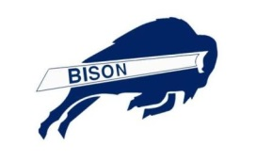

**Checklist**

Welcome to Greensboro Bison Baseball. We are excited about you considering our organization for Travel baseball. Please complete and submitted all forms at the same time to ensure registration acceptance.

**Application**

* Completed and signed by parent

**Code of Conduct**

* Completed and signed by Parent for Greensboro Bison
* Completed and signed by Player

**Medical Waiver Form**

* Completed and signed by Parent

**Picture/Video Consent Form**

* Completed and signed by Parent

**Concussion/Abuse Forms**

* Completed Concussion Form
* Completed Abuse Policy Form

Player’s Name______________________________________ Date________________________

Parent(s) Signature ______________________________________________ Date_________________________________

(Parent’s signature if under age of 18)

If you have any questions regarding this packet please contact Samantha Wilkerson, by phone at 336.451.6691 or by email at [gsobisonbaseball@yahoo.com](mailto:gsobisonbaseball@yahoo.com) .

Thank you,

Samantha Wilkerson

Greensboro Bison Baseball

**Achievements…**

* **12 U Bison Boys Baseball**
* **14 U Bison Boys Baseball**
* **16 U Lady Bison Softball**
* **16 U Bison Boys Baseball**
* **18/19 U Bison Boys Baseball**

## **2019 19U MJBL Inner City Classic and Black World Series Greensboro NC**

## **2019 USSSA 18U East Coast Championship Charlotte, NC**

## **2018 18U Runner-Up USSSA Tournament Raleigh NC**

## **2018 15U MJBL Inner City Classic and Black World Series Greensboro NC**

## **2017 14U MJBL Inner City Classic and Black World Series Greensboro NC**

## **2017 TopGun “Bow Net summer Sizzler” N Myrtle Beach, SC**

## **2017 USSSA March Madness Charlotte, NC**

## **2016 16U Cooperstown Baseball Oneonta NY**

## **2013 12UTop Gun Tournament Greensboro NC – Champions**

## **2013 11U Summertime Blues Elite Champion East Davidson**

## **2012 16U Freedom Florence Tournament Myrtle Beach, SC - Champions**

## **2012 18U Urban Baseball Classic Atlanta, GA - Runner –up**

## **2012 18U UnderArmour Invitational Greensboro, NC - Champions**

## **2012 Carolina Super Regional High School Champion**

## **2010 MJBL Inner City Classic and Black World Series**

## **2008 MJBL Inner City Classic and Black World Series**

## **2006 14U NC-USSSA Triad Sports Fall Open**

## **2006 NC-USSSA Winter Champion Runner Up**

## **2005 USSSA Carolina-Virginia Champion**

## **2005 Greensboro Parks and Recreation Invitational Champion**

## **2004 Campbell’s Tournament Champion**

**“A good coach will make his players see what they can be, rather than what they are”**

**Coach “JB” Baynes**

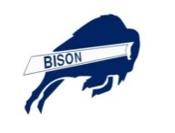

**Greensboro Bison**

**Registration Form**

**Personal** BATS________ THROWS_________ POSITION_____/_____ /______

PLAYER’S

Name: ____________________________________________________________

(First) (Middle) (Last)

DATE OF BIRTH____________________ HEIGHT__________ WEIGHT _________

AGE_________ SCHOOL_____________________________

PARENT(S) NAME(S)(FIRST&LAST)__________________________________________________

PARENT(S)

MAILING ADDRESS______________________________________________________

CITY____________________________ STATE_______

ZIP____________________________

PARENT CELL _____________________

(Include area code)

PLAYER’S CELL___________________________

(Include area code)

PARENTS EMAIL ADDRESS__________________________________

PLAYERS EMAIL ADDRESS _________________________________

IS PLAYER ALLERGIC TO ANY MEDICATIONS? _____ YES _____ NO

If yes, please list & explain:

_____________________________________________________________________________

DOES THIS PLAYER HAVE ANY MEDICAL PROBLEMS THAT WE MADE AWARE OF? ________________________________________________________________________________

(Signature of Applicant) over age 18 (Signature of Parent/Guardian) Date



Greensboro Bison Baseball

PARENT CONSENT AND PHOTO RELEASE FORM

*Please sign and return this form. At various times during the Spring and Fall tournaments a representative from the Bison organization and/or partners request permission to video or photograph your child. Subsequently they may be publish or use these materials for promotional purposes.*

**Photo Consent:** I do consent and allow my child to be videotaped and/or photographed for the use of Greensboro Bison Organization or partners and the media.

_____________________________________________________________________________________

Child’s Name Parent’s Signature Date

**No Photo Consent:** I do **NOT** consent and allow my child to be videotaped and/or photographed for the use of Greensboro Bison Organization or partners and the media.

_____________________________________________________________________________________

Child’s Name Parent’s Signature Date

Greensboro Bison

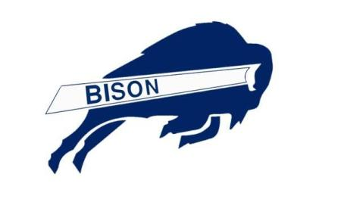 Parents Code of Conduct

1. I will be an encouragement to all players on all teams regardless of the score
2. I will demonstrate good sportsmanship by acting in a positive manner towards coaches, players and officials
3. I will represent Greensboro Bison Organization in an upstanding manner.
4. I will demand that my child treat other coaches, players, officials and spectators with respect regardless of race, creed, color, sex or ability.
5. I will encourage my child to shake hands with the other team at the conclusion of all games.
6. I will not engage in any kind of unsportsmanlike conduct with coaches, players or officials such as booing, taunting or using profane language or gestures.
7. I will exert self-control over my own ego and emotions.
8. I will avoid displays of anger, rage or frustration in front of the players and if needed, I will agree to speak with the coaches at an appointed time and place.
9. At no time will I abuse, mistreat, threaten or humiliate any player, umpire, other coach, Greensboro Bison Representative, parent or spectator.
10. I will expect an environment for my child that is free from the use of drugs, tobacco or alcohol while at games or practice.

### First offense will be a warning. Second and Final offense the child will be dismissed and all monies paid will not be refundable.

### Signed ____________________________________Date______________

### *Jeremiah 29:11 For I know the plans I have for you,” declares the LORD, “plans to prosper you and not to harm you, plans to give you hope and a future.*

**Greensboro Bison Baseball**

**RELEASE AND WAIVER OF LIABILITY, ASSUMPTION OF RISK, AND INDEMNITY AGREEMENT WITH PARENTAL CONSENT (“AGREEMENT”)**

IN CONSIDERATION of being permitted to participate in any way in any event (“Activity”) at any time during the current calendar year I, for myself, my personal representatives, assigns, heirs, and next of kin:

1. ACKNOWLEDGE, agree, and represent that I understand the nature of the Activity and that I am qualified, in good health, and in proper physical condition to participate in such Activity. I further agree and warrant that if, at any time, I believe the conditions to be unsafe, I will immediately discontinue further participation in the Activity.

2. FULLY UNDERSTAND that: (a) THIS ACTIVITY INVOLVES RISKS AND DANGERS OF SERIOUS BODILY INJURY, INCLUDING PERMANENT DISABILITY, PARALYSIS, AND DEATH (“Risks”); (b) these Risks and dangers may be caused by my own actions or inactions, the actions or inactions of others participating in the Activity, the conditions in which the Activity takes place, or THE NEGLIGENCE OF THE “RELEASEES” NAMED BELOW; (c) there may be OTHER RISKS or SOCIAL AND ECONOMIC LOSSES either not known to me or not readily foreseeable at this time; and I FULLY ACCEPT AND ASSUME ALL SUCH RISKS AND ALL RESPONSIBILITY FOR LOSSES, COSTS, and AND DAMAGES I incur as a result of my participation, or that of the minor, in the Activity.

3. HEREBY RELEASE, DISCHARGE, AND COVENANT NOT TO SUE the sanctioning organization(s), their administrators, directors, agents, officers, members, volunteers, and employees, other participants, officials, rescue personnel, sponsors, advertisers, owners and lessees of Premises on which the Activity is conducted, (each of the forgoing shall be considered one of the RELEASEES herein) FROM ALL LIABILITY, CLAIMS, DEMANDS, LOSSES, OR DAMAGES ON MY ACCOUNT CAUSED,OR ALLEGED TO BE CAUSED, IN WHOLE OR IN PART BY THE NEGLIGENCE OF THE RELEASEES OR OTHERWISE, INCLUDING NEGLIGENT RESCUE OPERATIONS; AND I FURTHER AGREE that if, despite this RELEASE AND WAIVER OF LIABILITY, ASSUMPTION OF RISK, AND INDEMNITY AGREEMENT I, or anyone on my behalf, makes a claim against any of the Releases, I WILL INDEMNIFY, SAVE, AND HOLD HARMLESS EACH OF THE RELEASEES from any litigation expenses, attorney fees, loss, liability, damage, or cost which may be incurred as the result of such claim.

I ACKNOWLEDGE THAT I AM AGE 18 OR OLDER, HAVE READ THIS AGREEMENT AND FULLY UNDERSTAND ITS TERMS, UNDERSTAND THAT I HAVE GIVEN UP SUBSTANTIAL RIGHTS BY SIGNING IT, HAVE SIGNED IT FREELY AND WITHOUT ANY INDUCEMENT OR ASSURANCE OF ANY NATURE, AND I INTEND IT TO BE A COMPLETE AND UNCONDITIONAL RELEASE OF ALLLIABILITY TO THE GREATEST EXTENT ALLOWED BY LAW AND AGREE THAT IF ANY PORTION OF THIS AGREEMENT IS HELDTO BE INVALID, THE BALANCE, NOTWITHSTANDING, SHALL CONTINUE IN FULL FORCE AND EFFECT.

**Greensboro Bison Baseball**



**RELEASE AND WAIVER OF LIABILITY, ASSUMPTION OF RISK, AND INDEMNITY**

**AGREEMENT WITH PARENTAL CONSENT (“AGREEMENT”**

PRINTED NAME OF PARTICIPANT: ________________________________________________________________________

PARTICIPANT’S SIGNATURE: _____________________________________________________________

(Over age 18)

ADDRESS: ___________________________________________________________________________

(Street) (City) (State) (Zip)

PHONE: _________________________________________ DATE: ________________________

**MINOR RELEASE:** (must be completed by Parent/Guardian for any participant under the age of 18)

AND I, THE MINOR’S PARENT AND/OR LEGAL GUARDIAN, UNDERSTAND THE NATURE OF THE ACTIVITY AND THE MINOR’S EXPERIENCE AND CAPABILITIES AND BELIEVE THE MINOR TO BE QUALIFIED, IN GOOD HEALTH, AND IN PROPER PHYSICAL CONDITION TO PARTICIPATE IN SUCH ACTIVITY. I HEREBY RELEASE, DISCHARGE, COVENANT NOT TO SUE, AND AGREE TO INDEMNIFY AND SAVE AND HOLD HARMLESS EACH OF THE RELEASEES FROM ALL LIABILITY, CLAIMS, DEMANDS, LOSSES, OR DAMAGES ON THE MINOR’S ACCOUNT CAUSED, OR ALLEGED TO BE CAUSED, IN WHOLE OR IN PART BY THE NEGLIGENCE OF THE “RELEASEES” OR OTHERWISE, INCLUDING NEGLIGENT RESCUE OPERATIONS AND FURTHER AGREE THAT IF, DESPITE THIS RELEASE, I, THE MINOR, OR ANYONE ON THE MINOR’S BEHALF MAKES A CLAIM AGAINST ANY OF THE RELEASEES NAMED ABOVE, I WILL INDEMNIFY, SAVE, AND HOLD HARMLESS EACH OF THE RELEASEES FROM ANY LITIGATION EXPENSES,ATTORNEY FEES, LOSS LIABILITY, DAMAGE, OR ANY COST THAT MAY OCCUR AS A RESULT OF ANY SUCH CLAIM.

PRINTED NAME OF PARENT/GUARDIAN: __________________________________________________________________

PARENT/GUARDIAN SIGNATURE (if participant is under the age of 18): ________________________

ADDRESS: __________________________________________________________________________

(Street) (City) (State) (Zip)

PHONE: ___________________________________________ DATE: ___________________________

Greensboro Bison

 Players

Code of Conduct

1. I will respect my coaches at all times and listen carefully to their instructions. I understand that they are giving their time to make me a better player.
2. I will work for the good of my team and give my best effort at all times.
3. I will be modest and generous when I win and gracious when I lose.
4. I will respect the game, follow the rules, and play the game fairly.
5. I will show respect for the authority of the referee, even though I will sometimes disagree with his/her calls.
6. I will conduct myself with honor and dignity and treat other players as I would like to be treated.
7. I will control my temper and not retaliate, even if I believe I have been wronged.
8. I will show good sportsmanship before, during, and after games. I understand that this is a game, and that the players on the other team are my opponents, not my enemies.
9. At no time will I abuse, mistreat, threaten or humiliate any player, umpire, other coach, **Greensboro Bison** Representative, parent or spectator.
10. I will not use or possess tobacco, alcohol, or illegal or performance-enhancing drugs while at games or practice.

### First offense will be a warning. Second and Final offense the player will be dismissed and all monies paid will not be refundable.

### Signed ____________________________________Date______________

### *Jeremiah 29:11 For I know the plans I have for you,” declares the LORD, “plans to prosper you and not to harm you, plans to give you hope and a future.*

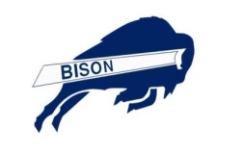

**Greensboro Bison Baseball**

**PO Box 10353**

**Greensboro NC 27415**

**Phone: 336.451.6691 or Fax: 336.335.2582**

**Please help support the Greensboro Bison Baseball team by purchasing a baseball for a $10 donation. Your support will offset the cost to attend tournaments this upcoming baseball season 2015. Thanks in advance for your support.**

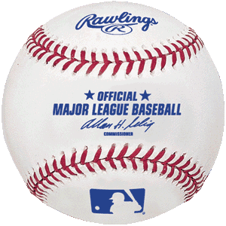  

  

  

**Bison Player**

**Greensboro Bison Baseball**

**Concussion Statement**

***(If there is anything on this sheet that you do not understand please seek assistance)***

**Player’s Name _________________________________________________________________**

**Parent/Legal Guardian Name(s) ___________________________________________________**

* **We have read and understand the Concussion Information sheet**

|  |  |  |
| --- | --- | --- |
| **Player Initials** |  | **Parent/Legal Guardian Initials** |
|  | A concussion is a brain injury, which should be reported to my parents, my coach(es) or a medical professional if one is available |  |
|  | A concussion can affect the ability to perform everyday activities such as the ability to think, balance and classroom performance |  |
|  | A concussion cannot be “seen.” Some symptoms might be present right away. Other symptoms can show up hours or days after an injury |  |
|  | I will tell my parents, my coach, and/or a medical professional about my injuries and illnesses | N/A |
|  | If I think a teammate has a concussion, I should tell my coach(es), parents, or medical professional about the concussion | N/A |
|  | I will not return to play in a game or practice if a hit to my head or body causes any concussion-related symptoms | N/A |
|  | I will/my child will need written permission from a medical professional trained in concussion management to return to play or practice after a concussion |  |
|  | Based on the latest data, most concussions take days or weeks to get better. A concussion may not go away right away. I realize that resolution from this injury is a process and may require more than one medical evaluation. |  |
|  | I realize that ER/Urgent Care physicians will not provide clearance if seen right away after the injury. |  |
|  | After a concussion, the brain needs time to heal. I understand that I am/my child is much more like to have another concussion or more serious brain injury if return to play or practice occurs before concussion symptoms go away |  |
|  | I have read the concussion symptoms on the Concussion information sheet. |  |

**Player Signature_____________________________________________ Date__________**

**Parent/Legal Guardian Signature________________________________ Date___________**

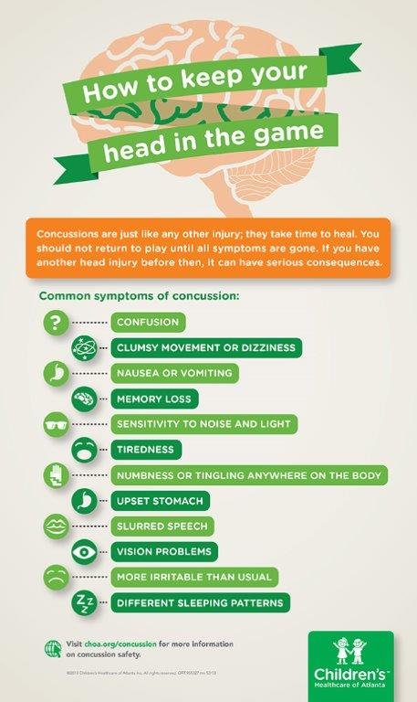

**Greensboro Bison Baseball**

**Abuse Policy and Procedure**

As a youth-serving organization, **Greensboro Bison Baseball, Inc.** considers the safety and well- being of the youth in our organization a top priority. It is the expressed policy of **Greensboro Bison Baseball, Inc.**, that all staff and volunteers shall adapt to the following Policy and Procedure in an effort to provide a safe environment for coaches, players, and their families.

We prohibit abuse and strive to proactively address reports of this type of conduct, even if it means that someone will be embarrassed or upset. Please report any problems or concerns by completing an incident report form, and we will strive to act on them expeditiously in a fair way.

All staff and volunteers shall not engage in sexually oriented activities, including sexual conversations with players, nor allow such conduct to exist between players themselves.

All staff and volunteers are responsible for stopping disrespectful behavior, degrading language and potential threats as well as intentional physical injury between team players, including sexual harassment. Committing any sexual offence against a minor including but not limited to engaging in sexual advances, sexual contact or engaging in verbal or physical contact is strictly prohibited.

All current and potential coaches will be subject to a background check. This background check will be updated yearly for each coach.

Should a suspected incident of abuse be reported, the staff member and/or volunteer in question may be temporarily dismissed from any and all duties while the investigation takes place.

**We will report suspected abuse to the proper law enforcement agencies.**

**Greensboro Bison Baseball**

**Abuse Policy and Procedure**

I, _______________________________ certify that I have received a copy of

Greensboro Bison Baseball, Inc., Abuse policy and procedure and will adhere to

the guidelines. I understand that I am required to report any incident of abuse to

the organization.

Date ______________________

Printed Name___________________________________________________

Signature ______________________________________________________