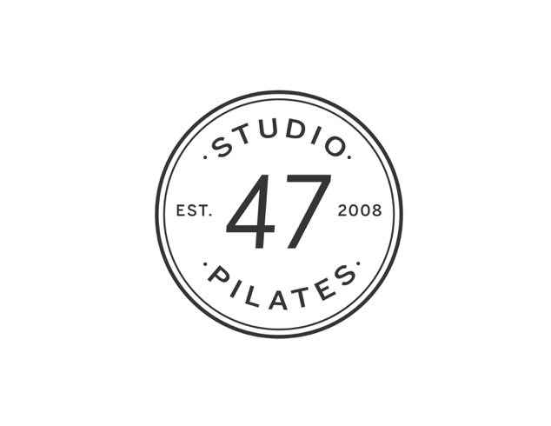

Waiver of Liability and Informed Consent Release

This release, Waiver and Hold Harmless Agreement is made by and between the undersigned client, student, participant (from hereon in client, student, participant will be written as the undersigned) and Barrington Pilates, Inc. D/B/A studio47 Pilates and entered into on the day, month and year noted below.

Please initial all sections and sign below:

- Barrington Pilates, Inc. provides space for and the instruction of Pilates classes and other forms of physical exercise and movement. The parties to this agreement recognize that the participation in these activities could lead to physical injury.

- The undersigned desires to undertake Barrington Pilates, Inc. program with the full knowledge of the possibility that physical injury could result from it and desires to assume the risk of any such injury.

- The undersigned recognizes that Barrington Pilates, Inc. will not be able to and will not provide its program to anyone without the execution of this agreement.

- Cancellation Policy: We have a 24 hour cancellation policy at the studio for all classes and private sessions. If you cancel at least 24 hours in advance, you will not be charged. If you cancel less than 24 hours before your class or session, please note you are responsible for payment.

- Class Cancellations: If for any reason the studio needs to cancel a class, you will be informed via email. While this is a rare occurrence, the studio reserves the right to cancel a class without notice, although we will try to always accommodate clients.

- All class cards are non-transferable: Any class cards you purchase may not be transferred to other clients and may not be used as payment for other services.

Therefore, the undersigned, in consideration of the above and of the Pilates, various exercise classes, and movement classes to be provided, hereby waives all claims for damage or loss to person or property which may be caused by any act, or failure to act, of Barrington Pilates, Inc. instructors, staff, landlord and their officers, agents, or employees. The undersigned assumes the risk of all dangerous conditions in and around the premises and waives any and all specific notice of the existence of such conditions. The undersigned also assumes the risk of any and all injuries that might result from participating in Barrington Pilates, Inc. Pilates or movement programs.

In consideration of my participation in Barrington Pilates, Inc. Pilates, exercise, and movement programs, I _______________________________, for myself, my heirs and assigns, hereby release Barrington Pilates, Inc., its employees, independent contractors and owners, from any claims, demands and causes of action arising from my participation in the pilates, exercise program. I hereby affirm that I have read and fully understand the above, am over eighteen years of age or am a legally emancipated minor.

Today’s Date: _____________________ Signature: _________________________________________

Email (please print clearly): _________________________________ Print Name: _______________________________________

Phone: __________________________ Street Address: _____________________________________

City/State/Zip: ______________________________________

Emergency Contact Name:_____________________________ Relationship: ___________________ Phone: _________________________________

Please fill out the following for minors (under the age of 18):
The undersigned is a parent or legal guardian of _____________________________ (client, student, participant herein,) and on his/her behalf, hereby agrees to all the conditions set forth above.

______________________ __________________________________
Today’s Date Parent/Legal Guardian Signature

CLIENT PROFILE

Below is completed by client please:

Today’s Date: __________________

Name: _____________________________________________ Date Started Pilates: ___________

Accident & Injury History: (please include current issues and injuries your instructor needs to be aware of)

__________________________________________________________________________________________________

__________________________________________________________________________________________________

Pregnancy History (if applicable):
How Many Pregnancies? ________ Any C-sections? ________
Any Complications?
__________________________________________________________________________________________________

Current Exercise Programs: (please list)
__________________________________________________________________________________________________

Personal Goals:
__________________________________________________________________________________________________

How did you hear about us? __________________________________________________________________________

FOR OFFICE USE ONLY

Instructor Name: _______________________________________________________________
Referral From: ____________________________________________________________

Type Of Class Taken:
_____ Mat /Barre
_____ Reformer Class
_____ Private Equipment Session: ____ single ____ duo ____ trio

Date & Time of Class/Session: ______________________

Payment:
$_____ Amount
______ Buy 1st class/get 2nd free
______ Paid Cash _____ Paid Check _____ Paid MB (credit card)

In Mindbody:
_____ Yes
_____ No

